**Progress & Achievements**

Our team member, Rownita Tasneem, has analyzed the purposes, intended audience, intended use ,product scope, and risk definitions of ‘Food Delight’-(online food delivery system).In this way, she has completed her task and written her SRS part. She is currently working on front-end part of this project. In the last week, she has learned HTML and some CSS through online documentations and tutorials. In addition, she has also analyzed the lay out of this website and done some codes to create layout. Here are some screen shots of her codes

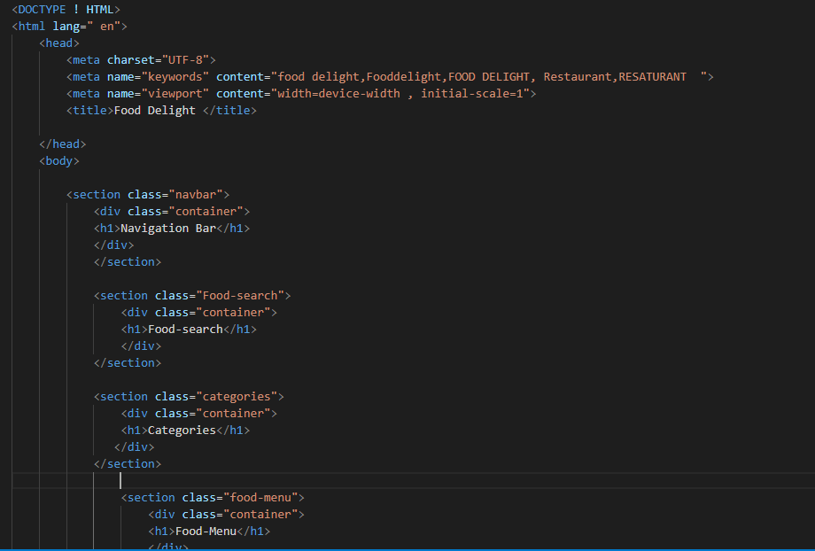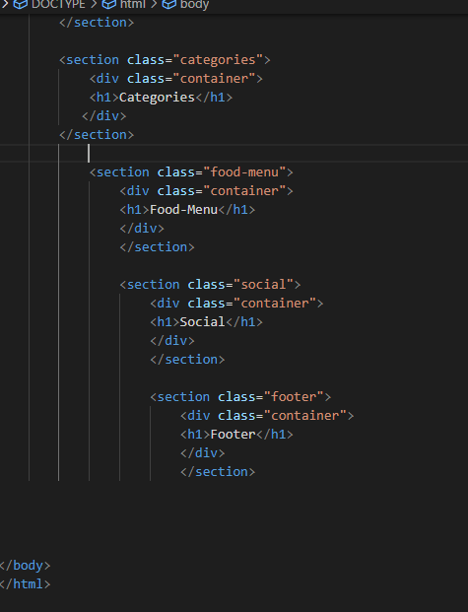

The outcome of the above code is shown below

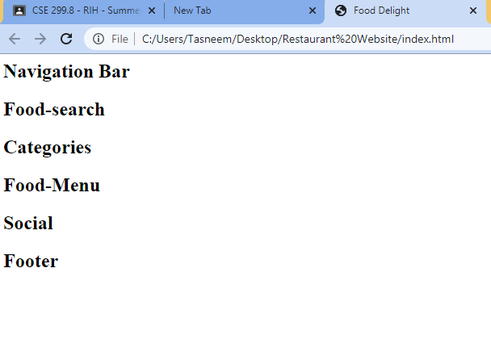

The above codes and layout of website are subjected to modification. In the upcoming weeks, the codes might be updated and modified as per the requirements of the project.