**3.Group member Rownita Tasneem**

Our teammate, Rownita Tasneem , has learned important and required concepts of HTML and CSS for styling ‘CATEGORIES’ page of ‘Food Delight’ through online documentations and tutorials. After that, she wrote the HTML and CSS codes for making ‘Categories’ page. Finally, she has completed the ‘Categories’ page as per the UI design.

**Here are the screenshots of the page**

* **Top part of the ‘CATEGORIES’ page**

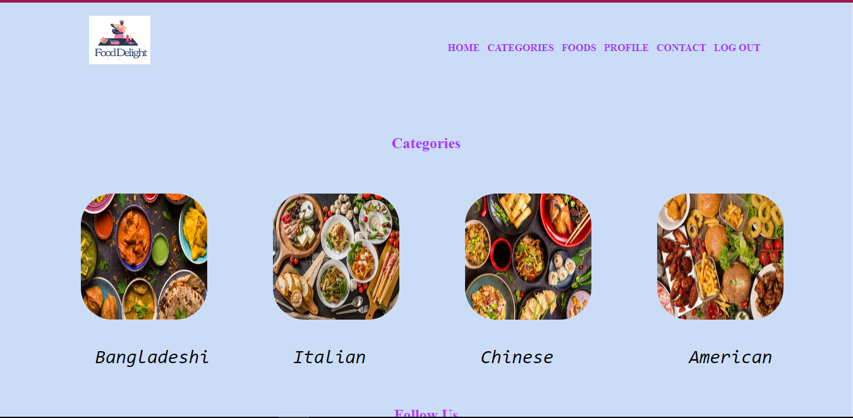

* **Bottom part of the ‘CATEGORIES’ page**

