**3.Group member :Rownita Tasneem**

Our teammate, Rownita Tasneem , has created profile page for ‘Food Delight’ and linked that pages to the ‘PROFILE’ of foods. She has designed this in a way that this page will take necessary user information for creating user profile. This page will show image of user and other related information such as name, email, and address. Customers will fill out information and after that they click the ‘Save’ button. Moreover,they can change and delete information and profile by clicking ‘Change’ and ‘Delete’ buttons.

1. Top part of PROFILE page :-

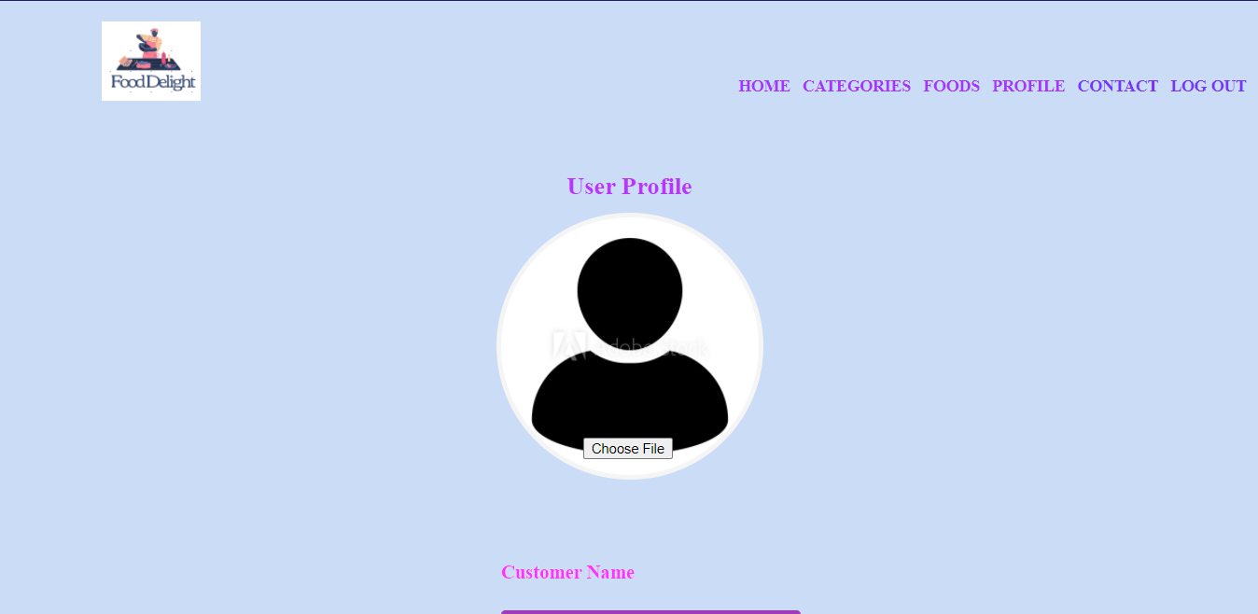

1. Middle part of PROFILE page :-

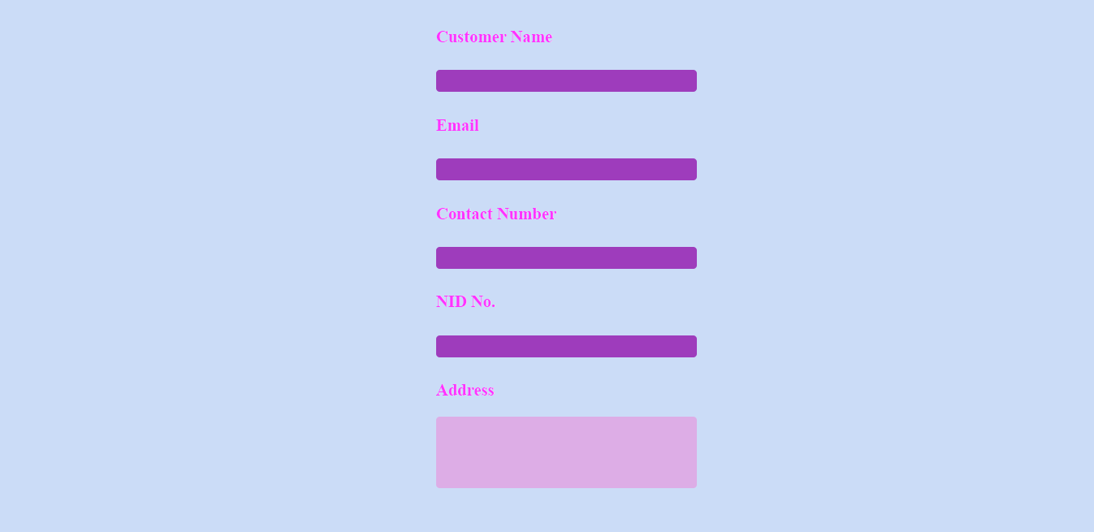

1. Bottom part of ‘PROFILE’ Page

