**3.Group member : Rownita Tasneem**

Our teammate, Rownita Tasneem , has created Delivery page for ‘Food Delight’ and through this page a customer can give their location through Google Autocomplete search box and provide name. This information through Google Map would go into the table named “map”. The table would store the information as latitude and longitude. In addition this code requires using API key .But she does not have billing account to pay money for the API key to Google. So, she could not run this feature. But she has done the necessary codes for implementing this Delivery feature so that it could depict how a real website could work if it could provide money for the Google Map API key. Moreover, she has changed the About page so that it could show the necessary information related to our website. She has also changed the “Order” page so that it could show the price for the food items. She has followed the documentation from this link-

**https://developers.google.com/maps/documentation/javascript/overview**

Here are the screenshots:-

I.DELIVERY page

Top part of Delivery page

.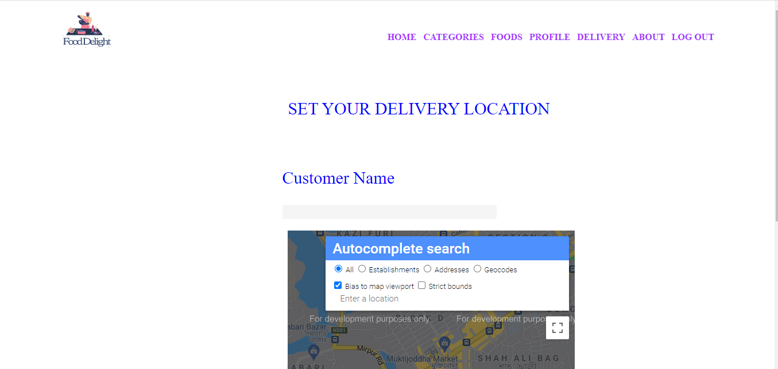

Middle part of the Delivery Page

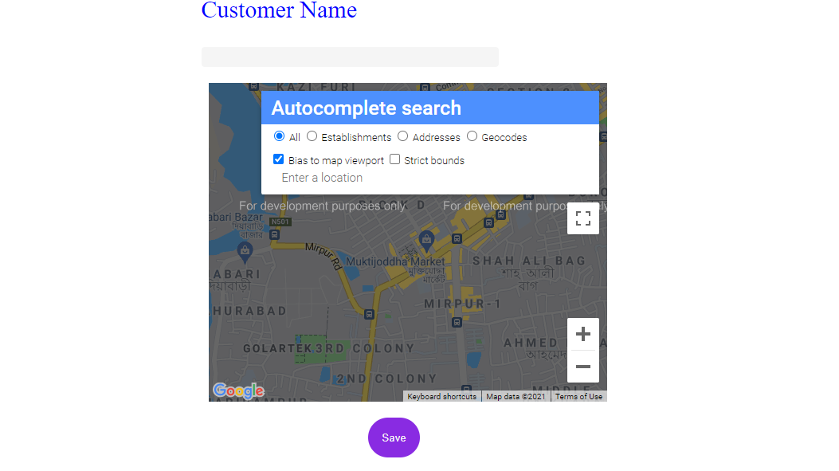

Bottom part of the Delivery page-

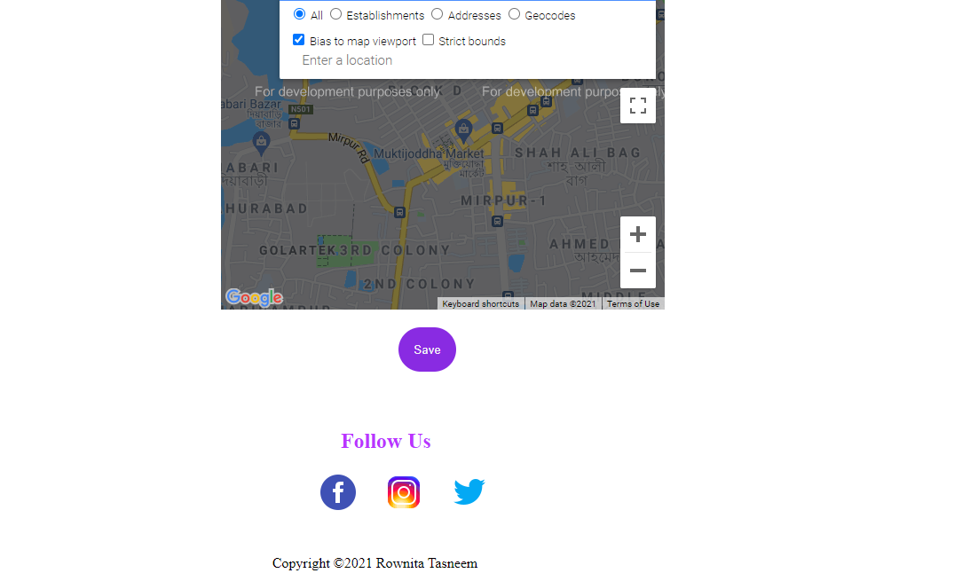

II.ABOUT page

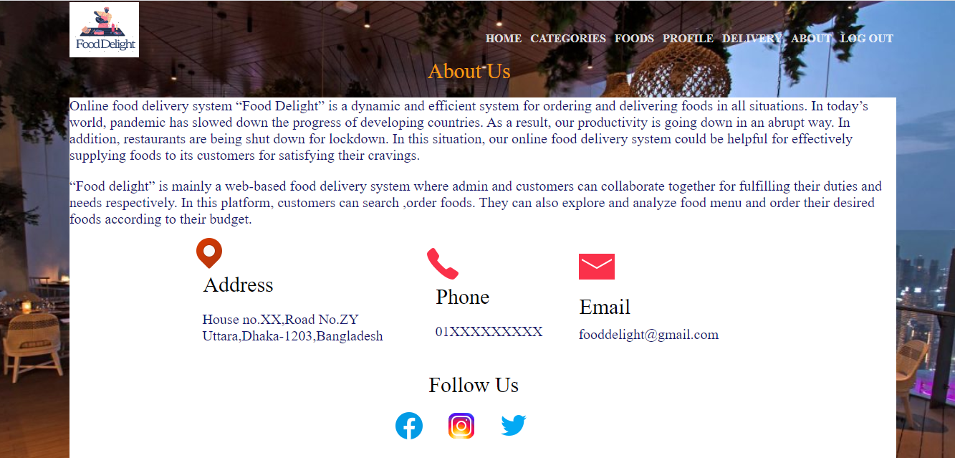

III. Order pages

Top part of the order pages-

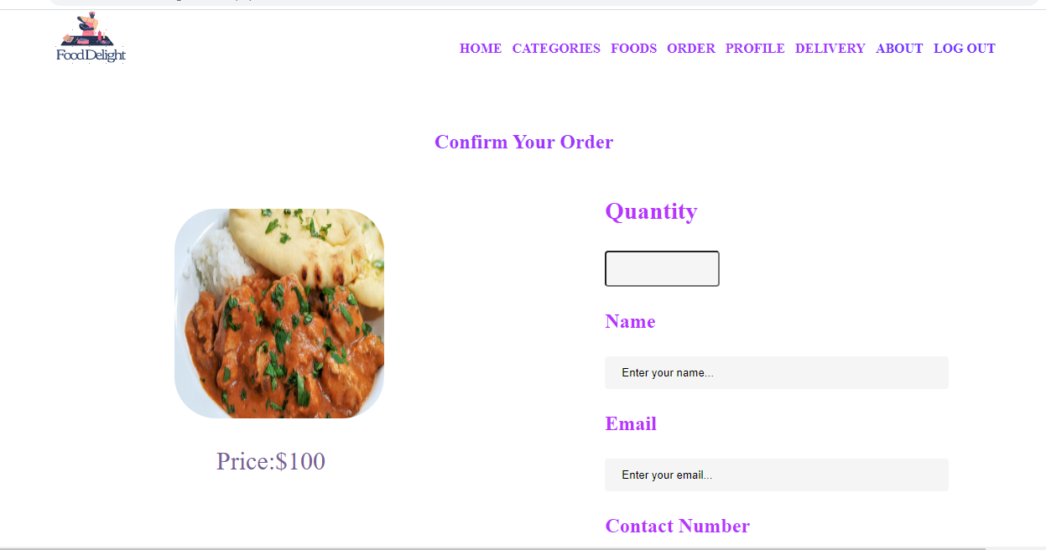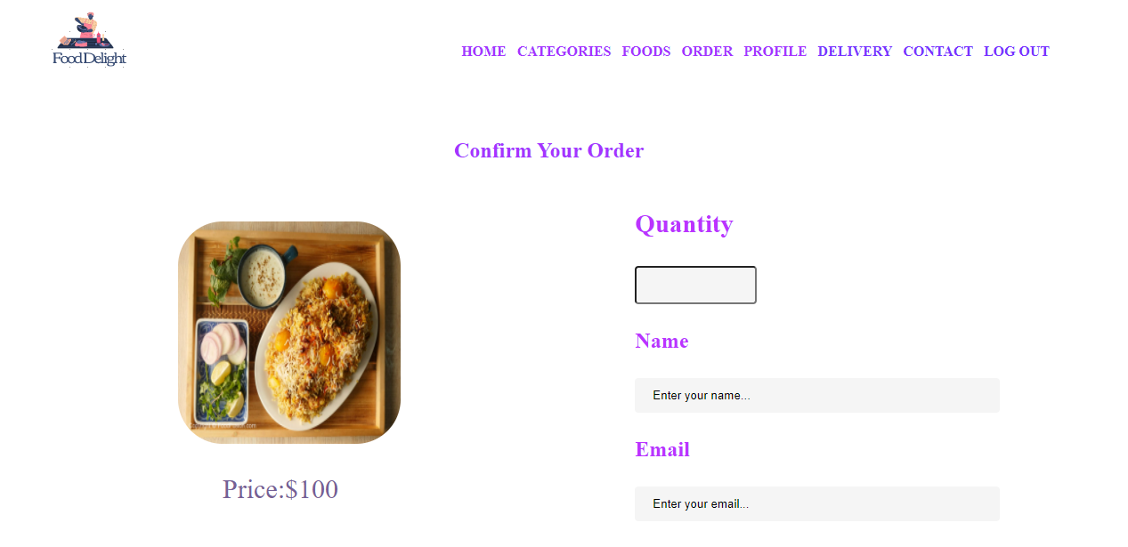

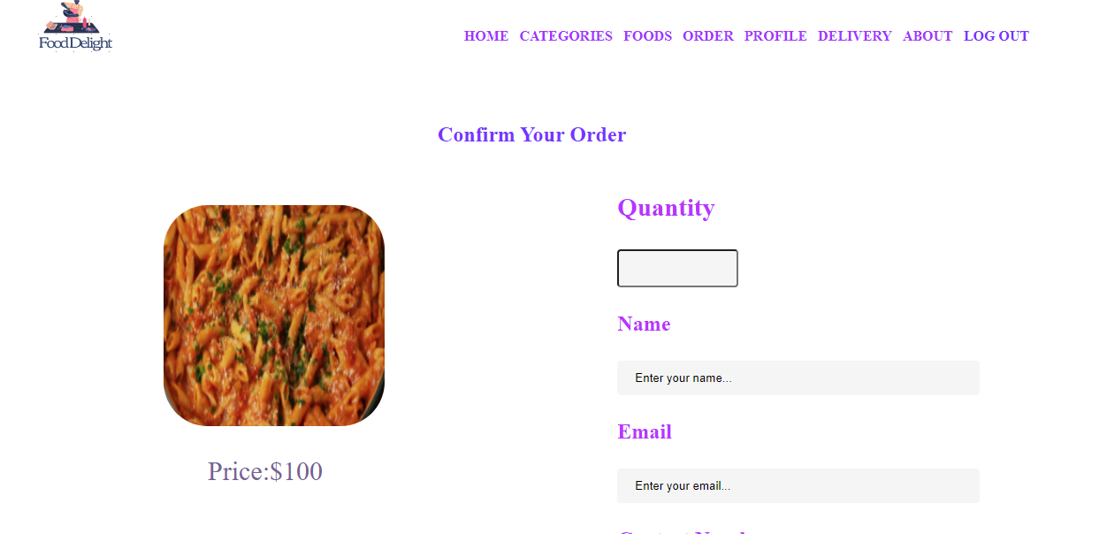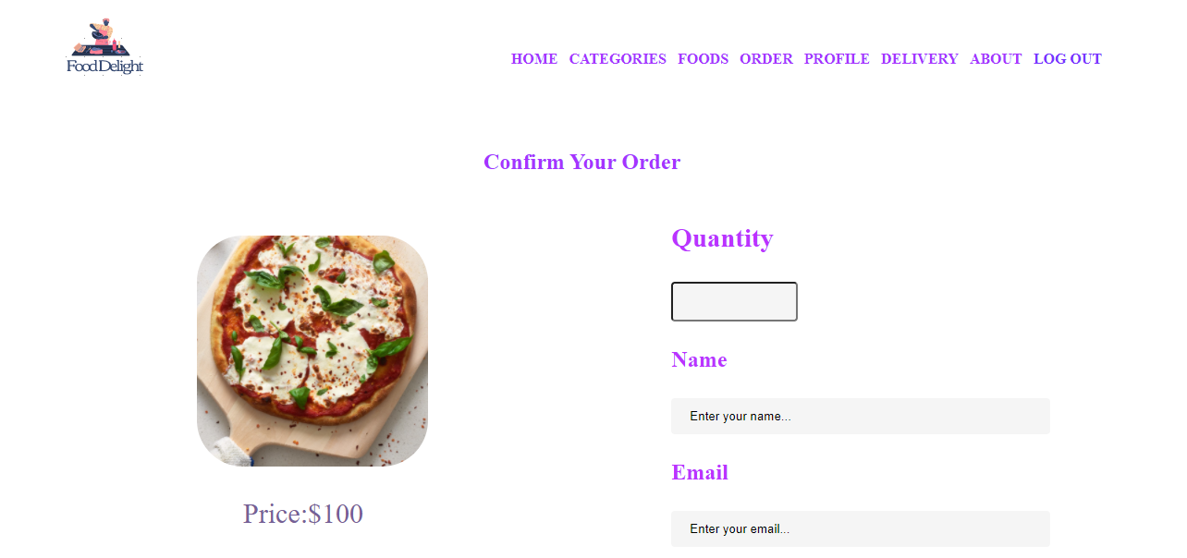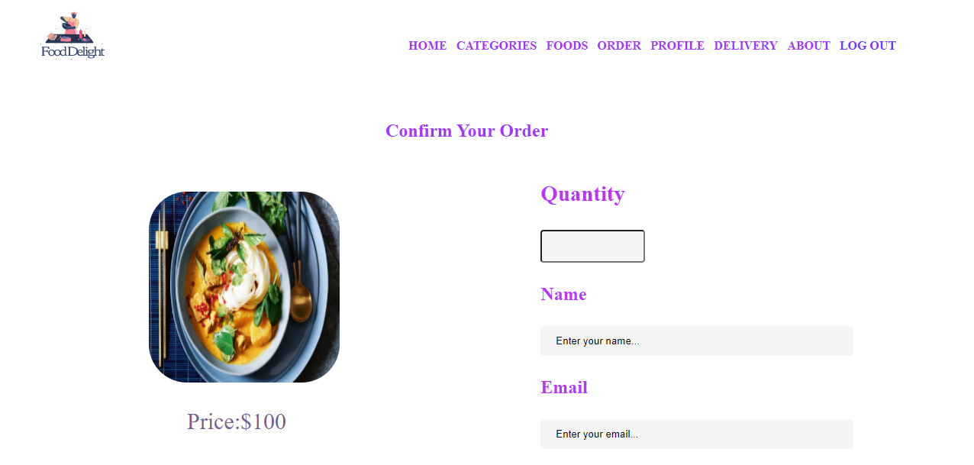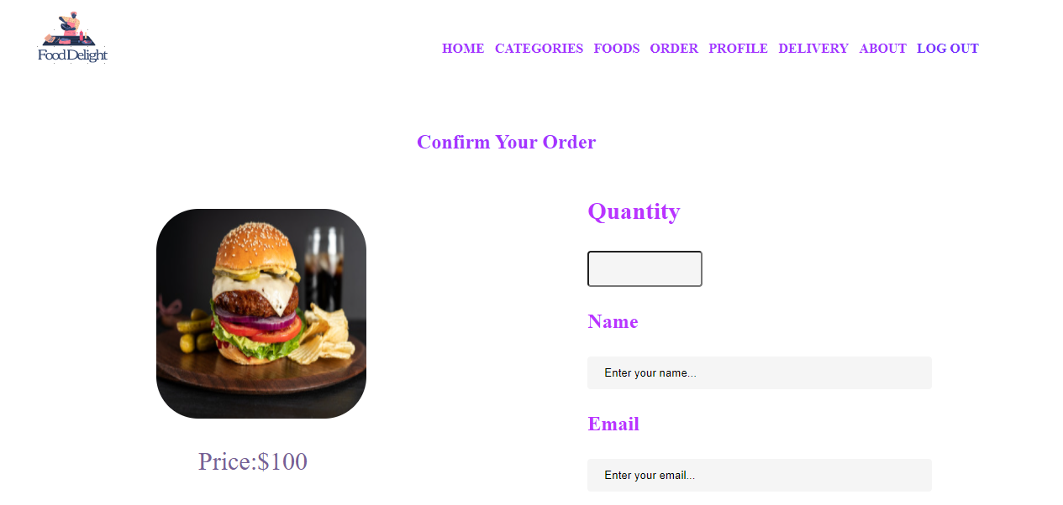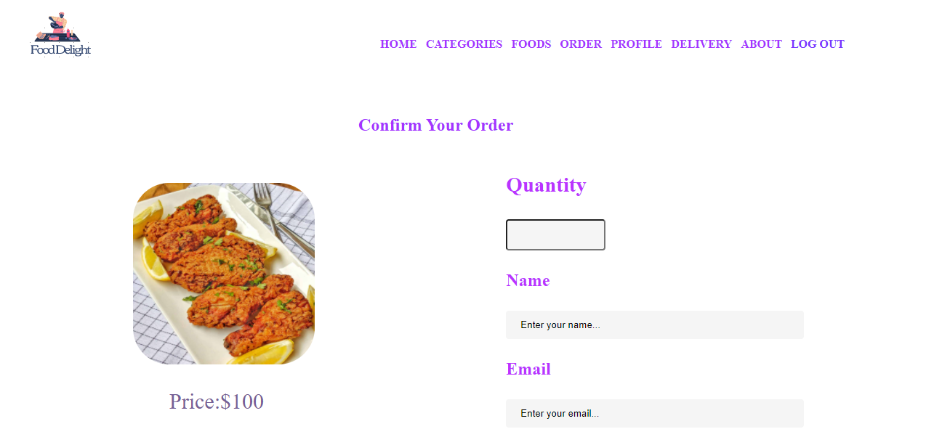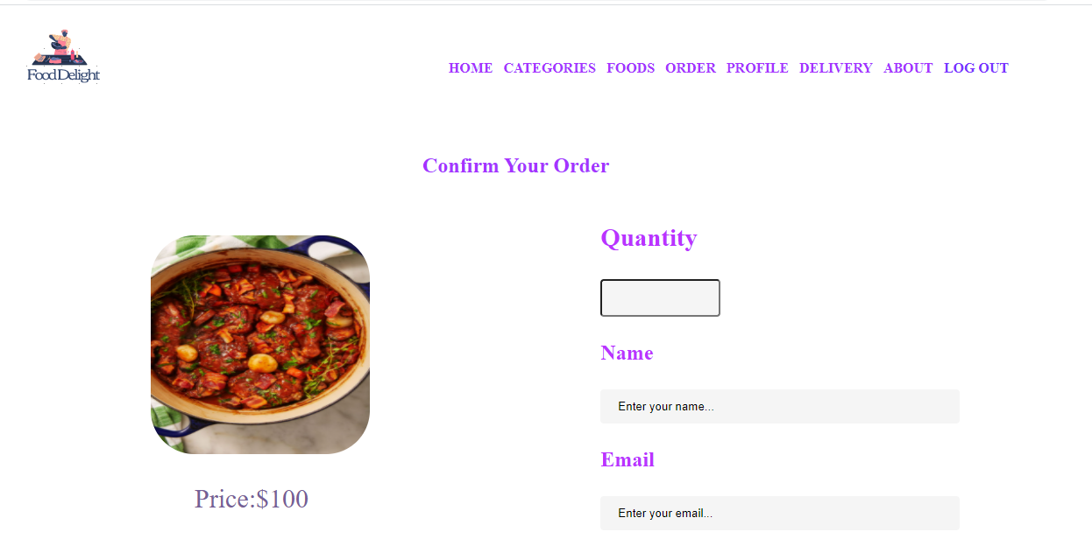

Bottom part of the Order pages

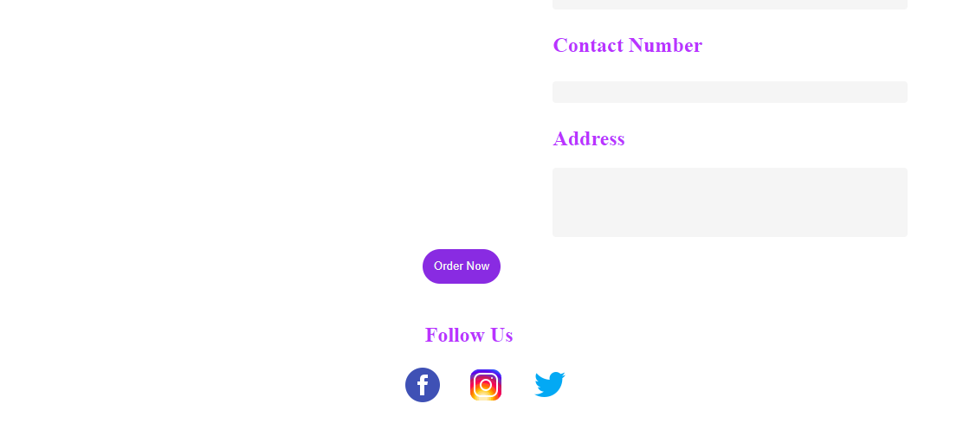

**Problem:**

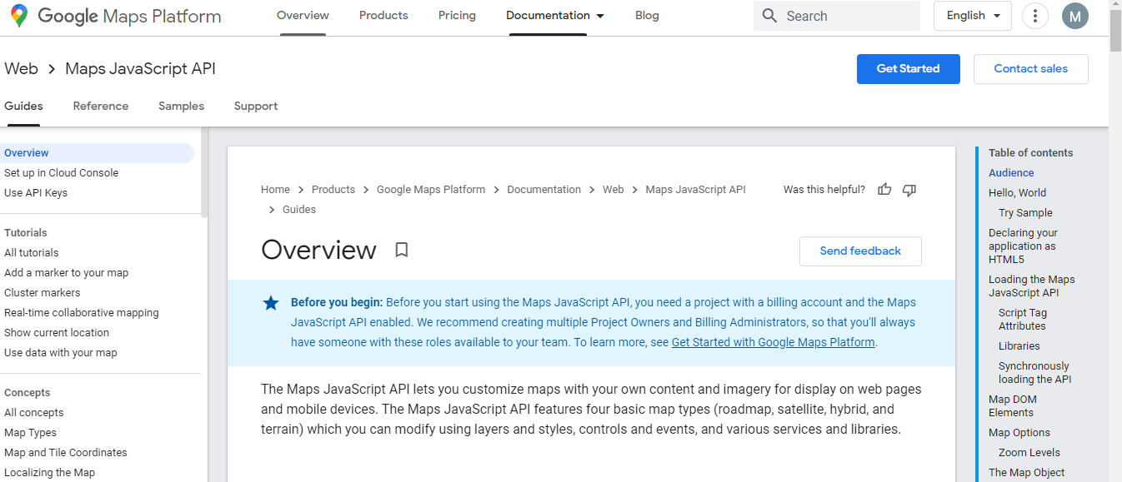

She needs a billing account for using Javascript Map API. So,she could not run this ‘Delivery’ feature.