# What is user testing? What are types of user testing?

An acceptance test can be understood as a way to check if a previously defined “*contract*” between the developer and the customer is still on track. Running those acceptance tests also ensures that no requirement change has happened in the meantime and that everything is as it should be to satisfy the customer.

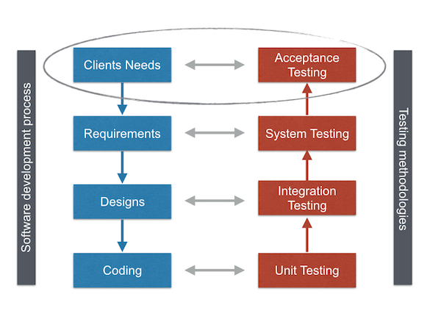

***Acceptance tests are useful, because:***

* they capture user requirements in a directly verifiable way,
* they identify problems which unit or integration tests might have missed,
* and they provide an overview on how “done” the system is.

When looking at the process of software development, we can see that UAT is utilized to identify & verify client needs.

**User Acceptance Tests** consist of a set of test steps, which verify if specific requirements are working for the user. If the customer and the supplier agree on the product, the software development starts. Legally. And practically.

**Types of User Acceptance Testing**

* Alpha & Beta Testing
* Contract Acceptance Testing
* Regulation Acceptance Testing
* Operational Acceptance Testing
* Black Box Testing