# **Assignment 4 (b)**

# State architecture for three sample case studies.

Types of architecture for building a software are as follows:

1. Layered architecture
2. The Repository pattern
3. Client-server architecture
4. Pipe and filter architecture

**Case 1.3.1 An insulin pump control system**

It is mentioned in the case study that the software controlling the system us an embedded system, that collects information from sensors and controls a pump that delivers a controlled dose of insulin to the user.

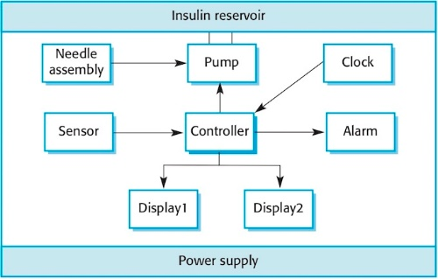

The system architecture for the software is Repository architecture.

1. All data in a system is managed in a central repository that is accessible to all system components. Components do not interact directly, only through the repository.
2. The system has several sub-systems such as sensor, pump, clock, alarm etc.
3. Each sub-system must share data or information.
4. Several sub-system depends on each other for performing certain actions.
5. All the sub-systems are linked together and controlled by a central controller system.
6. It is a data-driven systems where the inclusion of data in the repository triggers an action.

**Case 1.3.2 A patient information system for mental health care**

The MHC-PMS (Mental Health Care-Patient Management System) is an information system that is intended for use in clinics. A patient information system to support mental health care is a medical information system that maintains information about patients suffering from mental health problems and the treatments that they have received.

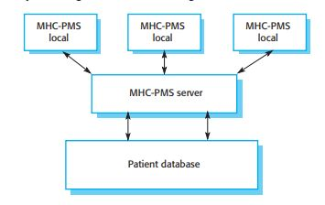

The system architecture for the software is a Client-Server architecture.

1. The system requires management of information that can be accessed from local systems.
2. The system has a database containing patient information.
3. Users of the system are – doctors, nurses, clinical staffs who needs to access patient information frequently.
4. A client-server system will help in the management of database easily.
5. Set of stand-alone servers which provide specific services such as printing, data management, etc.
6. Set of clients which call on these services.
7. Network which allows clients to access servers.

**Case 1.3.3 A wilderness weather station**

Wilderness weather stations are part of a larger system. To help monitor climate change and to improve the accuracy of weather forecasts in remote areas. These weather stations collect data from a set of sensors that measure temperature and pressure, sunshine, rainfall, wind speed and wind direction etc.

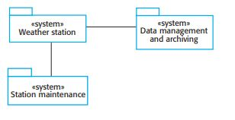

The system architecture for the software is a Layered architecture.

1. The system is an IOT layered architecture.
2. Organises the system into a set of layers (or abstract machines) each of which provide a set of services.
3. Each sub-system has a user interface.
4. The sub-systems can be accessed by authentic users.
5. The system also includes database or archiving system.
6. Organizes the system into layers with related functionality associated with each layer.
7. Used to model the interfacing of sub-systems.