Versions:

Date | Versiune | Autor | Comentarii
11.11.2020 | 1 | Ciocian Roxana  Cociș George | First documentation version.
19.11.2020 | 2 | Ciocian Roxana  Cociș George | Second documentation version.  -completed sections 8, 9, 10
26.11.2020 | 3 | Ciocian Roxana  Cociș George | Third documentation version.  -completed section 7, 11
03.12.2020 | 4 | Ciocian Roxana  Cociș George | Fourth documentation version  -updated the functionalities and use case diagrams sections
29.01.2021 | 5 | Ciocian Roxana  Cociș George | Fifth documentation version  -completed sections 12, 13  -updated sections 4, 9

Analisys&Design for <The meantime wheel>

Continut:
- General Presentation

- Theoretical Fundamentals

- IT Technology (which will be implemented)

- Functionalities

- Actors and related access rights

- Use Case Diagrams

- System Architecture

- Design (UML Diagrams)

- Operation Mode (Operation Guide, including screen-shots)

- Portability

- Competing Software

- Testing and validation

- Future development

- General Presentation

The project presented in this document is a C# based application, developed for users to ‘waste’ time in dynamic and constructive ways. There will be 3 actors that can interact with this application: moderator, visitor and user. The moderator is the one responsible for the maintenance of the application and he can log into the app via some username*password set. The visitor is the one who access the app for the first time. He can only create an account in order to benefit from the games within the application. The player, user, is restricted to a spinning wheel after logging in via some username*password set. Based on a roll from 1 to 8, the player will be taken to a minigame associated with the rolled number. The application incorporates 8 unique games, from quizzes to 2D platformers. Some games reward the player with in-game tokens.

- Theoretical Fundamentals

This project will use a database for storing the related information to the user and moderator. When a visitor creates an account, he needs to introduce some general information, such as his first name, last name, the username-password set etc., information that will be held into the database. There are some necessary pieces of information about the moderator as well, such as email, username and password, needed for logging into the application, which also will be held into the database. The tool used for designing the database is MySQL Workbench, which is a visual database design tool that integrates SQL development, administration, database design, creation and maintenance into a single integrated development environment for the MySQL database system.

- IT Technology

The Integrated Development Environment used is Visual Studio 2019. The project will be written in C# programming language and will take the shape of a windows form application. The window form app is an event driven application supported by Microsoft’s .NET framework.

- Functionalities

When the application launches a log in window pops out. In the absence of an account, the actor will be redirected to another window where he can choose to create an account. If the actor already has an account, he needs to choose what role he plays within the application. In the case he is a moderator, another window will pop out. This window contains all the action he can perform within the application. In the case he is a simple user, a new window will pop out and he can choose to go to the spinning wheel or to deposit/withdraw currency. If the user wants to start the game, he clicks on the hyperlink related to the spinning wheel. By pressing the roll button, a number from 1 to 8 will be generated, based on a random algorithm. Each number will correspond to a different minigame. Based on the rolled number, the corresponding mini-game will become available (a button redirecting the actor to the mini-game window will become visible).
- Trivia

The actor is taken to a form containing 8 different domains, such as music, movies, etc. Upon clicking on a specific domain, another window will pop out. This window will contain a start button and 4 guess buttons. There will be 6 categories: songs, movies, pop culture, flags, video games, Harry Pottter.

- Platformer

The actor is taken to a form containing all the rules and controls of the game. Upon clicking the start button, a new form containing the generated environment will pop out. The player moves by pressing left, right and space. The purpose is to collect as many coins as possible and reach the castle. Upon colliding with an enemy, a trap or falling off the map, the player will die. While being dead, the player has the option to restart the game.

- Pac-Man

Pac-Man is maze chase video game in which the player controls the character through the maze. The objective of the game is to eat all of the dots, representing the food, placed in the maze while avoiding the ghosts. There will be three colored ghosts will have their own artificial intelligence (A.I.) in order to be able to make their own movements, trying to go after Pac-Man. If Pac-Man makes contact with any ghost or with the walls, he will lose, and a specific message will be displayed. If Pac-Man manages to eat all of the dots, he will win the game and a specific message will be displayed. Before starting the game, a window will pop up containing a brief explanation of the game and the controls needed by the player in order to play.

- Match the cards

It is a card game in which all of the cards are laid face down and two cards are flipped face up over each turn. The objective of the game is to stimulate the memory of the player so that he can turn over the pairs of matching cards. The game contains 16 cards with 8 different pictures. Each turn, the player can face up two cards. If the cards match, they will disappear, but if the cards do not match, they will be flipped down, and the player needs to try again to find the pairs. The player must find the pairs within a minute, otherwise he loses. He wins when all pairs are found, and a specific message will be displayed.

- Jukebox

The visual interface of this game consists of several buttons. Each button will make a different sound by pressing it, and will activate an image related to the sound. It is a fun game where the player can relax and enjoy the time spent on the application. This environment has no final purpose, so the player does not earn tokens by playing it.

- Learning environment

The objective of this game is to test the player’s basic knowledge in a certain field. It is a good game where the player can relax while learning new things or just practicing what he already knows. There will be three types of exercises: exercises where the player needs to give the correct answer to some questions, exercises where he needs to continue the snippet, and exercises where he must write the answer. The game ends when the player manages to complete all of the exercises. If he fails at some exercises, he will have to start again the game, until he will finish them all.

- Gambling

The player has a virtual vault where the coins & tokens are stored. He must choose the currency type he wants to bet, the amount and the ‘roll value’. If the roll value matches the player roll, he will be rewarded accordingly. If they do not match, the player loses the amount.

- Puzzle

This game test the player’s logic and attention. A picture will be given at the beginning, and it will be divided into 9 parts. Those parts will be randomly placed, such that the player needs to make some moves in order to obtain the initial picture. Each move he makes is counted, and in the end, the player will obtain a score depending on number of moves. During the game, he can press pause, but the puzzle will disappear until he is back. The player must to reconstruct the picture within a minute, or he loses.

- Actors and related access rights

This application has 3 actors: visitor, moderator and user.

The first actor, visitor, interacts with the database, because he is the one who can create an account for the application, by introducing the data required: his first name, last name, email, phone number, country, the username and password which will be used for logging into the app as a user.

When the application launches, a log in window pops out and there will be 2 options: logging in as User or logging in as Moderator.

When the logging is done as a Moderator, based on some username*password set, the moderator can log into the application. He is the one who can insert, delete or update the user & app related information held into the database.

When the logging is done as a User, based on some username*password set, the user can log into the application. The user can deposit or withdraw cash within the database, play games and earn tokens.

- Use Case Diagrams

Use Case Diagram for Visitor:

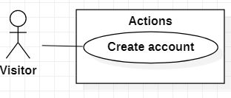

Use Case Diagram for Moderator:

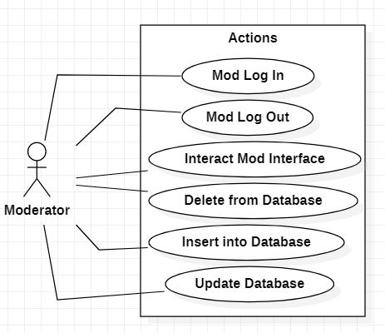

Use Case Diagram for User:

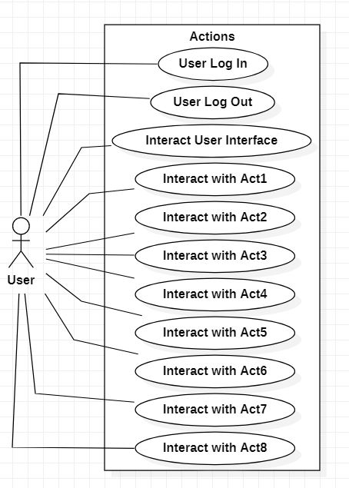

- System Architecture

This project is not structured under a specific architectural pattern. Being created within the same namespace, each class integrates a specific element of the user interface & the functionalities behind. The classes represent the forms that construct the program. Most of them function by themselves, after an instance of a new form is created and displayed from a previous one. Each form (representing a window) is specific in its way. Each element from the user interface (created within the form window) has its own functionality and purpose. All of them together create a single application window, and all the windows together create the application user interface. The classes are grouped by purpose under different folders. All the classes useful during the log in process are grouped under a Log In folder. The wheel folder contains the wheel class, while ActsOfWheel contains the start up forms of all the incorporated minigames. Each minigame has a folder containing all the other related mini-game classes, such as all the different trivia forms from the Trivia activity. All the resources (audio files, pictures etc) are grouped under Resources.
Each action taken during the game creates a new instance of the requested activity, for a refresh each time one of them is called. All the user/moderator related data is held in a MySQL Workbench database.

Architectural diagram

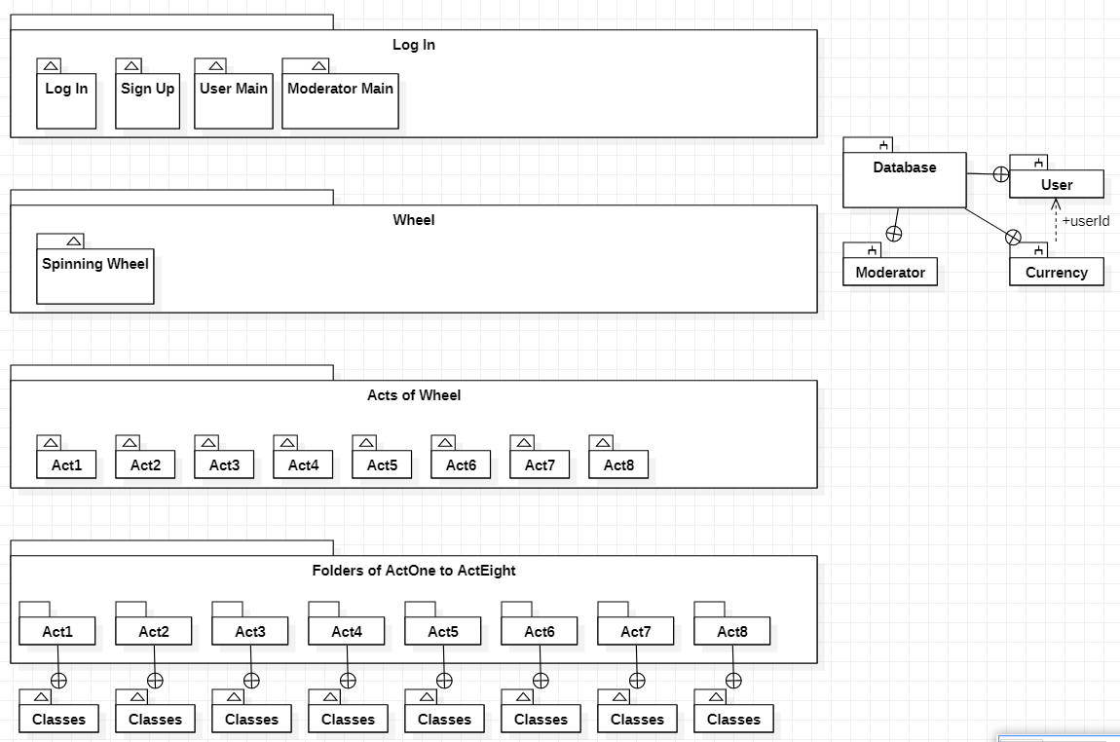

- Design (approx. 12 UML Diagrams!!!)

- Use-Case Diagrams
The use-case diagrams are presented in section 6.
- System Architecture/General System Diagram
The System Architecture is presented in section 7.

- Class Diagram

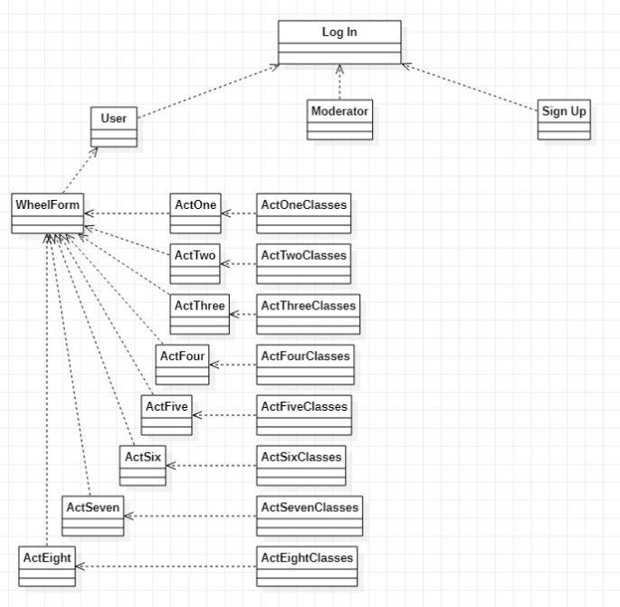

- Object Diagram

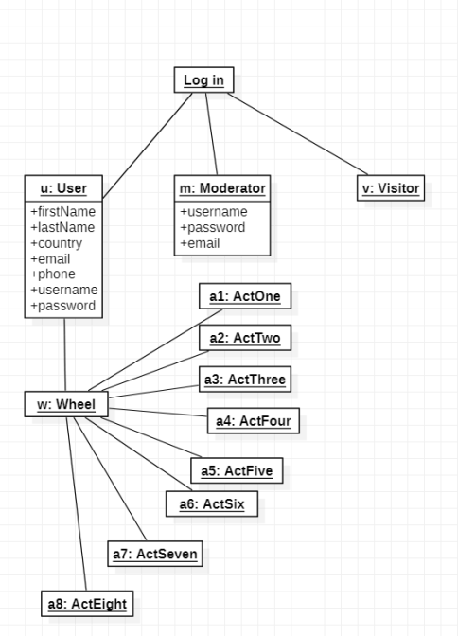

- Sequence Diagrams

User:
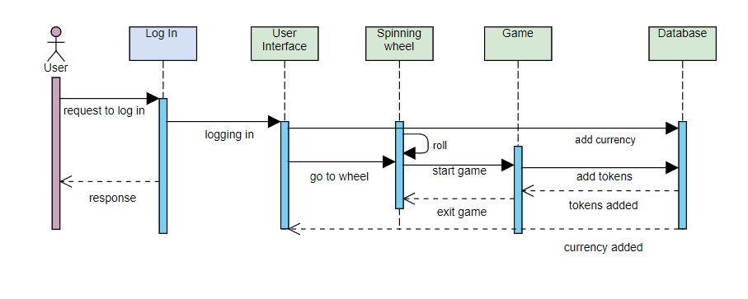
Moderator:

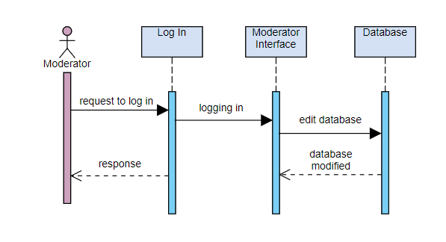

Visitor:
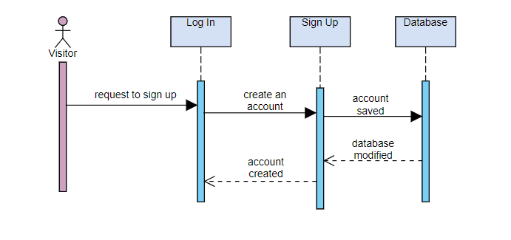
- Activity Diagram

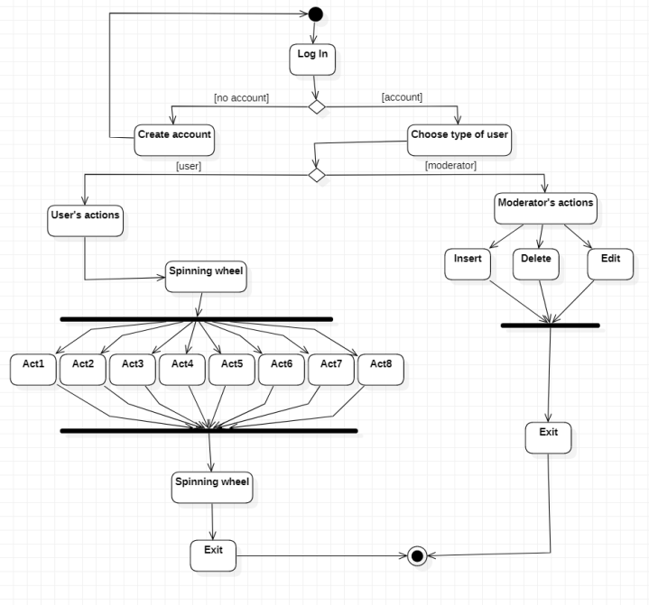
- State-Transition Diagram

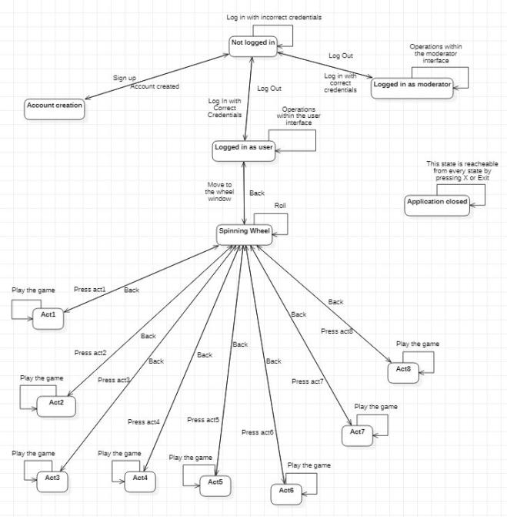

- Communication Diagrams

User:
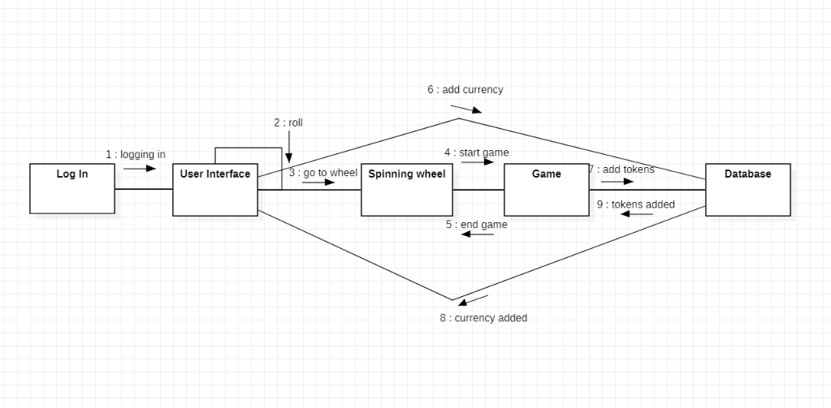

Moderator and visitor:
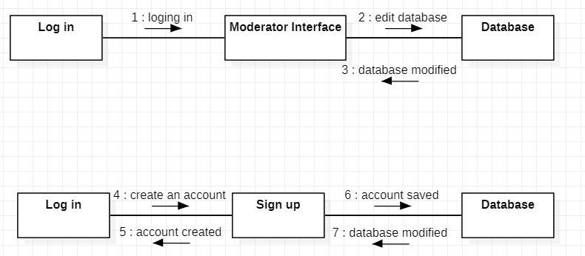

- Database Diagram

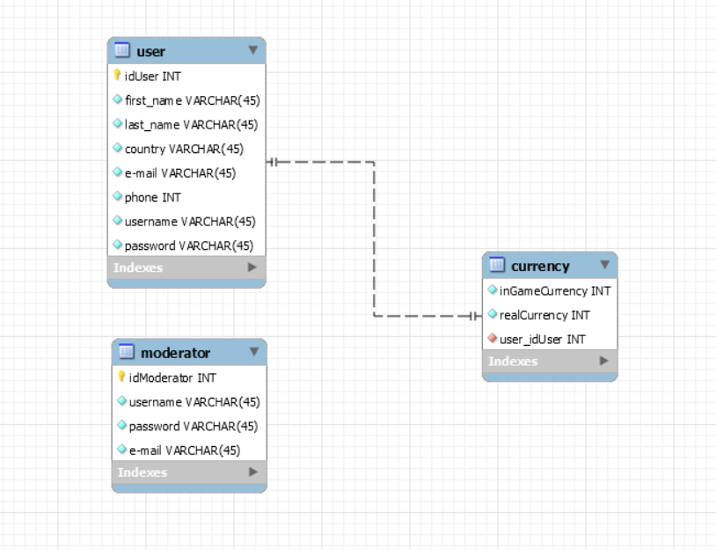

- Component Diagram

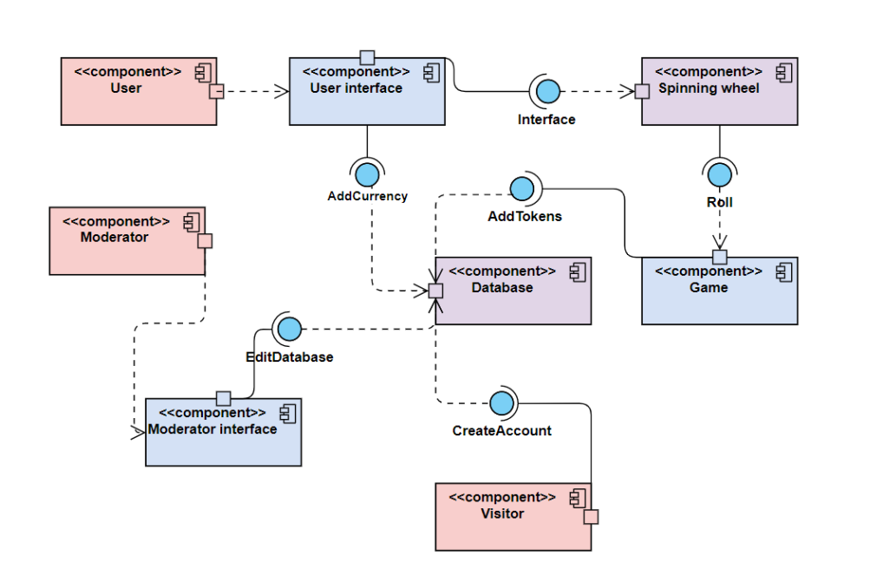
- Package Diagram -
- Deployment Diagram

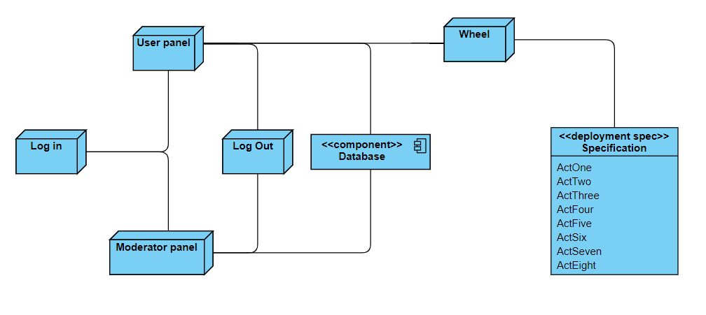

- Operation Mode (Interactivity presentation) + screen shots (UI design)
Log In:

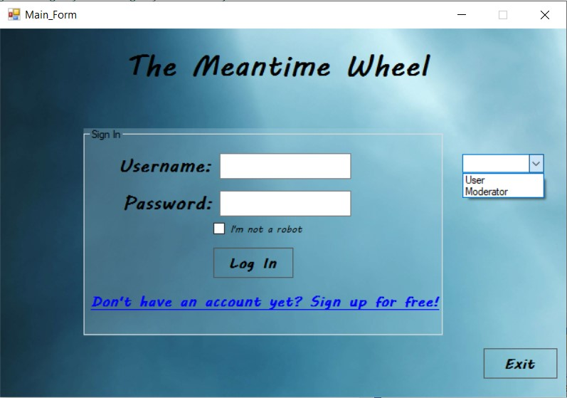

Moderator:

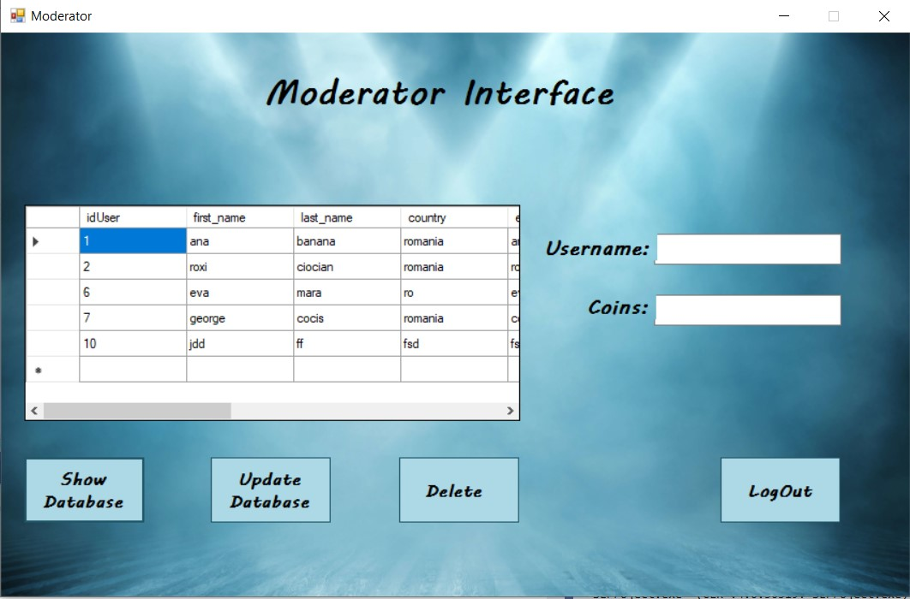

Register:

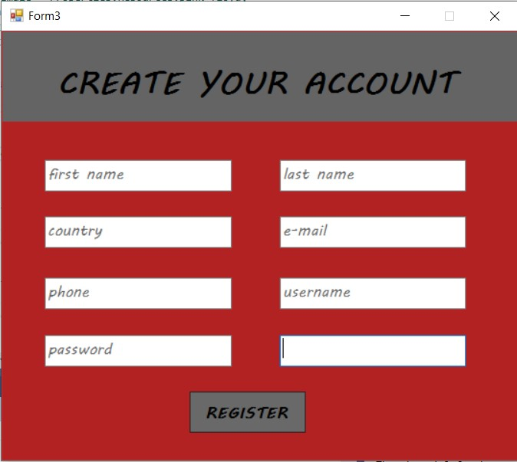

Pre user form:

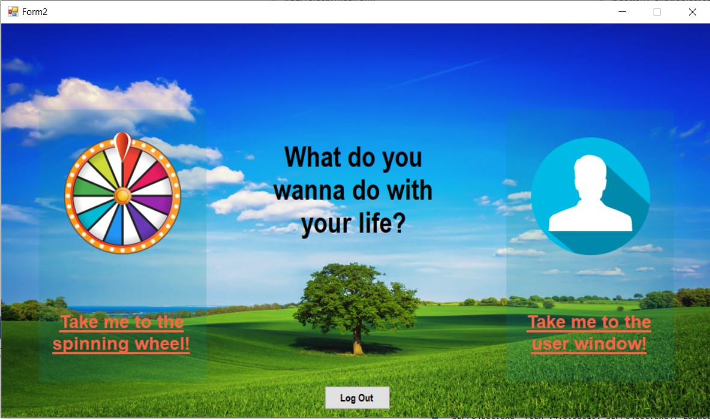

User form:

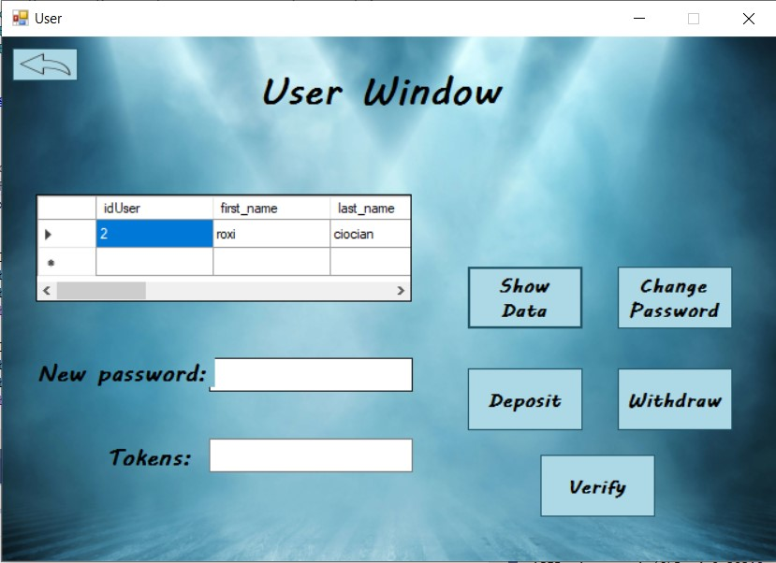
Wheel:
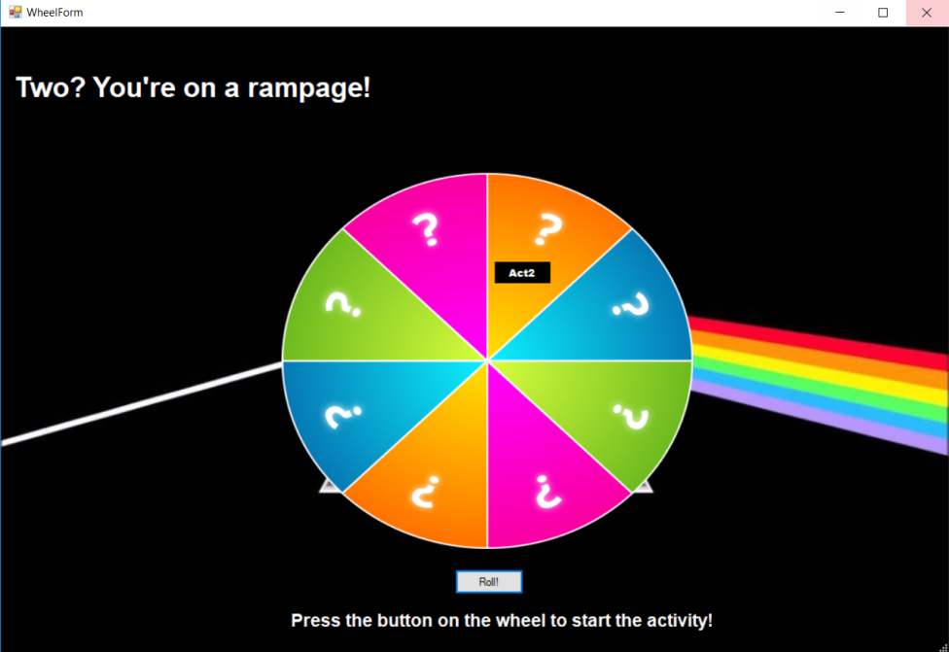

Act 1:
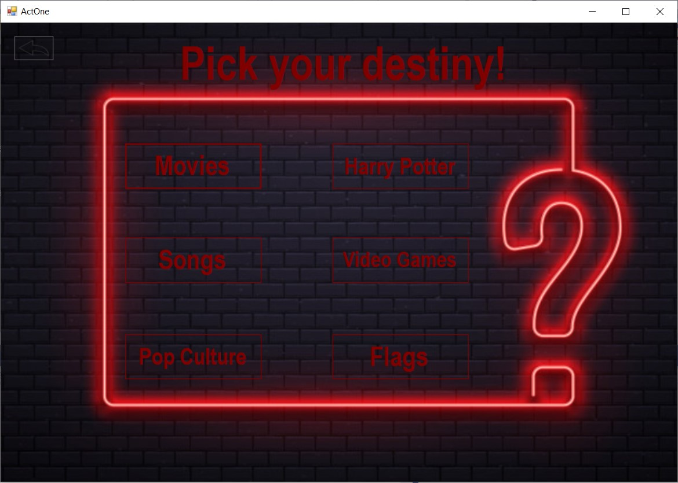
Movies form:
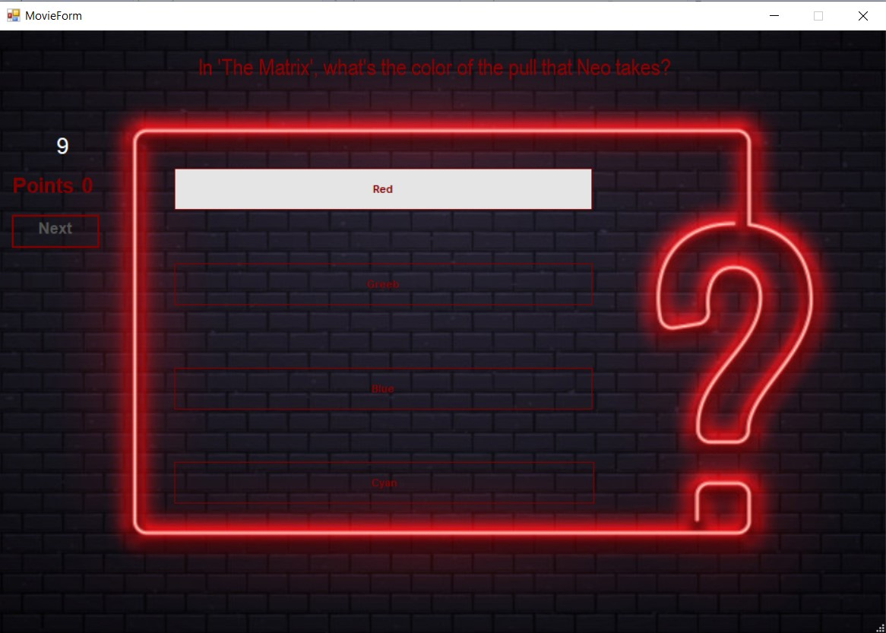
The other Act1 forms are similar to this one.

Act 2:
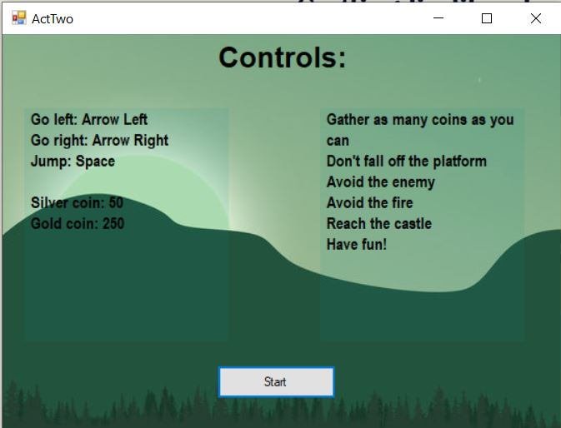

Act 3:
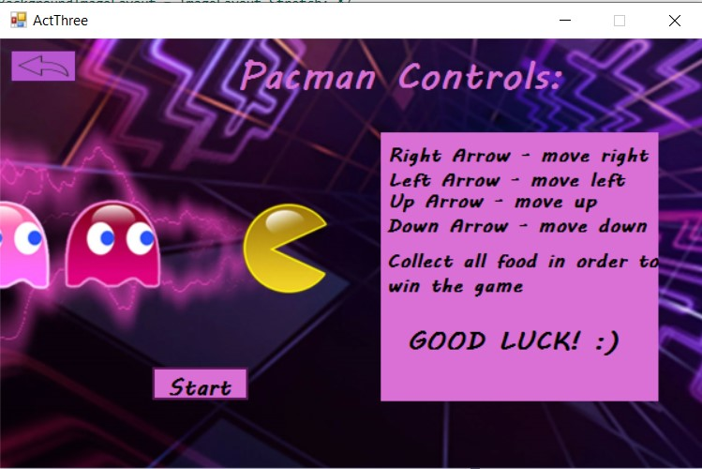
Act 4:
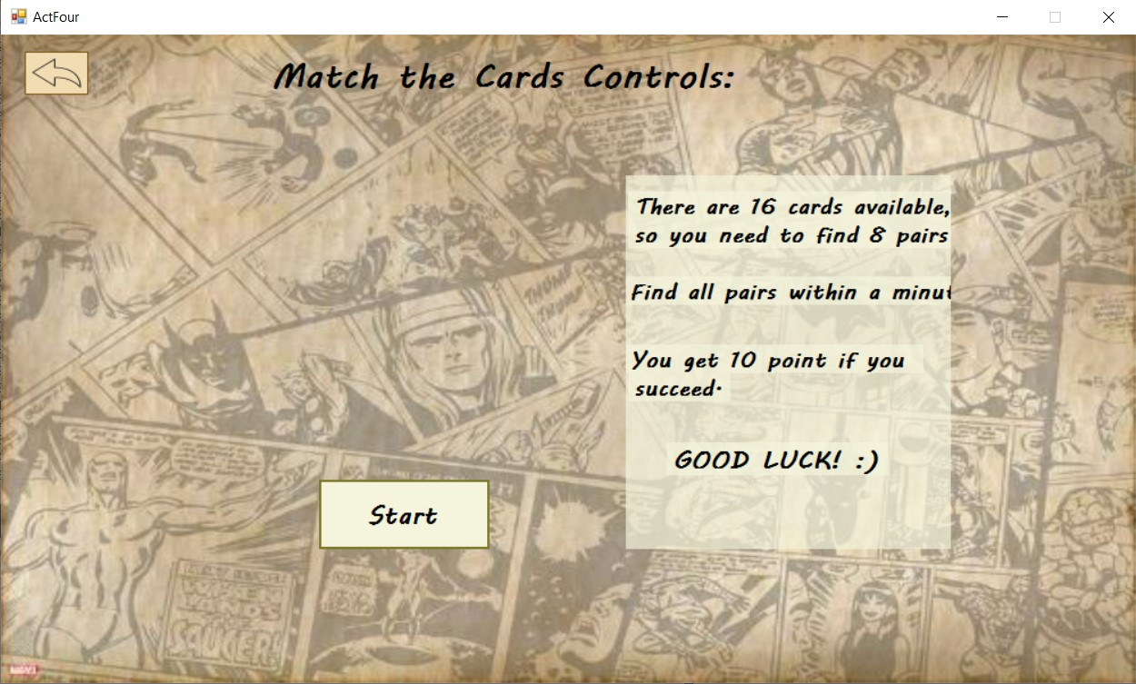

Platformer:

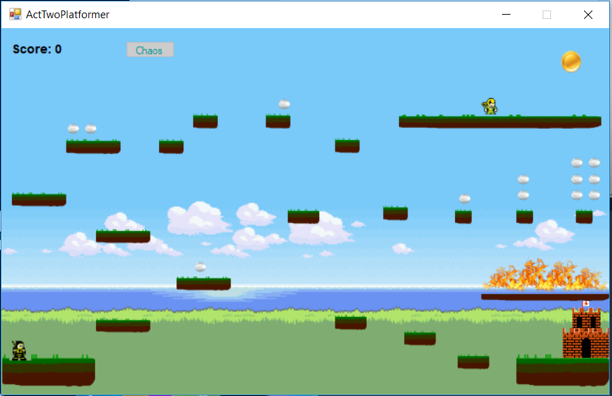

Match the cards:
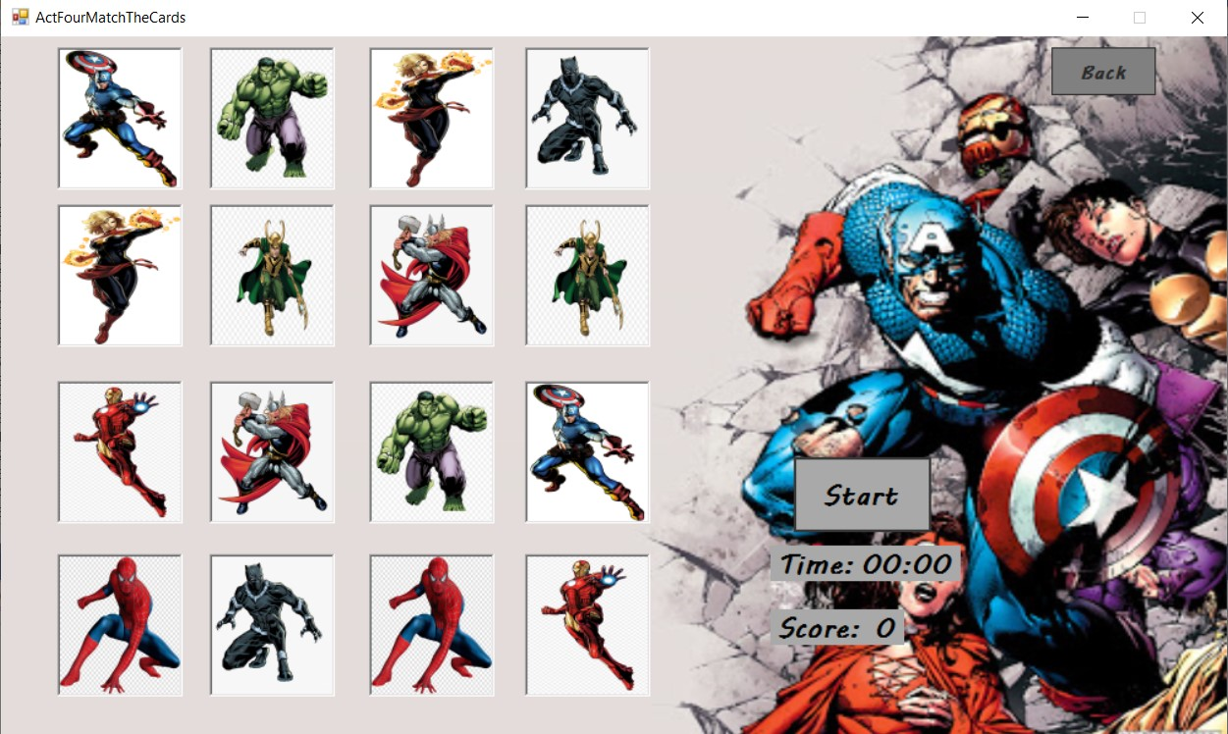

Act 5:
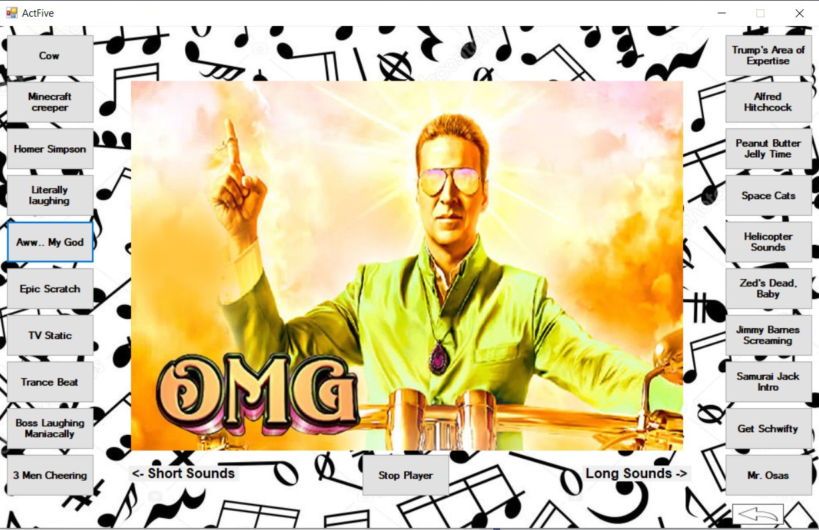
Act 6:
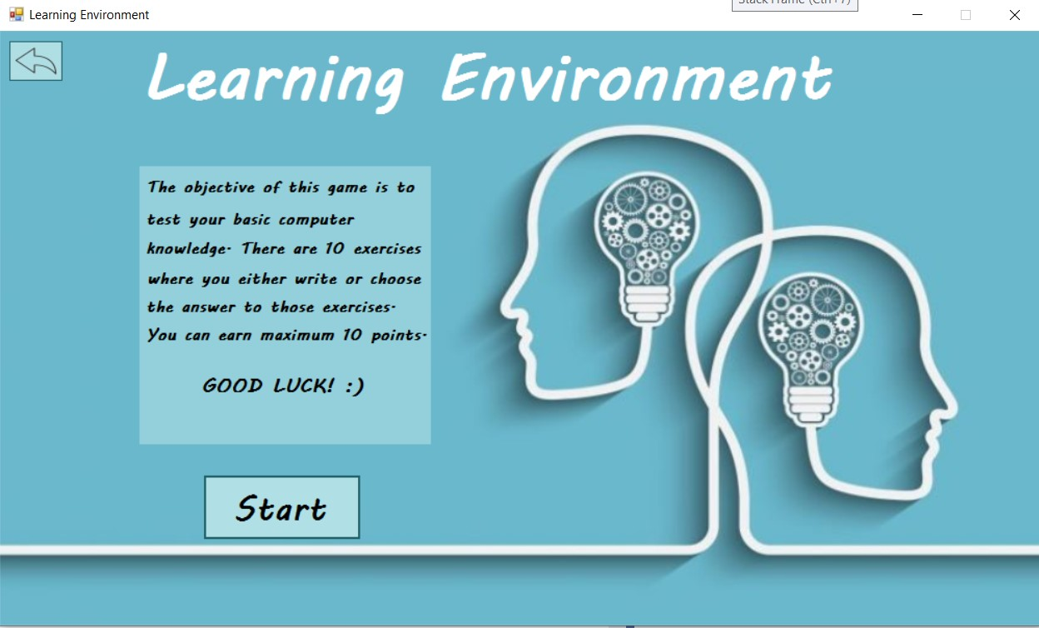

Act 7:
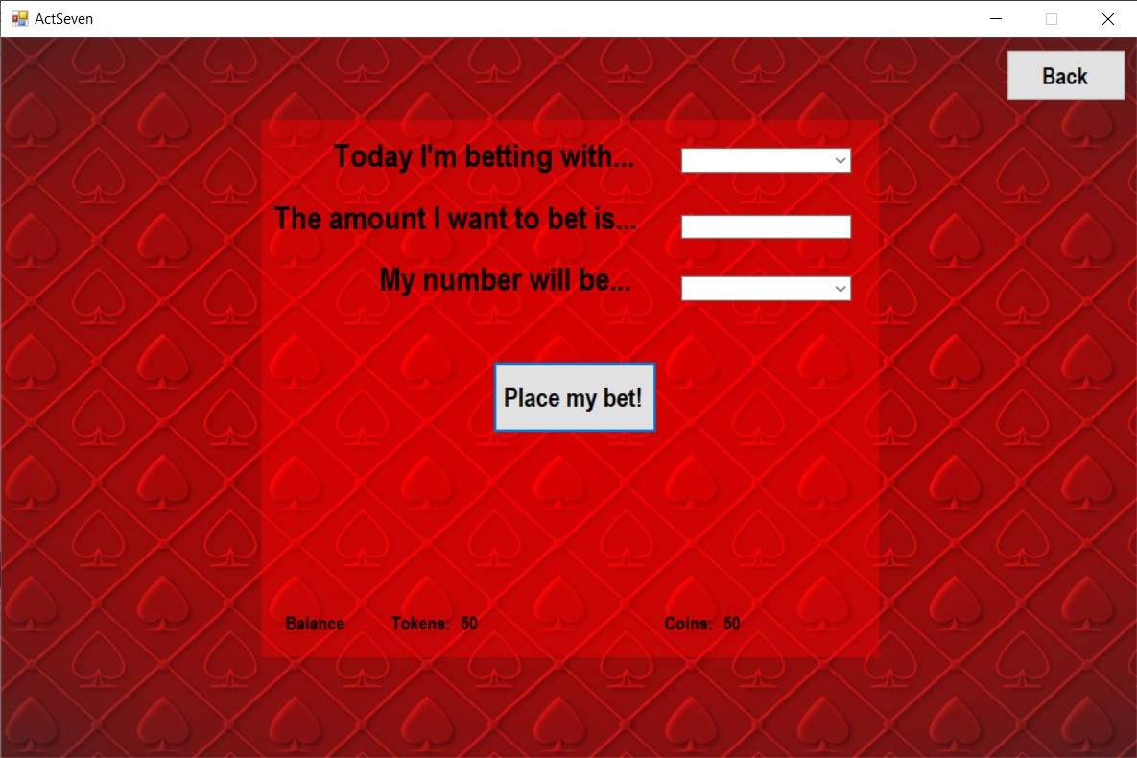
Act 8:
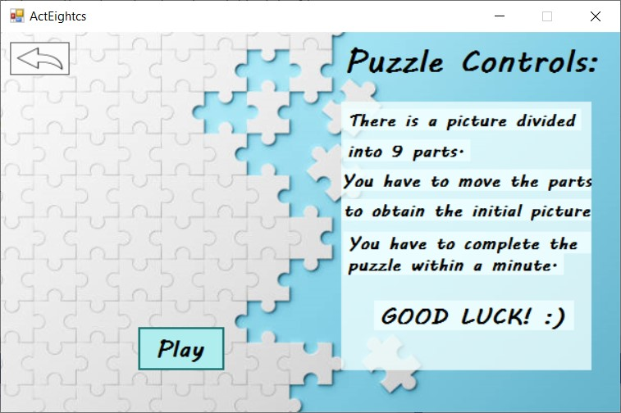

Learning form:
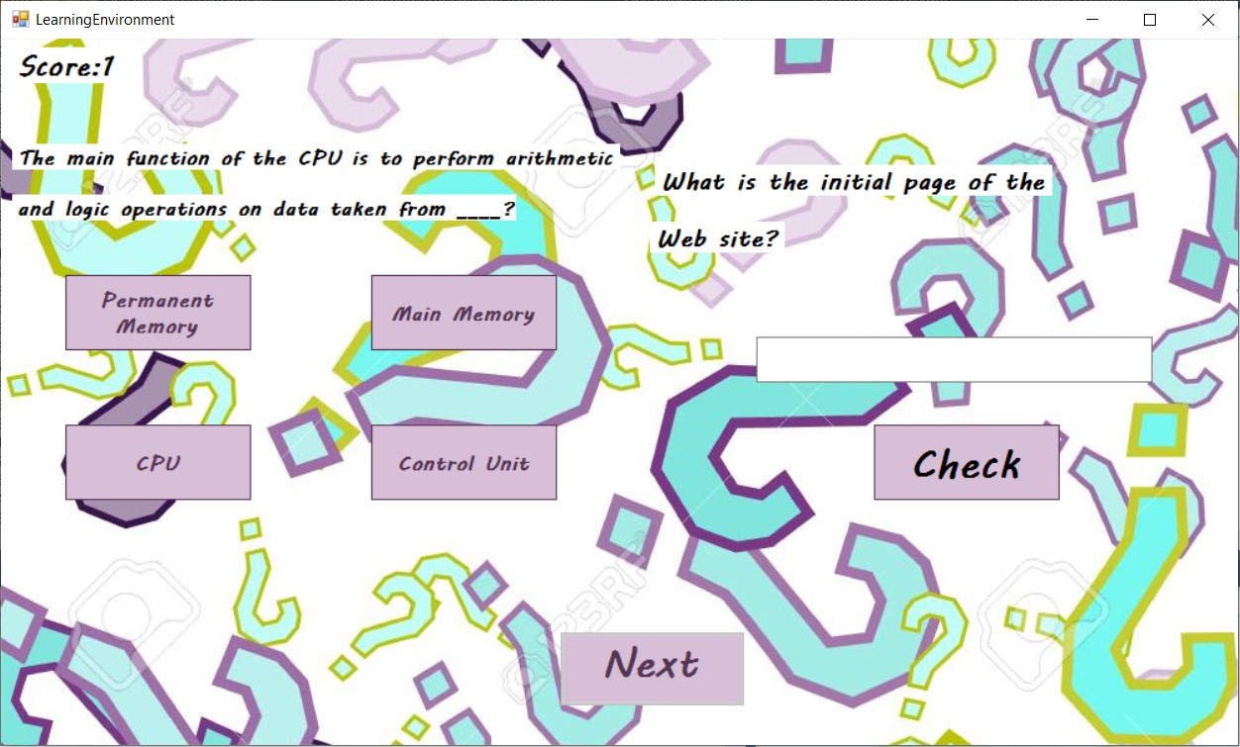
Puzzle form:
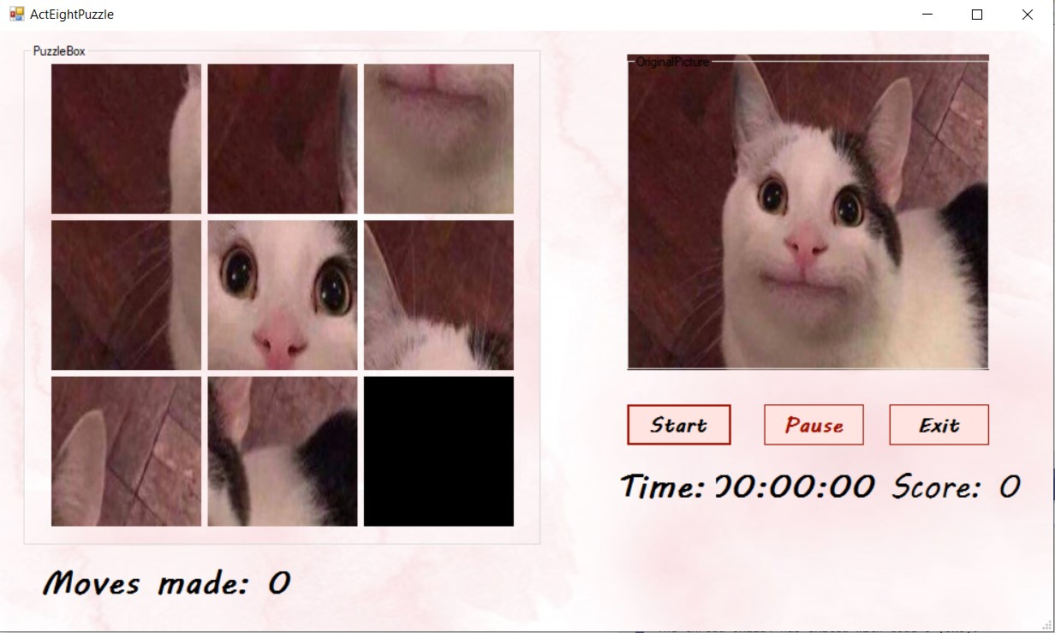

Pacman form:
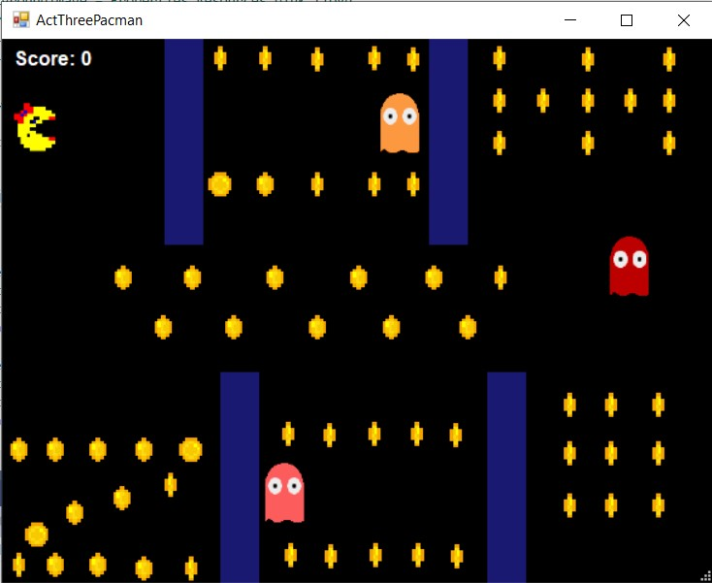

- Portability

The application can run on devices with Microsoft Windows operating system, such as PCs and laptops. It could run on mobile phones with the same OS (it doesn’t mean it necessarily will). The user needs to have the .exe file in order to launch the application.

- Competing software

The idea of the application revolves around the spinning wheel and 8 minigames, accessible form the wheel panel. Most of the minigames’ ideas are existing games by themselves, on a larger scale. For example, there are plenty of much more complex Platformer games released by different companies, such as Super Mario and Oddworld, that our minigames compete with. Our trivia game presents the same gameplay offered by other similar trivia games existing on the web. Songpop is a game that our Song Trivia minigame competes with. In addition to our version, Songpop and other similar song trivias include a multiplayer experience.
However, our application has the intent of taking 8 different unrelated game ideas and grouping them together under a spinning wheel context, in order to create a simple environment to ‘waste’ time on a supposedly constructive and/or fun manner. To our knowledge, there are no other applications that present the idea of our project, specifically.

- Testing and validation

We have encountered several problems during this process.
Timers synchronization – the timers that we used throughout the application had to work with respect to each other; some of them started counting wrong due to game restarts; solved by synchronizing them (ms) and stopping/disposing.
Database errors – connection & syntax errors, solved after many internet searches
Exit errors – exceptions were thrown when trying to kill the application, due to the fact that the collection gets modified whenever we create a new form; solved by adding the proper event & appropriate code
Other ‘small’ bugs that we managed to solve easily occurred during the process, but insignificant, comparing to the ones mentioned above.

- Future Development

Few possible updates for our application:
- Web extension
- Proper conversion from coins to tokens and vice versa
- Multiple levels for: pacman, platformer
- Random questions for trivia/learning environment, fetched from a database, instead of the 10 questions system
- More gambling possibilities
- A better design for the interface overall
- More jukebox sounds
- Possibility of selecting the puzzle picture
- Interactive wheel spinning instead of a roll

