LSTM with Simplified Feature Engineering

Roxana Niksefat

## Data description

Mastercard Inc. (stylized as MasterCard from 1979 to 2016 and MasterCard since 2016) is an American multinational financial services corporation headquartered in the Mastercard International Global Headquarters in Purchase, New York. The Global Operations Headquarters is located in O’Fallon, Missouri, a municipality of St. Charles County, Missouri. Throughout the world, its principal business is to process payments between the banks of merchants and the card-issuing banks or credit unions of the purchasers who use the “Mastercard” brand debit, credit, and prepaid cards to make purchases. Mastercard Worldwide has been a publicly traded company since 2006. Prior to its initial public offering, Mastercard Worldwide was a cooperative owned by the more than 25,000 financial institutions that issue its branded cards.

Mastercard, originally known as Interbank from 1966 to 1969 and Master Charge from 1969 to 1979, was created by an alliance of several regional bank card associations in response to the BankAmericard issued by Bank of America, which later became the Visa credit card issued by Visa Inc.

Mastercard is one of the best performing stocks of the decade of 2011-2020.

## Data processing

In order to make this dataset usable for training a RNN model we have to make some changes to it. We separated the data in to two parts: training and testing sets. Also we changed the scaling price between 0 and 1 so that the model can efficiently analyze and learn from it. Then we reshaped it to a format suitable for doing RNN (each sequence forming a 3D array with dimensions). This process helps us to identify patterns in historical prices and predict future closing prices.

### LSTM Model

Long short-term memory (LSTM) network is a recurrent neural network (RNN), aimed to deal with the vanishing gradient problem present in traditional RNNs. Its relative insensitivity to gap length is its advantage over other RNNs, hidden Markov models and other sequence learning methods.

## BRIEF Model description

This sequential RNN model utilizes three stacked LSTM layers with 50 units each, followed by a dense output layer, for predicting.

The key points I want to mention in this LSTM model : Architecture: Sequential RNN with 3 LSTM layers followed by a Dense layer. LSTM Details: Each LSTM layer has 50 units, returns sequences for further processing, and uses a sigmoid activation function. Dropout Layers: Dropout layers with a 20% rate are added after each LSTM layer to prevent overfitting. Output Layer: The Dense layer has one unit and uses a linear activation function to predict a single value. Compilation: The model is compiled with the Adam optimizer, mean squared error (MSE) loss function, and three metrics for evaluating prediction accuracy: MSE, MAE (mean absolute error), and MAPE (mean absolute percentage error).

model = Sequential([  
 LSTM(units=50, return_sequences=True, input_shape=(X_train.shape[1],1)),  
 layers.Dropout(0.2),  
   
 layers.LSTM(units=50, return_sequences=True),  
 layers.Dropout(0.2),  
   
 layers.LSTM(units=50, return_sequences=True),  
 layers.Dropout(0.2),  
  
 layers.LSTM(units=50),  
 layers.Dropout(0.2),  
   
 layers.Dense(units=1),  
])  
  
model.compile(optimizer='adam',loss='mse', metrics=['mse', 'mae', 'mape'])

## Plotting the actual values and the model predictions

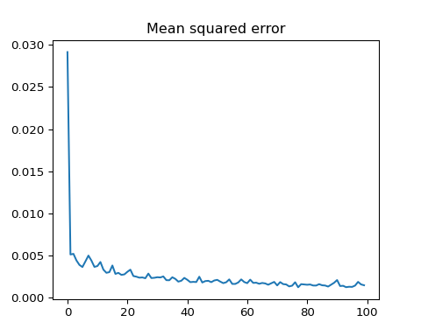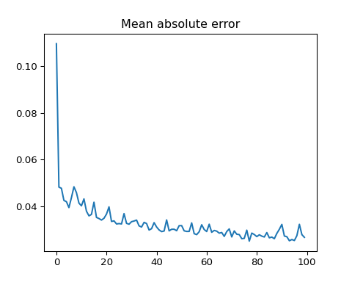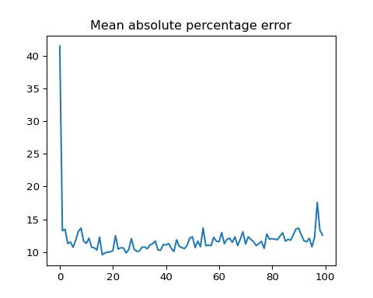

## 1/7 [===>..........................] - ETA: 6s3/7 [===========>..................] - ETA: 0s5/7 [====================>.........] - ETA: 0s7/7 [==============================] - ETA: 0s7/7 [==============================] - 1s 41ms/step

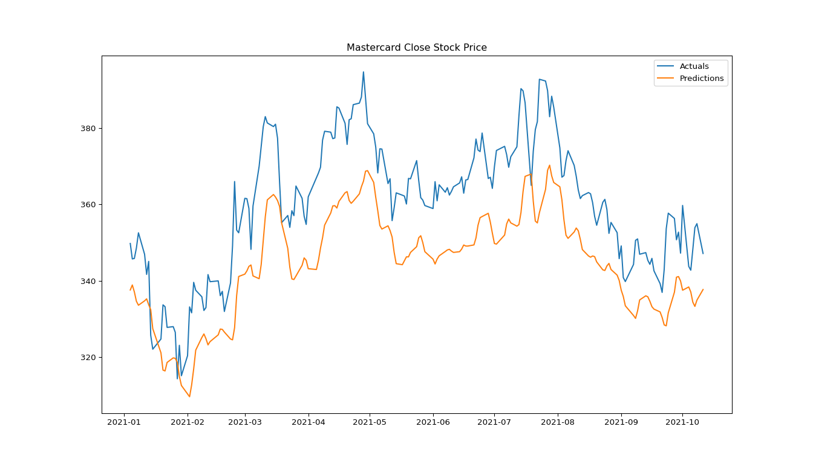

The model demonstrates a strong grasp of the data’s underlying trends and patterns. While minor deviations exist, the predictions (orange) closely track the actual closing prices (blue) in terms of both direction and magnitude.

Overall, the model exhibits promising accuracy in predicting Mastercard’s closing prices. It effectively captures the general fluctuations and movements, highlighting its capabilities for financial forecasting.

## Conclusion

Overall, this model demonstrates a promising ability to forecast Mastercard’s closing prices, capturing key trends and patterns with encouraging accuracy. Further optimizations hold significant potential for even finer predictions in the future.