**The presence/absence of beaver dams in relation to features of the water stream and vegetation characterizing the area**

*Study area*

The study area is located in the Burzenland region (Tara Barsei), in Southeastern Transylvania/Romania. The region is a lowland area in the Southern Carpathians mountains, whose stream network is well developed, with one of the major Romanian rivers, the Olt river, crossing it. The sampling units of the study are 7 streams: Prejmer, Raul Negru, Casinu Mic, Fundul Paraului, Martanus, Barsa and Panicel. These sampling units were selected based on field observations indicating the presence of beaver.

*Sampling Method*

The sampling strategy of the present investigation is based on the theory of occupancy models developed by Darryl MacKenzie (MacKnezie 2015), which is using the logit link to model the odds of occurrence of a species at different distances from the source. Following his approach, the sampling units of the present investigation are natural units, and not arbitrarily defined grid cells, stream segments or transects. Each sampling unit contains several sampling points, depending on the natural occurrence of beaver damns, the number of sampling points at each sampling unit being flexible. The response variable has two categories: presence and absence of beaver dams, each sampling unit allowing for both categories, in order to investigate limiting conditions of the beaver dam occurrence.

*Statistical modelling*

The response variable was the logit of the odds of occurrence of beaver dams at each point. The explanatory variables were features of the stream and vegetation around the sampling point, each sampling point representing the middle of a 100 m length plot. Following variables were recorded: altitude, water velocity, terrain slope, water deepness, width of the stream bed, meandering of the water course along the 100 m length plot, water course substrate (sand, mud, and gravel), available food, banks slope and height and an estimation of the overall favorability of the banks. Unfortunately, many missing values were recorded at the end of data collection phase, in particular altitude, slope, bank length and water deepness. There were no more than 2 complete cases. This fact excluded the possibility of using statistical analyses of the multiple type as initially planned.

Several simple logistic regression models were fitted to the data investigating the relationship between the logit of the odds of occurrence of beaver dams and water velocity, bank length, meandering, available food, bank slope, bank height, water deepness, terrain slope and altitude. On a small subset of data with no missing values, a multiple logistic regression model was fitted between the logit of the odds of occurrence of beaver dams and water velocity and terrain slope.

*Results of the statistical modeling*

The results of the models fitted are presented in the table below:

|  |  |  |  |
| --- | --- | --- | --- |
| Logistic Regression Model | df | Fitted model | P values estimated coeff.  (intercept)  (slope first expl. variable)  (slope second expl. variable) |
| g(x)=β0 + βvelocity | 24 | g(x)=4.170 - 8.381(velocity) | 0.0167  0.0478 |
| g(x)=β0 + βbank length | 20 | g(x)=0.78193 – 0.00225(bank length) | 0.00425  0.96757 |
| g(x)=β0 + βmeandering | 24 | g(x)=4.344 – 2.748(meandering) | 0.417  0.579 |
| g(x)=β0 + βfood below + βfood above | 23 | g(x)=3.44 – 0.024(food below) – 0.0008(food above) | 0.095  0.725  0.990 |
| g(x)=β0 + βacoperire mal | 24 | g(x)=1.011 + 0.013(acoperire mal) | 0.222  0.549 |
| g(x)=β0 + βbank slope | 22 | g(x)=2.791 – 0.030(bank slope) | 0.040  0.207 |
| g(x)=β0 + βbank height | 19 | g(x)=0.971 + 0.114(bank height) | 0.158  0.699 |
| g(x)=β0 + βterrain slope | 13 | g(x)=0.092 + 0.424(terrain slope) | 0.943  0.676 |
| g(x)=β0 + βvelocity+ βterrain slope | 12 | g(x)=6.427 – 22.241(velocity) +0.725(terrain slope) | 0.345  0.199  0.888 |
| g(x)=β0 + βaltitude | 10 | g(x)=3.239 -0.03(altitude) | 0.629  0.747 |

Of all the fitted models, only water velocity seems to significantly influence the occurrence of beaver dams in the stream landscape. This is why the logistic regression model relating the logit of occurrence of beaver dams explained by water velocity was used to predict the probability of occurrence of beaver dams related to velocity. The results are presented in the graphic below:

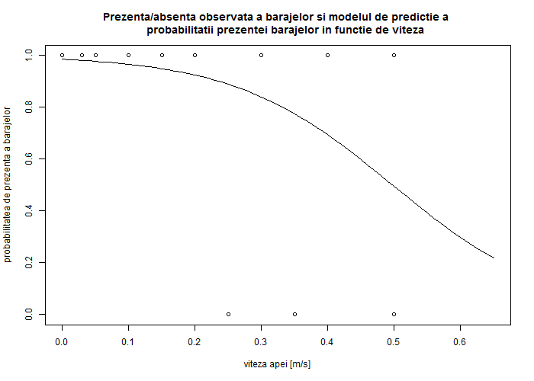

*Conclusions*

The study was designed to catch the most important controls of the occurrence of beaver dams in the stream landscape but failed to do so due to detrimental data collection (too many different missing values in different observations). Though, one important variable that influence the occurrence of beaver dams was identified, namely, water velocity. Others might be: altitude, terrain slope or bank length, but, this remains only a supposition, which could unfortunately not be statistically proven in the present study. The strengths of the present study are: the modern design of the sampling strategy, the careful selection of the variables to be collected and the development of a useful field sheet.

List of references

Cannon A R , Hartlaub B A, Lock R H, Rossman A J, Cobb G W, Legler J M, Moore T L, Witmer J A, 2013, Stat2 Building models for a world of data, W H Freeman and Co.

Crawley M J, 2013, The R book, Wiley

Kabacoff R I, R in action

MacKenzie D, 2015, Occupancy models, in Introduction in Ecological Sampling, eds. Manly B F J, Navarro J A N, CRC Press

Quinn G P, Keough M J, 2002, Experimental design and data analysis, CUP

R Development Core Team, 2008, R: A language and environment for statistical computing. R Foundation for Statistical Computing, Vienna, Austria. ISBN 3-900051-07-0, URL <http://www.R-project.org.>