1. **Purpose**
   1. The Thermo iCAP RQ ICP-MS (Inductively Coupled Plasma - Mass Spectrometer) is a spectrometer that is capable of analyzing the concentrations in the parts per trillions range (ppt) of up to 80 elements in a liquid sample. A standard curve using known concentrations must be generated for each element to be analyzed.
   2. The ICP-MS works by introducing a liquid sample into a nebulizer, where it is dispersed into small droplets. The smallest of these droplets get carried to the sample tube and into the torch, where they are ionized by a 9000K Argon based plasma stream..
2. **List of Terms**

|  |  |
| --- | --- |
| **ICP** | **Inductively Coupled Plasma -** A way of generating plasma that uses electromagnetic induction to generate the energy to create a gas into plasma for the ionization and introduction of samples into a detector. |
| **MS** | **Mass Spectrometer-** A detection system that can separate ions of different masses based on their behavior in an electromagnetic field. |
| **Carrier** | **A rinse solution, which is used to flush the system between samples.** |
| **CCT** | **Collision Cell Technology, which refers to the collision/reaction cell.** |
| **CRM** | **Certified Reference Material** |
| **IR** | **Isotope Ratio** |
| **Q-cell** | **Collision/reaction cell between the QID and quadrupole detector** |
| **QID** | **Quadrupole ion deflector. Downstream from the cones.** |
| **TDS** | **Total Dissolved Solids** |
| **Water Quality** | **DI = Deionized Water = 1-3 MΩ-cm**  **DW = Distilled Water = 1-3 MΩ-cm**  **DDI=Distilled and Deionized= UltraPure=MilliQ=18.2 MΩ-cm** |
| **ppm** | **Parts Per Million = 1/1,000,000**  **1 ppm = 1 mg/L = 1 ug/mL**  **1 ppm = 1 ug/g = 1 mg/kg**  **1000 ppm = 1 g/L = 0.1%** |
| **ppb** | **Parts Per Billion = 1/1,000,000,000**  **1000 ppb = 1 ppm**  **100 ppb = 0.1 mg/L = 100 ug/L** |
| **ppt** | **Parts Per Trillion = 1/1,000,000,000,000** |
| **%** | **% = 1/100**  **1000 ppm = 0.1%** |

1. **Required Materials**
   1. **Table 1.**

|  |  |  |  |
| --- | --- | --- | --- |
| **Item** | **Vendor** | **Catalog #** | **Cost** |
| **Argon** | **Praxair or Airgas** |  | **$400** |
| **Trace Metal Grade Nitric Acid** | **Fisher Scientific** |  |  |
| **iCAP RQ Tune Solution** | **Thermo Scientific or Inorganic Venture** |  | **$300** |
| **iCAP RQ Calibration Solution** | **Thermo Scientific or Inorganic Venture** |  | **$300** |
| **0.2µm Syringe Filter** |  |  |  |
| **Syringe** |  |  |  |
| **Acid-Washed 15mL Conical Tube** | **Various** |  |  |
| **Acid-Washed 50mL Conical Tube** | **Various** |  |  |
| **UltraPure Water (18.2 MΩ)** | **In-House** | **N/A** | **N/A** |
| **Elemental Standards (Multi-Element)** | **Inorganic Ventures?** |  |  |

**\****GENERAL NOTE: WEAR GLOVES AT ALL TIMES DURING PREPARATION STEPS TO REDUCE CONTAMINATION\**

* 1. **Plasticware Preparation**
     1. Make 5 Liters of 5% Nitric Acid Solution with 18.2MΩ water and Trace Metal Grade Nitiric Acid. (Can also use OES Grade Nitric Acid)
     2. Put 15mL and 50mL Conical Tubes in 5% Nitric Acid Bath overnight (Tubes and Caps). Use Apron and Acid-Resistant Gloves. Make sure the tubes are full submerged in the Acid Bath
     3. Rinse with UltraPure Water from Carboy and let dry overnight. (Dry upside-down on KimWipes to prevent contamination)
     4. Wrap with plastic wrap once they are dry.
  2. **Solution Preparation**
     1. **ICP-MS Rinse Solution (2% Nitric Acid (v/v)) -** Ex. Add 20mL of Trace Metal Grade Nitric Acid to 1000mL of UltraPure Water (18.2 MΩ). (Scale up as needed).
     2. **Standard Curve Solutions -** Need at least 4 different concentration levels of the elements that are going to be analyzed. (Ex. 100ppm, 10ppm, 1ppm, 100ppb, 10ppb)

Standards are prepared by diluting the multi-element lab standards in 18 MΩ water in acid-washed 15 mL centrifuge tubes. This is best done in the clean lab. Diluted standards should be acidified to 2% nitric acid (0.2 mL nitric acid in 9.8 mL standard solution)

* 1. **Sample Preparation**
     1. **Solid Samples**
        1. Dry and weigh the sample, transfer to a clean 15 mL centrifuge tube.
        2. Dissolve ~0.5 g sample in 10 mL 10% analytical grade nitric acid. Sample should fizz (evolve CO2), and stop fizzing if the reaction is complete. If more acid is required for complete dissolution, note the final amount used.
        3. Treat the dissolved carbonate as a liquid sample and proceed to the following steps.
     2. **Liquid Samples**
        1. Filter sample with a 0.2 µm pore size syringe filter. The final (post-filtering and dilution) volume should be ~15 mL (so Great Salt Lake waters only require filtration of < 1 mL).
        2. Using acid-washed, analytical-grade glassware, dilute the sample to ~1 ppm TDS with 18 MΩ water. (Ex: 14% salinity Great Salt Lake waters should be diluted 1:10,000, i.e. 0.1 mL filtered sample diluted to 1L with 18 MΩ water).
        3. Transfer 45 mL of filtered, diluted sample into a clean (acid-washed) 50 mL conical tube (or if you have a smaller sample volume, 9.8 mL into a 15 mL conical tube).
        4. Acidify to 2% HNO3 with full-strength trace metals/ICP-MS grade nitric acid (e.g., add 0.2 mL acid to 9.8 mL sample, or 1 mL acid to 45 mL sample).
        5. Store all samples capped and protected (e.g., in a clean bin or wrapped in plastic wrap) to prevent environmental contamination.

1. **Instrument Operation**
   1. **Software Overview**
      1. **Windows Login**
         1. **Log into SUMS**
      2. **Instrument Control & Qtegra**
         1. The ThermoScientific software for the operation of the iCAP Q ICP-MS is called Qtegra. It has two components: **Instrument Control** and **Qtegra**.
         2. Note that there may be some confusion because the name of one of the components is the same as that of the two components together. In this document, Qtegra means the component, unless otherwise noted.
         3. Instrument Control should be used to ignite the plasma, run performance tests, and tune the system. Qtegra must be used to acquire mass spectra. Qtegra may also be used to ignite the plasma, run performance tests, and tune the system but for those applications it is not as versatile and gives less information than Instrument Control. Consequently, the latter is preferred for those applications and those features of Qtegra are not discussed in this procedure.
         4. Mass spectra are measured and the results are displayed in a LabBook in Qtegra. Initially, a LabBook is essentially a complete recipe for a set of measurements. When a LabBook is run, the measured data are added to it. Once measured data are added, they cannot be deleted from the LabBook.
   2. **Instrument Preparation**
      1. **Turn on Water Chiller - Let it cool down to 20°C**
      2. **Check Argon Gas Level and open Valves** 
         1. Check Argon gas level and confirm there is enough for a sample run (Ask instrument technician for history of recent Argon use)
         2. Open Main Valve on Argon Tank (Twist left to Open)
         3. Adjust Regulator coming off Argon cylinder to ensure ~90 PSI
         4. Turn Argon Valve on the overhead chase to be parallel to the flow of gas to the ICP-MS to open the valve.
      3. **Check Waste/Rinse Solution Levels**
         1. Check the Rinse Solution bottle and confirm there is at least 1 Liter of solution. If necessary, make more solution as described in section 3.3.1.
         2. Check and confirm that the level of the waste is below 75% full in the waste container. Ensure that the waste lines are properly going into the waste container.
      4. **Turn On Autosampler**
         1. Flip Switch on side of Autosampler
         2. Initialize in Instrument Control
      5. **Connect Tubes on Peristaltic Pump**
         1. Check the condition of the peristaltic pump tubing. If the section which is stretched over the pump is flattened, try the adjacent section. If both sections are flattened, replace the tubing. (The peristaltic pump tubing is color coded by three plastic stops: orange – yellow - orange. One can place either the section of tubing between the first (orange) and second (yellow) stops or that between the second (yellow) and third (orange) stops over the pump drum. The lifetime of the tubing can be extended by using one section and then the other. For new tubing, start with the first (orange) and second (yellow).)
         2. Connect tubes/ tension on peristaltic pump (confirm that sample and drain tubes are in the correct direction for the pump). The pump turns clockwise so the ends of the tubing going into the Nebulizer and into the Waste container need to be on the right side of the pump, as shown below.
         3. Place the tube clips into the holders on the both sides of the pump to tension the tubing and then close the clamps.

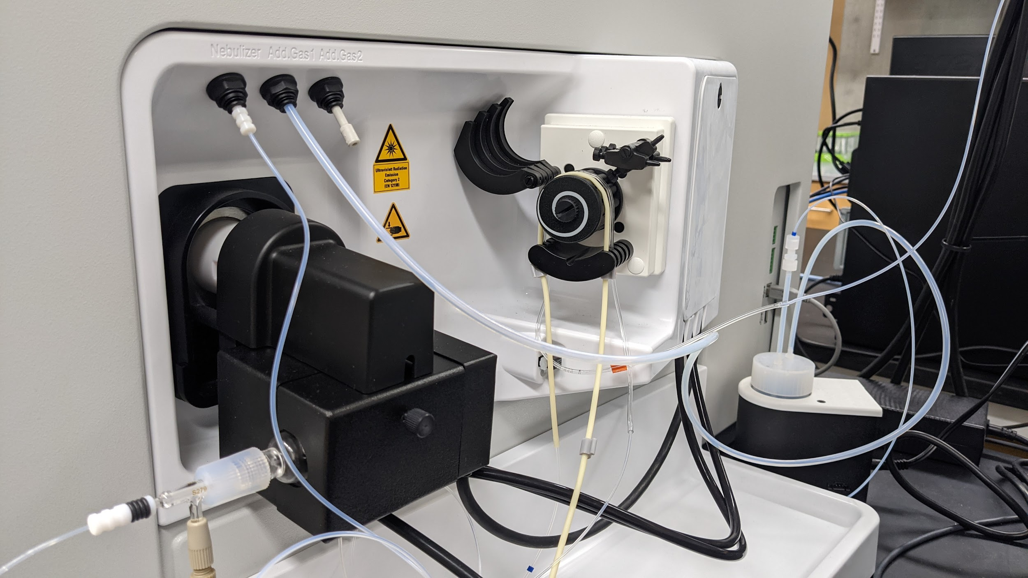

**Figure 1. Peristaltic Pump Orientation**

* 1. **Turning on the Plasma**

**4.3.1 Open the Instrument Control and Camera(to see the plasma) programs on the Desktop**

* + 1. **In Instrument Control, go to the Control Panel, on the left side.**
    2. **Select the Inlet panel.**
       1. Ensure that the Peristaltic Pump Speed is set to 20 rpm.
       2. Press the Peristaltic Pump On button.
    3. **Click on Experiment Configuration in the Instrument Control menu bar and select iCAP**
    4. **Select the ESI SC-4DX tab, which should appear to the right of the iCAP tab.**
       1. Select Tools: Initialize and wait for initialization to complete.
    5. **Ignite the plasma as follows.**
       1. Click on iCAP in the Instrument Control menu bar. The iCAP ribbon should open.
       2. Press the On button in the Control group on the iCAP ribbon
       3. At the prompt, confirm that you wish to ignite the plasma. The plasma ignition process should commence. Its progress may be observed in the log window.
       4. Flickering once or twice during the first second or two is normal. If flickering continues for more than 5 s, extinguish the plasma rapidly.
       5. Wait for the message "Operate" to appear in the Log View window, indicating that the start-up procedure has completed successfully.
    6. **Press the Run button in the Control group on the iCAP ribbon.**
    7. **Open the Data Display window to display the real-time measurements. In the display, the following notation is used:**
       1. Doubly charged = 137Ba++:137Ba+ ratio.
       2. Oxides = 140CeO+:140Ce+
       3. KED = 59Co+:35Cl 16O+ ratio. It is desirable for it to be high.
    8. **In the iCAP ribbon, go to the Measurement mode group, and select the STD mode in the Select**
    9. **Wait 30 min to allow the system to stabilize and, if required, the collision/reaction cell gas lines to be purged.**
       1. For a clean system with 2% HNO3 flowing, the 238U intensity should be ~ 20 c/s
       2. RSDs in the real-time display are typically higher than in measurements because only 10 sweeps are used. RSD ≤ 5% is good.
  1. **Performance Report Testing**
     1. **A built-in set of performance tests allows one to check whether the iCAP Q meets specifications for a specific measurement mode.**
     2. **This section describes how to run the performance tests. It is assumed that the plasma has been ignited, the manual sample probes are in the rinse solution, and the system has stabilized (15-30 min after ignition).**
     3. **Ensure that the iCAP ribbon is open. If it is not, click on iCAP in the Instrument Control menu bar. The iCAP ribbon should open.**
     4. **Place sample probe in the iCAP Q Tune solution.**
     5. **Observe the Data Display window.**
     6. **After 80 s, the intensities of the selected analytes should rise sharply and continue to increase over 20 s. (Ba, Bi, Ce, Co, In, Li, U)**
     7. **In STD mode, intensities should be ~ 105 c/s (if intensities are low, the cones may need to be cleaned)**
     8. **In the Wizards group, select Performance Report. The Performance Report Wizard window should open.**
     9. **Select Run Performance Report from active Measurement mode.**
     10. **You will be asked to confirm that the measurement probes are in the "1 ppb Tune in 2% HNO3 and 0.5% HCl" solution. Click Next to confirm. Performance tests should begin. About 10 min is required to complete the tests. When the tests are completed, a summary of the results of the tests will be displayed in the Performance Report Wizard window.**
     11. **In the Performance Report, observe whether all tests were passed.**
         1. If all tests were passed, move the probe to the rinse solution and proceed to making measurements.
         2. If any test fails, carry out tuning, as described in Appendix 1. If Source Tune is performed promptly, the probe may be left in the tuning solution because it will be required for auto- tuning. Otherwise, move the probes to the rinse solution.
  2. **Creating a LabBook**
     1. **Open Qtegra. Normally, the Dashboard will be displayed. If not, select Home Page: Dashboard.**
     2. **Make sure the color of the Get Ready button is Green.**
     3. **On the left pane, select LabBooks. The LabBooks window should open, as shown in Figure 4.**
     4. **Select ‘Create from existing’ (if you want to copy the setup from a prior LabBook), or ‘Create new’ (if you want to start new), and check the template option. Click [Create LabBook] to create a new LabBook, or click [Open] to open an existing LabBook. See Figure 4.**

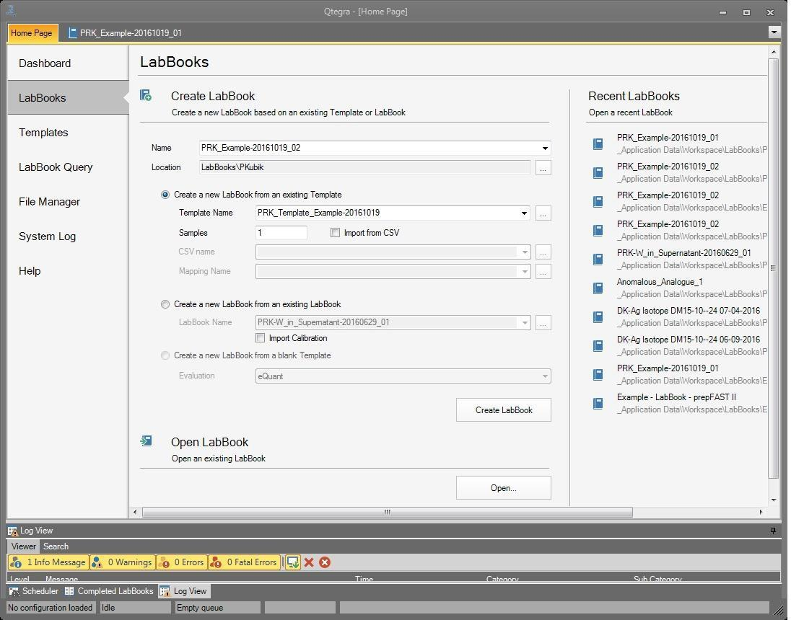

**Figure 4. Creating a LabBook**

* + 1. **Choose a folder/ pathway. Name the LabBook using the date (year_month_date), operator ID, and sample set ID (e.g. 2019_08_12 MM salt lake water1).**
    2. **You can also open and work on a prior LabBook here.**
  1. **Setting Up Method Parameters**
     1. **Choosing Analytes**
        1. Choose [Analytes] on the left “Content” tree. The Periodic table of the elements will appear. See Figure 5.

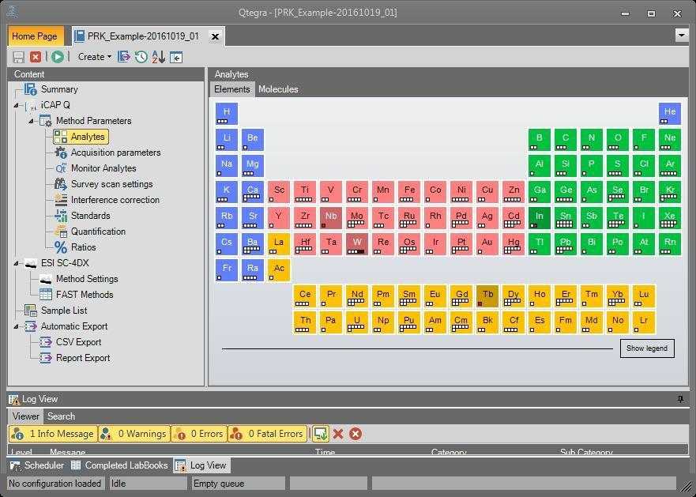

**Figure 5. Method Parameters: Analytes window**

* + - 1. Left click an element to select the most abundant isotope.(Figure 6.)
      2. Right click an element to open the isotopes window for the element. Check the checkboxes of the desired isotopes in the first column.

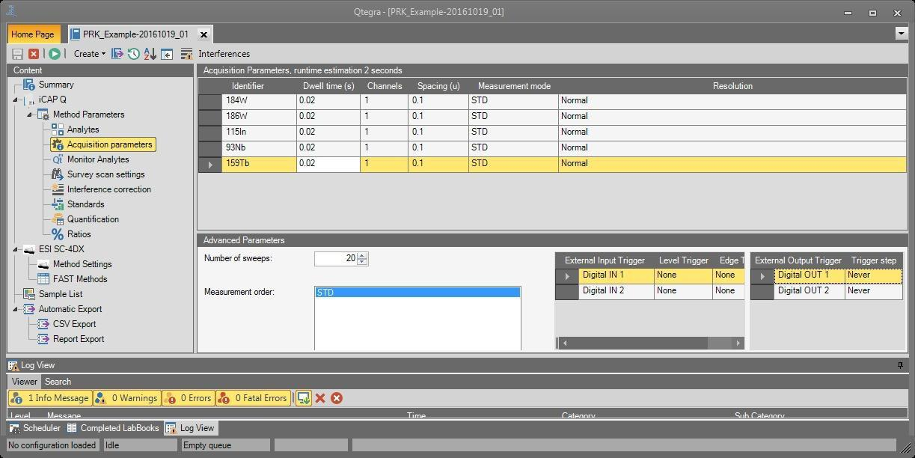

**Figure 6. Method Parameters: Acquisition Parameters window**

* + 1. **Enter the Acquisition Parameters for each analyte as follows.**
       1. Dwell time: Use the following guidelines.
          1. In general, 5 ms ≤ Dwell time ≤ 200 ms. Default is 10 ms.
          2. STD mode: Typically, 10 ms ≤ Dwell time ≤ 20 ms.
          3. KED: Typically, 30 ms ≤ Dwell time ≤ 50 ms.34
       2. Use longer dwell times for analytes with low intensities, e.g., due to low concentration or high mass.
       3. Channels: Use the default value, i.e., 1.
       4. Spacing: Use the default value, i.e., 0.1.
       5. Measurement mode: Set as desired. Stability may be compromised if more than one mode is selected.
       6. Resolution: Usually, should be set to Normal; however, if intensities are expected to be excessive, they can be reduced by setting Resolution to High.
       7. Enter the Advanced Parameters for each analyte as follows.
          1. Number of sweeps: Use the following guidelines.

In general, 10 ≤ Number of sweeps ≤ 50, except for isotope ratios. Default is 10 sweeps.

STD mode:

Concentrations ≥ 10 ppb, try 10 sweeps.

Concentrations ≤ 10 ppb, try 20 sweeps.

KED mode: try 20 sweeps.

Isotope ratios: try 200 sweeps. For high precision, more may be required.

* + - * 1. Measurement order: Drag the mode to the desired position.
    1. **Monitor Analytes**
       1. Monitor Analytes is an optional feature (except for tQuant and trQuant), which allows one to modify the uptake and wash, depending on the signal intensity and stability of one or more user-specified monitored analytes. Uptake starts when the monitored analyte signal meets the user-specified stability value. If the stability falls below the user-specified value after the measurement, the wash starts.
       2. In the left pane of the LabBook, select Method Parameters: Monitor Analytes. The Monitored Analytes window should open, as shown in Figure 7.
       3. Set the ranges for the uptake and wash delays.
       4. To add a monitored analyte, click Monitored Analyte. An empty row will be added to the table
       5. In the Analyte column, type the mass and chemical symbol of the monitored analyte, e.g., 115In.
       6. To enable the uptake settings:
          1. Check the checkbox in the Uptake column.
          2. Type the desired Signal Above (cps) threshold.
          3. Type the desired Stability (%RSD) threshold.
          4. In the On Failure column, select the desired outcome on failure from the dropdown list.
       7. To enable the wash settings:
          1. Check the checkbox in the Wash column.
          2. Type the desired Signal Above (cps) threshold.
          3. Type the desired Stability (%RSD) threshold.
          4. In the On Failure column, select the desired outcome on failure from the dropdown list.

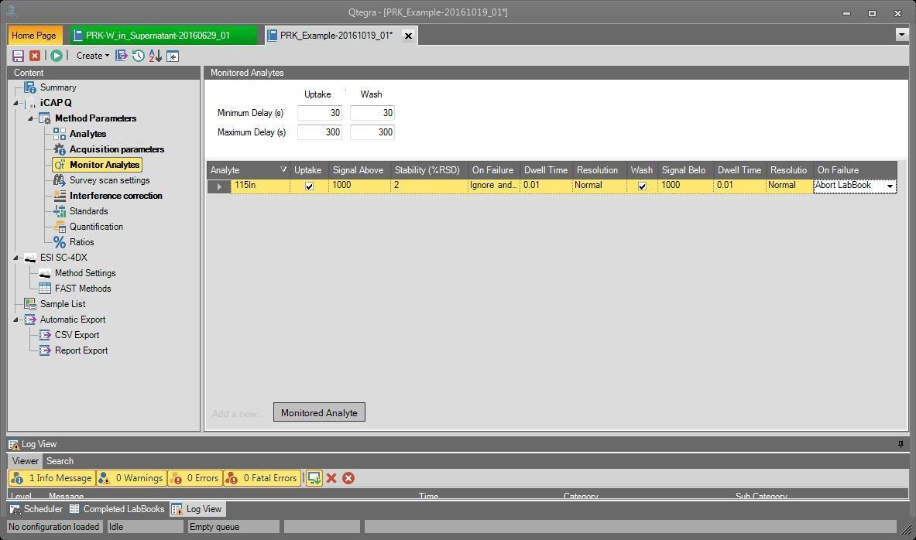

**Figure 7. Method Parameters: Monitor Analytes window**

* 1. **Standards**
     1. **ICP-MS measurements are inherently qualitative but the use of standards can make them quantitative. External and isotopic standards are defined in the Standards window of a Lab- Book. One can either define a new standard or load a standard from the global standards database.**
     2. **Defining a New Standard**
        1. In the left pane of the LabBook, select Method Parameters: Standards. The Standards window should open, as shown in Figure 8.
     3. **Click the ‘New’/ green + button as shown in Figure 10. Choose ‘Element Standard’ (or ‘Internal Standard’ or ‘Concentration Ratio’). Enter the standard name based on the stock standard number and dilution factor, or lab made standard ID and dilution factor, e.g. Stock_12345_1X for no dilution, 10X for ten times dilution, etc.**
     4. If you want to use an existing analyte list set up prior, then click the box ‘Create standard using analyte list’.

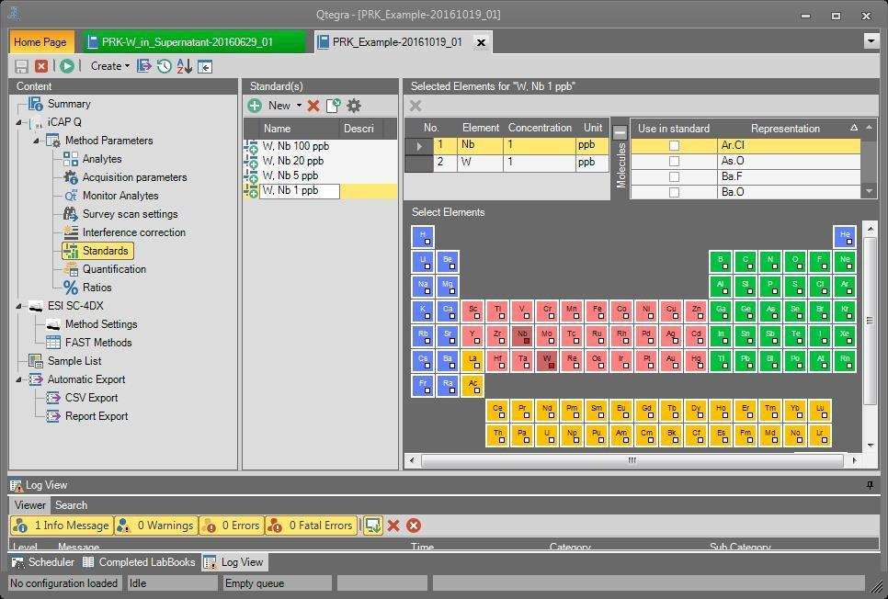

**Figure 8. Method Parameters: Standards window**

* + 1. **Enter the standard concentrations for each element (double click the desired cell and edit it as needed; note that key shortcuts can be used, see shortcut sheet for fill down, fill up, increment sequential, shift click to select multiple cells, etc.). You can also change units by double clicking the unit cell (e.g. ppm, ppb). These units will be kept all the way through concentration analysis. This is the only place that units can be edited.**

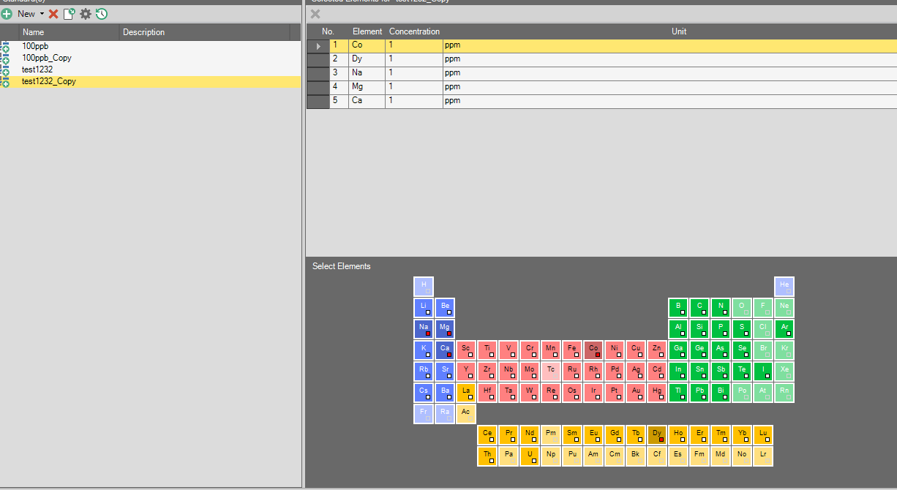

**Figure 11. Adding Analytes and Concentration to Standards**

* + 1. **To copy a standard list and all cell values, right click the name to bring up a dialogue box that allows you to enter the dilution factor (new concentrations calculated using concentrations in the selected row). Rename the copied row by double clicking on the text in the name column (check that the concentrations are correct).**
    2. **Generally do not change the options in “quantification”. (Check what to do for internal standards option). %Ratios: Generally no need to specify ratios. During method development you may want to ratio wavelength for a single element to look for interferences. See Figure 12.**

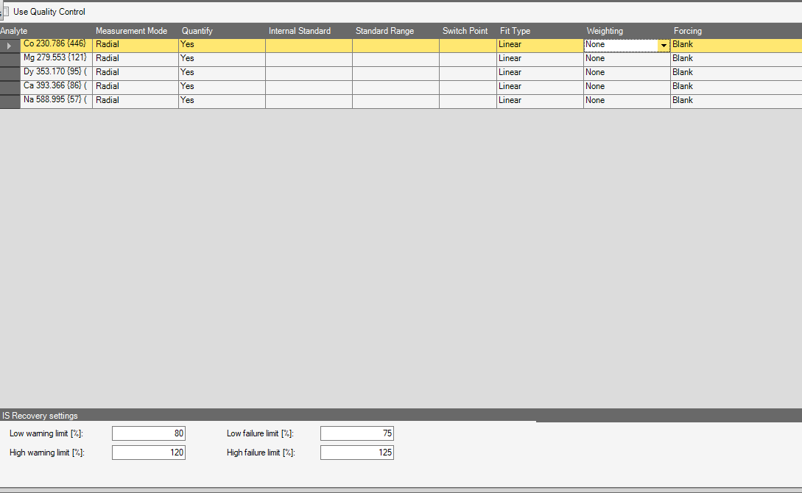

**Figure 12. Quantification Menu**

* + 1. **ESI SC-2DX: DO NOT CHANGE RACK HERE. If you need to change the rack configuration, then click on ‘Home Page’ in top left, select ‘Dashboard’ tab on left, select ‘ESI SC-2DX‘ menu box (See Figure 13). This is a good time to recheck the sample and standard locations.**

**Figure 13. Autosampler Rack Layout. Must match the physical racks in the autosampler.**

* 1. **Enter Samples in Sample List**
     1. **Select your LabBook from the top bar of Qtegra and go to the Sample List menu. See Figure 14.**

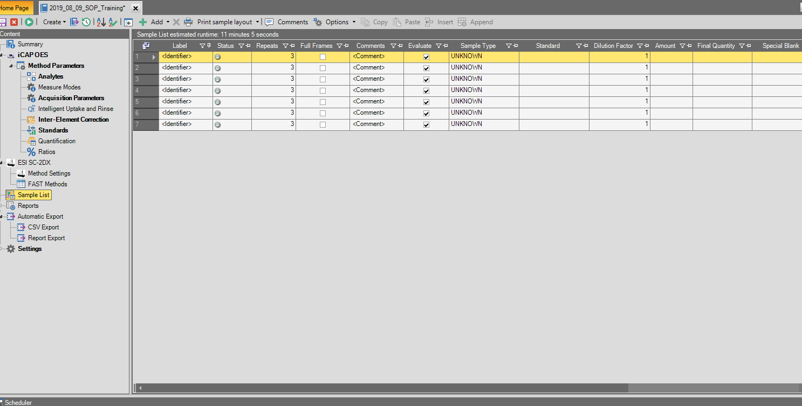

**Figure 14. Sample List**

* + 1. **Enter labels/names in order of what is to be run. Typical example: Blank (as Blank), Standard solutions (put in from lowest to highest concentration), Lab prep blank (as unknown), Sample names (as unknowns).**
    2. **In the type column choose: STD, BLK, or UNKNOWN. [All should have a similar matrix, e.g. 2% HNO3). Enter number of repeats (typically 3).**
    3. **Click ‘Full Frame’ if you want to save a qualitative spectral image for a sample/ standard. Somewhere there is a speed option- do not use Sprint.**
    4. **Put in another Rinse, Blank after 10 unknowns to check for any sticky contamination.**
    5. **To add a line use the green plus ‘Add’ button from the menu bar.**
    6. **Make sure that the sample locations in the sample list match the correct RACK and VIAL position as the physical location in the autosampler.**
  1. **Schedule and Run**
     1. **When the LabBook (list of samples/standards and analysis settings) is set up, you are ready to schedule the run. Click the green play button in the top menu bar (near left). This will put the named labbook into the scheduler on the bottom. You can schedule additional LabBooks if desired.**
     2. **Now we are ready to RUN. Click on the Scheduler window in the lower part of the screen and click the green play button. (check to see if it can deselect / select within the scheduler).**
     3. **You can monitor your run by the status icon next to the sample name. Green arrow means the sample is currently being injected and a green circle indicates that the sample is finished running. You can analyze the data in real time as it is coming off the instrument by going to the concentration side tab. This allows you to see how linear the standard curve is and the calculated concentration of your unknowns.**
  2. **Instrument Shutdown**
     1. **After the run has been successfully completed, select the ESi SC-2DX Autosampler and move the probe into the Rinse Solution. Allow the Rinse to proceed for 10 minutes to clean the flow path.**

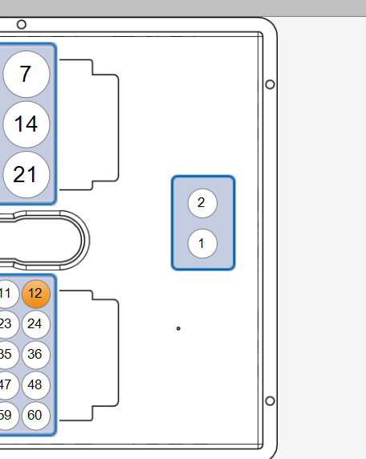

**Figure 15. Autosampler Rinse Position**

* + 1. **Move the Probe out of the Rinse Solution and let the instrument run dry for 60 seconds. Monitor the peristaltic pump tubing and the spray chamber to ensure that there is no more liquid going into the system.**
    2. **Select the blue GET READY button at the top of the screen. Select [Turn Off plasma].**
    3. **After the Peristaltic Pump has stopped rotating, release the tube holders so that the tubing is slack to help preserve its longevity.**
    4. **Turn off the Chiller ~10 minutes after the Plasma has extinguished.**
    5. **Remove your samples from the AutoSampler**
    6. **Check the Waste Container, empty if needed.**

1. **Data Analysis**
   1. **Check Standards for Linearity**
      1. **Each analyte will have a standard curve generated from the standards of different concentrations.**
         1. If you have multiple wavelengths for a single analyte analysis the standard curve to determine if one wavelength is giving more accurate results
         2. R² will be ~1.0 for an analyte with a standard curve that is within the linear range
      2. **If any Standards look like they may have an injection issue or a value that does not make sense individual data points can be excluded from the linear regression**
   2. **Check the Blanks**
      1. **There should be multiple blanks in your run. An initial blank assigned as “Blank” in the sample list to zero out the detector, and subsequent blanks after the standards and at the end of the run assigned as “Unknowns”.**
         1. Check both the concentration values and the count values for each Blank injection to see if there is any carryover occurring or if your sample Blank or Rinse solution may be contaminated with an analyte of interest
   3. **Export Data**
      1. **Data Should be exported as an .xml file type that can then be opened in Excel.** 
         1. Use the Excel Export Template to quickly export data. This template will export the raw concentration average and the count averages for all the analytes along with their dilution factor and sample name.
         2. You can create a custom export template if you wish to export more data
      2. **After opening the file in Excel, convert the file into an Excel file for easier transfer.**
      3. **Move data onto a flash drive to move to a different computer**

**Appendix 1. Purchases**

For tubes and acids, I usually go with VWR or Fisher (depending on who’s cheaper), but in general these trace metal clean centrifuge tubes work and fit the 60x 15 ml rack and the the 10x 50 ml standard rack for the autosampler.

|  |
| --- |
|  |
| |  | | --- | | [VWR® Sterile Metal-Free Centrifuge Tubes, PP](https://us.vwr.com/store/product/4648943/vwr-sterile-metal-free-centrifuge-tubes-pp)  [us.vwr.com](https://us.vwr.com/store/product/4648943/vwr-sterile-metal-free-centrifuge-tubes-pp) | |

For nitric acid, I usually go with Fisher’s 2.5 L of TraceMetal Grade:

|  |  |  |
| --- | --- | --- |
| |  |  | | --- | --- | | [Nitric Acid (TraceMetal Grade), Fisher Chemical, Quantity: 500 mL | Fisher Scientific](https://www.fishersci.com/shop/products/nitric-acid-tracemetal-grade-fisher-chemical-3/A509P212)  [fishersci.com](https://www.fishersci.com/shop/products/nitric-acid-tracemetal-grade-fisher-chemical-3/A509P212) | [favicon.ico](https://www.fishersci.com/shop/products/nitric-acid-tracemetal-grade-fisher-chemical-3/A509P212) | |

**Cleaning the nebulizer**

For the nebulizer, they say to soak it in 10% nitric for 15 minutes and then rinse with DI. Here’s the full set of cone cleaning and nebulizer cleaning instructions in case it’s handy (and if the iCAP ever throws a detector error again):

* + Remove the cones and sonicate in DI water only for 15, then let to dry or blow off with nitrogen….DO NOT USE CAN AIR OR ACID ON THE CONES
  + Remove the neb and soak it in 10% nitric for 15 minutes, then rinse with DI
  + Put cones and neb back in

* + Ensuring the cones are tight, and the insert is in place on the skimmer cone
  + New pump tubing
  + Ensure your icap is in STD mode and use     TUNE B or 4A.
  + Run a iCaliTuneSTDS auto tune …….  TUNE B or 4A.
  + **Then run a HV SETUP AND CROSS CAL (detector wizard**)        SETUP SOLUTION or 5A

* + Then follow up with the iCaliTuneSTD-100v…….  TUNE B or 4A.
  + Run a performance report… TUNE B or 4A.