Problem 8.2

function [Q,R] = mgs(A)

[m,n] = size(A);

if (m < n)

print("Error: rows more than cols!")

end

Q = zeros(m,n); R = zeros(n,n);

for i = 1 : n

Q(:,i) = A(:,i);

end

for i = 1 : n

R(i,i) = norm(Q(:,i),2);

Q(:,i) = Q(:,i) / R(i,i);

for j = (i + 1) : n

R(i,j) = Q(:,i)' * Q(:,j);

Q(:,j) = Q(:,j) - R(i,j) * Q(:,i);

end

end

end

Problem 10.2

(a)

function [W,R] = house(A)

[m,n] = size(A);

if (m < n)

print("Error: rows more than cols!")

end

W = zeros(m,n);

for k = 1:n

x = A(k:m,k);

if (x(1) > 0)

sgn = 1;

else

sgn = -1;

end

v = sgn * norm(x,2) * eye(m - k + 1, 1) + x;

v = v / norm(v,2);

A(k:m,k:n) = A(k:m,k:n) - 2 * v * v' * A(k:m,k:n);

W(k:m,k) = v;

end

R = A(1:n,:);

end

(b)

function Q = formQ(W)

[m,n] = size(W);

if (m < n)

print("Error: rows more than cols!")

end

Q = eye(m,m);

for k = 1:m

Q(:,k) = formQx(W,Q(:,k));

end

end

function y = formQx(W,x)

[m,n] = size(W);

if (m < n)

print("Error: rows more than cols!")

end

for k = n:-1:1

x(k:m) = x(k:m) - 2 * W(k:m,k) * (W(k:m,k)' * x(k:m));

end

y = x;

end

Problem 11.3

function x = ploy_apprx

format long;

m = 50; n = 12;

t = linspace(0, 1, m);

A = fliplr(vander(t));

A = A(:,1:n);

b = cos(4 * t)';

%(a)

R = chol(A' * A);

x1 = R \ (R' \ (A' * b));

%(b)

[Q, R] = mgs(A);

x2 = R \ (Q' * b);

%(c)

[W, R] = house(A);

Q = formQ(W);

Q = Q(:,1:n);

x3 = R \ (Q' * b);

%(d)

[Q, R] = qr(A);

x4 = R \ (Q' * b);

%(e)

x5 = A \ b;

%(f)

[U, S, V] = svd(A, 0);

x6 = V * (S \ (U' * b));

x = [x1, x2, x3, x4, x5, x6];

end

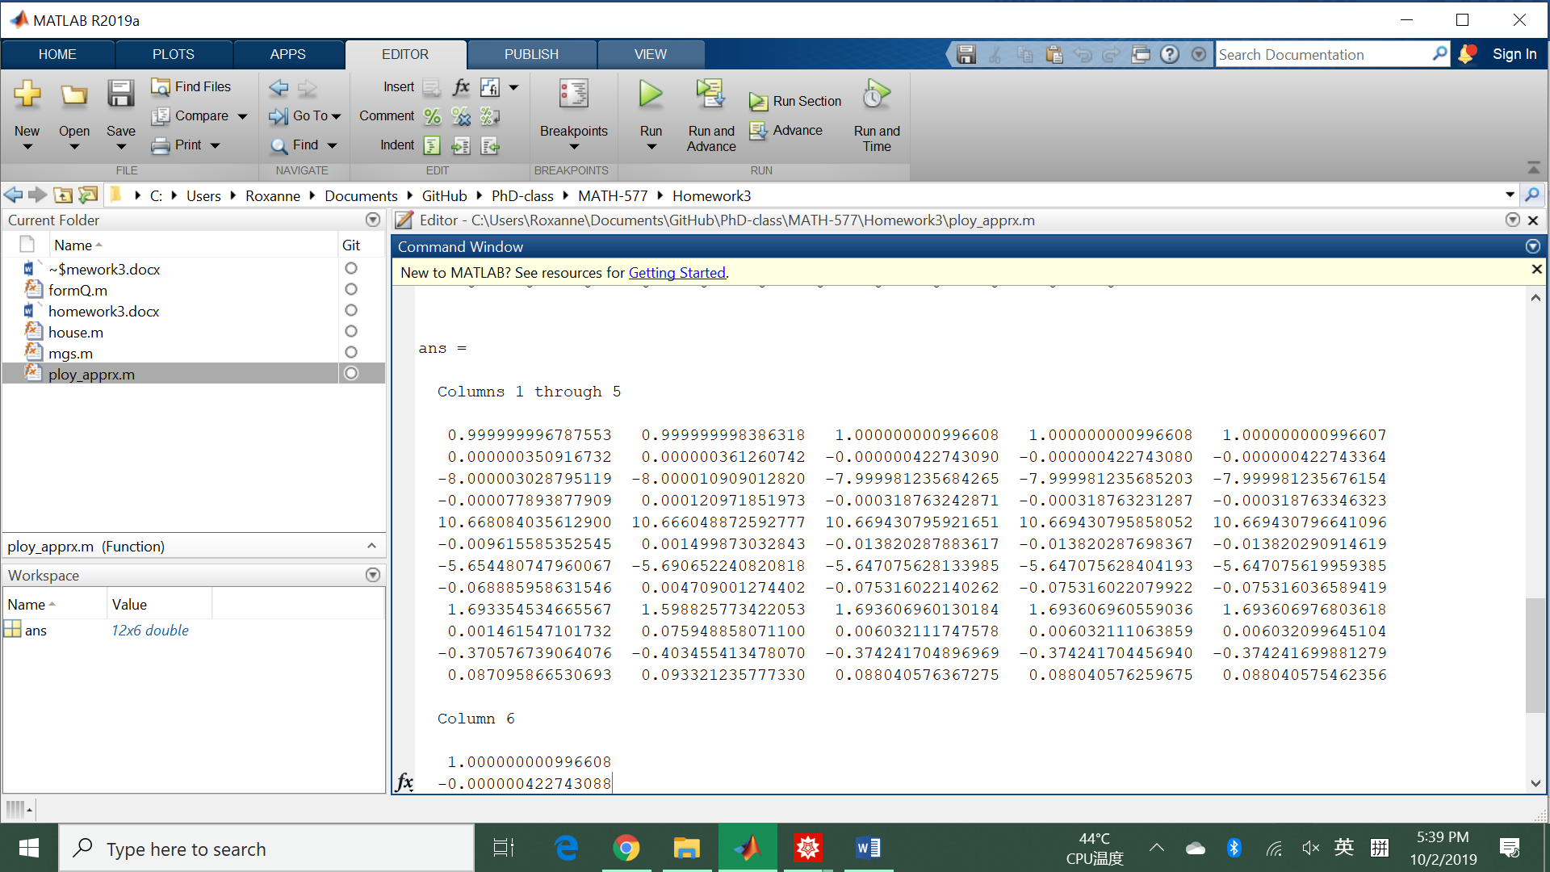

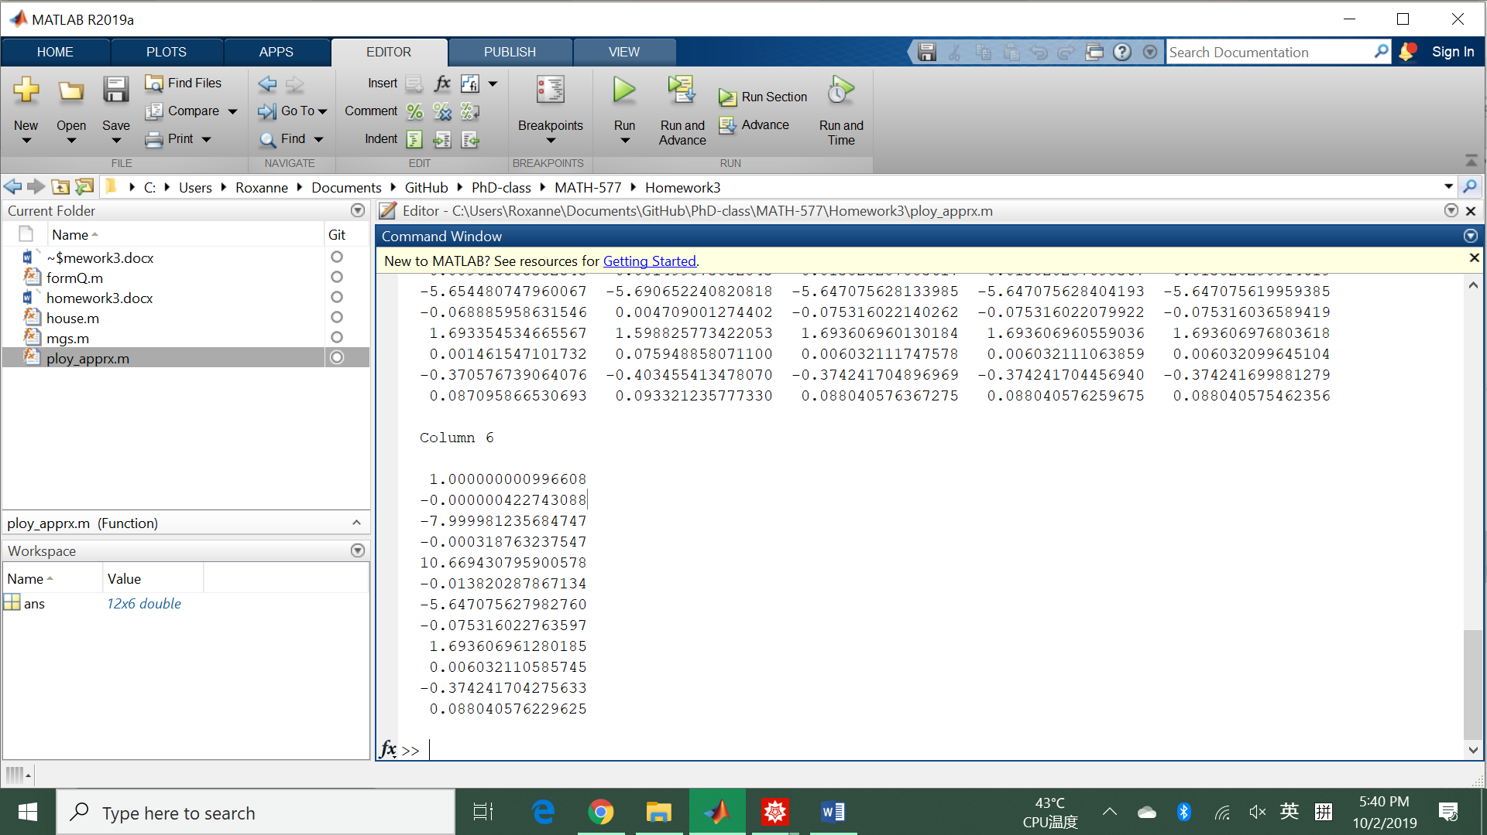

We can see that (c)-(f) are consistent, (b) computes some answer not correct, and (a) is not stable.