Problem 22.2

Code:

m = 60;

b = 2:-1:-57; b(m) = -58; b = b';

x0 = ones(m,1);

A = tril(-ones(m),-1) + diag(ones(m,1));

A(:,m) = 1;

[L,U,P] = lu(A);

d = P \* b; y = zeros(m,1); x = zeros(m,1);

y(1)=d(1);

for i=2:m

for j=1:i-1

d(i)=d(i)-L(i,j)\*y(j);

end

y(i)=d(i);

end

x(m)=y(m)/U(m,m);

for i=(m-1):-1:1

for j=m:-1:i+1

y(i)=y(i)-U(i,j)\*x(j);

end

x(i)=y(i)/U(i,i);

end

max(abs(U(:)))

norm(x - x0, inf)

B = A;

B(:,m) = 1.1;

[L1,U1,P1] = lu(B);

d1 = P1 \* b; y1 = zeros(m,1); x1 = zeros(m,1);

y1(1)=d1(1);

for i=2:m

for j=1:i-1

d1(i)=d1(i)-L1(i,j)\*y1(j);

end

y1(i)=d1(i);

end

x1(m)=y1(m)/U1(m,m);

for i=(m-1):-1:1

for j=m:-1:i+1

y1(i)=y1(i)-U1(i,j)\*x1(j);

end

x1(i)=y1(i)/U1(i,i);

end

x2 = B \ b;

max(abs(U1(:)))

norm(x1 – x2, inf)

Answer:

I choose real solution of x0 as (1, 1, …, 1), and compute its corresponding b. And the growth factor of A is 5.7646e+17. The computed solution x with Gaussian Elimination is almost all 1 but few of elements are 0. Thus, the rounding number (inf-norm of the true x0 and x) is 1, which is not “very” big. However, if I modify matrix A slightly, i.e. I make the last column of A as 1.1 rather than 1. And I compute the real value as x2 above (compute the inverse straightly). The growth factor is 6.3411e+17, which is nearly the same as before, but the solution of x1 is much different with before, some of the elements are far more from 1. And the rounding error is 13.6727, which is larger than before.

Problem 26.2

Code:

1. & (b)

m = 32;

supdia1 = diag(ones(m-1,1));supdia2 = diag(ones(m-2,1));

appd1 = zeros(m-1,1); appd2 = zeros(1,m);

appd3 = zeros(m-2,1); appd4 = zeros(1,m-1);

A = diag(-ones(m,1)) + [[appd1 supdia1]; appd2] + [[appd1 [[appd3 supdia2]; appd4]]; appd2];

eigtool(A)

y = [];

for i = 0:0.5:50

y = [y norm(expm(i .\* A),2)];

end

t = 0:0.5:50;

figure

semilogy(t,y)

Answer:

I use eigtool to plot the boundaries of 2-norm epsilon-pseudospectra of A for given epsilon. And the plot is as follows:

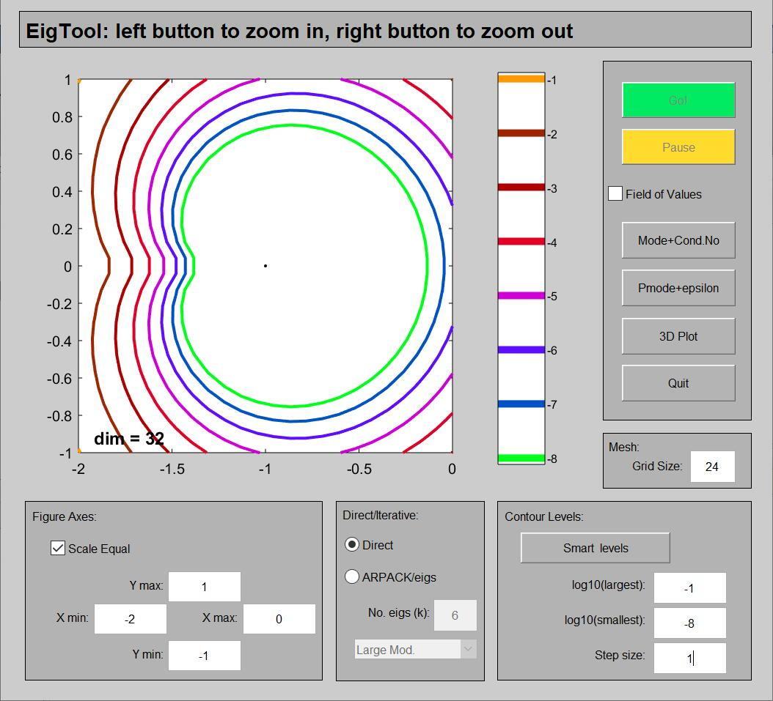

We can see that the boundary converges to the black point as epsilon decreases.

Then I plot the semiology as follows:

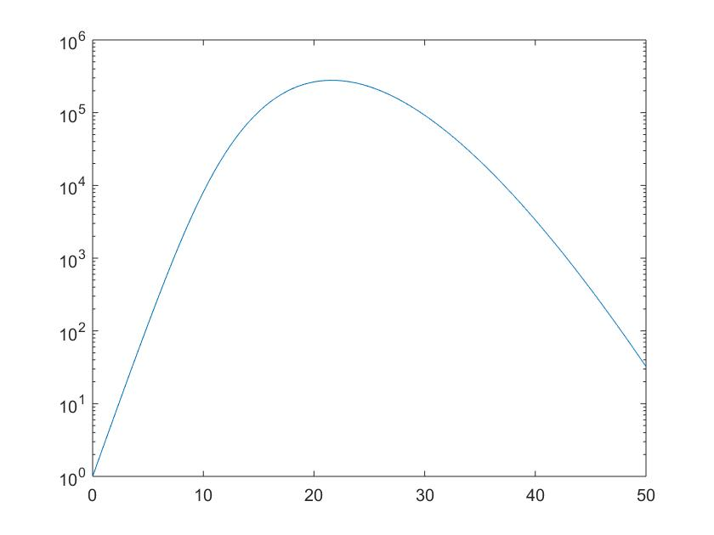

Notice the initial growth rate is nearly linear increasing. Since it’s semiology plot, which means the value is increasing exponentially. Notice that the 2-norm is related to the largest singular value of A, and according the conclusion of 26.1. pseudospectra is related to the smallest singular value of A.