Problem 1

Function:

function price = Cbs(T,S,K,r,sigma)

d1 = (log(S/K) + (r + sigma^2/2) * T)/(sigma * sqrt(T));

d2 = d1 - sigma * sqrt(T);

price = S * normcdf(d1) - K*exp(-r * T) * normcdf(d2);

end

Problem 2

Function:

function y = bisection(f,a,b,TOL)

if sign(f(a)) * sign(f(b)) >= 0

error('f(a)f(b)<0 not satisfied');

end

while (b-a)/2 >TOL

c = (a + b)/2;

if f(c) == 0

break

end

if sign(f(a)) * sign(f(c)) < 0

b = c;

else a = c;

end

end

y = (a + b)/2;

end

function xc = secant(f,x0,x1,TOL)

x = [x0, x1];

while abs(x(2) - x(1))>TOL

xc = x(2) - (f(x(2)) * (x(2) - x(1)))/(f(x(2)) - f(x(1)));

x(1) = x(2);

x(2) = xc;

end

end

Main:

K = [500 550 600 650 700 750 800 850 900 950];

C = [210.3400 166.3140 126.5249 89.0857 59.5878 43.5040 31.3392 25.2330 20.1734 15.7494];

S = 700;

T = 1/4;

r = 0.03;

sigmac1 = [];

for i = 1:10

fi = @(sigma)Cbs(T,S,K(i),r,sigma) - C(i);

a = 0.0001; b = 1; TOL = 10^(-6);

sigmac1(i) = bisection(fi,a,b,TOL);

end

vpa(sigmac1, 6)

sigmac2 = [];

for i = 1:10

fi = @(sigma)Cbs(T,S,K(i),r,sigma) - C(i);

x0 = 0.3; x1 = 0.35; TOL = 10^(-8);

sigmac2(i) = secant(fi,x0,x1,TOL);

end

vpa(sigmac2, 6)

Result :

(1)= [0.520000, 0.490000, 0.470000, 0.429999, 0.410001, 0.440000, 0.459999, 0.499999, 0.530001, 0.549999]

(2)= [ 0.520000, 0.489999, 0.470000, 0.430000, 0.410000, 0.440000, 0.460000, 0.500000, 0.530000, 0.550000]

Problem 3

Main:

plot (K, sigmac1)

hold on

plot (K, sigmac2)

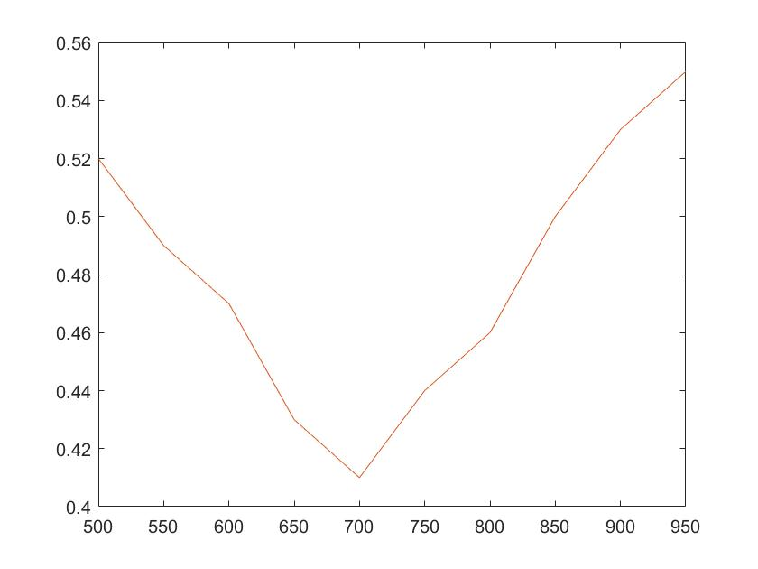

Problem 5 section 3.4 CP 3

Function:

Same as textbook of **splinecoeff.m** and **splineplot.m**

Main:

x = [0 1 2 3 4];

y = [1 3 3 4 2];

splinecoeff(x,y)

splineplot(x,y,10)

The coefficient of function:

2.660714285714286 0 -0.660714285714286

0.678571428571429 -1.982142857142857 1.303571428571429

0.625000000000000 1.928571428571428 -1.553571428571428

-0.178571428571429 -2.732142857142857 0.910714285714286

Thus, the function we get is:

 is the function on interval [0,1]

 is the function on interval [1,2]

 is the function on interval [2,3]

 is the function on interval [3,4]

The plot is as follows:

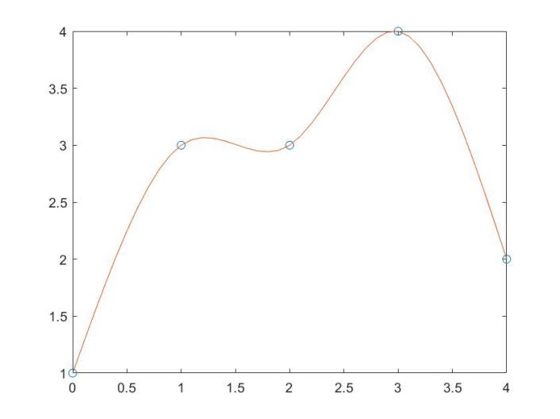

Problem 6 section 5.2 CP 1 (b) & (h)

Function:

function y = com_trap_rule(f,a,b,m)

h = (b - a)/m;

x = linspace(a, b, m+1);

sumy = 0;

for i = 2:m

sumy = sumy +f(x(i));

end

y =h/2 * (f(a) + f(b) + 2 * sumy);

end

Main:

f1 = @(x)x^3/(x^2 + 1);

yb16 = com_trap_rule(f1,0,1,16)

yb32 = com_trap_rule(f1,0,1,32)

syms x

vpa(abs(int(x^3/(x^2 + 1),0,1) - yb16),4)

vpa(abs(int(x^3/(x^2 + 1),0,1) - yb32),4)

f2 = @(x)x/sqrt(x^4 + 1);

yh16 = com_trap_rule(f2,0,1,16)

yh32 = com_trap_rule(f2,0,1,32)

syms x

vpa(abs(int(x/sqrt(x^4 + 1),0,1) - yh16),4)

vpa(abs(int(x/sqrt(x^4 + 1),0,1) - yh32),4)

Result:

(b) For m = 16, the approximate of definite integral is 0.153752089736523, the error with correct integral is 0.0003257

For m = 32, the approximate of definite integral is 0.153507799866167, the error with correct integral is 8.139e-5

The correct integral is 1/2 - log(2)/2

(h) For m = 16, the approximate of definite integral is 0.440361182629694, the error with correct integral is 0.0003256

For m = 32, the approximate of definite integral is 0.440605407679783, the error with correct integral is 8.139e-5

The correct integral is log(2^(1/2) + 1)/2

Problem 7 section 5.3 CP 1 (a) & (c)

Function:

function r=romberg(f,a,b,n)

h=(b-a)./(2.^(0:n-1));

r(1,1)=(b-a)*(f(a)+f(b))/2;

for j=2:n

subtotal = 0;

for i=1:2^(j-2)

subtotal = subtotal + f(a+(2*i-1)*h(j));

end

r(j,1) = r(j-1,1)/2+h(j)*subtotal;

for k=2:j

r(j,k)=(4^(k-1)*r(j,k-1)-r(j-1,k-1))/(4^(k-1)-1);

end

end

Main:

f1 = @(x)x/sqrt(x^2 + 9);

ya = romberg(f1,0,4,5);

ya(5,5)

syms x

vpa(abs(int(x/sqrt(x^2 + 9),0,4) - ya(5,5)),4)

int(x/sqrt(x^2 + 9),0,4)

f2 = @(x)x * exp(x)

yc = romberg(f2,0,1,5);

yc(5,5)

syms x

vpa(abs(int(x * exp(x),0,1) - yc(5,5)),4)

int(x * exp(x),0,1)

(a) The Romberg Integration approximation of  is 2.0000, the correct integral is 2, and the error is 1.041e-7

(c) The Romberg Integration approximation of  is 1.0000 the correct integral is 1, and the error is 3.477e-13