**STATS 500 Homework 2 YUAN YIN**

Problem 1

1. Fit the regression model with R, also we omit the missing values at first, the result is as follows:

Call:

lm(formula = wage ~ educ + exper, data = uswages)

Residuals:

Min 1Q Median 3Q Max

-1014.7 -235.2 -52.1 150.1 7249.2

Coefficients:

Estimate Std. Error t value Pr(>|t|)

(Intercept) -239.1146 50.7111 -4.715 2.58e-06 ***

educ 51.8654 3.3423 15.518 < 2e-16 ***

exper 9.3287 0.7602 12.271 < 2e-16 ***

---

Signif. codes: 0 ‘***’ 0.001 ‘**’ 0.01 ‘*’ 0.05 ‘.’ 0.1 ‘ ’ 1

Residual standard error: 426.8 on 1964 degrees of freedom

Multiple R-squared: 0.1348, Adjusted R-squared: 0.1339

F-statistic: 153 on 2 and 1964 DF, p-value: < 2.2e-16

The final regression model is as follows:



2. From the result above we can see that Multiple R - squared is 0.1348, which means the percentage of variation in the response explained by these predictors is 13.48%.

3. We use which.max() function to find the maximum residual of our regression, the case number is 15387, it’s the 1550th data of uswages and the max residual value is 7249.17.

Attention: 1550th represents the number in data which has been omitted the missing values, so it’s not the same in original data “uswages”.

4. Use mean() and median() function finding that the mean of residuals is -1.381535e-15 and the median of residuals is -52.14337, we found that these two results have a large difference, this is because mean is influenced by the variance of every residuals but median is only influenced by the middle residuals after sorted. As we found that the mean is almost zero but median is much less than zero, it means that of all residuals, the number of negative residuals are more than positive residuals but the absolute value of positive residuals are commonly larger than negative ones.

5. The correlation of residuals and fitted values is 6.35678e-17, the plot is as follows:

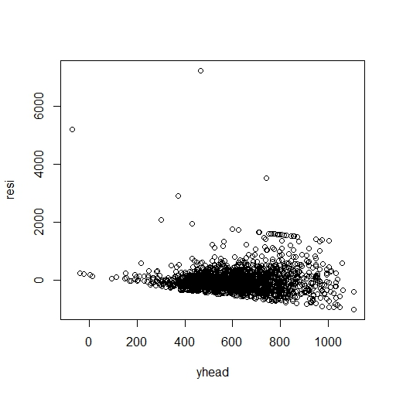

Fig 1 residuals against fitted values

1. The regression model is as follows:



It means, for two people with the same education but one year difference in experience, their wages may have $9.3287 difference.

1. The new model is as follows:

Call:

lm(formula = ystar ~ educ + exper, data = uswages)

Residuals:

Min 1Q Median 3Q Max

-2.7527 -0.3383 0.1002 0.4297 3.5728

Coefficients:

Estimate Std. Error t value Pr(>|t|)

(Intercept) 4.675518 0.077085 60.65 <2e-16 ***

educ 0.091940 0.005080 18.10 <2e-16 ***

exper 0.016516 0.001156 14.29 <2e-16 ***

---

Signif. codes: 0 ‘***’ 0.001 ‘**’ 0.01 ‘*’ 0.05 ‘.’ 0.1 ‘ ’ 1

Residual standard error: 0.6488 on 1964 degrees of freedom

Multiple R-squared: 0.1747, Adjusted R-squared: 0.1739

F-statistic: 207.9 on 2 and 1964 DF, p-value: < 2.2e-16

The final regression model is:



Here “ystar” equals to log(wages)

We notice that in this model, R-squared has a little higher than before, but still, they are both far from 1, now we analyze this model from the plot of log(wages), we can found that when the year of education adds 1 unit, log(wages) will add 0.09, this means with the higher original wages, it will also increase more when year of education increases. Also we can see that the changes of experience has little influence on wages, which also fits with the plot of wages and year of experiences. So we conclude that the second model is more natural.

**Appendix**

## read in the data

library(faraway)

data(uswages)

## get the X matrix

dim(uswages)

uswages$exper[uswages$exper < 0] = NA

uswages = na.omit(uswages)

## use the lm() function

temp = lm(wage ~ educ + exper, data = uswages)

summary(temp)

##residual sum of squares

resi = residuals(temp)

summary(resi)

which.max(resi)

## compute mean and median

mean(resi)

median(resi)

## fit the model

yhead = fitted(temp)

cor(resi,yhead)

plot(yhead,resi)

## log wage as response

ystar = log(uswages$wage)

tempstar = lm(ystar ~ educ + exper, data = uswages)

summary(tempstar)