**STATS 500 Homework 6 YUAN YIN**

Problem 1

1. First we use ordinary least squares to fit the model and the result is as follows:

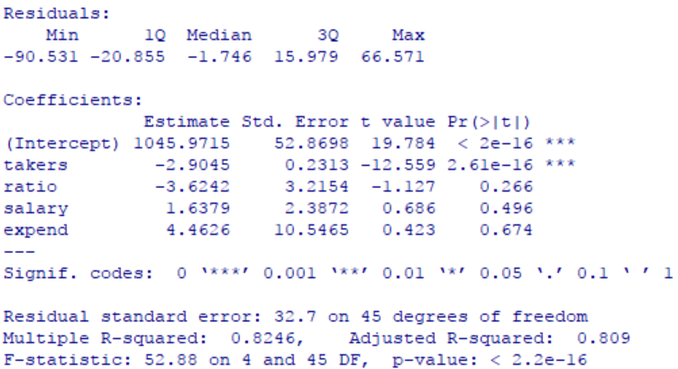

To compare the results of different methods of regression, we also have the result of LAD, Huber’s and LTS method as follows:

LAD:

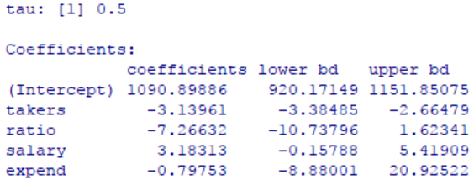

Huber’s method:

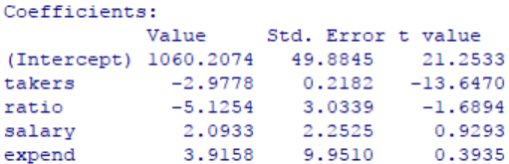

LTS:



To compute the standard error of parameters we get from LTS method, we use bootstrap method, and we can get the 95% confidence intervals for parameters as follows:



We can make a table of what we get from the results above, the change of every parameter is as follows:

|  |  |  |  |  |  |
| --- | --- | --- | --- | --- | --- |
| parameter | intercept | takers | ratio | salary | expend |
| OLS | 1045.97 | -2.90 | -3.62 | 1.64 | 4.46 |
| LAD | 1090.90 | -3.14 | -7.27 | 3.18 | -0.80 |
| Huber | 1060.21 | -2.98 | -5.13 | 2.09 | 3.92 |
| LTS | 1118.15 | -3.17 | -9.89 | 1.73 | 10.89 |

Table 1

From the table above, we can find that intercept and  didn’t change a lot in different methods. But for “ratio”, “salary” and “expend”, the parameters’ changes are obvious. Maybe it because there are some outliers and influential points that affect the results. However, before confirming our conclusion, we should first look at the significance for all the parameters in each method.

* First for OLS method, only intercept and  are significant.
* Also, in LAD method, only for intercept and  that are significant.
* For Huber’s method, we need to compare t-value with the table of T-test. When α = 0.05 and degree of freedom is 45, the significance value is 2.014, again, only intercept and  are significant.
* At last for LTS method, we found that intercept,  and  are all significant. What need to be noticed here is that the upper bound of  is close to 0, so it is possible for some results that  becomes not significant.

That is to say, for LAD and Huber’s method, although we find that some of the changes of parameters are obvious, we can’t say there are something wrong with our original method as these parameters are not siginificant. But for LTS method, we find the change of “” is large and also siginificant and we want to find out what causes this problem.

1. Now we detect outliers and influential points for our model. We find the largest residual and compute its p-value which is 0.003149625. Compare it with adjusted α which is 0.05/50 = 0.001, we find that it’s larger that adjusted α which means we fail to reject our null hypothesis. Then there is no outliers for our model.

Then we use cook’s distance to check influential points. First from the halfnorm plot as follows we can see that 44th data is far more influential than other data:

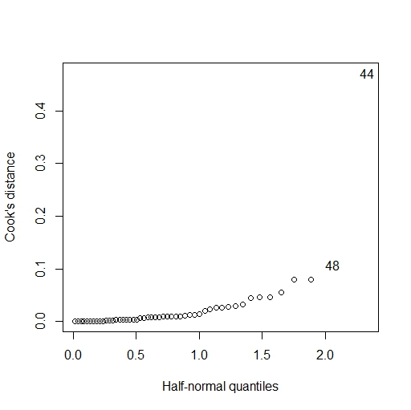

Fig 1 cook’s distance

Then we check changes of each coffecient after removing every point of the data, and we only find some of the coefficients have siginificant changes:

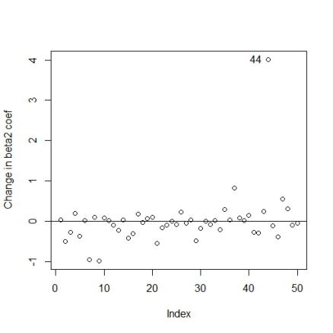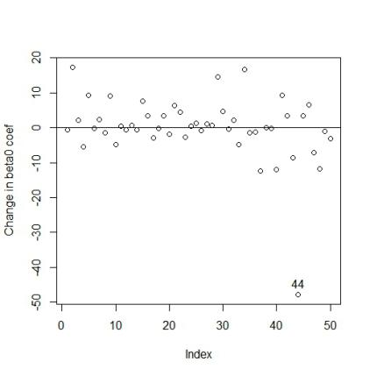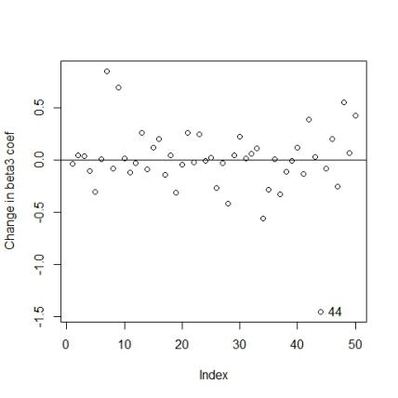

Fig 2 changes of cofficients

And we can see that the only data which has obvious effect on the coffecient is 44th data. In conclusion, the influential point is 44.

After remove outliers and influential points, we refitted our model and the result is as follows:

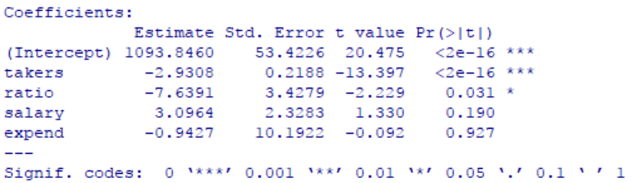

We can see that the parameter of ratio also becomes significant.

Compare the result with table 1, we can see that for those parameter which are significant, only parameter of ratio in LTS changes a lot. But for LAD and Huber method, we can’t find anything wrong with  (the only significant parameter). That is to say, M-estimation failed to identify the influential points. But LTS method indeed tested something wrong because the change of  (which is significant) is large. And we can find that after removing influential point, the parameter of ratio becomes significant, this also confirms that LTS method works in detecting ourliers and influential points for our model. Again to be noticed that although LTS method tested the influential points. It doesn’t always works as the upper bound is close to 0. The only more informative method is to use diagnostics method.

Appendix

library(faraway)

data(sat)

# ordinary least squares

yols = lm(total ~ takers + ratio + salary + expend, data = sat)

summary(yols)

# least absolute deviations

library(quantreg)

ylad = rq(total ~ takers + ratio + salary + expend, data = sat)

summary(ylad)

# Huber's method

library(MASS)

yhuber = rlm(total ~ takers + ratio + salary + expend, data = sat)

summary(yhuber)

# least trimmed squares

ylts = ltsreg(total ~ takers + ratio + salary + expend, data = sat, nsamp = "exact")

round(ylts$coef, 3)

# extract matrix of predictors for ltsreg

x = sat[,1:4]

## bootstrap 1000 times

bcoef = matrix(0, nrow = 1000, ncol = 5)

for(i in 1:1000){

newy <- ylts$fit + ylts$resid[sample(50, rep = T)]

bcoef[i,] <- ltsreg(x, newy, nsamp = "best")$coef

}

## 95% C.I. for parameters

colnames(bcoef) = c("(Intercept)","expend","ratio","salary","takers")

apply(bcoef, 2, function(x) quantile(x, c(0.025, 0.975)))

## compute p-value

ri = rstudent(yols)

2*(1 - pt(max(abs(ri)), df = 50-5-1))

## compare to alpha/n

0.05/50

#there is no outliers

## compute cook's distance

cook = cooks.distance(yols)

plot(dfbeta(yols)[,1], ylab = "Change in beta0 coef")

abline(h=0)

identify(dfbeta(yols)[,1])

halfnorm(cook, nlab = 2, ylab = "Cook's distance")

sat[c(44),]

plot(dfbeta(yols)[,2], ylab = "Change in beta1 coef")

abline(h=0)

identify(dfbeta(yols)[,2])

plot(dfbeta(yols)[,3], ylab = "Change in beta2 coef")

abline(h=0)

identify(dfbeta(yols)[,3])

plot(dfbeta(yols)[,4], ylab = "Change in beta3 coef")

abline(h=0)

identify(dfbeta(yols)[,4])

sat1 = sat[-c(44),]

## new least squares

yols1 = lm(total ~ takers + ratio + salary + expend, data = sat1)

coef(yols1)