Question 2.1 (c)

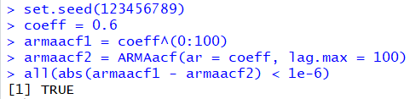

plot(armaacf1,type="l", col='red', xlab ="lag")

lines(armaacf2, lty =2, col='blue')

legend("topright", legend = c("our result", "R function"), col = c("red","blue"), lty =c(1,2))

