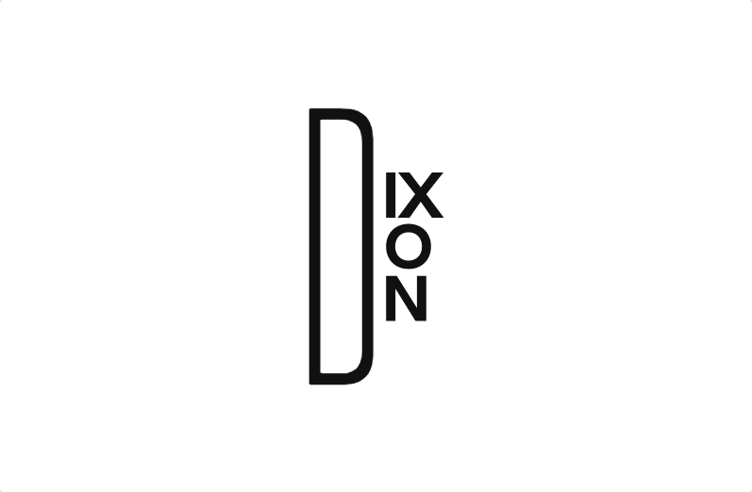

Selected products only. Terms and conditions applied

OFFERS UP TO 50%

YEAREND SALE