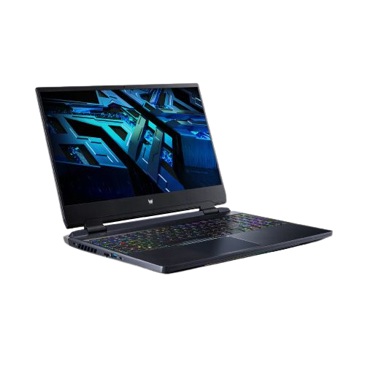

ACER NITRO 5 Intel® Core i9-12900H

RM5,999.00

ACER PREDATOR HELIOS 300

RM5,999.00

NEW FACES IN THE NEIGHBOR-HOOD