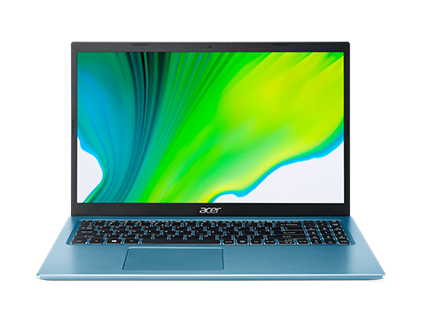

LIMITED TIME ONLY!!

CLICK FOR MORE DETAILS >

Acer Aspire 5

~~RM3099.99~~ RM2599.99