Shortest Path Algorithm Preview

ScreenShots:

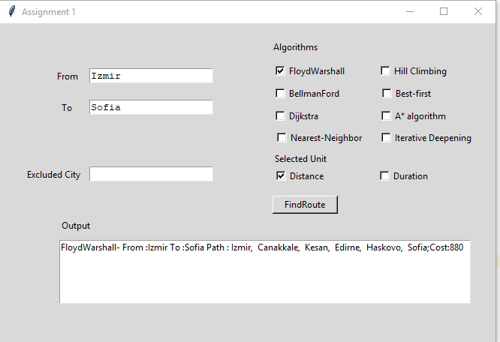

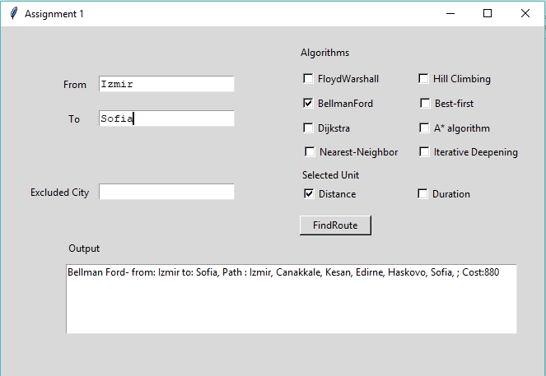

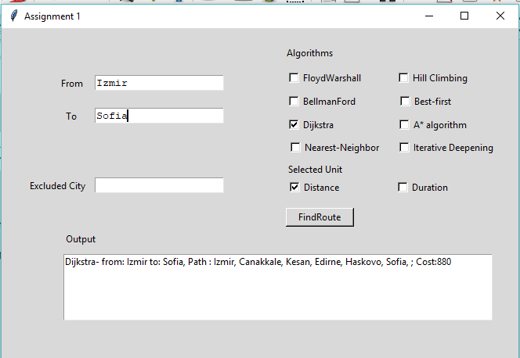

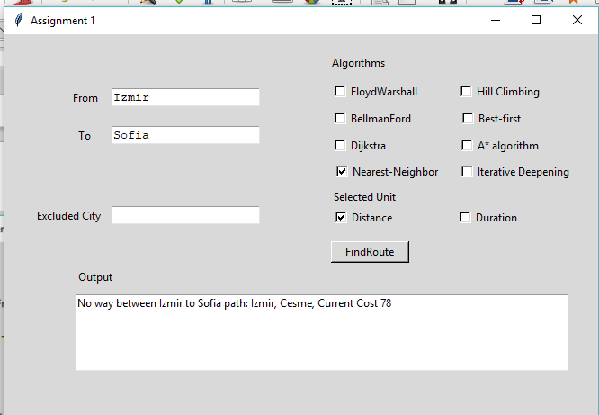

-Nearest neighbor with excluded city Cesme

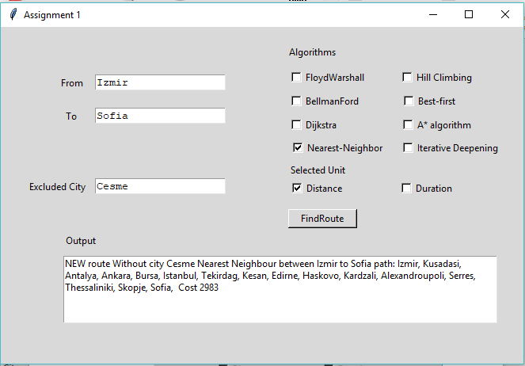

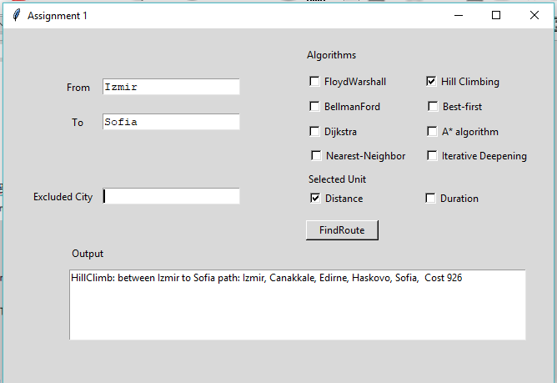

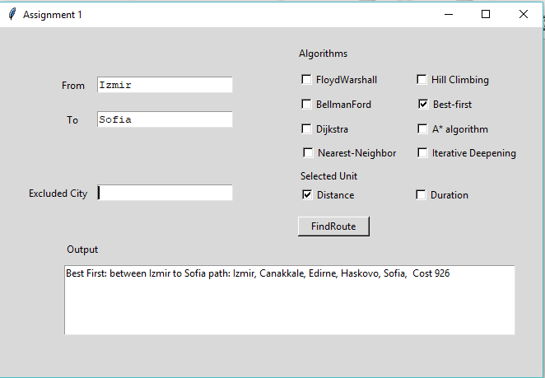

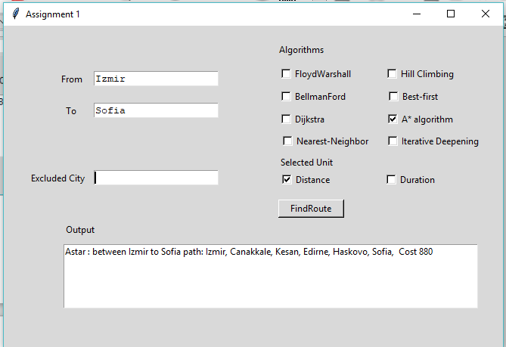

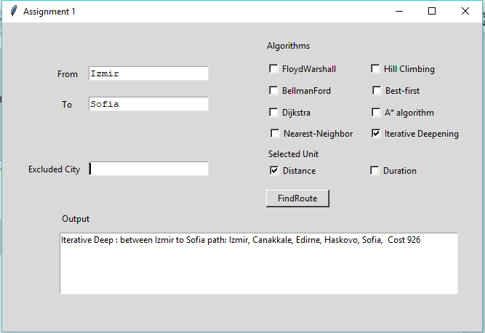

Some other examles:

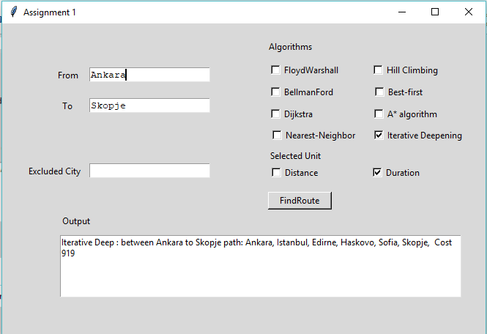

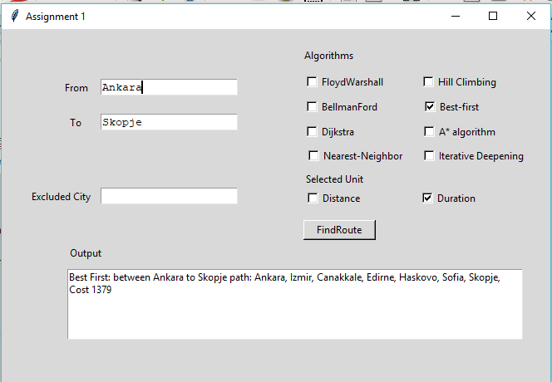

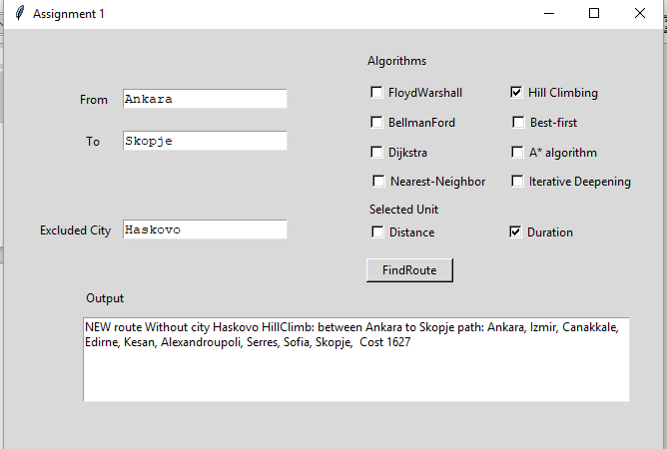

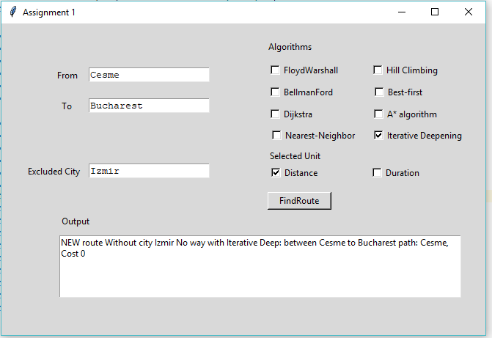

Result output with all tests:

BellMan-Ford Drive Distance (km)

Bellman Ford- from: Izmir to: Sofia, Path : Izmir, Canakkale, Kesan, Edirne, Haskovo, Sofia, ; Cost:880

Bellman Ford- from: Izmir to: Athens, Path : Izmir, Canakkale, Kesan, Alexandroupoli, Serres, Thessaliniki, Athens, ; Cost:1397

Bellman Ford- from: Ankara to: Athens, Path : Ankara, Istanbul, Tekirdag, Alexandroupoli, Serres, Thessaliniki, Athens, ; Cost:1622

Bellman Ford- from: Antalya to: Skopje, Path : Antalya, Bursa, Istanbul, Edirne, Haskovo, Sofia, Skopje, ; Cost:1546

BellMan-Ford Duration (minutes)

Bellman Ford- from: Izmir to: Sofia, Path : Izmir, Canakkale, Kesan, Edirne, Haskovo, Sofia, ; Cost:724

Bellman Ford- from: Izmir to: Athens, Path : Izmir, Canakkale, Kesan, Alexandroupoli, Serres, Thessaliniki, Athens, ; Cost:1044

Bellman Ford- from: Ankara to: Athens, Path : Ankara, Istanbul, Tekirdag, Alexandroupoli, Serres, Thessaliniki, Athens, ; Cost:1096

Bellman Ford- from: Antalya to: Skopje, Path : Antalya, Bursa, Istanbul, Edirne, Haskovo, Sofia, Skopje, ; Cost:1153

Floyd Warshall drive (km)

FloydWarshall- From :Izmir To :Sofia Path : Izmir, Canakkale, Kesan, Edirne, Haskovo, Sofia;Cost: 880

FloydWarshall- From :Izmir To :Athens Path : Izmir, Canakkale, Kesan, Alexandroupoli, Serres, Thessaliniki, Athens;Cost: 1397

FloydWarshall- From :Ankara To :Athens Path : Ankara, Istanbul, Tekirdag, Alexandroupoli, Serres, Thessaliniki, Athens;Cost: 1622

FloydWarshall- From :Antalya To :Skopje Path : Antalya, Bursa, Istanbul, Edirne, Haskovo, Sofia, Skopje;Cost: 1546

Floyd Warshall Duration (minutes)

FloydWarshall- From :Izmir To :Sofia Path : Izmir, Canakkale, Kesan, Edirne, Haskovo, Sofia;Cost: 724

FloydWarshall- From :Izmir To :Athens Path : Izmir, Canakkale, Kesan, Alexandroupoli, Serres, Thessaliniki, Athens;Cost: 1044

FloydWarshall- From :Ankara To :Athens Path : Ankara, Istanbul, Tekirdag, Alexandroupoli, Serres, Thessaliniki, Athens;Cost: 1096

FloydWarshall- From :Antalya To :Skopje Path : Antalya, Bursa, Istanbul, Edirne, Haskovo, Sofia, Skopje;Cost: 1153

Dijkstra drive (km)

Dijkstra- from: Izmir to: Sofia, Path : Izmir, Canakkale, Kesan, Edirne, Haskovo, Sofia, ; Cost:880

Dijkstra- from: Izmir to: Athens, Path : Izmir, Canakkale, Kesan, Alexandroupoli, Serres, Thessaliniki, Athens, ; Cost:1397

Dijkstra- from: Ankara to: Athens, Path : Ankara, Istanbul, Tekirdag, Alexandroupoli, Serres, Thessaliniki, Athens, ; Cost:1622

Dijkstra- from: Antalya to: Skopje, Path : Antalya, Bursa, Istanbul, Edirne, Haskovo, Sofia, Skopje, ; Cost:1546

Dijkstra Duration (minutes)

Dijkstra- from: Izmir to: Sofia, Path : Izmir, Canakkale, Kesan, Edirne, Haskovo, Sofia, ; Cost:724

Dijkstra- from: Izmir to: Athens, Path : Izmir, Canakkale, Kesan, Alexandroupoli, Serres, Thessaliniki, Athens, ; Cost:1044

Dijkstra- from: Ankara to: Athens, Path : Ankara, Istanbul, Tekirdag, Alexandroupoli, Serres, Thessaliniki, Athens, ; Cost:1096

Dijkstra- from: Antalya to: Skopje, Path : Antalya, Bursa, Istanbul, Edirne, Haskovo, Sofia, Skopje, ; Cost:1153

Nearestneighbour drive (km)

No way between Izmir to Sofia path: Izmir, Cesme, Current Cost 78

No way between Izmir to Athens path: Izmir, Cesme, Current Cost 78

No way between Ankara to Athens path: Ankara, Bursa, Istanbul, Tekirdag, Kesan, Edirne, Haskovo, Kardzali, Alexandroupoli, Serres, Thessaliniki, Skopje, Sofia, Bucharest, Current Cost 2324

No way between Antalya to Skopje path: Antalya, Kusadasi, Izmir, Cesme, Current Cost 580

Nearesneighbour Duration (minutes)

No way between Izmir to Sofia path: Izmir, Cesme, Current Cost 58

No way between Izmir to Athens path: Izmir, Cesme, Current Cost 58

No way between Ankara to Athens path: Ankara, Bursa, Balikesir, Izmir, Cesme, Current Cost 560

No way between Antalya to Skopje path: Antalya, Kusadasi, Izmir, Cesme, Current Cost 461

hillclimb drive (km)

HillClimb: between Izmir to Sofia path: Izmir, Canakkale, Edirne, Haskovo, Sofia, Cost 926

Hill Climb: No way between Izmir to Athens path: Izmir, Cesme, Current Cost 78

Hill Climb: No way between Ankara to Athens path: Ankara, Izmir, Cesme, Current Cost 663

HillClimb: between Antalya to Skopje path: Antalya, Izmir, Canakkale, Edirne, Haskovo, Sofia, Skopje, Cost 1629

hillclimb Duration (minutes)

HillClimb: between Izmir to Sofia path: Izmir, Canakkale, Edirne, Haskovo, Sofia, Cost 746

Hill Climb: No way between Izmir to Athens path: Izmir, Cesme, Current Cost 58

Hill Climb: No way between Ankara to Athens path: Ankara, Izmir, Cesme, Current Cost 486

HillClimb: between Antalya to Skopje path: Antalya, Izmir, Canakkale, Edirne, Haskovo, Sofia, Skopje, Cost 1293

Best first drive (km)

Best First: between Izmir to Sofia path: Izmir, Canakkale, Edirne, Haskovo, Sofia, Cost 926

Best First: between Izmir to Athens path: Izmir, Canakkale, Kesan, Alexandroupoli, Serres, Thessaliniki, Athens, Cost 1397

Best First: between Ankara to Athens path: Ankara, Bursa, Canakkale, Kesan, Alexandroupoli, Serres, Thessaliniki, Athens, Cost 1707

Best First: between Antalya to Skopje path: Antalya, Izmir, Canakkale, Edirne, Haskovo, Sofia, Skopje, Cost 1629

Best first duration (minutes)

Best First: between Izmir to Sofia path: Izmir, Canakkale, Edirne, Haskovo, Sofia, Cost 746

Best First: between Izmir to Athens path: Izmir, Canakkale, Kesan, Alexandroupoli, Serres, Thessaliniki, Athens, Cost 1044

Best First: between Ankara to Athens path: Ankara, Bursa, Canakkale, Kesan, Alexandroupoli, Serres, Thessaliniki, Athens, Cost 1238

Best First: between Antalya to Skopje path: Antalya, Izmir, Canakkale, Edirne, Haskovo, Sofia, Skopje, Cost 1293

Astar drive (km)

Astar : between Izmir to Sofia path: Izmir, Canakkale, Kesan, Edirne, Haskovo, Sofia, Cost 880

Astar : between Izmir to Athens path: Izmir, Ankara, Bucharest, Sofia, Serres, Thessaliniki, Athens, Cost 1756

Astar : between Ankara to Athens path: Ankara, Istanbul, Bucharest, Sofia, Serres, Thessaliniki, Athens, Cost 1621

Astar : between Antalya to Skopje path: Antalya, Izmir, Cesme, Canakkale, Kesan, Alexandroupoli, Serres, Thessaliniki, Skopje, Cost 1377

Astar duration (minutes)

Astar : between Izmir to Sofia path: Izmir, Canakkale, Kesan, Edirne, Haskovo, Sofia, Cost 724

Astar : between Izmir to Athens path: Izmir, Canakkale, Kesan, Alexandroupoli, Serres, Thessaliniki, Athens, Cost 1044

Astar : between Ankara to Athens path: Ankara, Bursa, Balikesir, Canakkale, Kesan, Alexandroupoli, Serres, Thessaliniki, Athens, Cost 1286

Astar : between Antalya to Skopje path: Antalya, Izmir, Cesme, Canakkale, Kesan, Alexandroupoli, Serres, Thessaliniki, Skopje, Cost 1043

Iterative Deepening drive (km)

Iterative Deep : between Izmir to Sofia path: Izmir, Canakkale, Edirne, Haskovo, Sofia, Cost 926

Iterative Deep : between Izmir to Athens path: Izmir, Canakkale, Kesan, Alexandroupoli, Serres, Thessaliniki, Athens, Cost 1397

Iterative Deep : between Ankara to Athens path: Ankara, Istanbul, Tekirdag, Alexandroupoli, Serres, Thessaliniki, Athens, Cost 1622

Iterative Deep : between Antalya to Skopje path: Antalya, Bursa, Istanbul, Edirne, Haskovo, Sofia, Skopje, Cost 1546

Iterative Deepening duration (minutes)

Iterative Deep : between Izmir to Sofia path: Izmir, Canakkale, Edirne, Haskovo, Sofia, Cost 746

Iterative Deep : between Izmir to Athens path: Izmir, Canakkale, Kesan, Alexandroupoli, Serres, Thessaliniki, Athens, Cost 1044

Iterative Deep : between Ankara to Athens path: Ankara, Istanbul, Tekirdag, Alexandroupoli, Serres, Thessaliniki, Athens, Cost 1096

Iterative Deep : between Antalya to Skopje path: Antalya, Bursa, Istanbul, Edirne, Haskovo, Sofia, Skopje, Cost 1153