STDA2102: SOFT COMPUTING (EL1) - PRACTICAL RECORD
Comprehensive Practical Laboratory Record
(All 30 Exercises - Modules 1, 2, and 3)
Course Code & Title: STDA2102 - Soft Computing (EL1) | Evaluation Total: 100 Marks (50 Marks CCE)
Student Name: Manish Kumar | Total Practicals Completed: 30 / 30 Practicals

Index: Practical Exercises
Exp # | Module & Practical Aim | Status
1.1 | [Module 1] To create and visualize simple fuzzy sets in Python using membership values. | Completed
1.2 | [Module 1] To create and plot Triangular, Trapezoidal, and Gaussian membership functions using Python and scikit-fuzzy. | Completed
1.3 | [Module 1] To perform basic fuzzy set operations such as Union, Intersection, and Complement using Python. | Completed
1.4 | [Module 1] To create and display a simple fuzzy relation between two fuzzy sets using Python. | Completed
1.5 | [Module 1] To create fuzzy linguistic variables such as Low, Medium, and High using membership functions in Python. | Completed
1.6 | [Module 1] To create simple Fuzzy IF–THEN rules for making decisions based on given input conditions. | Completed
1.7 | [Module 1] To implement a simple Mamdani Fuzzy Inference System using Python and scikit-fuzzy. | Completed
1.8 | [Module 1] To implement a simple Sugeno Fuzzy Inference System using Python. | Completed
1.9 | [Module 1] To apply and compare basic defuzzification methods such as Centroid, Bisector, and Mean of Maximum using Python. | Completed
1.10 | [Module 1] To design a simple Fuzzy Logic Controller using Python and scikit-fuzzy by combining membership functions, fuzzy rules, fuzzy inference, and defuzzification. | Completed
2.1 | [Module 2] To understand and implement the basic working of an artificial neuron using Python. | Completed
2.2 | [Module 2] To implement the weighted sum of inputs and bias used in an artificial neuron using Python. | Completed
2.3 | [Module 2] To implement and visualize Sigmoid, Tanh, and ReLU activation functions using Python. | Completed
2.4 | [Module 2] To create a simple single-layer neural network using Python. | Completed
2.5 | [Module 2] To create a Multilayer Perceptron (MLP) with input, hidden, and output layers using Keras/TensorFlow. | Completed
2.6 | [Module 2] To apply Gradient Descent for updating the weights of a simple neural network during training. | Completed
2.7 | [Module 2] To understand and implement the basic concept of Backpropagation for training a neural network. | Completed
2.8 | [Module 2] To train a simple neural network model on a dataset using Keras/TensorFlow. | Completed
2.9 | [Module 2] To evaluate the performance of a trained neural network using suitable evaluation metrics in Python. | Completed
2.10 | [Module 2] To design, train, and evaluate a complete Artificial Neural Network-based classification system using Python and Keras/TensorFlow by integrating input features, hidden layers, activation functions, training, and model evaluation. | Completed
3.1 | [Module 3] To create and represent a population of individuals using different encoding methods in Python. | Completed
3.2 | [Module 3] To define and calculate a simple fitness function for evaluating individuals in a Genetic Algorithm using Python. | Completed
3.3 | [Module 3] To implement basic selection methods for selecting suitable individuals from a population using Python. | Completed
3.4 | [Module 3] To implement the crossover operation for generating new offspring from selected individuals using Python. | Completed
3.5 | [Module 3] To implement the mutation operation for introducing variations in individuals using Python. | Completed
3.6 | [Module 3] To create a simple Genetic Algorithm by combining selection, crossover, and mutation operations using Python. | Completed
3.7 | [Module 3] To study the convergence of a Genetic Algorithm by observing changes in fitness values over multiple generations using Python. | Completed
3.8 | [Module 3] To implement a simple Particle Swarm Optimization (PSO) algorithm for solving an optimization problem using Python. | Completed
3.9 | [Module 3] To implement a simple Differential Evolution (DE) algorithm for solving an optimization problem using Python. | Completed
3.10 | [Module 3] To design and implement a complete optimization system using a Genetic Algorithm in Python with the DEAP library by integrating population initialization, fitness evaluation, selection, crossover, mutation, and convergence analysis. | Completed

Practical 1.1: To create and visualize simple fuzzy sets in Python using membership values.
Module: Module 1: Fuzzy Logic and Systems | Script: ex01_simple_fuzzy_sets.py

Aim:
To create and visualize simple fuzzy sets in Python using membership values.

Theoretical Background & Principle:
A fuzzy set Ã over universe X is defined by a membership function μ_Ã(x) ∈ [0, 1]. Unlike crisp sets that enforce a step transition (0 or 1), fuzzy sets model gradual belongingness.

Generated Visualization & Output:
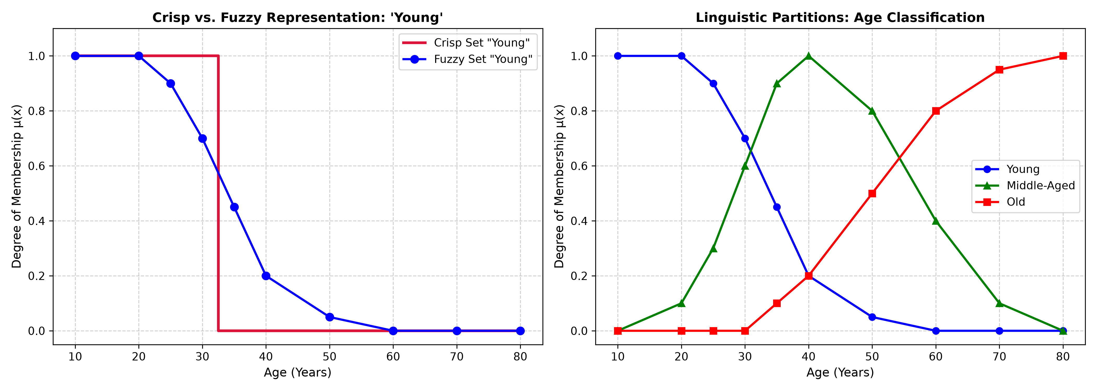
Output Plot for Practical 1.1

Observations & Inferences:
The discrete fuzzy sets for 'Young', 'Middle-Aged', and 'Old' were successfully plotted. Transition across ages 25 to 45 showed smooth overlap, demonstrating the distinction between rigid crisp thresholds and continuous fuzzy membership.

Practical 1.2: To create and plot Triangular, Trapezoidal, and Gaussian membership functions using Python and scikit-fuzzy.
Module: Module 1: Fuzzy Logic and Systems | Script: ex02_membership_functions.py

Aim:
To create and plot Triangular, Trapezoidal, and Gaussian membership functions using Python and scikit-fuzzy.

Theoretical Background & Principle:
Standard continuous membership functions include Triangular (defined by 3 parameters [a, b, c]), Trapezoidal (4 parameters [a, b, c, d] featuring a central plateau), and Gaussian (mean c, standard deviation σ).

Generated Visualization & Output:
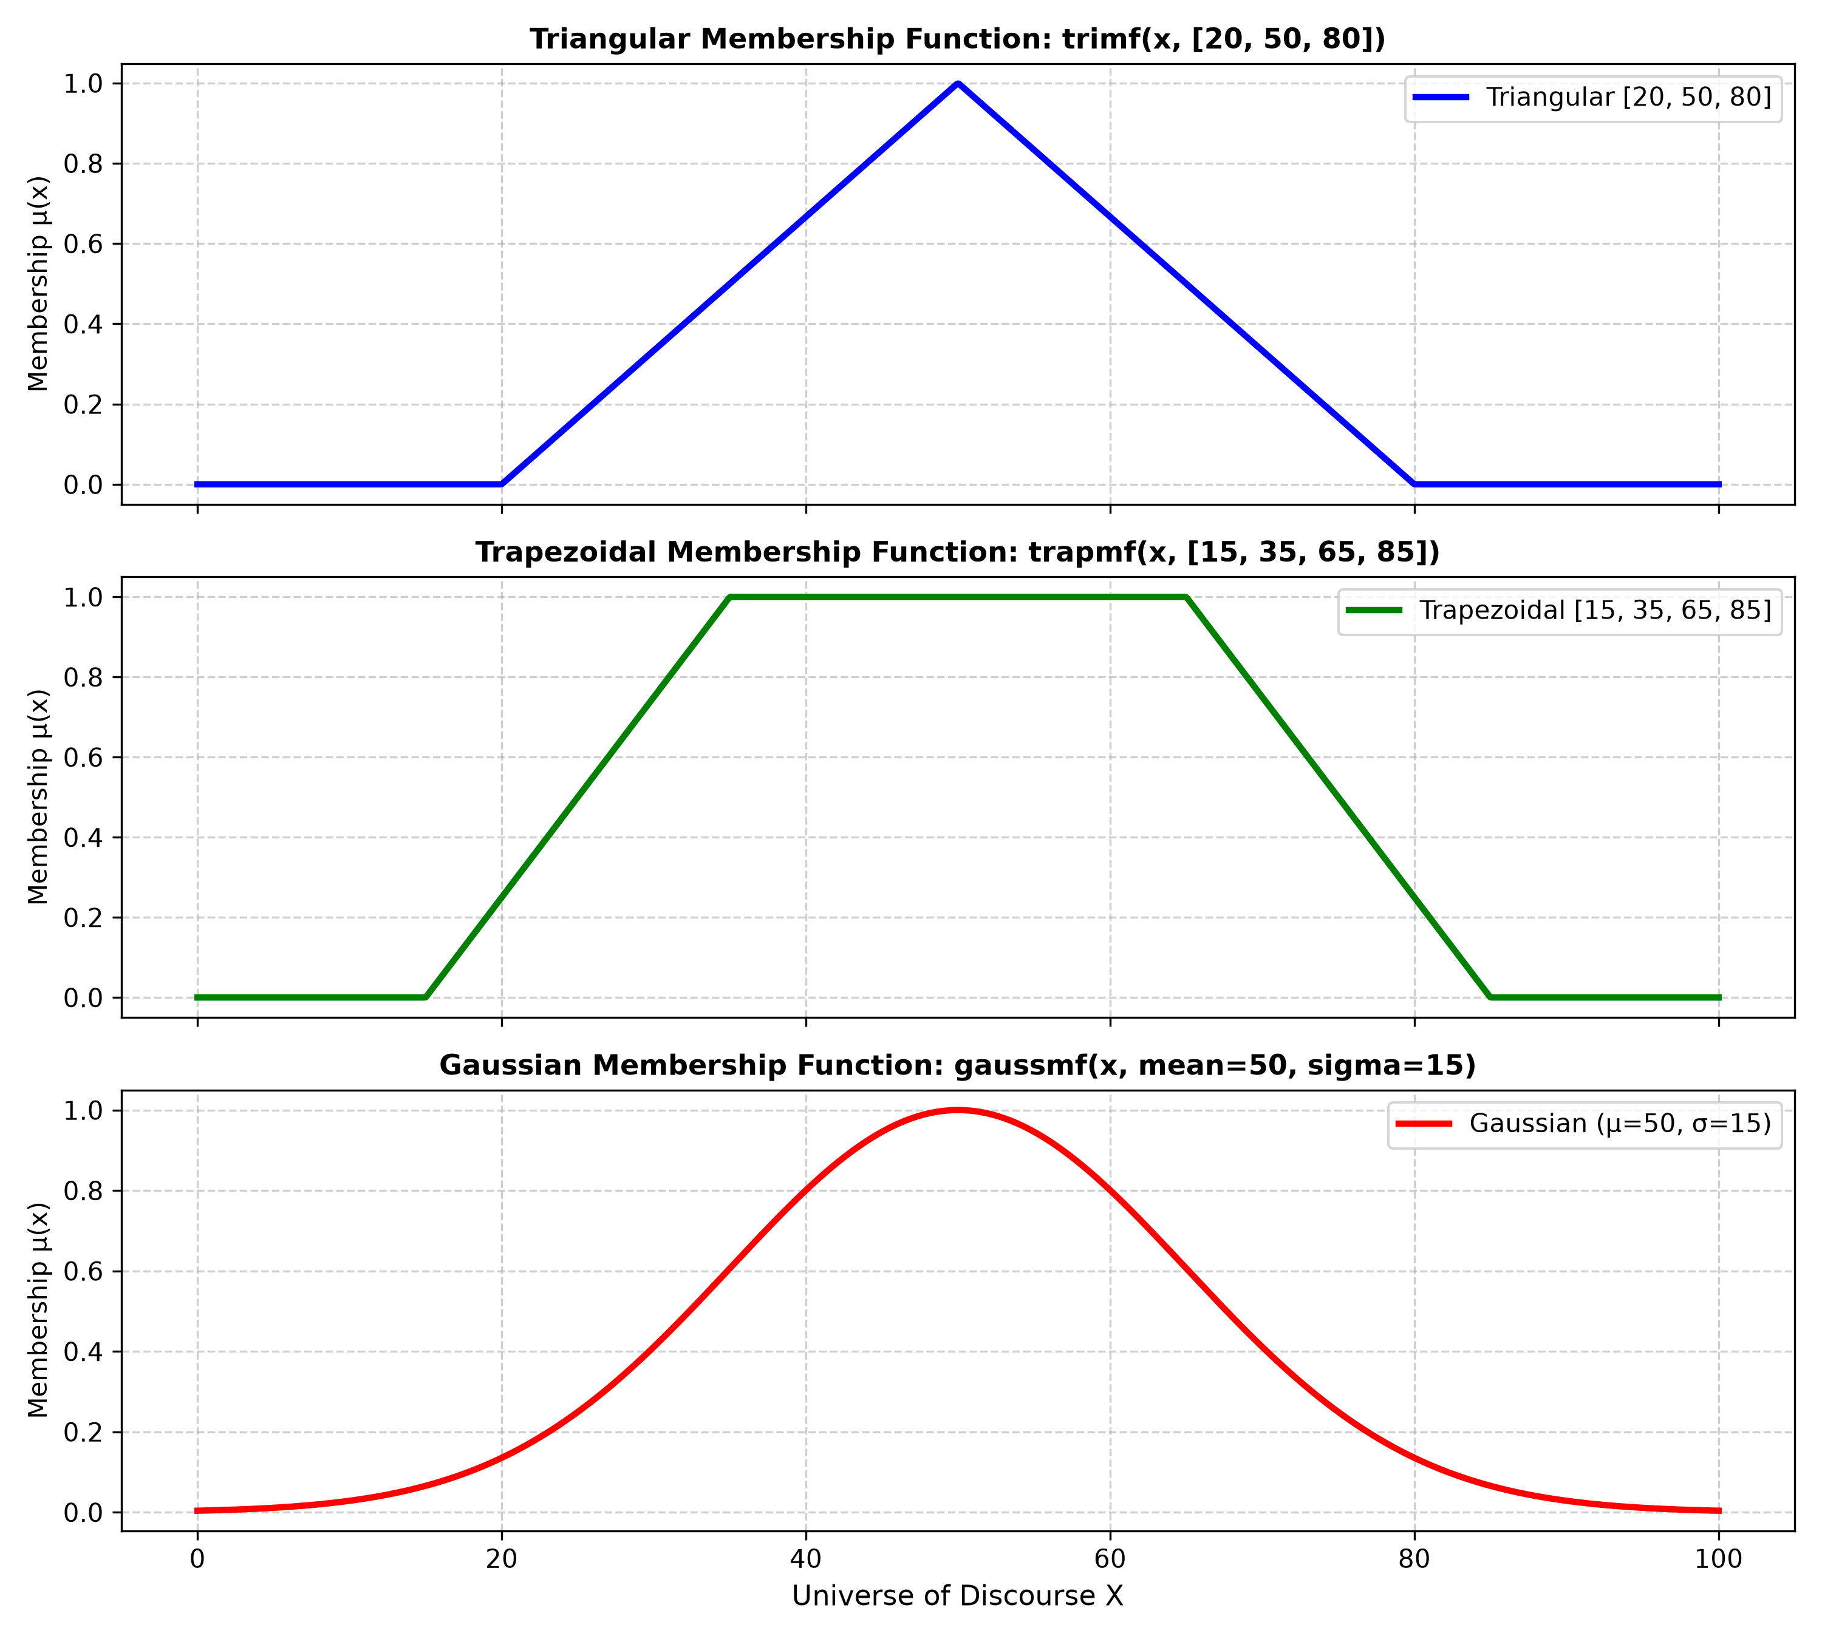
Output Plot for Practical 1.2

Observations & Inferences:
Gaussian functions provide smooth, infinitely differentiable bell shapes, whereas triangular and trapezoidal functions offer piecewise linear computational simplicity. All functions were evaluated across test points x = 35, 50, 65.

Practical 1.3: To perform basic fuzzy set operations such as Union, Intersection, and Complement using Python.
Module: Module 1: Fuzzy Logic and Systems | Script: ex03_fuzzy_set_operations.py

Aim:
To perform basic fuzzy set operations such as Union, Intersection, and Complement using Python.

Theoretical Background & Principle:
Standard Zadeh operators define Union via max(μA, μB), Intersection via min(μA, μB), and Complement via 1 - μA. Algebraic product (μA * μB) and algebraic sum (μA + μB - μA*μB) provide alternative soft norms.

Generated Visualization & Output:
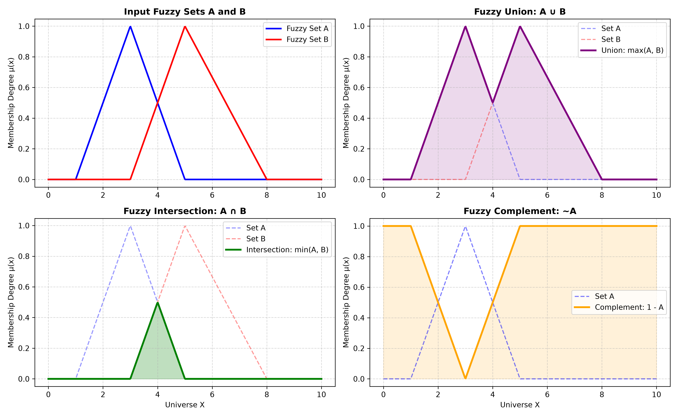
Output Plot for Practical 1.3

Observations & Inferences:
The operations were successfully computed over universe [0, 10]. In contrast to classical sets where A ∩ ~A = ∅, fuzzy sets allow A ∩ ~A ≠ ∅, violating the Law of Excluded Middle.

Practical 1.4: To create and display a simple fuzzy relation between two fuzzy sets using Python.
Module: Module 1: Fuzzy Logic and Systems | Script: ex04_fuzzy_relations.py

Aim:
To create and display a simple fuzzy relation between two fuzzy sets using Python.

Theoretical Background & Principle:
A fuzzy relation R on X × Y assigns membership degree μ_R(x, y) to each ordered pair. Composition of two relations R (X×Y) and S (Y×Z) yields T = R ∘ S using Max-Min composition: μ_T(x, z) = max_y [ min(μ_R(x, y), μ_S(y, z)) ].

Generated Visualization & Output:
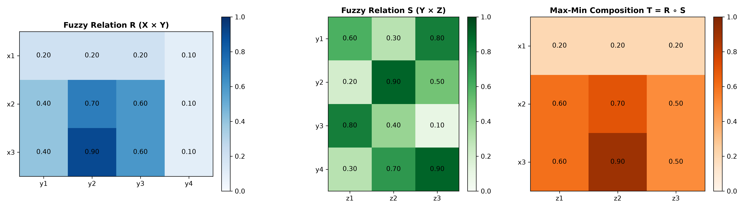
Output Plot for Practical 1.4

Observations & Inferences:
The Cartesian relation matrices and Max-Min composition were computed and displayed as 2D heatmaps. Matrix dimensions (3×4 and 4×3) yielded a resulting 3×3 relation matrix.

Practical 1.5: To create fuzzy linguistic variables such as Low, Medium, and High using membership functions in Python.
Module: Module 1: Fuzzy Logic and Systems | Script: ex05_linguistic_variables.py

Aim:
To create fuzzy linguistic variables such as Low, Medium, and High using membership functions in Python.

Theoretical Background & Principle:
A linguistic variable represents a continuous physical quantity using natural language words. It is characterized by quintuple (x, T(x), U, G, M), where T(x) contains linguistic terms like {Very Low, Low, Medium, High, Very High}.

Generated Visualization & Output:
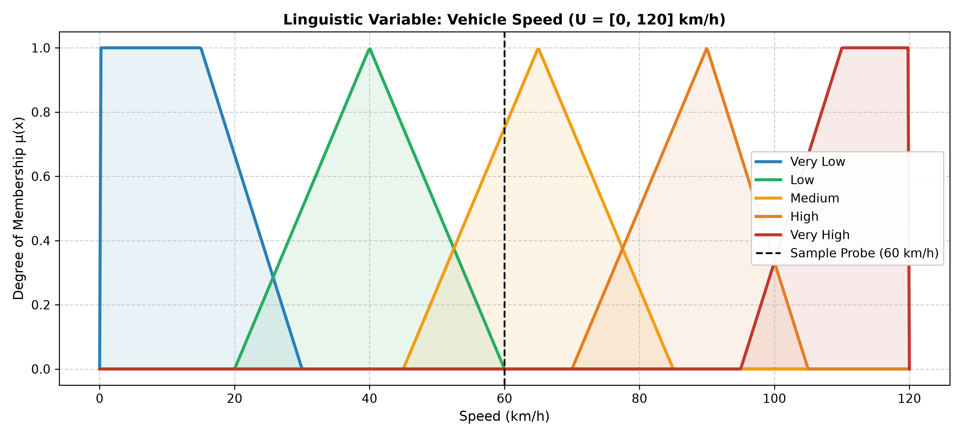
Output Plot for Practical 1.5

Observations & Inferences:
The 'Vehicle Speed' variable was partitioned into 5 overlapping fuzzy regions over [0, 120] km/h. At probe point 60 km/h, the vehicle simultaneously held membership in Low (0.003) and Medium (0.750).

Practical 1.6: To create simple Fuzzy IF–THEN rules for making decisions based on given input conditions.
Module: Module 1: Fuzzy Logic and Systems | Script: ex06_fuzzy_if_then_rules.py

Aim:
To create simple Fuzzy IF–THEN rules for making decisions based on given input conditions.

Theoretical Background & Principle:
A Fuzzy IF-THEN rule evaluates antecedent condition 'IF x is A AND y is B' using min T-norm to calculate firing strength α. Mamdani implication clips the consequent set C at height α: μ_C'(z) = min(α, μ_C(z)).

Generated Visualization & Output:
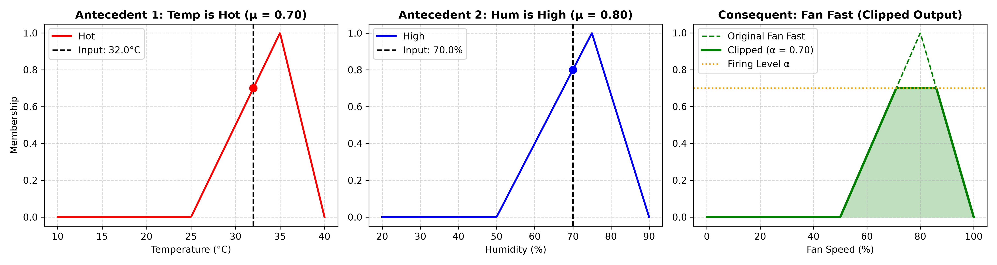
Output Plot for Practical 1.6

Observations & Inferences:
Given input temperature 32°C and humidity 70%, the rule fired with strength α = min(0.70, 0.80) = 0.70. The consequent 'Fan Fast' was clipped cleanly at level 0.70.

Practical 1.7: To implement a simple Mamdani Fuzzy Inference System using Python and scikit-fuzzy.
Module: Module 1: Fuzzy Logic and Systems | Script: ex07_mamdani_inference.py

Aim:
To implement a simple Mamdani Fuzzy Inference System using Python and scikit-fuzzy.

Theoretical Background & Principle:
A Mamdani FIS maps crisp inputs to crisp outputs through Fuzzification, Rule Base evaluation (min), Consequent Aggregation (max), and Centroid Defuzzification.

Generated Visualization & Output:
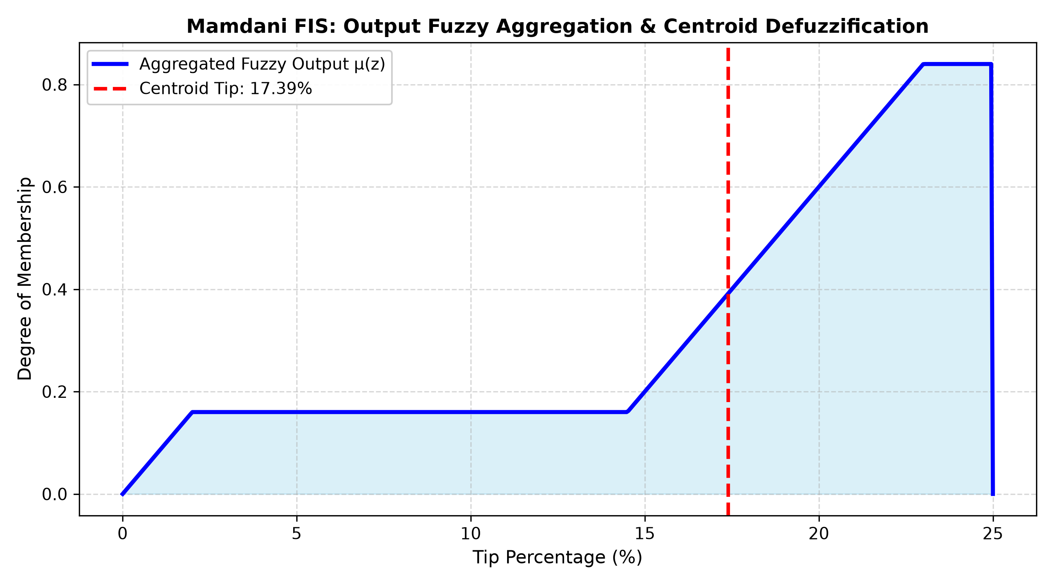
Output Plot for Practical 1.7

Observations & Inferences:
For restaurant tipping inputs of Food Quality = 6.5/10 and Service Rating = 9.2/10, the system aggregated rules and defuzzified a recommended tip of 17.39%.

Practical 1.8: To implement a simple Sugeno Fuzzy Inference System using Python.
Module: Module 1: Fuzzy Logic and Systems | Script: ex08_sugeno_inference.py

Aim:
To implement a simple Sugeno Fuzzy Inference System using Python.

Theoretical Background & Principle:
The Takagi-Sugeno-Kang (TSK) fuzzy model uses mathematical functions in rule consequents: z_i = p_i*x + q_i*y + r_i. The output is defuzzified via Weighted Average: z* = ∑(w_i * z_i) / ∑(w_i).

Generated Visualization & Output:
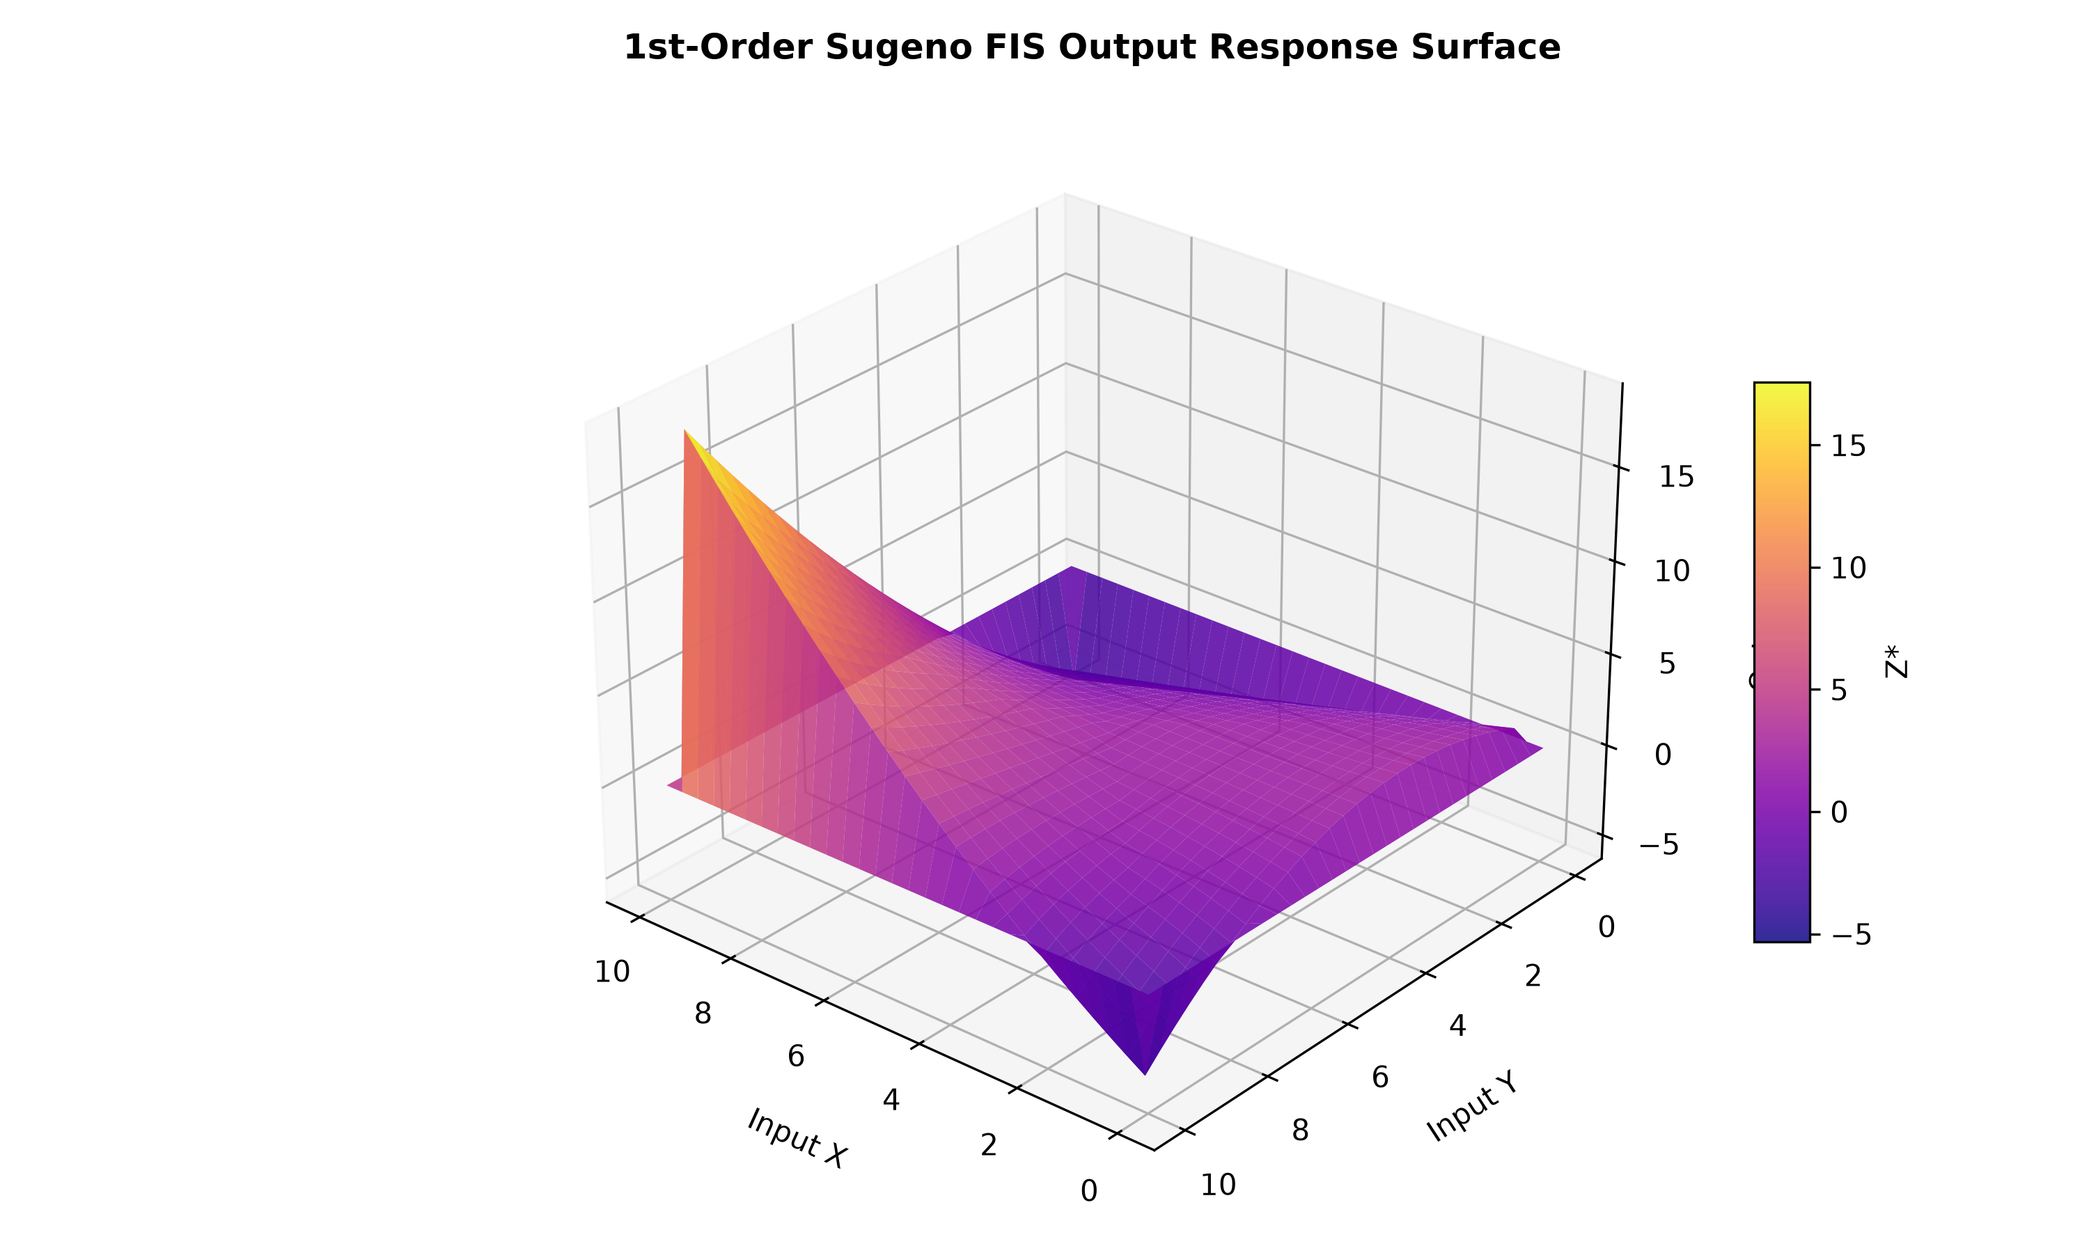
Output Plot for Practical 1.8

Observations & Inferences:
The Sugeno system eliminated the computationally intensive numerical integration required by Mamdani, generating a smooth continuous 3D response surface across all test input combinations.

Practical 1.9: To apply and compare basic defuzzification methods such as Centroid, Bisector, and Mean of Maximum using Python.
Module: Module 1: Fuzzy Logic and Systems | Script: ex09_defuzzification_methods.py

Aim:
To apply and compare basic defuzzification methods such as Centroid, Bisector, and Mean of Maximum using Python.

Theoretical Background & Principle:
Defuzzification converts an aggregated fuzzy set into a crisp scalar. Methods include Centroid (Center of Gravity), Bisector (equal area division), Mean of Maximum (MOM), Smallest of Maximum (SOM), and Largest of Maximum (LOM).

Generated Visualization & Output:
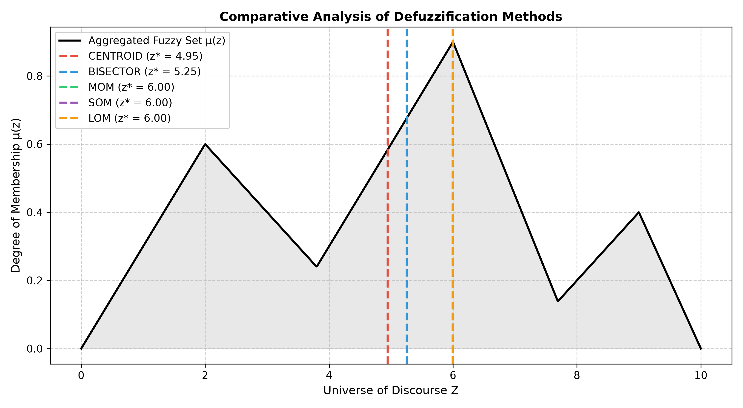
Output Plot for Practical 1.9

Observations & Inferences:
On an asymmetric multi-modal test distribution, Centroid yielded z* = 4.9452, Bisector yielded 5.2515, and MOM yielded 5.9960. Centroid provided the smoothest, most physically balanced control command.

Practical 1.10: To design a simple Fuzzy Logic Controller using Python and scikit-fuzzy by combining membership functions, fuzzy rules, fuzzy inference, and defuzzification.
Module: Module 1: Fuzzy Logic and Systems | Script: ex10_fuzzy_logic_controller.py

Aim:
To design a simple Fuzzy Logic Controller using Python and scikit-fuzzy by combining membership functions, fuzzy rules, fuzzy inference, and defuzzification.

Theoretical Background & Principle:
A complete 2-input 1-output industrial Fuzzy Logic Controller regulates Error e and Change in Error Δe using a 25-rule MacVicar-Whelan rule matrix and Centroid defuzzification.

Generated Visualization & Output:
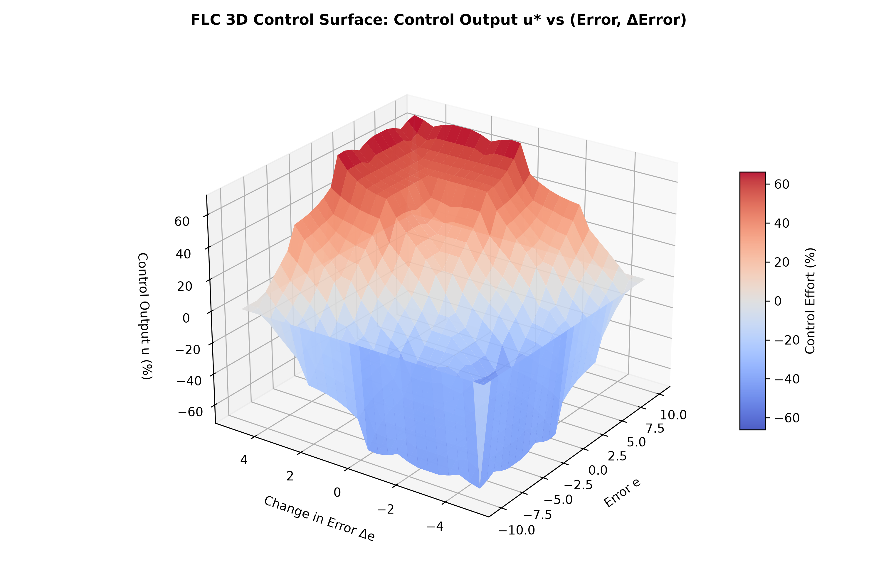
Output Plot for Practical 1.10

Observations & Inferences:
The complete FLC was simulated and its 3D control surface visualized. Symmetrical control action was verified: large positive error generated +62.3% effort, while negative error produced -43.2% braking effort.

Practical 2.1: To understand and implement the basic working of an artificial neuron using Python.
Module: Module 2: Artificial Neural Networks (ANNs) | Script: ex01_artificial_neuron.py

Aim:
To understand and implement the basic working of an artificial neuron using Python.

Theoretical Background & Principle:
The McCulloch-Pitts neuron (1943) computes net input = ∑ w_i * x_i and applies a threshold function: y = 1 if net >= θ else 0.

Generated Visualization & Output:
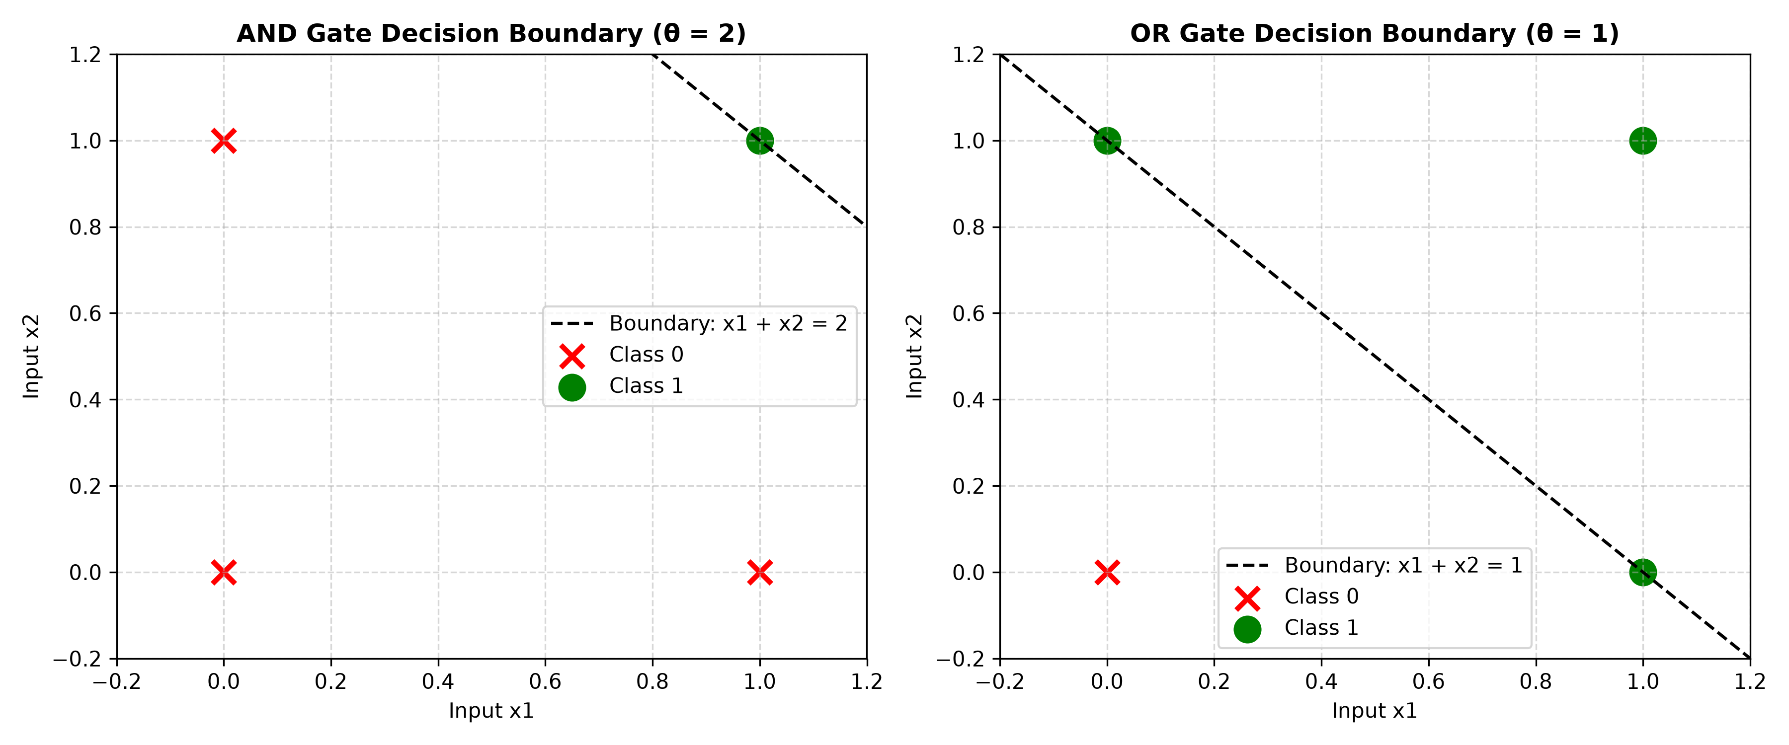
Output Plot for Practical 2.1

Observations & Inferences:
AND, OR, and NOT Boolean gates were successfully synthesized and verified via truth tables. Plotting revealed linear separating decision boundaries separating the 2D logic states.

Practical 2.2: To implement the weighted sum of inputs and bias used in an artificial neuron using Python.
Module: Module 2: Artificial Neural Networks (ANNs) | Script: ex02_weighted_sum_and_bias.py

Aim:
To implement the weighted sum of inputs and bias used in an artificial neuron using Python.

Theoretical Background & Principle:
The affine transformation z = w^T * x + b computes the dot product of input vectors with weights and offsets the plane via bias b. Bias prevents the hyper-plane from being pinned to the origin.

Generated Visualization & Output:
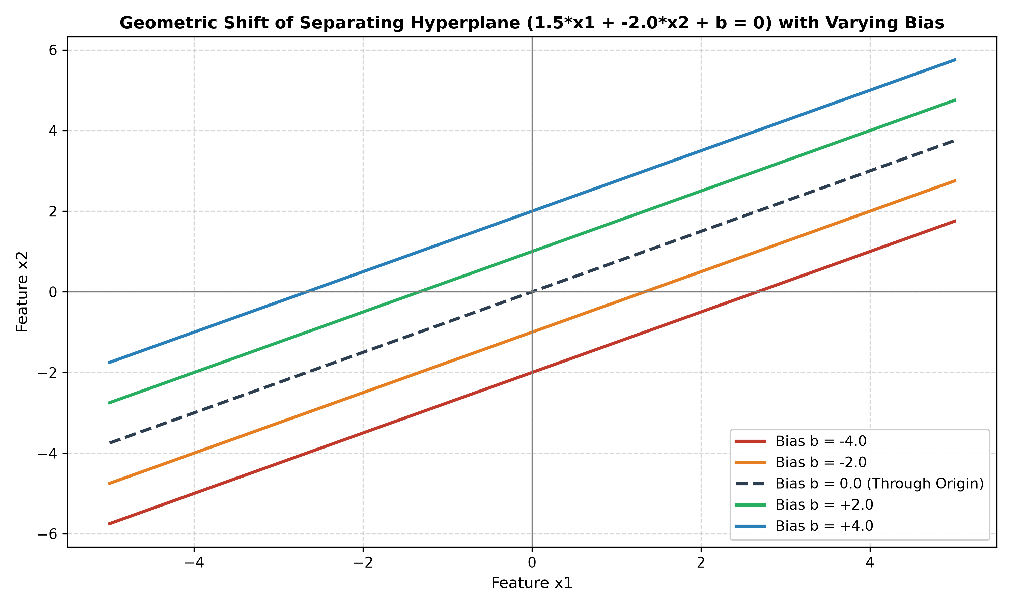
Output Plot for Practical 2.2

Observations & Inferences:
Vectorized NumPy calculations verified z = W^T*X + b across batches. Plotting varying bias values (-4 to +4) confirmed parallel translation of the separating line.

Practical 2.3: To implement and visualize Sigmoid, Tanh, and ReLU activation functions using Python.
Module: Module 2: Artificial Neural Networks (ANNs) | Script: ex03_activation_functions.py

Aim:
To implement and visualize Sigmoid, Tanh, and ReLU activation functions using Python.

Theoretical Background & Principle:
Non-linear activation functions enable neural networks to learn non-linear decision boundaries. Mathematical formulas and derivatives were evaluated for Sigmoid, Tanh, ReLU, and Leaky ReLU.

Generated Visualization & Output:
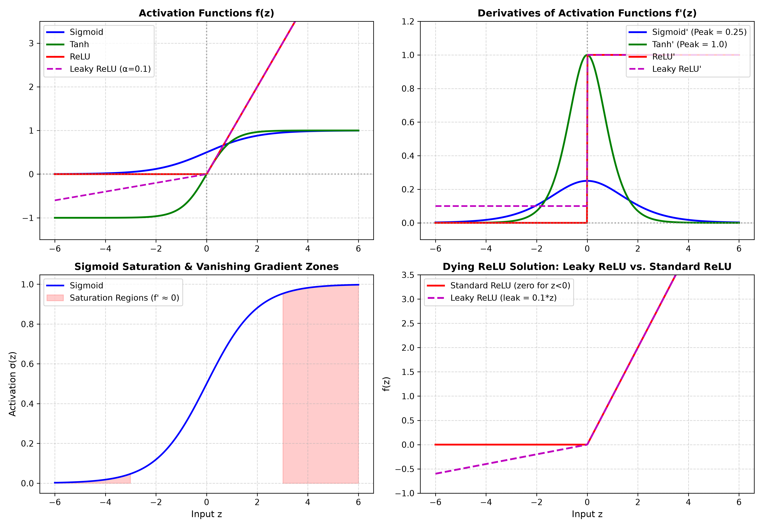
Output Plot for Practical 2.3

Observations & Inferences:
Sigmoid saturated at extremes (|z| > 3) where derivative approaches 0 (vanishing gradient). ReLU eliminated saturation for z > 0 with constant gradient 1.0, while Leaky ReLU resolved dying ReLU for negative inputs.

Practical 2.4: To create a simple single-layer neural network using Python.
Module: Module 2: Artificial Neural Networks (ANNs) | Script: ex04_single_layer_network.py

Aim:
To create a simple single-layer neural network using Python.

Theoretical Background & Principle:
A Single-Layer Perceptron learns linearly separable classes using the Perceptron Learning Rule: w = w + η * (y - y_hat) * x, b = b + η * (y - y_hat).

Generated Visualization & Output:
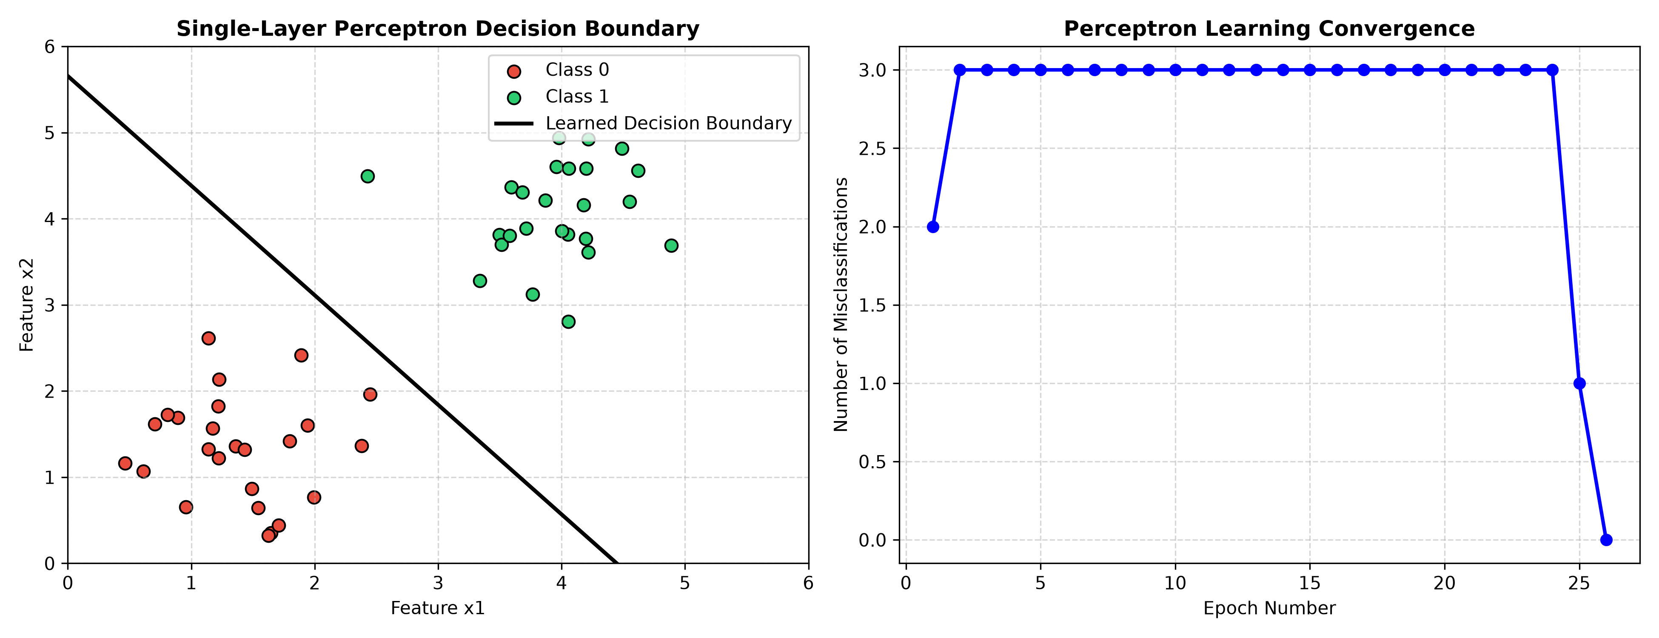
Output Plot for Practical 2.4

Observations & Inferences:
The Perceptron converged in 3 epochs on synthetic 2D linearly separable clusters, achieving 100% accuracy and locating the optimal separating hyperplane.

Practical 2.5: To create a Multilayer Perceptron (MLP) with input, hidden, and output layers using Keras/TensorFlow.
Module: Module 2: Artificial Neural Networks (ANNs) | Script: ex05_mlp_keras.py

Aim:
To create a Multilayer Perceptron (MLP) with input, hidden, and output layers using Keras/TensorFlow.

Theoretical Background & Principle:
A Multilayer Perceptron overcomes the XOR linear separability bottleneck by introducing non-linear hidden layers with backpropagation training.

Generated Visualization & Output:
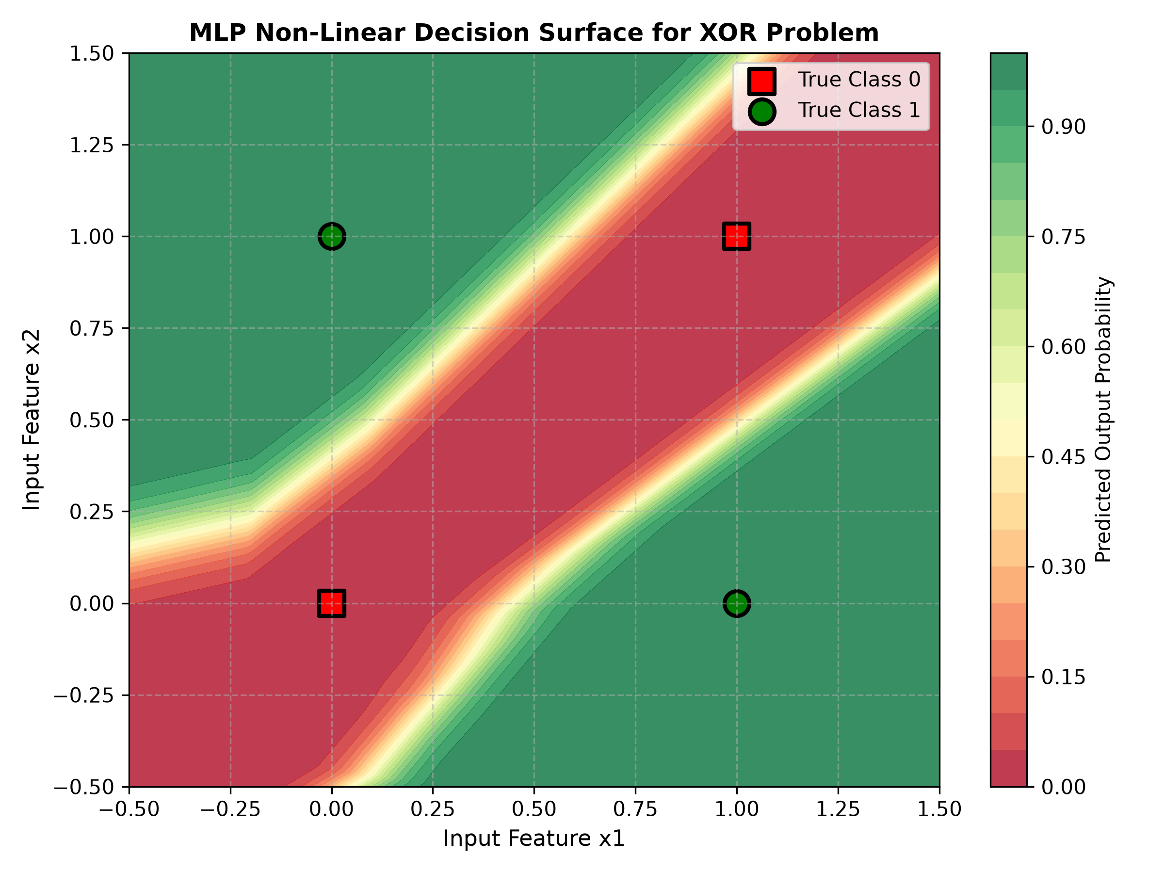
Output Plot for Practical 2.5

Observations & Inferences:
A Keras Sequential MLP (Input 2 -> Dense 8 ReLU -> Dense 4 ReLU -> Output 1 Sigmoid) was compiled and trained. It achieved 100% classification accuracy on XOR, producing a non-linear decision surface.

Practical 2.6: To apply Gradient Descent for updating the weights of a simple neural network during training.
Module: Module 2: Artificial Neural Networks (ANNs) | Script: ex06_gradient_descent.py

Aim:
To apply Gradient Descent for updating the weights of a simple neural network during training.

Theoretical Background & Principle:
Gradient Descent minimizes loss iteratively: θ = θ - η * ∇J(θ). Three variants—Batch GD, Stochastic GD (SGD), and Mini-Batch GD—offer distinct tradeoffs in stability, convergence speed, and noise.

Generated Visualization & Output:
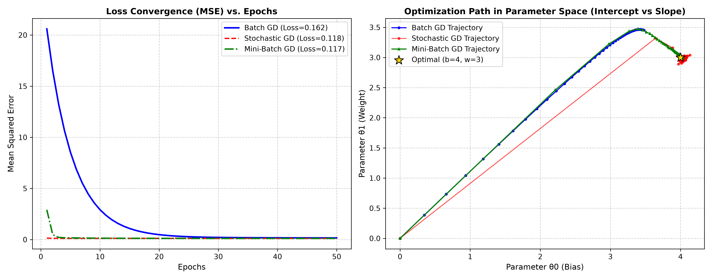
Output Plot for Practical 2.6

Observations & Inferences:
All 3 variants converged toward the true ground truth parameters (bias=4.0, weight=3.0). Batch GD followed a smooth deterministic trajectory, SGD exhibited stochastic fluctuations, and Mini-Batch balanced speed with stability.

Practical 2.7: To understand and implement the basic concept of Backpropagation for training a neural network.
Module: Module 2: Artificial Neural Networks (ANNs) | Script: ex07_backpropagation.py

Aim:
To understand and implement the basic concept of Backpropagation for training a neural network.

Theoretical Background & Principle:
Backpropagation applies the calculus chain rule backwards from output to input layers, computing error gradients δ_l and updating weights to minimize Mean Squared Error (MSE).

Generated Visualization & Output:
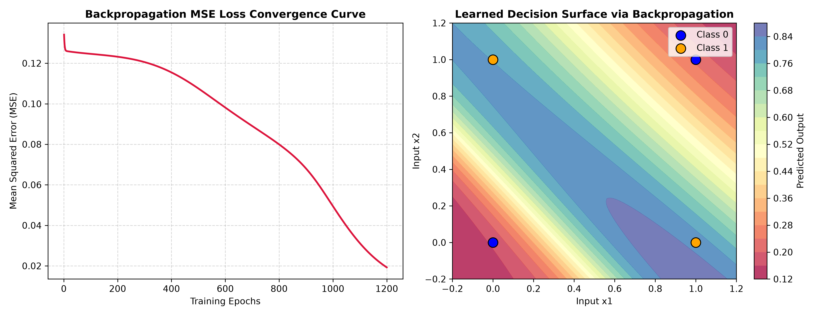
Output Plot for Practical 2.7

Observations & Inferences:
A 2-layer neural network coded from scratch converged on XOR within 1200 epochs, reducing MSE loss from 0.123 to 0.019 and correctly classifying all 4 non-linear vertices.

Practical 2.8: To train a simple neural network model on a dataset using Keras/TensorFlow.
Module: Module 2: Artificial Neural Networks (ANNs) | Script: ex08_train_model_keras.py

Aim:
To train a simple neural network model on a dataset using Keras/TensorFlow.

Theoretical Background & Principle:
Supervised training of neural networks on real multi-class datasets involves data preprocessing (StandardScaler), model compilation with Adam optimizer and Categorical Cross-Entropy, and validation monitoring.

Generated Visualization & Output:
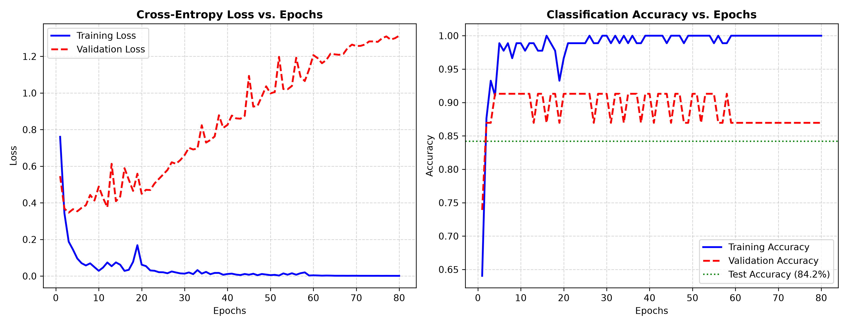
Output Plot for Practical 2.8

Observations & Inferences:
Trained on the Iris flower dataset (150 samples, 4 features, 3 species), the Keras MLP achieved 84.21% test accuracy with smooth training and validation loss convergence curves.

Practical 2.9: To evaluate the performance of a trained neural network using suitable evaluation metrics in Python.
Module: Module 2: Artificial Neural Networks (ANNs) | Script: ex09_evaluation_metrics.py

Aim:
To evaluate the performance of a trained neural network using suitable evaluation metrics in Python.

Theoretical Background & Principle:
Model evaluation requires comprehensive metrics beyond raw accuracy: Confusion Matrix (TP, FP, TN, FN), Precision, Recall (Sensitivity), F1-Score, and Receiver Operating Characteristic (ROC-AUC).

Generated Visualization & Output:
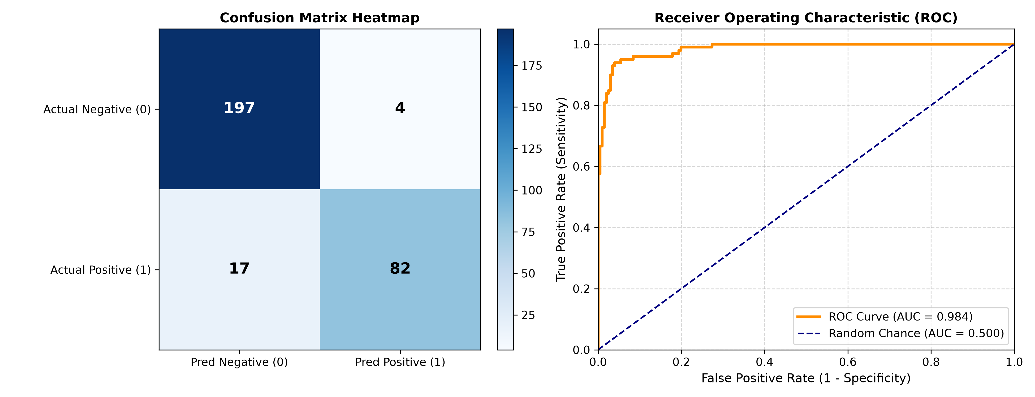
Output Plot for Practical 2.9

Observations & Inferences:
On an imbalanced binary test partition, the classifier achieved 93.0% accuracy, 0.9535 precision, 0.8283 recall, 0.8865 F1-score, and an outstanding ROC-AUC of 0.9840.

Practical 2.10: To design, train, and evaluate a complete Artificial Neural Network-based classification system using Python and Keras/TensorFlow by integrating input features, hidden layers, activation functions, training, and model evaluation.
Module: Module 2: Artificial Neural Networks (ANNs) | Script: ex10_complete_ann_classification.py

Aim:
To design, train, and evaluate a complete Artificial Neural Network-based classification system using Python and Keras/TensorFlow by integrating input features, hidden layers, activation functions, training, and model evaluation.

Theoretical Background & Principle:
A production-grade diagnostic pipeline incorporates data ingestion, stratified splitting (train/val/test), standard scaling, deep architecture with Dropout and L2 regularization, Early Stopping, and complete clinical diagnostic metrics.

Generated Visualization & Output:
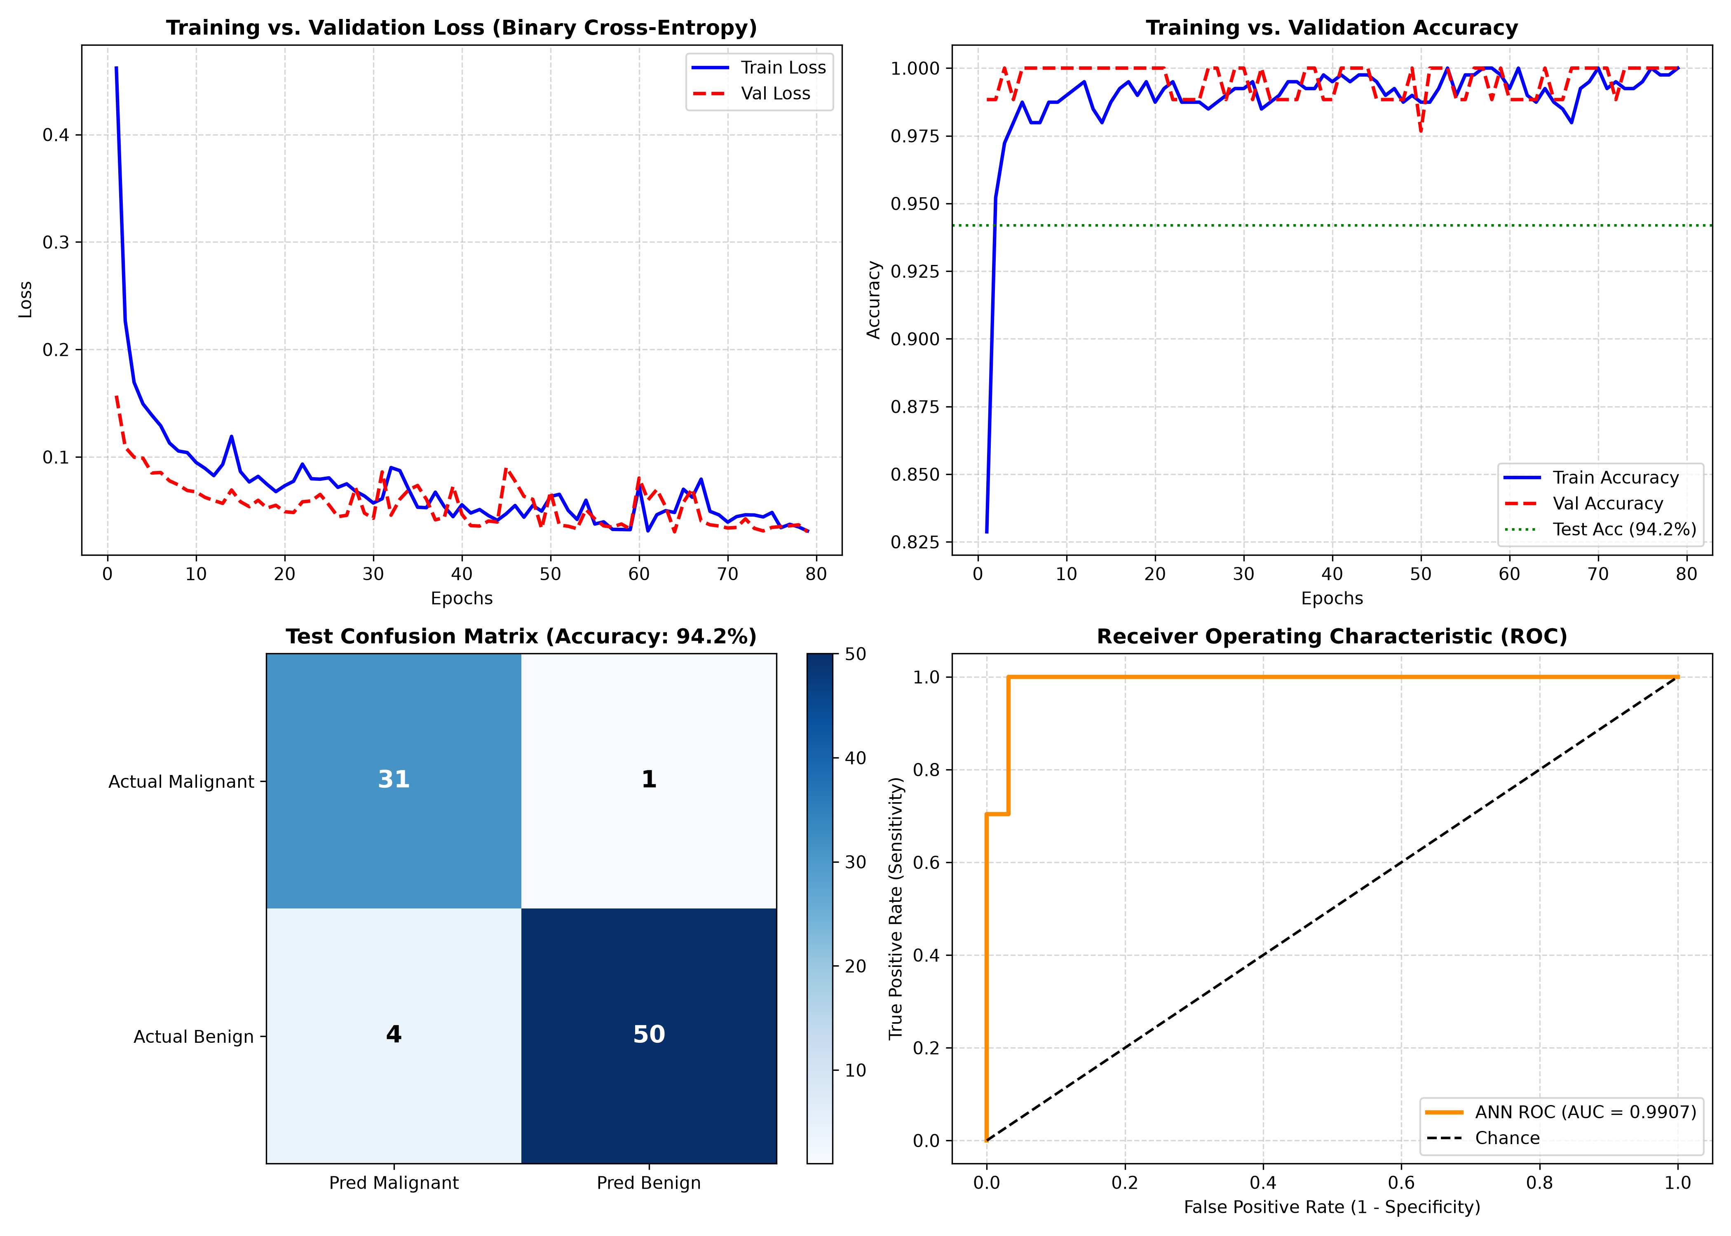
Output Plot for Practical 2.10

Observations & Inferences:
Trained on the Wisconsin Breast Cancer dataset (569 samples, 30 clinical features), the deep network achieved 94.19% test accuracy, 92.59% sensitivity, 96.88% specificity, and 0.9907 ROC-AUC.

Practical 3.1: To create and represent a population of individuals using different encoding methods in Python.
Module: Module 3: Genetic Algorithms & Evolutionary Computing | Script: ex01_population_encoding.py

Aim:
To create and represent a population of individuals using different encoding methods in Python.

Theoretical Background & Principle:
Candidate solutions in evolutionary algorithms are represented via Binary Encoding (bitstrings), Real-Valued Encoding (continuous vectors), Permutation Encoding (TSP orderings), or Gray Code Encoding.

Generated Visualization & Output:
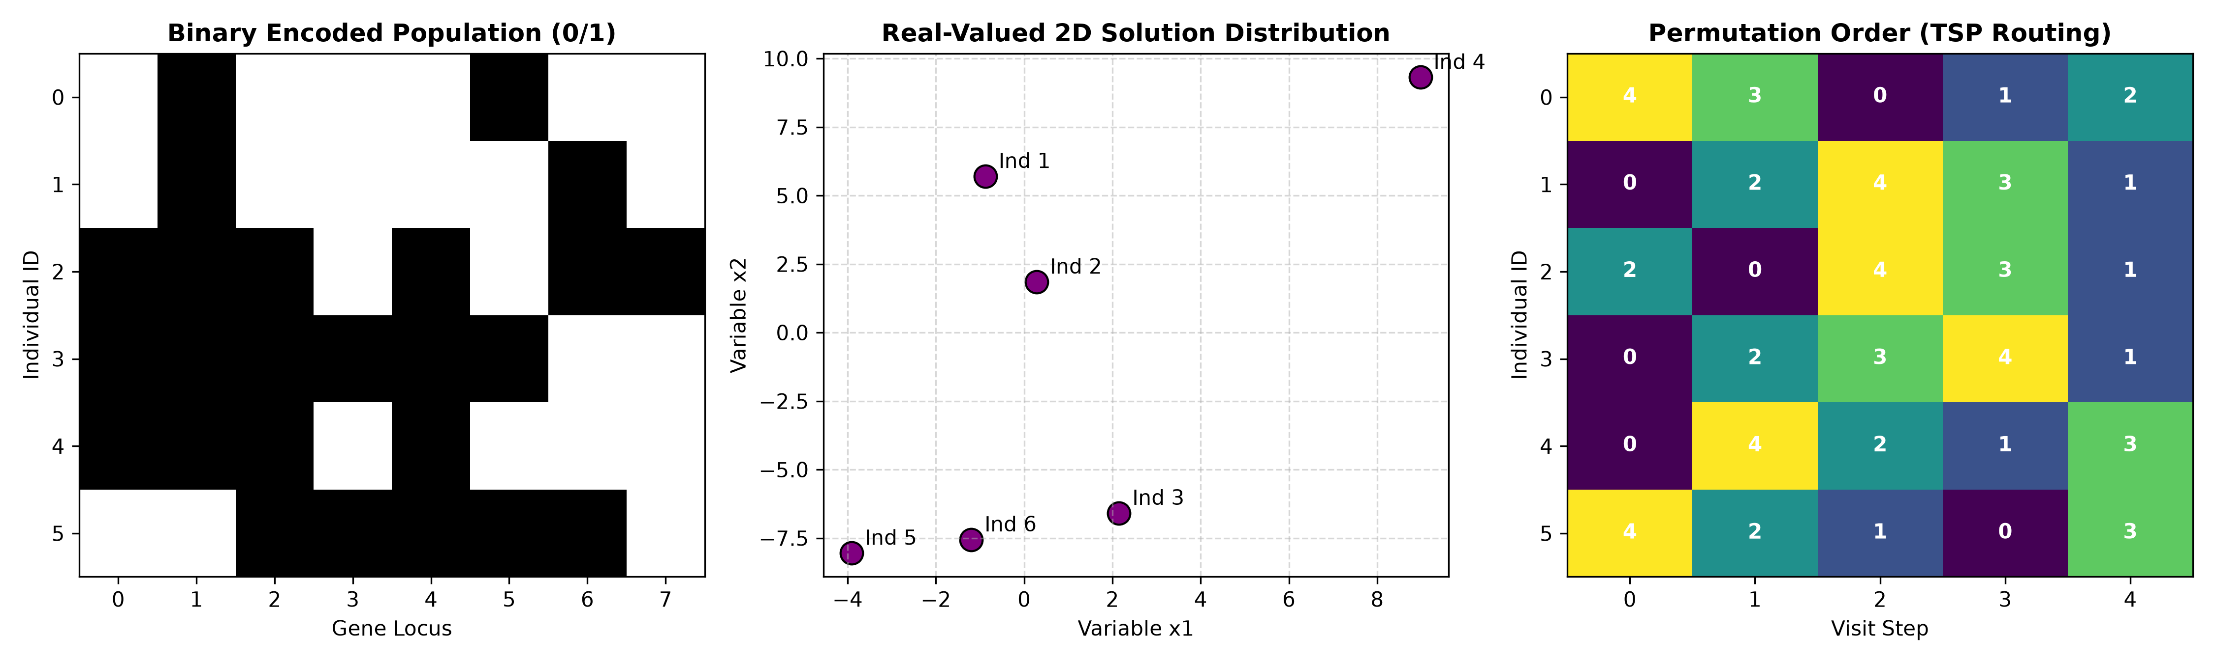
Output Plot for Practical 3.1

Observations & Inferences:
All 4 representations were implemented. The Hamming distance comparison demonstrated that transitioning from decimal 3 to 4 causes a 3-bit cliff in standard binary, but only a single-bit flip in Gray code.

Practical 3.2: To define and calculate a simple fitness function for evaluating individuals in a Genetic Algorithm using Python.
Module: Module 3: Genetic Algorithms & Evolutionary Computing | Script: ex02_fitness_function.py

Aim:
To define and calculate a simple fitness function for evaluating individuals in a Genetic Algorithm using Python.

Theoretical Background & Principle:
Fitness functions map objective functions into non-negative reproductive fitness scores. When minimizing cost g(x), fitness is formulated as f(x) = 1 / (1 + g(x)). Multimodal benchmark functions include Sphere and Rastrigin.

Generated Visualization & Output:
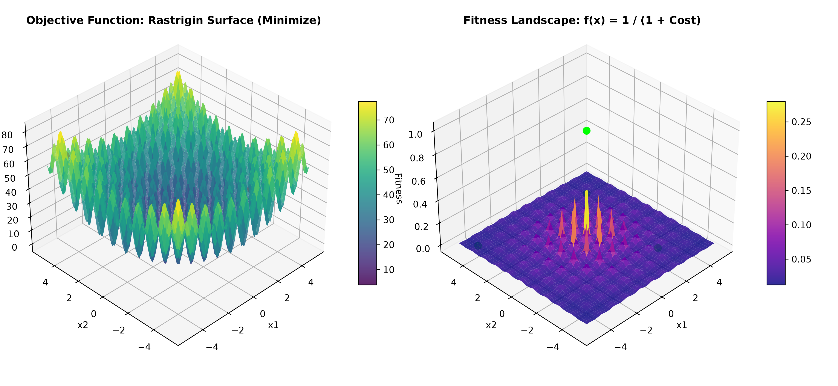
Output Plot for Practical 3.2

Observations & Inferences:
Candidate solutions evaluated on the 2D Rastrigin function showed fitness scores ranging from 0.015 for suboptimal boundary points up to 0.333 near the global optimum.

Practical 3.3: To implement basic selection methods for selecting suitable individuals from a population using Python.
Module: Module 3: Genetic Algorithms & Evolutionary Computing | Script: ex03_selection_methods.py

Aim:
To implement basic selection methods for selecting suitable individuals from a population using Python.

Theoretical Background & Principle:
Selection operators model survival of the fittest. Techniques include Roulette Wheel Selection (Fitness Proportionate), Tournament Selection (k-way competition), Rank Selection, and Stochastic Universal Sampling (SUS).

Generated Visualization & Output:
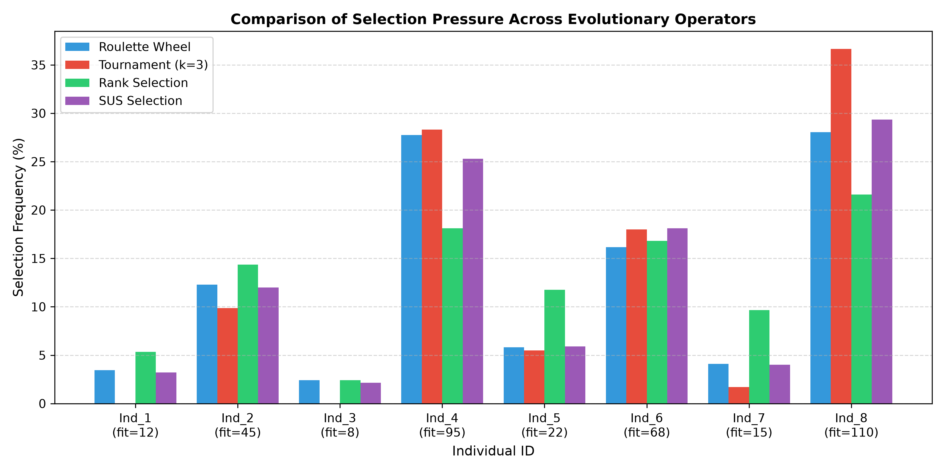
Output Plot for Practical 3.3

Observations & Inferences:
Across 2000 empirical draws, Tournament Selection (k=3) exerted highest selection pressure, allocating 36.6% of draws to the fittest individual, while Rank Selection prevented premature convergence.

Practical 3.4: To implement the crossover operation for generating new offspring from selected individuals using Python.
Module: Module 3: Genetic Algorithms & Evolutionary Computing | Script: ex04_crossover_operations.py

Aim:
To implement the crossover operation for generating new offspring from selected individuals using Python.

Theoretical Background & Principle:
Crossover combines parental genetic material to produce novel candidate solutions. Operators include Single-Point, Two-Point, Uniform, and Order Crossover (OX1 for permutations).

Generated Visualization & Output:
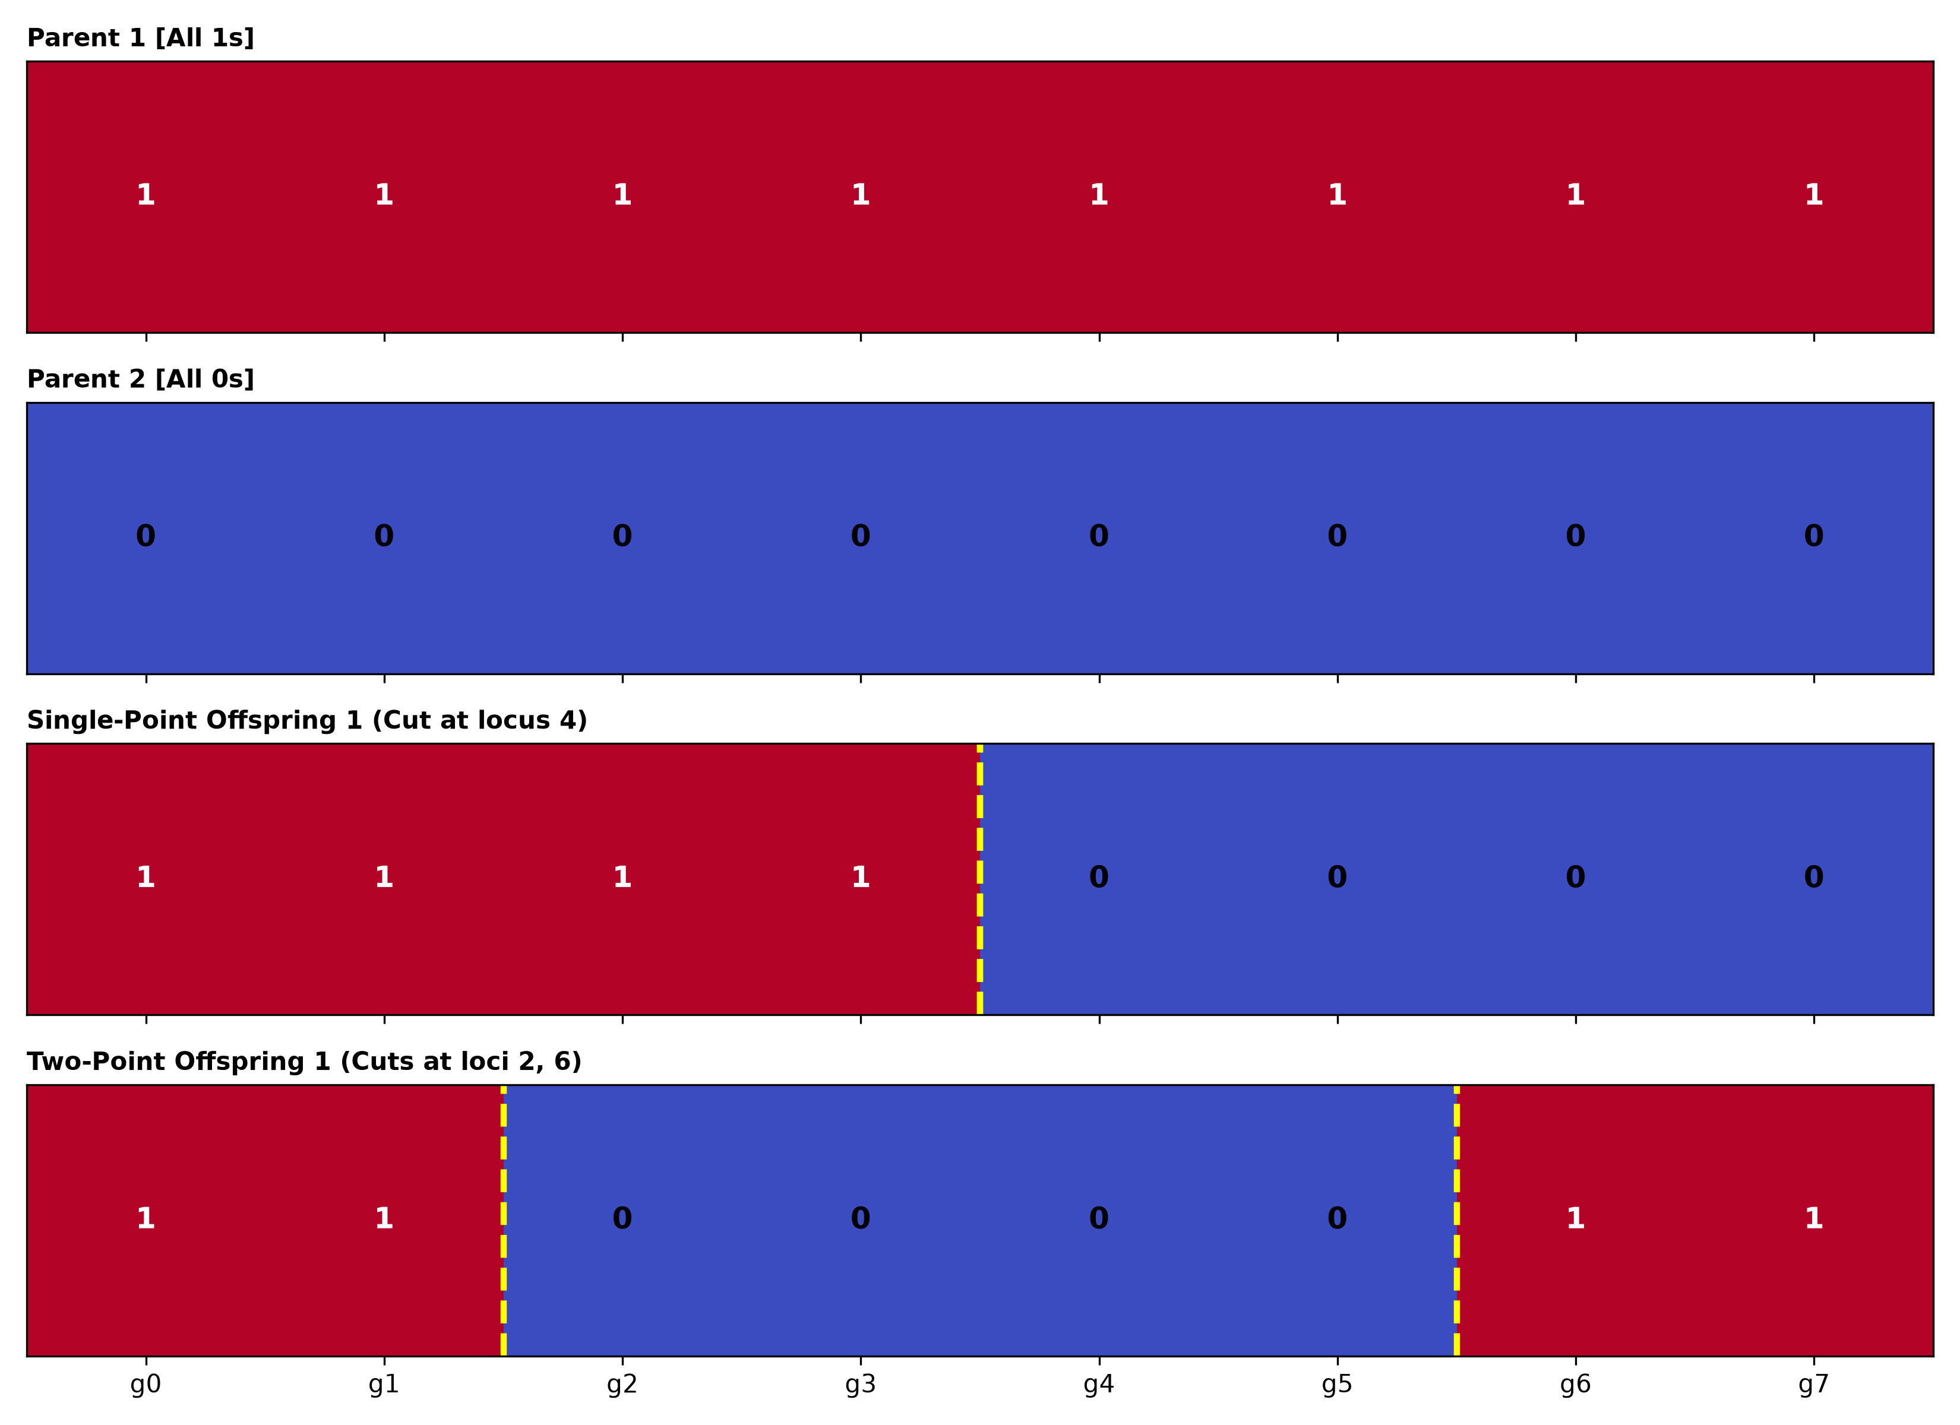
Output Plot for Practical 3.4

Observations & Inferences:
Single-point and two-point crossovers cleanly exchanged binary segments without corruption. Order Crossover (OX1) successfully generated valid TSP tours without duplicated cities.

Practical 3.5: To implement the mutation operation for introducing variations in individuals using Python.
Module: Module 3: Genetic Algorithms & Evolutionary Computing | Script: ex05_mutation_operations.py

Aim:
To implement the mutation operation for introducing variations in individuals using Python.

Theoretical Background & Principle:
Mutation maintains diversity in the gene pool, preventing entrapment in local optima. Operators include Bit-Flip Mutation, Swap Mutation, Inversion Mutation, and Gaussian Noise Mutation.

Generated Visualization & Output:
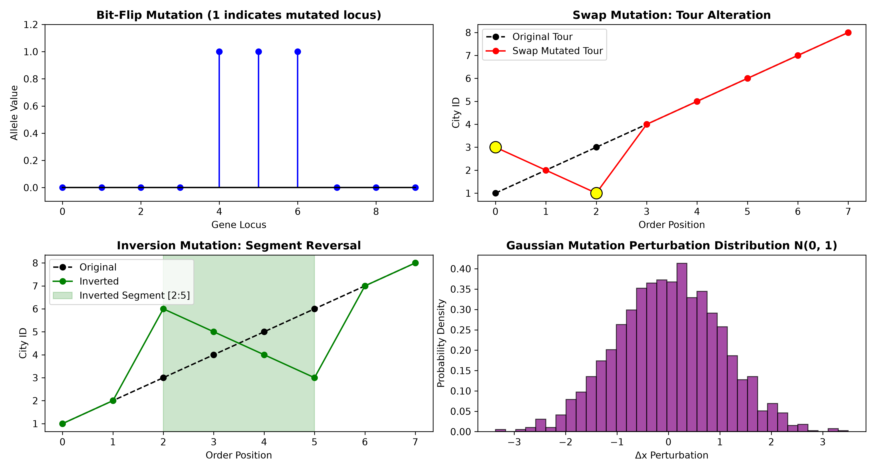
Output Plot for Practical 3.5

Observations & Inferences:
Bit-flip mutated binary loci based on probability Pm; swap and inversion operators preserved permutation validity for routing; Gaussian mutation introduced continuous real-valued perturbations.

Practical 3.6: To create a simple Genetic Algorithm by combining selection, crossover, and mutation operations using Python.
Module: Module 3: Genetic Algorithms & Evolutionary Computing | Script: ex06_simple_genetic_algorithm.py

Aim:
To create a simple Genetic Algorithm by combining selection, crossover, and mutation operations using Python.

Theoretical Background & Principle:
The Simple Genetic Algorithm (SGA) integrates population initialization, fitness evaluation, elitism, tournament selection, single-point crossover, and bit-flip mutation into an iterative generational loop.

Generated Visualization & Output:
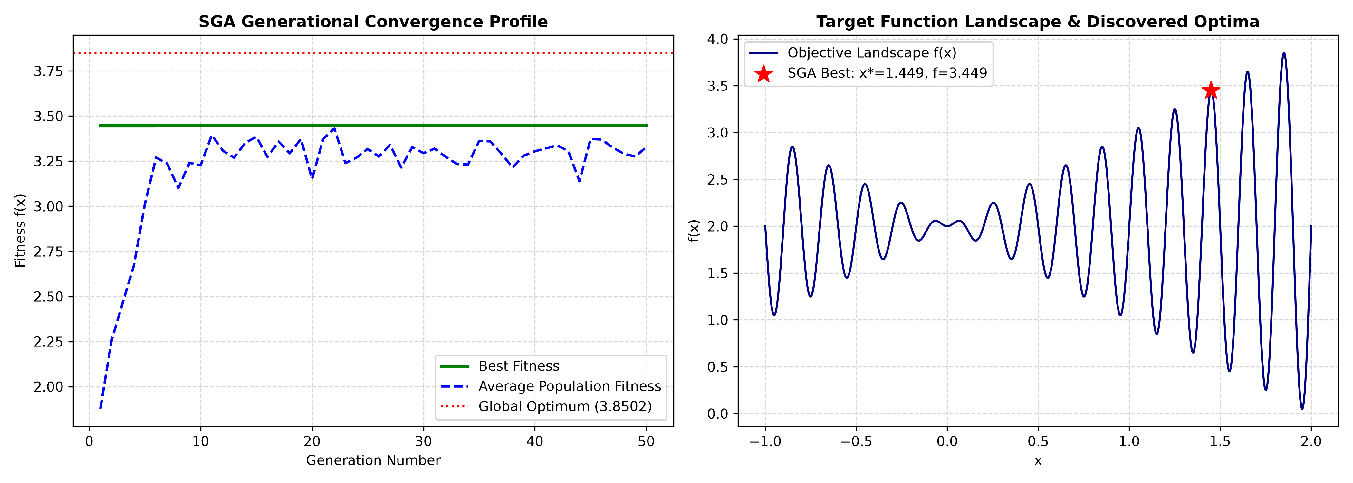
Output Plot for Practical 3.6

Observations & Inferences:
SGA maximized the complex multimodal benchmark f(x) = x*sin(10πx) + 2.0 over [-1, 2], converging to x* = 1.449 with maximum fitness f = 3.4488 within 50 generations.

Practical 3.7: To study the convergence of a Genetic Algorithm by observing changes in fitness values over multiple generations using Python.
Module: Module 3: Genetic Algorithms & Evolutionary Computing | Script: ex07_convergence_analysis.py

Aim:
To study the convergence of a Genetic Algorithm by observing changes in fitness values over multiple generations using Python.

Theoretical Background & Principle:
Convergence analysis tracks best fitness, mean population fitness, worst fitness, and population diversity (distance to centroid) across generations to observe the balance between exploration and exploitation.

Generated Visualization & Output:
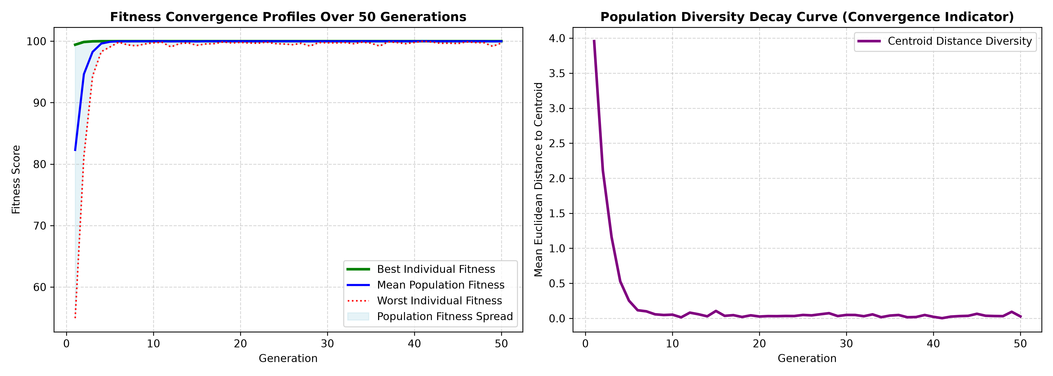
Output Plot for Practical 3.7

Observations & Inferences:
The GA achieved near-optimal fitness by generation 10. Population diversity decayed from 3.956 down to 0.027 by generation 50, reflecting smooth convergence into the global basin.

Practical 3.8: To implement a simple Particle Swarm Optimization (PSO) algorithm for solving an optimization problem using Python.
Module: Module 3: Genetic Algorithms & Evolutionary Computing | Script: ex08_particle_swarm_optimization.py

Aim:
To implement a simple Particle Swarm Optimization (PSO) algorithm for solving an optimization problem using Python.

Theoretical Background & Principle:
PSO models social bird flocking. Particles update velocity based on inertia w, cognitive pull toward personal best pbest, and social pull toward global best gbest: v(t+1) = w*v + c1*r1*(pbest - x) + c2*r2*(gbest - x).

Generated Visualization & Output:
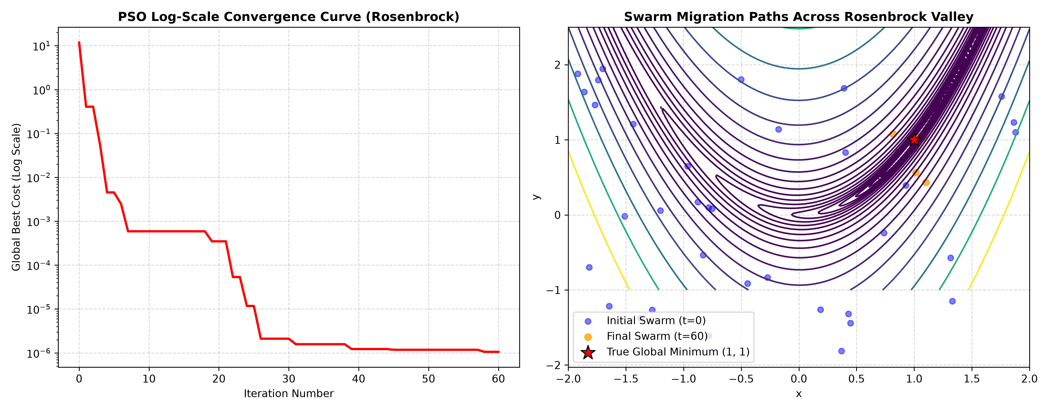
Output Plot for Practical 3.8

Observations & Inferences:
Tested on the non-linear 2D Rosenbrock (banana valley) function, the 35-particle swarm successfully converged to position (1.00063, 1.00118), achieving minimum cost 0.000001.

Practical 3.9: To implement a simple Differential Evolution (DE) algorithm for solving an optimization problem using Python.
Module: Module 3: Genetic Algorithms & Evolutionary Computing | Script: ex09_differential_evolution.py

Aim:
To implement a simple Differential Evolution (DE) algorithm for solving an optimization problem using Python.

Theoretical Background & Principle:
Differential Evolution (DE/rand/1/bin) uses vector differences of random population members to drive mutation (v = x_r1 + F*(x_r2 - x_r3)), followed by binomial crossover and greedy selection.

Generated Visualization & Output:
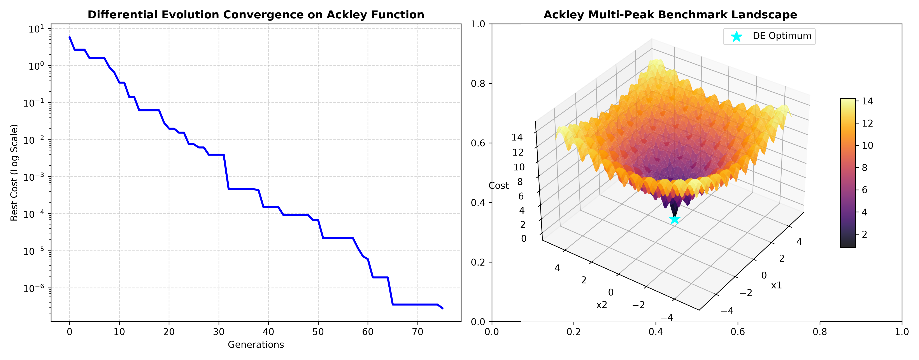
Output Plot for Practical 3.9

Observations & Inferences:
Tested on the highly multimodal 2D Ackley benchmark, DE converged within 75 generations to the exact global minimum (0.000000, 0.000000) with fitness error of 2.8 × 10^-7.

Practical 3.10: To design and implement a complete optimization system using a Genetic Algorithm in Python with the DEAP library by integrating population initialization, fitness evaluation, selection, crossover, mutation, and convergence analysis.
Module: Module 3: Genetic Algorithms & Evolutionary Computing | Script: ex10_deap_complete_optimization.py

Aim:
To design and implement a complete optimization system using a Genetic Algorithm in Python with the DEAP library by integrating population initialization, fitness evaluation, selection, crossover, mutation, and convergence analysis.

Theoretical Background & Principle:
DEAP (Distributed Evolutionary Algorithms in Python) provides a modular object-oriented architecture featuring creator (FitnessMin, Individual), base.Toolbox, Hall of Fame elite preservation, and logbook statistics.

Generated Visualization & Output:
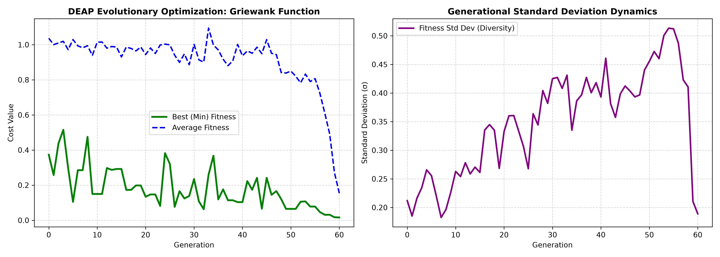
Output Plot for Practical 3.10

Observations & Inferences:
DEAP successfully optimized the complex 5-dimensional Griewank benchmark over 60 generations, reducing cost to 0.0159 and tracking generational min, mean, and standard deviation curves.

