NAME – SINDHU SINGH   
 ROLL NUM - 20CS8066   
 EMBEDDED SYSTEMS ASSIGNMENT – 8

----------------------------------------------------***************-------------------------------------------------

Q.

CODE -   
// Real time clock and calendar with set buttons using DS1307 and Arduino

// include LCD library code   
#include <LiquidCrystal.h>   
// include Wire library code (needed for I2C protocol devices) #include <Wire.h>

// LCD module connections (RS, E, D4, D5, D6, D7)   
LiquidCrystal lcd(7, 6, 5, 4, 3, 2);

void setup() {   
 pinMode(8, INPUT_PULLUP); // button1 is connected to pin 8 pinMode(9, INPUT_PULLUP); // button2 is connected to pin 9 // set up the LCD's number of columns and rows   
 lcd.begin(16, 2);   
 Wire.begin(); // Join i2c bus   
}

char Time[] = "TIME: : : ";   
char Calendar[] = "DATE: / /20 ";   
byte i, second, minute, hour, date, month, year;

void DS1307_display(){

// Convert BCD to decimal   
 second = (second >> 4) * 10 + (second & 0x0F);   
 minute = (minute >> 4) * 10 + (minute & 0x0F);   
 hour = (hour >> 4) * 10 + (hour & 0x0F);   
 date = (date >> 4) * 10 + (date & 0x0F);   
 month = (month >> 4) * 10 + (month & 0x0F);   
 year = (year >> 4) * 10 + (year & 0x0F);   
 // End conversion   
 Time[12] = second % 10 + 48;   
 Time[11] = second / 10 + 48;   
 Time[9] = minute % 10 + 48;   
 Time[8] = minute / 10 + 48;   
 Time[6] = hour % 10 + 48;   
 Time[5] = hour / 10 + 48;   
 Calendar[14] = year % 10 + 48;   
 Calendar[13] = year / 10 + 48;   
 Calendar[9] = month % 10 + 48;   
 Calendar[8] = month / 10 + 48;   
 Calendar[6] = date % 10 + 48;   
 Calendar[5] = date / 10 + 48;   
 lcd.setCursor(0, 0);   
 lcd.print(Time); // Display time   
 lcd.setCursor(0, 1);   
 lcd.print(Calendar); // Display calendar }   
void blink_parameter(){   
 byte j = 0;   
 while(j < 10 && digitalRead(8) && digitalRead(9)){ j++;   
 delay(25);   
 }

}

byte edit(byte x, byte y, byte parameter){   
 char text[3];   
 while(!digitalRead(8)); // Wait until button (pin #8) released while(true){   
 while(!digitalRead(9)){ // If button (pin #9) is pressed parameter++;   
 if(i == 0 && parameter > 23) // If hours > 23 ==> hours = 0 parameter = 0;   
 if(i == 1 && parameter > 59) // If minutes > 59 ==> minutes = 0 parameter = 0;   
 if(i == 2 && parameter > 31) // If date > 31 ==> date = 1 parameter = 1;   
 if(i == 3 && parameter > 12) // If month > 12 ==> month = 1 parameter = 1;   
 if(i == 4 && parameter > 99) // If year > 99 ==> year = 0   
 parameter = 0;   
 sprintf(text,"%02u", parameter);   
 lcd.setCursor(x, y);   
 lcd.print(text);   
 delay(200); // Wait 200ms   
 }   
 lcd.setCursor(x, y);   
 lcd.print(" "); // Display two spaces   
 blink_parameter();   
 sprintf(text,"%02u", parameter);   
 lcd.setCursor(x, y);   
 lcd.print(text);   
 blink_parameter();   
 if(!digitalRead(8)){ // If button (pin #8) is pressed

i++; // Increament 'i' for the next parameter return parameter; // Return parameter value and exit }   
 }   
}

void loop() {   
 if(!digitalRead(8)){ // If button (pin #8) is pressed   
 i = 0;   
 hour = edit(5, 0, hour);   
 minute = edit(8, 0, minute);   
 date = edit(5, 1, date);   
 month = edit(8, 1, month);   
 year = edit(13, 1, year);   
 // Convert decimal to BCD   
 minute = ((minute / 10) << 4) + (minute % 10);   
 hour = ((hour / 10) << 4) + (hour % 10);   
 date = ((date / 10) << 4) + (date % 10);   
 month = ((month / 10) << 4) + (month % 10);   
 year = ((year / 10) << 4) + (year % 10);   
 // End conversion   
 // Write data to DS1307 RTC   
 Wire.beginTransmission(0x68); // Start I2C protocol with DS1307 address Wire.write(0); // Send register address   
 Wire.write(0); // Reset sesonds and start oscillator   
 Wire.write(minute); // Write minute   
 Wire.write(hour); // Write hour   
 Wire.write(1); // Write day (not used)   
 Wire.write(date); // Write date   
 Wire.write(month); // Write month   
 Wire.write(year); // Write year

Wire.endTransmission(); // Stop transmission and release the I2C bus   
 delay(200); // Wait 200ms   
 }   
 Wire.beginTransmission(0x68); // Start I2C protocol with DS1307 address   
 Wire.write(0); // Send register address   
 Wire.endTransmission(false); // I2C restart   
 Wire.requestFrom(0x68, 7); // Request 7 bytes from DS1307 and release I2C bus at end of reading   
 second = Wire.read(); // Read seconds from register 0   
 minute = Wire.read(); // Read minuts from register 1   
 hour = Wire.read(); // Read hour from register 2   
 Wire.read(); // Read day from register 3 (not used)   
 date = Wire.read(); // Read date from register 4   
 month = Wire.read(); // Read month from register 5   
 year = Wire.read(); // Read year from register 6   
 DS1307_display(); // Diaplay time & calendar   
 delay(50); // Wait 50ms   
}

BEFORE RUNNING –

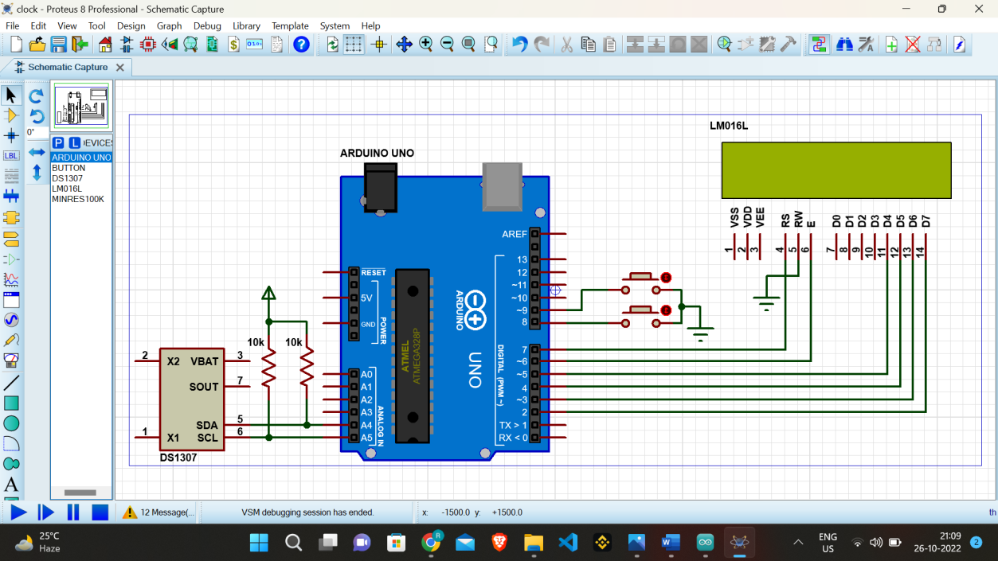

AFTER RUNNING -

