1.Topics -

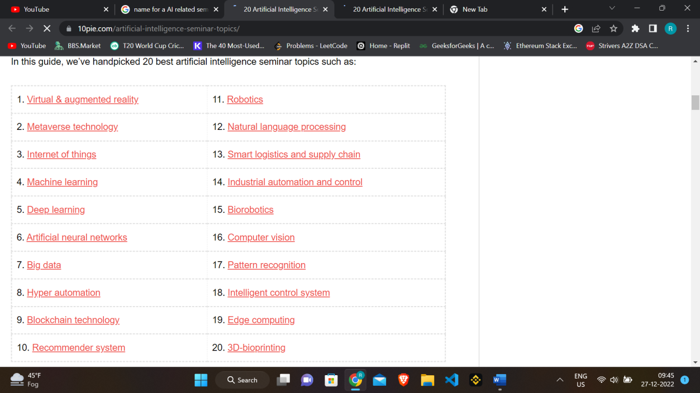

2.Name of the event - Artificial Brilliance/ Brain Bossing

3.Budget – Include cost of posters – 1k, Cost of Refreshment for Guests speaker and Professors = 5X100 = 500 (no water or drinks for students)

4.No charge from student to attend it (A free seminar on AI and ML)

5.No. of posters 50(copies of A2)X10 + 2X100(Big banner of seminar with name and design)

|  |  |
| --- | --- |
| 6. |  |

7.Seeting is limited register now - link or registration 8.Venue - NAB auditorium

9.