initial_centroids =

|  |  |  |  |  |  |  |
| --- | --- | --- | --- | --- | --- | --- |
|  | Angles | | | | | |
| Centeroid 1 | 109 | 109 | 109 | 109 | 109 | 109 |
| Centeroid 2 | 114 | 112 | 110 | 108 | 106 | 104 |
| Centeroid 3 | 125 | 117 | 110 | 105 | 100 | 91 |
| Centeroid 4 | 130 | 127 | 122 | 119 | 80 | 78 |
| Centeroid 5 | 140 | 125 | 108 | 97 | 90 | 84 |
| Centeroid 6 | 180 | 180 | 95 | 95 | 84 | 84 |

K-Means iteration 20/20...

Centroids computed:

|  |  |  |  |  |  |  |  |  |  |  |  |  |  |  |  |  |  |  |
| --- | --- | --- | --- | --- | --- | --- | --- | --- | --- | --- | --- | --- | --- | --- | --- | --- | --- | --- |
|  | | Angles | | | | | | | | | | | | | | | | |
| Centeroid 1 | | 111.9725 | | | | 110.9385 | | 110.0617 | | | 108.9301 | | | 107.9793 | | | 106.8236 | |
| Centeroid 2 | | 118.3287 | | | | 113.9581 | | 110.7006 | | | 107.855 | | | 104.0872 | | | 100.7631 | |
| Centeroid 3 | | 126.7267 | | | | 117.7953 | | 111.9454 | | | 105.2724 | | | 100.2076 | | | 89.7849 | |
| Centeroid 4 | | 130.0432 | | | | 127.4767 | | 122.3971 | | | 119.5705 | | | 80.43576 | | | 78.09767 | |
| Centeroid 5 | | 141.3169 | | | | 125.6578 | | 108.2575 | | | 97.79234 | | | 90.16783 | | | 84.41057 | |
| Centeroid 6 | | 175.0231 | | | | 174.7469 | | 94.46475 | | | 94.46433 | | | 84.6895 | | | 84.6895 | |
|  |  | |  |  | | | | |  | | | |  | | |
| Trial 3  initial_centroids= |  | |  |  | | | | |  | | | |  | | |
|  | | Angles | | | | | | | | | | | | | | | |
| Centeroid 1 | | 109 | | | 109 | | 109 | | | 109 | | 109 | | | 109 | | |
| Centeroid 2 | | 111 | | | 110 | | 110 | | | 108 | | 107 | | | 106 | | |
| Centeroid 3 | | 114 | | | 112 | | 110 | | | 108 | | 106 | | | 104 | | |
| Centeroid 4 | | 125 | | | 117 | | 110 | | | 105 | | 100 | | | 91 | | |
| Centeroid 5 | | 130 | | | 127 | | 122 | | | 119 | | 80 | | | 78 | | |
| Centeroid 6 | | 140 | | | 125 | | 108 | | | 97 | | 90 | | | 84 | | |
| Centeroid 7 | | 180 | | | 180 | | 95 | | | 95 | | 84 | | | 84 | | |

K-Means iteration 20/20...

Centroids computed:

|  |  |  |  |  |  |  |
| --- | --- | --- | --- | --- | --- | --- |
|  | Angles | | | | | |
| Centeroid 1 | 111.3718 | 110.525 | 109.8436 | 108.9407 | 108.4131 | 107.6672 |
| Centeroid 2 | 115.9011 | 113.0798 | 111.1586 | 108.6409 | 105.1474 | 102.1838 |
| Centeroid 3 | 122.9644 | 115.3228 | 109.71 | 106.1903 | 102.2625 | 98.15846 |
| Centeroid 4 | 127.1672 | 118.5848 | 112.3893 | 105.0889 | 99.91585 | 87.7598 |
| Centeroid 5 | 130.0036 | 127.5921 | 122.5037 | 119.6599 | 80.20241 | 78.21841 |
| Centeroid 6 | 142.0354 | 125.8163 | 108.3159 | 97.62539 | 89.71665 | 84.45269 |
| Centeroid 7 | 175.0231 | 174.7469 | 94.46475 | 94.46433 | 84.6895 | 84.6895 |

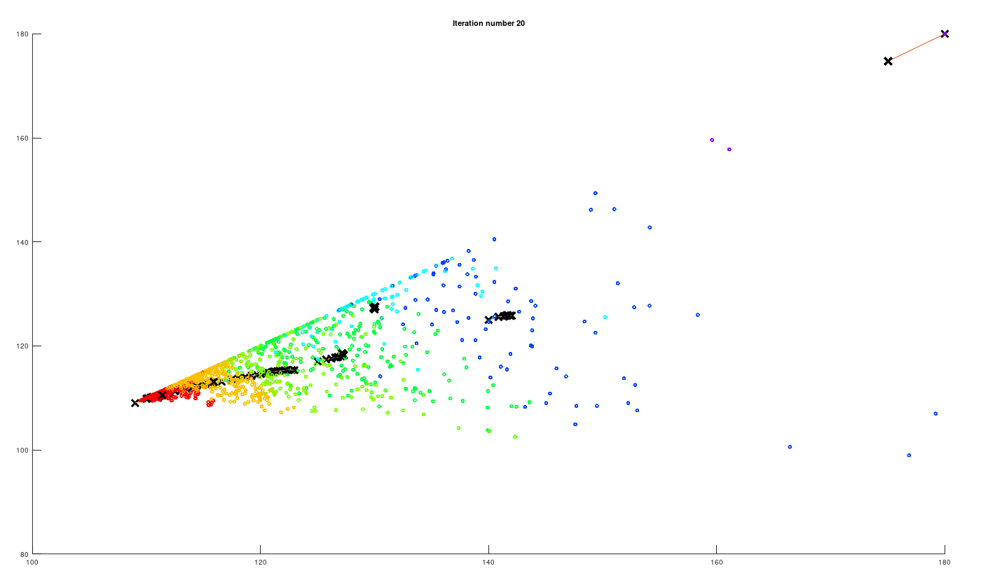

K-Means iteration 100/100...

Centroids computed:

|  |  |  |  |  |  |  |
| --- | --- | --- | --- | --- | --- | --- |
|  | Angles | | | | | |
| Centeroid 1 | 112.0479 | 110.9622 | 110.0599 | 108.8932 | 107.939 | 106.7924 |
| Centeroid 2 | 118.2344 | 114.1345 | 110.8867 | 107.961 | 103.9702 | 100.4176 |
| Centeroid 3 | 135.1816 | 112.8542 | 106.6332 | 103.016 | 99.74602 | 94.26274 |
| Centeroid 4 | 125.0482 | 120.2361 | 113.5775 | 105.7109 | 99.11301 | 87.26902 |
| Centeroid 5 | 130.7208 | 128.4061 | 123.3879 | 121.2866 | 79.03716 | 77.30463 |
| Centeroid 6 | 141.6693 | 128.9152 | 109.4667 | 96.94875 | 87.97268 | 82.52417 |
| Centeroid 7 | 175.0231 | 174.7469 | 94.46475 | 94.46433 | 84.6895 | 84.6895 |

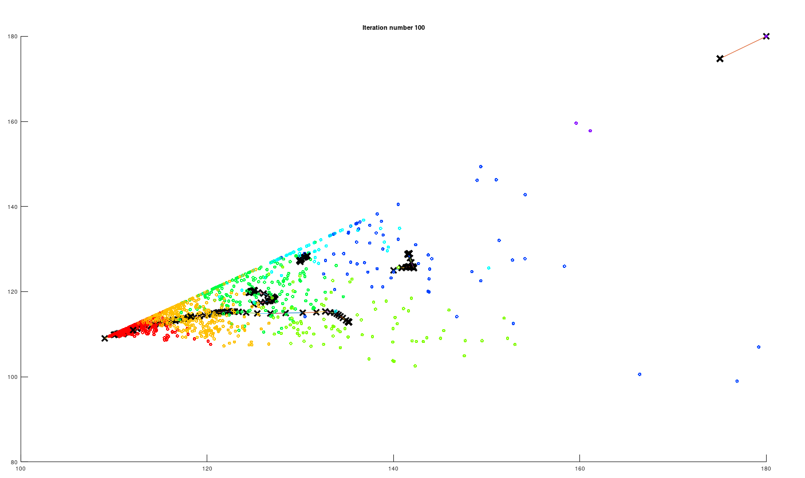

Trial 4: 8 Centeroid

initial_centroids=

|  |  |  |  |  |  |  |
| --- | --- | --- | --- | --- | --- | --- |
|  | Angles | | | | | |
| Centeroid 1 | 109 | 109 | 109 | 109 | 109 | 109 |
| Centeroid 2 | 111 | 110 | 110 | 108 | 107 | 106 |
| Centeroid 3 | 114 | 112 | 110 | 108 | 106 | 104 |
| Centeroid 4 | 125 | 117 | 110 | 105 | 100 | 91 |
| Centeroid 5 | 130 | 127 | 122 | 119 | 80 | 78 |
| Centeroid 6 | 135 | 112 | 106 | 103 | 99 | 94 |
| Centeroid 7 | 140 | 125 | 108 | 97 | 90 | 84 |
| Centeroid 8 | 180 | 180 | 95 | 95 | 84 | 84 |

K-Means iteration 20/20...

Centroids computed

|  |  |  |  |  |  |  |
| --- | --- | --- | --- | --- | --- | --- |
|  | Angles | | | | | |
| Centeroid 1 | 111.4591 | 110.6156 | 109.8744 | 108.9225 | 108.3398 | 107.5371 |
| Centeroid 2 | 116.4352 | 113.1118 | 111.0788 | 108.55 | 105.05 | 101.7987 |
| Centeroid 3 | 123.8509 | 116.4067 | 109.633 | 105.9002 | 101.4438 | 97.30015 |
| Centeroid 4 | 125.2968 | 120.0747 | 114.0567 | 105.7559 | 99.09404 | 85.97843 |
| Centeroid 5 | 130.7208 | 128.4061 | 123.3879 | 121.2866 | 79.03716 | 77.30463 |
| Centeroid 6 | 142.2611 | 111.3919 | 105.0442 | 101.3343 | 97.78769 | 91.569 |
| Centeroid 7 | 139.6445 | 130.6079 | 110.3226 | 96.95163 | 87.88641 | 82.53069 |
| Centeroid 8 | 175.0231 | 174.7469 | 94.46475 | 94.46433 | 84.6895 | 84.6895 |

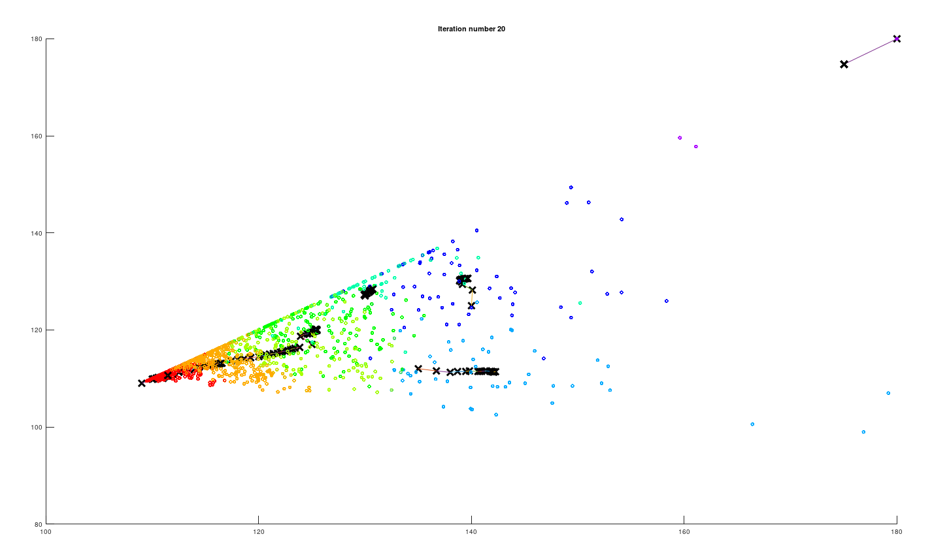

K-Means iteration 100/100...

Centroids computed

|  |  |  |  |  |  |  |
| --- | --- | --- | --- | --- | --- | --- |
|  | Angles | | | | | |
| Centeroid 1 | 112.0156 | 110.9188 | 110.0233 | 108.8977 | 108.0043 | 106.8393 |
| Centeroid 2 | 117.7977 | 113.7188 | 111.2775 | 108.2607 | 104.1096 | 100.4171 |
| Centeroid 3 | 128.3293 | 118.043 | 107.845 | 104.0143 | 99.92281 | 96.17001 |
| Centeroid 4 | 124.5112 | 119.3244 | 114.7796 | 106.1984 | 99.57349 | 85.81334 |
| Centeroid 5 | 130.7208 | 128.4061 | 123.3879 | 121.2866 | 79.03716 | 77.30463 |
| Centeroid 6 | 145.3056 | 110.6046 | 103.593 | 100.7186 | 97.17431 | 91.08849 |
| Centeroid 7 | 139.3422 | 130.4561 | 110.1567 | 97.07046 | 88.14521 | 82.29837 |
| Centeroid 8 | 175.0231 | 174.7469 | 94.46475 | 94.46433 | 84.6895 | 84.6895 |
|  |  |  |  |  |  |  |

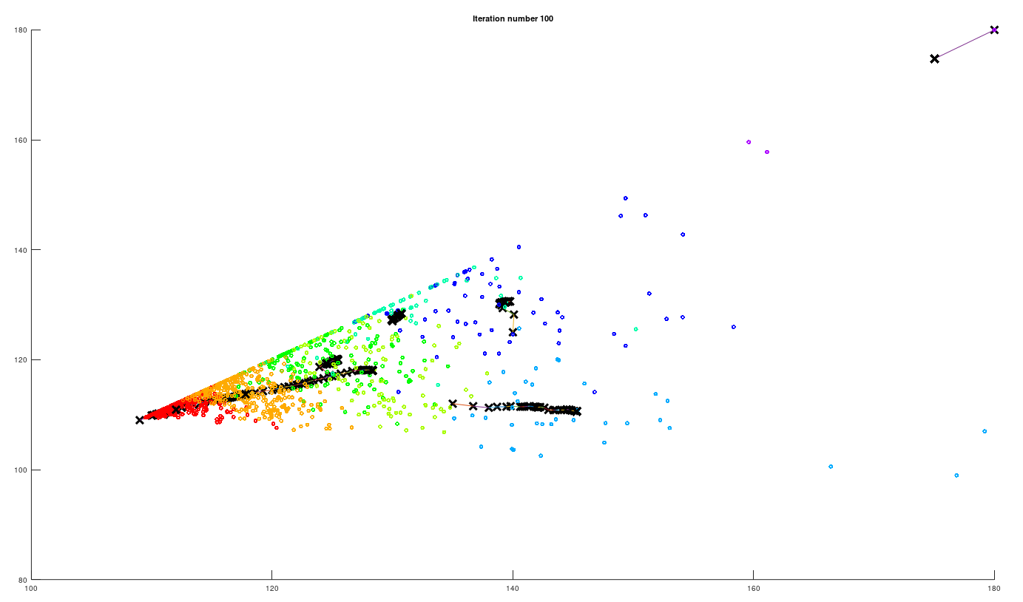

9 Centeroid

Initial centeroid

|  |  |  |  |  |  |  |
| --- | --- | --- | --- | --- | --- | --- |
|  | Angles | | | | | |
| Centeroid 1 | 109 | 109 | 109 | 109 | 109 | 109 |
| Centeroid 2 | 111 | 110 | 110 | 108 | 107 | 106 |
| Centeroid 3 | 114 | 112 | 110 | 108 | 106 | 104 |
| Centeroid 4 | 125 | 117 | 110 | 105 | 100 | 91 |
| Centeroid 5 | 130 | 127 | 122 | 119 | 80 | 78 |
| Centeroid 6 | 135 | 112 | 106 | 103 | 99 | 94 |
| Centeroid 7 | 140 | 125 | 108 | 97 | 90 | 84 |
| Centeroid 8 | 180 | 100 | 100 | 100 | 100 | 100 |
| Centeroid 9 | 180 | 180 | 95 | 95 | 84 | 84 |

K-Means iteration 20/20...

Centroids computed:

|  |  |  |  |  |  |  |
| --- | --- | --- | --- | --- | --- | --- |
|  | Angles | | | | | |
| Centeroid 1 | 111.3271 | 110.4946 | 109.8631 | 108.9636 | 108.4333 | 107.6796 |
| Centeroid 2 | 116.0735 | 112.8741 | 110.9688 | 108.5465 | 105.2538 | 102.4137 |
| Centeroid 3 | 122.1409 | 116.1728 | 110.1338 | 106.4663 | 102.1717 | 97.73776 |
| Centeroid 4 | 125.2262 | 120.0672 | 113.8999 | 105.829 | 99.10828 | 86.34694 |
| Centeroid 5 | 130.7208 | 128.4061 | 123.3879 | 121.2866 | 79.03716 | 77.30463 |
| Centeroid 6 | 138.5419 | 112.2529 | 106.3703 | 102.548 | 98.60397 | 92.50797 |
| Centeroid 7 | 139.3558 | 130.5453 | 110.2173 | 97.02736 | 88.14801 | 82.52194 |
| Centeroid 8 | 174.1537 | 102.1697 | 95.05467 | 92.14833 | 88.509 | 83.35233 |
| Centeroid 9 | 175.0231 | 174.7469 | 94.46475 | 94.46433 | 84.6895 | 84.6895 |

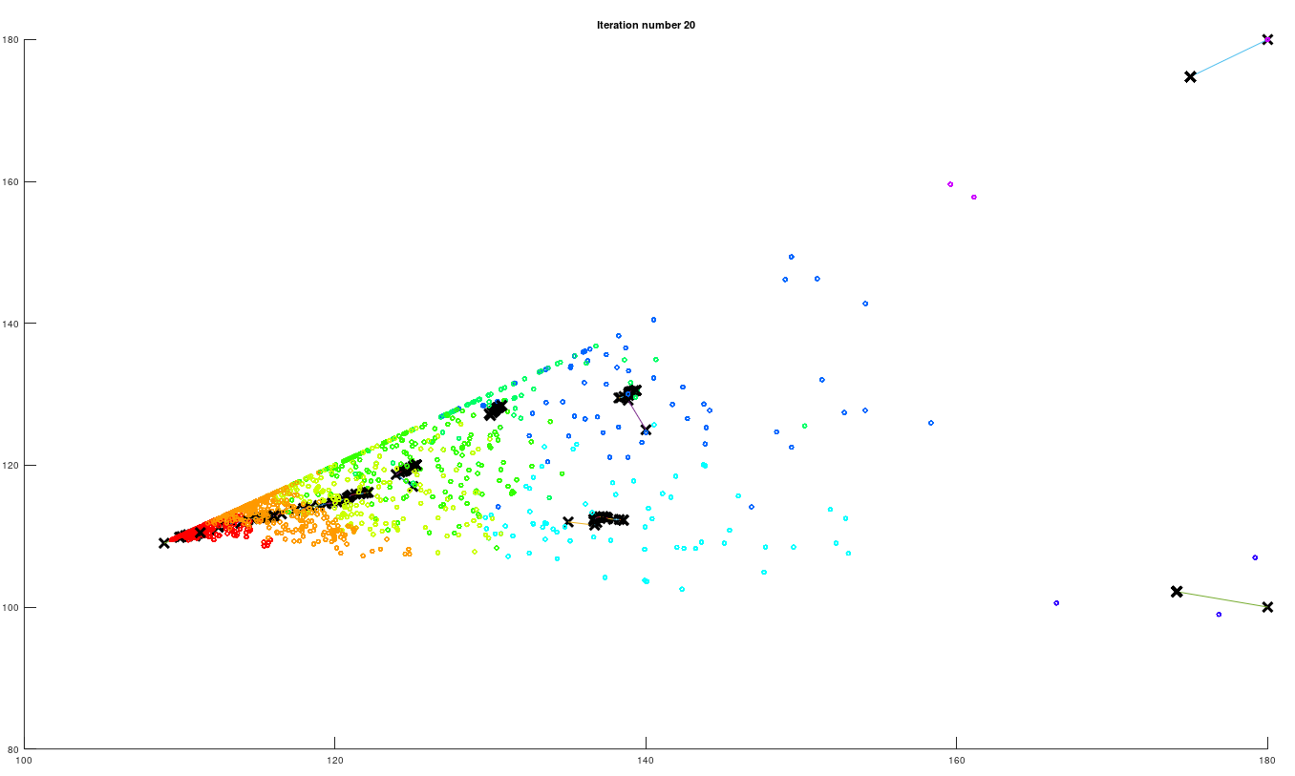

K-Means iteration 100/100...

Centroids computed:

|  |  |  |  |  |  |  |  |
| --- | --- | --- | --- | --- | --- | --- | --- |
| Centeroid 1 | 112.0156 | 110.9188 | 110.0233 | 108.8977 | 108.0043 | 106.8393 | tetrahedral |
| Centeroid 2 | 117.7519 | 113.6303 | 111.334 | 108.31 | 104.1294 | 100.4327 |  |
| Centeroid 3 | 127.1814 | 119.2289 | 107.8274 | 104.068 | 99.90567 | 96.66881 |  |
| Centeroid 4 | 124.4513 | 119.3463 | 114.8037 | 106.2581 | 99.5553 | 85.69723 |  |
| Centeroid 5 | 130.7208 | 128.4061 | 123.3879 | 121.2866 | 79.03716 | 77.30463 |  |
| Centeroid 6 | 140.3017 | 111.2727 | 105.6136 | 102.1331 | 98.76769 | 91.98382 |  |
| Centeroid 7 | 139.4242 | 130.4092 | 110.2597 | 96.9838 | 88.03157 | 82.13507 |  |
| Centeroid 8 | 174.1537 | 102.1697 | 95.05467 | 92.14833 | 88.509 | 83.35233 | Seesaw |
| Centeroid 9 | 175.0231 | 174.7469 | 94.46475 | 94.46433 | 84.6895 | 84.6895 | Square Planar |

