

American International University-Bangladesh (AIUB)

**Department of Computer Science Faculty of Science &Technology (FST) FALL 21_22**

**One-time renting app**

Software Development Project Management

|  |  |
| --- | --- |
| Sec: B |  |
| Project submitted |  |
| By |  |
| ***ROY DIP*** | ***(18-38628-2)*** |
| ***EHASANUL MOSTOFA (18-38383-2)*** | |
| ***NUSRAT KEYA*** | ***(18-38365-2)*** |
| ***SADIA EMA*** | ***(18-38378-2)*** |
|  |  |

1. PROJECT TITLE ONE TIME RENTING APP
2. OVERVIEW OF THE PROJECT

Our project is for renting. Sometimes we have to buy something that we use for just a single time. So our objective is to create a software which will help us to lessen this kind of problem. The project is basically ran by

three actors. They are “Seller /owner ”, “Customer”, and “Admin”. These three actors have their particular actions to perform. So here we want to bulled up a communication between two people who want to rent that small tool and who want to give that tool to him. This is our only and main goal.

1. **Justification And Development Plan**

**SDLC:** SDLC is a process followed for a software project, within a software organization. It consists of a detailed plan describing how to develop, maintain, replace, and alter or enhance specific software. The life cycle defines a methodology for improving the quality of software and the overall development process.

A typical Software Development Life Cycle consists of the following stages: -

* Planning and Requirement Analysis.
* Defining Requirements.
* Designing the Product Architecture.
* Building or Developing the Product.
* Testing the Product.
* Deployment in the Market and Maintenance.

**Planning and Requirement Analysis:** Requirement analysis is the most important and fundamental stage in SDLC. It is performed by the senior members of the team with inputs from the customer, the sales department, market surveys and domain experts in the industry. This information is then used to plan the basic project approach and to conduct product feasibility study in the economical, operational and technical areas.

Planning for the quality assurance requirements and identification of the risks associated with the project is also done in the planning stage. The outcome of the technical feasibility study is to define the various technical approaches that can be followed to implement the project successfully with minimum risks.

**Designing the Product Architecture:** Once the requirement analysis is done the next step is to clearly define and document the product requirements and get them approved from the customer or the market analysts. This is done through an SRS (Software Requirement Specification) document which consists of all the product requirements to be designed and developed during the project life cycle.

**Defining Requirements:** SRS is the reference for product architects to come out with the best architecture for the product to be developed. Based on the requirements specified in SRS, usually more than one design approach for the product architecture is proposed and documented in a DDS - Design Document Specification. This DDS is reviewed by all the important stakeholders and based on various parameters as risk assessment, product robustness, design modularity, budget and time constraints, the best design approach is selected for the product. A design approach clearly defines all the architectural modules of the product along with its communication and data flow representation with the external and third-party modules. The internal design of all the modules of the proposed architecture should be clearly defined with the minutest of the details in DDS.

**Building or Developing the Product:** In this stage of SDLC the actual development starts and the

product is built. The programming code is generated as per DDS during this stage. If the design is

performed in a detailed and organized manner, code generation can be accomplished without much hassle.

Developers must follow the coding guidelines defined by their organization and programming tools like compilers, interpreters, debuggers, etc. are used to generate the code. Different high level programming languages such as C, C++, Pascal, Java and PHP are used for coding. The programming language is chosen with respect to the type of software being developed

**Testing the Product:** This stage is usually a subset of all the stages as in the modern SDLC models, the testing activities are mostly involved in all the stages of SDLC. However, this stage refers to the testing only stage of the product where product defects are reported, tracked, fixed and retested, until the product reaches the quality standards defined in the SRS.

**Deployment in the Market and Maintenance:** Once the product is tested and ready to be deployed it is released formally in the appropriate market. Sometimes product deployment happens in stages as per the business strategy of that organization. The product may first be released in a limited segment and tested in the real business environment. Then based on the feedback, the product may be released as it is or with suggested enhancements in the targeting market segment. After the product is released in the market, its maintenance is done for the existing customer base.

SDLC provides a series of steps to be followed to develop a software product efficiently. SDLC framework includes the following steps:

**Communication:** This is the first step where the user initiates the request for a desired software product. He contacts the service provider and tries to negotiate the terms. He submits his request to the service providing organization in writing.

**Requirement Gathering:** This step onwards the software development team works to carry on the project. The team holds discussions with various stakeholders from problem domain and tries to bring out as much information as possible on their requirements. The requirements are contemplated and segregated into user requirements, system requirements and functional requirements.

**Feasibility Study:** After requirement gathering, the team comes up with a rough plan of software process. At this step the team analyzes if a software can be made to fulfill all requirements of the user and if there is any possibility of software being no more useful. It is found out, if the project is financially, practically and technologically feasible for the organization to take up. There are many algorithms available, which help the developers to conclude the feasibility of a software project

**System Analysis:** At this step the developers decide a roadmap of their plan and try to bring up the best software model suitable for the project. System analysis includes Understanding of software product limitations, learning system related problems or changes to be done in existing systems beforehand, identifying and addressing the impact of project on organization and personnel etc. The project team analyzes the scope of the project and plans the schedule and resources accordingly.

**Software Design:** Next step is to bring down whole knowledge of requirements and analysis on the desk and design the software product. The inputs from users and information gathered in requirement gathering phase are the inputs of this step. The output of this step comes in the form of two designs; logical design and physical design. Engineers produce meta-data and data dictionaries, logical diagrams, data-flow diagrams and in some cases pseudo codes.

**Coding:** This step is also known as programming phase. The implementation of software design starts in terms of writing program code in the suitable programming language and developing error-free executable programs efficiently.

**Testing:** An estimate says that 50% of whole software development process should be tested. Errors may ruin the software from critical level to its own removal. Software testing is done while coding by the developers and thorough testing is conducted by testing experts at various levels of code such as module testing, program testing, product testing, in-house testing and testing the product at user’s end. Early discovery of errors and their remedy is the key to reliable software.

**Integration:** Software may need to be integrated with the libraries, databases and other program(s). This stage of SDLC is involved in the integration of software with outer world entities.

**Implementation:** This means installing the software on user machines. At times, software needs post-installation configurations at user end. Software is tested for portability and adaptability and integration related issues are solved during implementation.

**Operation and Maintenance:** This phase confirms the software operation in terms of more efficiency and less errors. If required, the users are trained on, or aided with the documentation on how to operate the software and how to keep the software operational. The software is maintained timely by updating the code according to the changes taking place in user end environment or technology. This phase may face challenges from hidden bugs and real-world unidentified problems.

1. **Vison and scope**

Project vision is the general fantastic thought of where the group or venture is going. The assertion then again is somewhat of a device that permits to impart this vision in a reasonable and compact way. To lay it out plainly, project vision articulation is a recorded adaptation of the project vision.

A project's scope and vision define the broad parameters of the project and provide the foundation for all subsequent steps in project or program cycle. A clear scope sets the rough boundaries for what the project will attempt to do.

The software main goal is to bulled up a correspondence between two individuals who need to lease that little device and who need to give that apparatus to him and there must be a admin, customer and seller. This is a basically a renting app. We all know about Daraj app where

there is a group and another group is sales. Where the customer can buy the things they need and the seller with the help of an offer sell their products. Admin mainly head of the software who rents the app.

1. STAKEHOLDERS ANALYSIS:

Stakeholders are mainly two types internal and external.

Internal Stakeholders are also two types primary and secondary

**5.1 Primary stakeholders**

**Who get directly benefit from this project those are,**

The owner

employees,

suppliers,

vendors

Users

and Business Partner.

5.2 **Secondary Stakeholders**

**Who get directly benefit from this project those are,**

online sellers, competitors

**5.3 External stakeholders**

Local communities, and the government

6. FUNCTIONAL REQUIREMENT

There are a lot of software requirements specifications included in the functional requirements of the OTR System, which contains various process, namely Registration, Check out, Report Generation, and Database.

**Adding User**

* The admin enables the include new user to the system.
* Assigning an ID to the user
  + Information of the User
* Availability of the product
* Mandatory User Information
  + Updating User Information

**APPS Rules**

* Transaction corrections, adjustments, and cancellations.
* Administrative functions.
* Authentication.
* Authorization levels.
* APP Tracking.
* External Interfaces.
  1. **NON FUNCTIONAL REQUIREMENT**

**7.1 Security requirement:**

* User Identification: The system needs the patient to recognize herself or himself using the phone.
* Logon ID: Any users who make use of the system need to hold a Logon ID and password.
* Modifications: Any modifications like insert, delete, update, etc. for the database can be synchronized quickly and executed only by the ward administrator.
* Administrator rights: The administrator can view as well as alter any information in the System.

**7.2 Performance**

* Response Time: The system provides acknowledgment in just one second once the users is checked.
* Capacity: The system needs to support at least 1000 people at once.
* User-Interface: The user interface acknowledges within five seconds.
* Conformity: The system needs to ensure that the guidelines of the Microsoft accessibilities are followed.

**7.3 Maintainability**

* Back-Up: The system offers the efficiency for data back up.
* Errors: The system will track every mistake as well as keep a log of it.

**7.4 Reliability**

* Availability: The system is available all the time.

**7.5 Keywords**

Web Application, Online Platform, product Renting, Smart, Security, Advertise, Network, Remote Interaction.

8. MODULES OF THE PROJECT

* USER INVOICE SYSTEM .
* BUYER MANAGEMENT SYSTEM.
* SELLER MANAGEMENT SYSTEM.
* ADMINISTRATIVE MANAGEMENT SYSTEM.
* ONLINE DEALER MANAGEMENET SYSTEM.
* INVENTORY MANAGEMENT SYSTEM

9. SYSTEM REQUIREMENT OF THE PROJECT

* Must have android phone
  + App ,
* barcode scanner and
* a printer machine.

10. PROJECT DESIGN

For designing our project we select agile model .

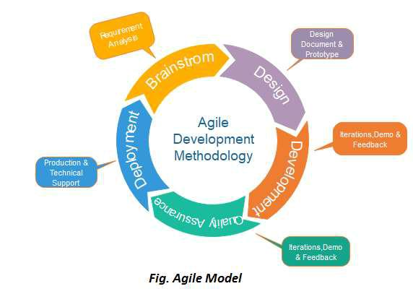

**Why we choose agile?**

1.Suitable for small to medium

2.Extreme Programming

3.Can accommodate changes at any

Time.

4.Dynamic System

5.Effective for the dynamic

6.Development Method

development environmen.

7.Kanban

8.Required expernt agile personnel

the life cycle

9.sucess achived through freedom and chaos.

1. **Diagrams**
   * use-case diagram:

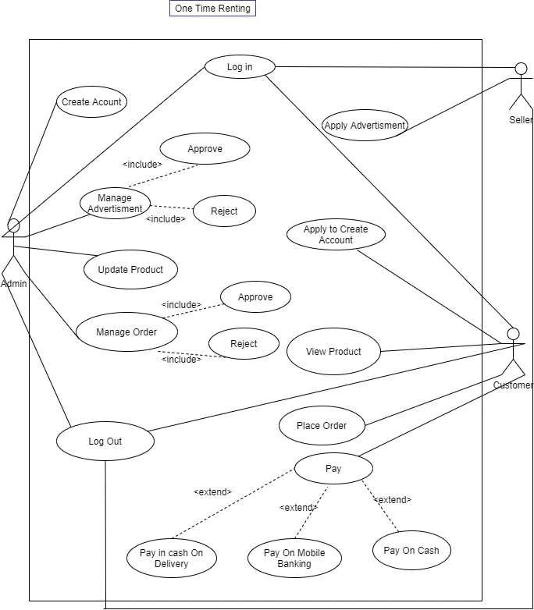

o

* activity diagram:

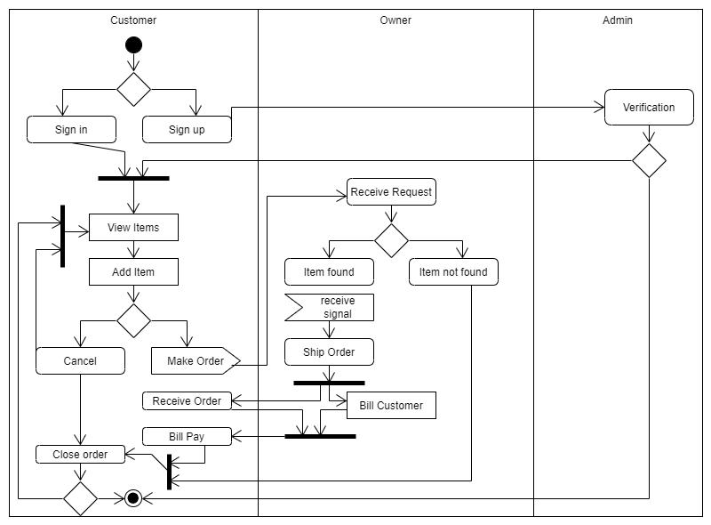

* class diagram

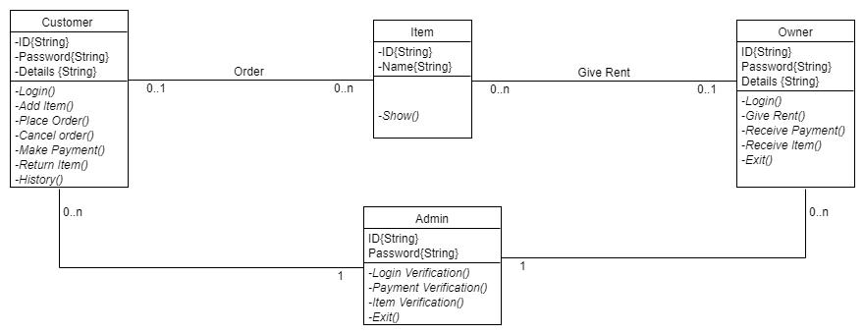

* E-R diagram

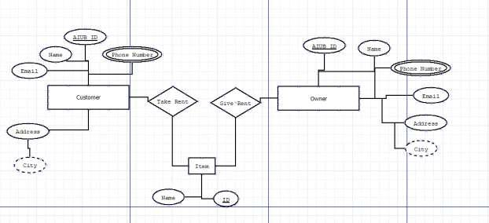

**12 . Social Impact of this Project**

Rent app has a great impact on the society. Rent app products have been known to save time and money of users. According to a study conducted by a newspaper, 95% people have to buy many products for one or two time using. This app can help them to rent product for some hour or days which they prefer. As a result, they can save their money and they can use product that they need. You can rent your thing and you can have some if you need. It also can give you some money as well if we want to give your product in rent. We can also minimize the wastes because we don’t have buy product for one time using. Besides that, lower income people have to think many times for buy product which they need for some time, they are available to rent product from this app. Sometimes it is seen that elderly people can’t walk properly as a result if they any product for one time use, it’s a realistic solution for them to use this app. This are the social impact of our product.

****** THE END ******