

American International University-Bangladesh (AIUB)

**Department of Computer Science Faculty of Science &Technology (FST) spring 2021-2022**

**One-time renting app SOFTWARE DEVELOPMENT PROJECT MANAGEMENT**

Sec: B

## Project submitted

By

***DIP ROY (18-38628-2)***

***EHSANUL MOSTOFA (18-38383-2)***

***SADIA EMA (18-38378-2)***

***NUSRAT RAHMAN KEYA (18-38365-2)***

PROJECT TITLE ONE TIME RENTING APP

1. Introduction

The main goal of our project is that people buy or renting their urgent needed in a very short time.

1. Over of the Project

Our project is for renting. Sometimes we have to buy something that we use for just a single time. Therefore, our objective is to create software, which will help us to lessen this kind of problem. Three actors run the project. They are “Owner”, “Customer”, and “Admin”. These three actors have their particular actions to perform. So here, we want to bull up a communication between two people who want to rent that small tool and who want to give that tool to him. This is our only and main goal.

# Justification and Development Plan

**SDLC:** SDLC is a process followed for a software project, within a software organization. It consists of a detailed plan describing how to develop, maintain, replace, and alter or enhance specific software. The life cycle defines a methodology for improving the quality of software and the overall development process.

A typical Software Development Life Cycle consists of the following stages: -

* + Planning and Requirement Analysis.
  + Defining Requirements.
  + Designing the Product Architecture.
  + Building or Developing the Product.
  + Testing the Product.
  + Deployment in the Market and Maintenance.

**Planning and Requirement Analysis:** Requirement analysis is the most important and fundamental stage in SDLC. It is performed by the senior members of the team with inputs from the customer, the sales department, market surveys and domain experts in the industry. This information is then used to plan the basic project approach and to conduct product feasibility study in the economical, operational and technical areas.

Planning for the quality assurance requirements and identification of the risks associated with the project is also done in the planning stage. The outcome of the technical feasibility study is to define the various technical approaches that can be followed to implement the project successfully with minimum risks.

**Designing the Product Architecture:** Once the requirement analysis is done the next step is to clearly define and document the product requirements and get them approved from the customer or the market analysts. This is done through an SRS (Software Requirement Specification) document, which consists of all the product requirements to be designed and developed during the project life cycle.

**Defining Requirements:** SRS is the reference for product architects to come out with the best architecture for the product to be developed. Based on the requirements specified in SRS, usually more than one design approach for the product architecture is proposed and documented in a DDS - Design Document Specification. This DDS is reviewed by all the important stakeholders and based on various parameters as risk assessment, product robustness, design modularity, budget and time constraints, the best design approach is selected for the product. A design approach clearly defines all the architectural modules of the product along with its communication and data flow representation with the external and third party modules. The internal design of all the modules of the proposed architecture should be clearly defined with the minutest of the details in DDS.

**Building or Developing the Product:** In this stage of SDLC the actual development starts and the product is built. The programming code is generated as per DDS during this stage. If the design is performed in a detailed and organized manner, code generation can be accomplished without much hassle.

Developers must follow the coding guidelines defined by their organization and programming tools like compilers, interpreters, debuggers, etc. are used to generate the code. Different high-level programming languages such as C, C++, Pascal, Java and PHP are used for coding. The programming language is chosen with respect to the type of software being developed

**Testing the Product:** This stage is usually a subset of all the stages as in the modern SDLC models, the testing activities are mostly involved in all the stages of SDLC. However, this stage refers to the testing only stage of the product where product defects are reported, tracked, fixed and retested, until the product reaches the quality standards defined in the SRS.

**Deployment in the Market and Maintenance:** Once the product is tested and ready to be deployed it is released formally in the appropriate market. Sometimes product deployment happens in stages as per the business strategy of that organization. The product may first be released in a limited segment and tested in the real business environment. Then based on the feedback, the product may be released as it is or with suggested enhancements in the targeting market segment. After the product is released in the market, its maintenance is done for the existing customer base.

SDLC provides a series of steps to be followed to develop a software product efficiently. SDLC framework includes the following steps:

**Communication:** This is the first step where the user initiates the request for a desired software product. He contacts the service provider and tries to negotiate the terms. He submits his request to the service providing organization in writing.

**Requirement Gathering:** This step onwards the software development team works to carry on the project. The team holds discussions with various stakeholders from problem domain and tries to bring out as much information as possible on their requirements. The requirements are contemplated and segregated into user requirements, system requirements and functional requirements.

**Feasibility Study:** After requirement gathering, the team comes up with a rough plan of software process. At this step, the team analyzes if software can be made to fulfill all requirements of the user and if there is any possibility of software being no more useful. It is found out, if the project is financially, practically and technologically feasible for the organization to take up. There are many algorithms available, which help the developers to conclude the feasibility of a software project

**System Analysis:** At this step, the developers decide a roadmap of their plan and try to bring up the best software model suitable for the project. System analysis includes Understanding of software product limitations, learning system related problems or changes to be done in existing systems beforehand, identifying and addressing the impact of project on organization and personnel etc. The project team analyzes the scope of the project and plans the schedule and resources accordingly.

**Software Design:** Next step is to bring down whole knowledge of requirements and analysis on the desk and design the software product. The inputs from users and information gathered in requirement gathering phase are the inputs of this step. The output of this step comes in the form of two designs; logical design and physical design. Engineers produce meta-data and data dictionaries, logical diagrams, data-flow diagrams and in some cases pseudo codes.

**Coding:** This step is also known as programming phase. The implementation of software design starts in terms of writing program code in the suitable programming language and developing error-free executable programs efficiently.

**Testing:** An estimate says that 50% of whole software development process should be tested. Errors may ruin the software from critical level to its own removal. Software testing is done while coding by the developers and thorough testing is conducted by testing experts at various levels of code such as module testing, program testing, product testing, in-house testing and testing the product at user’s end. Early discovery of errors and their remedy is the key to reliable software.

**Integration:** Software may need to be integrated with the libraries, databases and other program(s). This stage of SDLC is involved in the integration of software with outer world entities.

**Implementation:** This means installing the software on user machines. At times, software needs post- installation configurations at user end. Software is tested for portability and adaptability and integration related issues are solved during implementation.

**Operation and Maintenance:** This phase confirms the software operation in terms of more efficiency and less errors. If required, the users are trained on, or aided with the documentation on how to operate the software and how to keep the software operational. The software is maintained timely by updating the code according to the changes taking place in user end environment or technology. This phase may face challenges from hidden bugs and real-world unidentified problems.

# Vison and scope

Project vision is the general fantastic thought of where the group or venture is going. The assertion then again is somewhat of a device that permits to impart this vision in a reasonable and compact way. To lay it out plainly, project vision articulation is a recorded adaptation of the project vision.

A project's scope and vision define the broad parameters of the project and provide the foundation for all subsequent steps in project or program cycle. A clear scope sets the rough boundaries for what the project will attempt to do.

The software main goal is to bull up a correspondence between two individuals who need to lease that little device and who need to give that apparatus to him and there must be a admin, customer and seller. This is a basically a renting app. We all know about Daraz app where

There is a group and another group is sales. Where the customer can buy, the things they need and the seller with the help of an offer sell their products. Admin mainly head of the software who rents the app.

The project vision can be tailored to cope with variation in industries and different levels of complexity in projects, yet, all visions share a common purpose. To be effective, the vision document should address the problem to be solved by the project and the benefits reaped from the solution. Since it is customer-centric, it must define customers and stakeholders affected by the project along with their needs. Stakeholders' needs guide the definition of product features and set the product boundaries (scope) which helps the project team prevent scope creep.

# Define the Business Opportunity

We needs to describe the benefits reaped from completing the project. The project may result in higher competitive benchmark, or the expected annual revenues may be doubled by selling the product of the project. This step is vital to get management's buy-in and to authorize the project.

1. STAKEHOLDERS ANALYSIS:
   1. **Primary stakeholders**

**Who get directly benefit from this project those are, Our Primary stakeholders are,**

* + 1. The owner,
    2. Employees,
    3. Users and
    4. Business Partner.
  1. **Secondary stakeholders**

**Whom get directly benefit from this project those are,**

* + 1. Online Sellers,
    2. Competitors ,
    3. Suppliers and
    4. vendors
  1. **External stakeholders**

1. Local communities and
2. Government

# Identify Stakeholders and Users

Stakeholder analysis is critical to the success of any project. In this step, we needs to list all parties that are positively or negatively affected by the project outcome; referred to as Stakeholders. Every stakeholder should be identified along with his/her influence, role in the project, and the mechanism to leverage or mitigate his/her influence. On the other hand, user groups should be identified in terms of their responsibilities with respect to the system (product), the stakeholder group they relate to, and how they define the success of the solution to be developed.

# Summarize Stakeholders' and Users' Needs

After stakeholders and users have been defined, we needs should be understood and documented. 'Needs' can be discovered by understanding key problems the stakeholders experience with the existing system. It is also important to understand priorities, as perceived by the stakeholders, to solve these problems.

# Develop a Product Overview

The Product Overview defines the scope of the system and its interfaces with external parties. I personally prefer depicting the product overview using the Context Diagram, in which we can define how the system as a unit interacts with external stakeholders and users, and how information flows in and out of the system, from and to external parties. In addition to showing how the system is related to external stakeholders, the Context Diagram can be expanded to depict the relationships amongst internal system modules.

# Define Product Features

Based on stakeholders' needs, we will be able to develop the high-level capabilities of the system that will meet these needs. Each feature should describe the functionality required in the system to meet one or more of the stakeholders' needs. For example, a need to quickly approve

accounting documents can be met by having a feature of workflow capability to route documents electronically for sign-off by authorized personnel.

# List Assumptions and Constraints

In this step, we lists all project assumptions that if changed will alter the project vision. An assumption may state that a specific version of an operating system will be available at the time of installing the system. If this assumption proves false, the vision document may need to be revised. Besides, we should identify all limitations affecting the project. Constraints may be design-related, time and budget-related, environmental, or regulatory.

# Define Documentation Requirements

Depending on system complexity and customer requirements, it may be required to provide supporting documentation as part of the project deliverables. Documentation includes user manuals, online help, installation guides, and Read Me files.

When the project vision is signed off, the customer and the we should have a clear vision of the project's product. This document is the starting point for the Software Requirements Specifications (SRS) in which detailed requirements are articulated to meet the product features. Hence, team members should refer to it frequently to ensure alignment with customer requirements and to prevent scope creep.

**6: Feasibility Study**

A feasibility analysis is used to determine the viability of an idea, such as ensuring a project is legally and technically feasible as well as economically justifiable. Its tells us whether a project is worth the investment. A well- designed study should offer a historical background of the business or project, such as a description of the product or service, accounting statements, details of operations and management, marketing research and policies, financial data, legal requirements, and tax obligations. A feasibility analysis evaluates the project's potential for success; therefore, perceived objectivity is an essential factor in the credibility of the study for potential investors and lending institutions. In our project One-Time Renting App, we focus 5 types of feasibility study.

✓ **Technical Feasibility:** This assessment focuses on the technical resources available to the organization. It helps organizations to determine whether the technical resources meet capacity and whether the technical team is capable of converting the ideas into working systems. Technical Feasibility also involves the evaluations of the hardware, software, and other technical requirements of the proposed system. In our project, we focus in the hardware parts, and software parts .In technical we work hard the testing analysis in our project, find the bug and fixed the bug at the early stage. Programmer also works hard fixed the anomaly of the system.

✓ **Economic Feasibility:** This assessment typically involves a cost and benefits analysis of the project, helping organizations determine the viability, cost, and benefits associated with a project before financial resources are allocated. It also serves as an independent project assessment and enhances project credibility—helping decision-makers determine the positive economic benefits to the organization that the proposed project will provide. In our project, our budget estimation is completed. We use COCOMO model for budget estimation, and stating our project, we know how many programmers have been work and time duration of our project. Also making a full project how many cost need. Economic feasibility is very important for any project.

✓ **Legal Feasibility**: This assessment investigates whether any aspect of the proposed project conflicts with legal requirements like zoning laws, data protection acts or social media laws.

✓ **Operational Feasibility**: This assessment involves undertaking a study to analyze and determine whether—and how well—the organization’s needs can be met by completing the project. Operational feasibility studies also examine how a project plan satisfies the requirements identified in the requirements analysis phase of system development.

✓ **Scheduling Feasibility:** This assessment is the most important for project success; after all, a project will fail if not completed on time. In scheduling feasibility, an organization estimates how much time the project will take to complete.

When these areas have all been examined, the feasibility analysis helps identify any constraints the proposed project may face, including:

Internal Project Constraints: Technical, Technology, Budget, Resource, etc.

Internal Corporate Constraints: Financial, Marketing, Export, etc.

External Constraints: Logistics, Environment, Laws, and Regulations, etc.

**7: System Components**

A Project management system covers a broad range of elements in a project. The system helps to organize and access this information when needed.

✓ Scope: Setting a clearly defined scope for a project is impotant.it defines the expectations for the project and ensures that all parties understand these expectations. Clearly outlining our scope within our project management system can help top avoid scope creep, in which a client or stakeholders attempts to add new elements without corresponding allowances.

✓ **Deliverables**: At the end of the project, if stakeholders expect specified deliverables from the project, it is important to include this in the project management system. This section may also include details about deliverables, such as quantity and quality information. Listing the deliverables in the project management system provides a written record of the expectations for the project to avoid misunderstandings or disagreements at delivery.

✓ **Work breakdown Structure**: The Work breakdown structure is critical component of system components. This section defines the task required in order to complete the project and meet all the goals and expectations for it. It a includes which staff members or teams are responsible for each takes in project and helps to ensure that the staff understands their roles and expectations during execution/

✓ **Schedule**: Setting a timeline is an important step for any project plan. The system components system helps to manage scheduling throughout the execution of a project by providing timelines for both the overall project and individual elements within its execution.

✓ **Budget**: Keeping a project on budget is an important task for a project manager. In a system, components can help our track both the overall spending on a project and help and we allocate our budget efficiently.

✓ **Quality Controls**: Quality control is the process of ensuring that deliverables and production on a project meet the required standards. System components may put safeguards into place to identify when metrics show quality levels have fallen below a set threshold. This allows we make to prompt changes in order to increase quality levels and meet targets.

✓ **Staff Management plan**: A staff management plan provides guidance for human resources professionals within an organization. It can be a valuable part of a system component system by helping to provide structure to human resources staff working with staff on the project.

✓ **Stakeholders**: The stakeholders on a project are those who have an invested interest in its success. This may include both outside investors and ownership within an organization. The stakeholders sections list whom the stakeholders are for a project as well as their levels of control, which may vary from being active participant to simply benefiting from the results of a successful operation.

✓ **Communication pipeline**: Communication is important on any project, and our system components can facilitate in two ways. First, nothing plans for normal communication within the organization, such as any important events and meetings. The software we see as part of our project may also help us improve communication on the project by providing software, such as company chat rooms or messaging systems, to discuss the project.

✓ **Risk Assessment**: Understanding the risks of a project is a key piece of planning effectively in order to minimize our exposure. The risk section of a project management system analyzes both the potential cost of risks we face on the project and the likelihood of encountering them in order to determine the overall risk they present. Risks we may include in this component can include time-based, quality-based and financial.

✓ **Procurement plan**: When working on a project that requires outside resources, it is important to account for how we intended to obtain the resources. This can refer to the physical resources we need in order to execute the project. It may also refer to labor resources, such as tasks that require us to contract out work to another professional or organization.

🗹 FUNCTIONAL REQUIREMENT

There are many software requirements specifications included in the functional requirements of the OTR System, which contains various process, namely Registration, Check out, Report Generation, and Database.

**✓ Adding User**

* Admin enables the include new user to the system.
* Assigning an ID to the user
* Information of the User
* Availability of the product
* Mandatory User Information
* Updating User Information

**✓ APPS Rules**

* Transaction corrections, adjustments, and cancellations.

Administrative functions.

* Authentication.
* Authorization levels.
* APP Tracking.
* External Interfaces.

# 🗹 NON FUNCTIONAL REQUIREMENT

**✓ Security requirement:**

* User Identification: The system needs the patient to recognize her or himself using the phone.
* Logon ID: Any users who make use of the system need to hold a Logon ID and password.
* Modifications: Any modifications like insert delete, update, etc. for the database can be synchronized quickly and executed only by the ward administrator.
* Administrator rights: The administrator can view as well as alter any information in the System.

**✓ Performance**

* Response Time: The system provides acknowledgment in just one second once the users is checked.
* Capacity: The system needs to support at least 1000 people at once.
* User-Interface: The user interface acknowledges within five seconds.
* Conformity: The system needs to ensure that the guidelines of the Microsoft accessibilities are followed.

**✓ Maintainability**

* Back Up: The system offers the efficiency for data backup.
* Errors: The system will track every mistake as well as keep a log of it.

**✓ Reliability**

* Availability: The system is available all the time.

# 🗹 Keywords

Web Application, Online Platform, product Renting, Smart, Security, Advertise, Network, Remote Interaction.

## ACTIVITY DIAGRAM FOR THE PROJECT

|  |  |  |
| --- | --- | --- |
| Activity | Preceding Activity | Duration |
| Requirement | - | 2 |
| Design | A | 3 |
| coding | B | 2 |
| Testing | C | 2 |
| Integration | D | 1 |
| Maintenance | E | 2 |
| Documentation | E, F | 1 |

## 

Fig 1: Networking diagram with preceding node

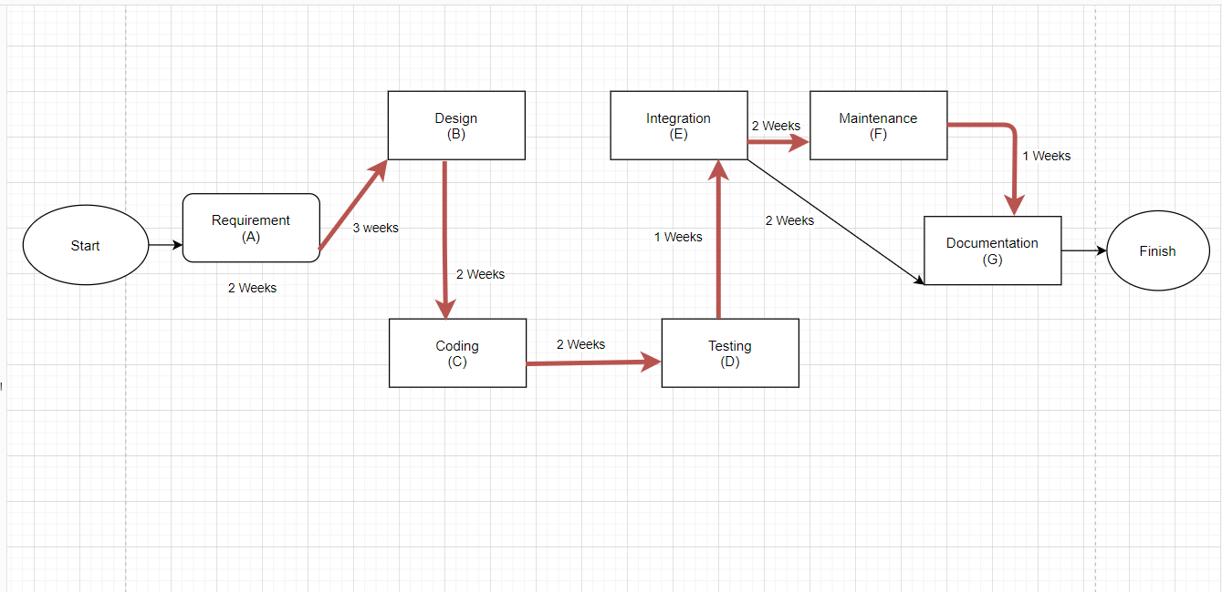

Fig 2: Critical path

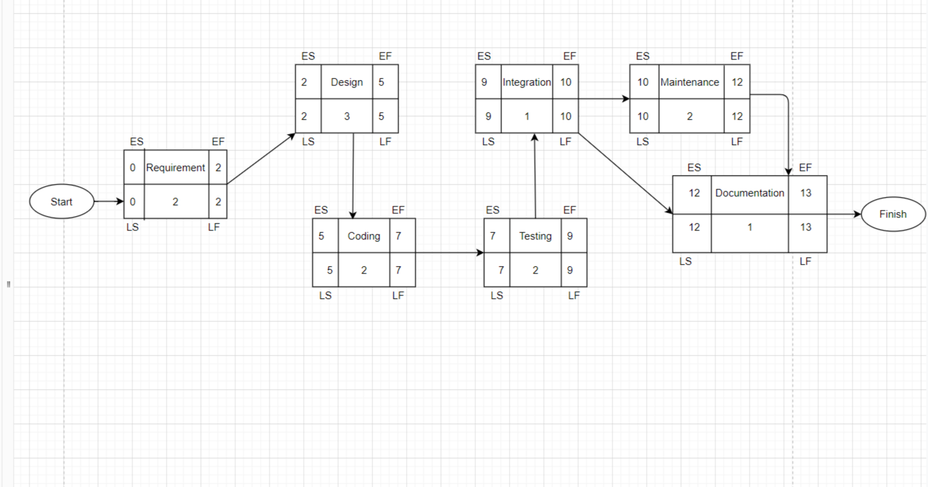

Fig 3: Earliest Start, Earliest Finish, Latest Start , Latest Finish Calculation with Forwarding and Back warding method.

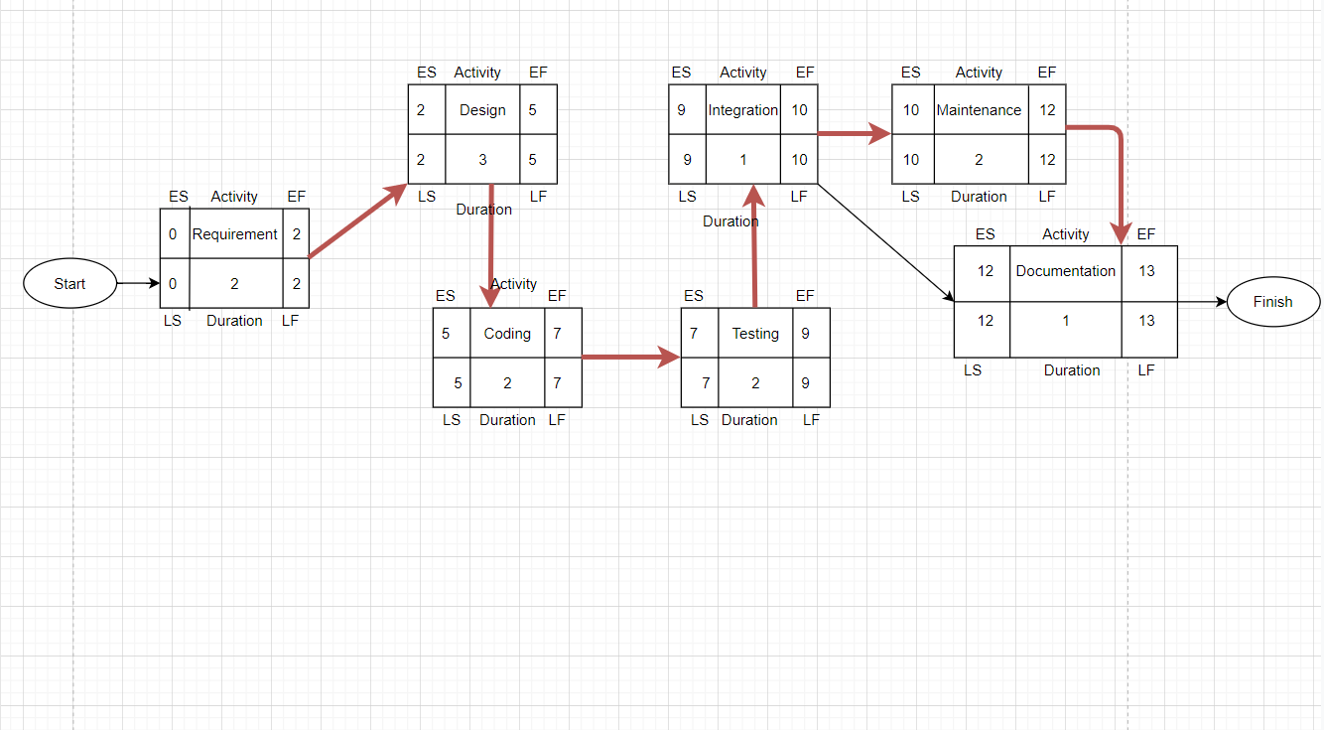

Fig 4: Critical path

## MODULES OF THE PROJECT

* User Invoice System.
* Buyer Management System.
* Seller Management System.
* Online Dealer Management System.

## SYSTEM REQUIREMENT OF THE PROJECT

* Users Must have android phone
* App ,
* barcode scanner and
* Printer machine.

## 9: PROJECT DESIGN

For designing our project, we select agile model.

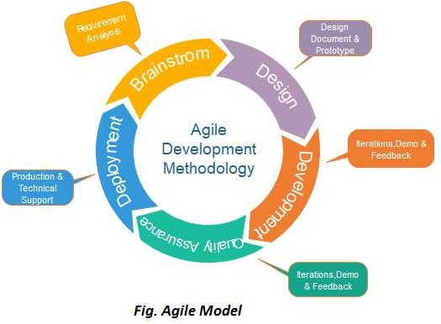

# Why we choose agile model for our project?

1. Suitable for small to medium

2. Extreme Programming

1. Can accommodate changes at any Time.
2. Dynamic System 5.Effective for the dynamic 6.Development Method development environment.

# Diagrams

## Use-case diagram:

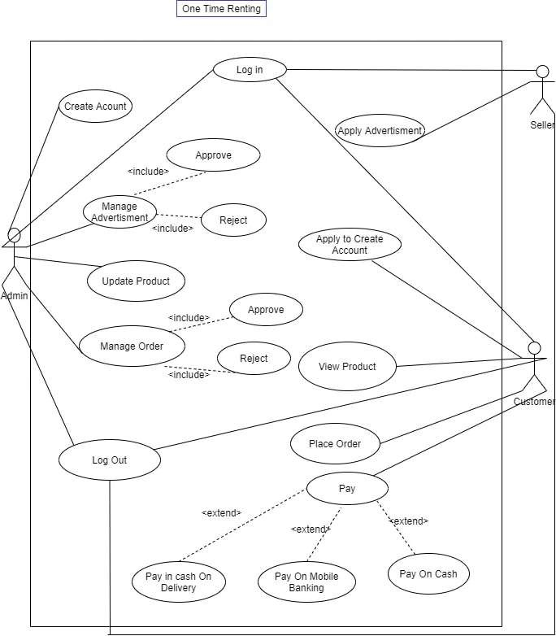

Fig 4: Use-case Diagram

## Activity diagram:

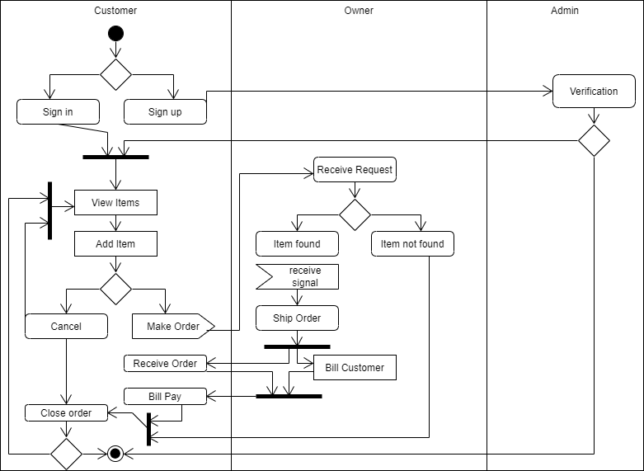

Fig 6: Activity Diagram

* + Class diagram

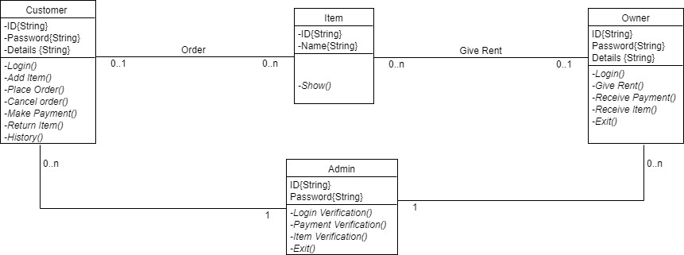

Fig 7: Class Diagram

* + - 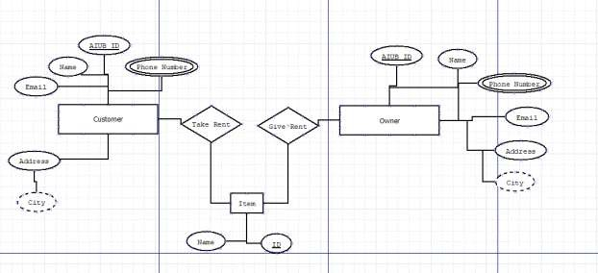E-R diagram

Fig 8: E-R Diagram

# 10: Budget Estimation

One time renting app is not that much big, so we can say it is an organic model, and let us assumes we will develop in java language.

so, Source lines of code, SLOC=12000.

We know Effort =PM=Coefficient*(SLOC/1000)^P. For organic project type,

Coefficient = 2.4, P = 1.05, T = 038.

So

Effort =PM =2.4*(12)^1.05 [SLOC/1000=12000/1000=12]

=32.61 staff-months

=33 staff-months

Development time = DM = 2.50*(PM)^T

= 2.50*(33) ^0.38

= 9.44 month

Let take it as 9 months

Required number of people=ST=PM/DM

= 33/9=3.67 = 4

Working hours per day for a single person=8 hours per person salary in a month=85,000

Per hour salary for a person in a month=85,000/180 [In a month working hours= 180]

=472.22

In 9 months number working days=180

Hours =180*8

=1440 hours So, Charge for the project 1440*472.22

=679996=680000

Requirement analysis =15days*8hours

=120hour

Charge for requirement analysis=120*300=36000 Travel expense=20000

Office rent expense=30000*9=270000. Electricity & Gas bill=2000*9=18000 Training and hardware cost=100000 Maintenance for 9 months=9*8=72 hours Maintenance cost=72 hours*1500

=108000

Utility cost:

Per month cost 5000 Taka

Total = 9 months*5000 =45000 tk

Total cost=680000+36000+20000+270000+18000+100000+108000+45000

=1007000

Bill=Total cost+20%=1007000+201400=1208400=1208400.

Work Breakdown Structure:

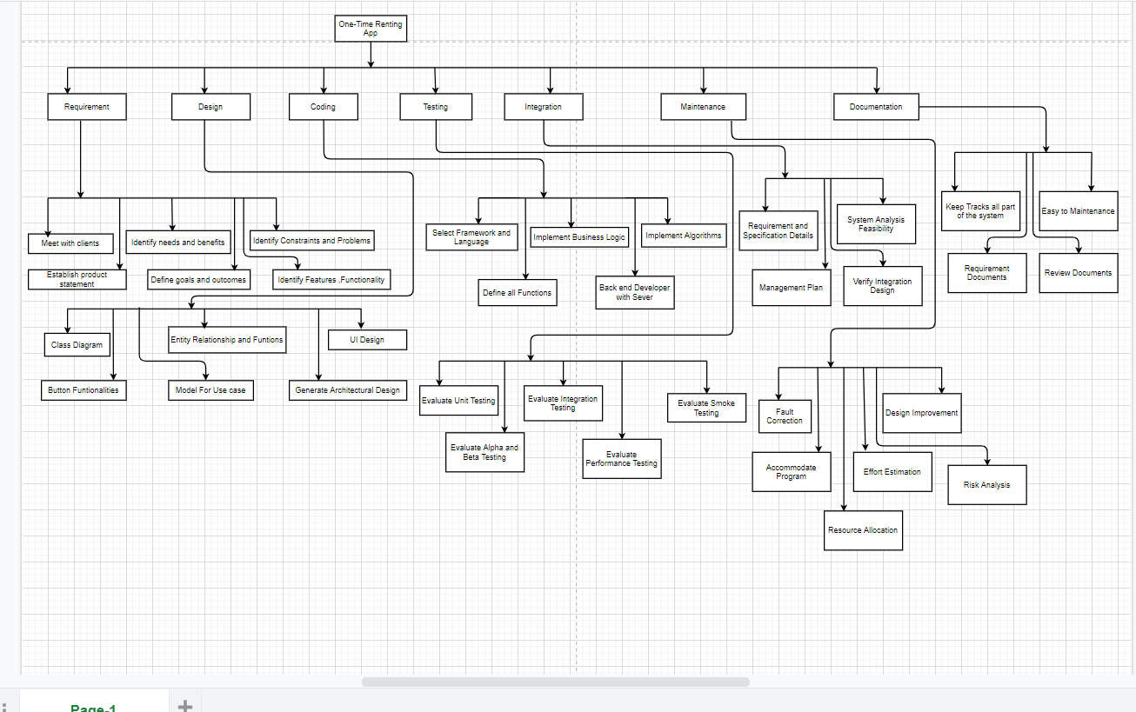

Fig 9: Work Breakdown Our Project

## Manpower Requirement.

Manpower prerequisites show up at each step of our investigation as a basic and proceeding with an issue. Expecting to be the possible improvement of a sensibly the positive political environment, the stockpile of prepared labor might arise as it were unrealistic limitation in utilizations of tertiary recuperation. Such deficiencies exist all through the field of energy supply. In tertiary recuperation applications, nonetheless, likewise with any lacking innovation, there is an especially troublesome kind of roundabout the rationale at work: we anticipate labor deficiencies, when and as tertiary applications grow; however, the advancement of improvement itself is now obliged by the absence of prepared labor (For example, in government financing organizations). For this situation, we might require a "crash program" assuming that quick advancement is to be\made inside the following decade.

## Project constraint of this document

### Project constraints affect the success or failure of a project directly. Project managers must be very cautious about monitoring and controlling project constraints throughout the project. Project constraint means a limitation or restriction by dictionary definition.

Project constraint is similar in project management as well. Projects have constraints and the project manager must manage these project constraints.

11: Project Scheduling

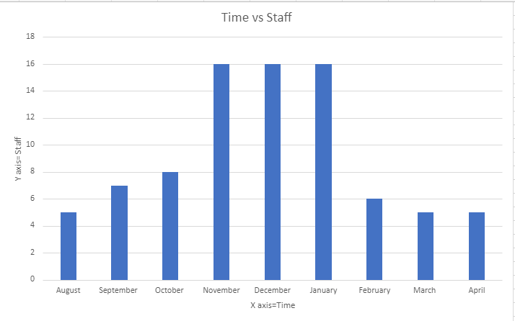

Fig 10: Risk Analysis with likelihood and severity

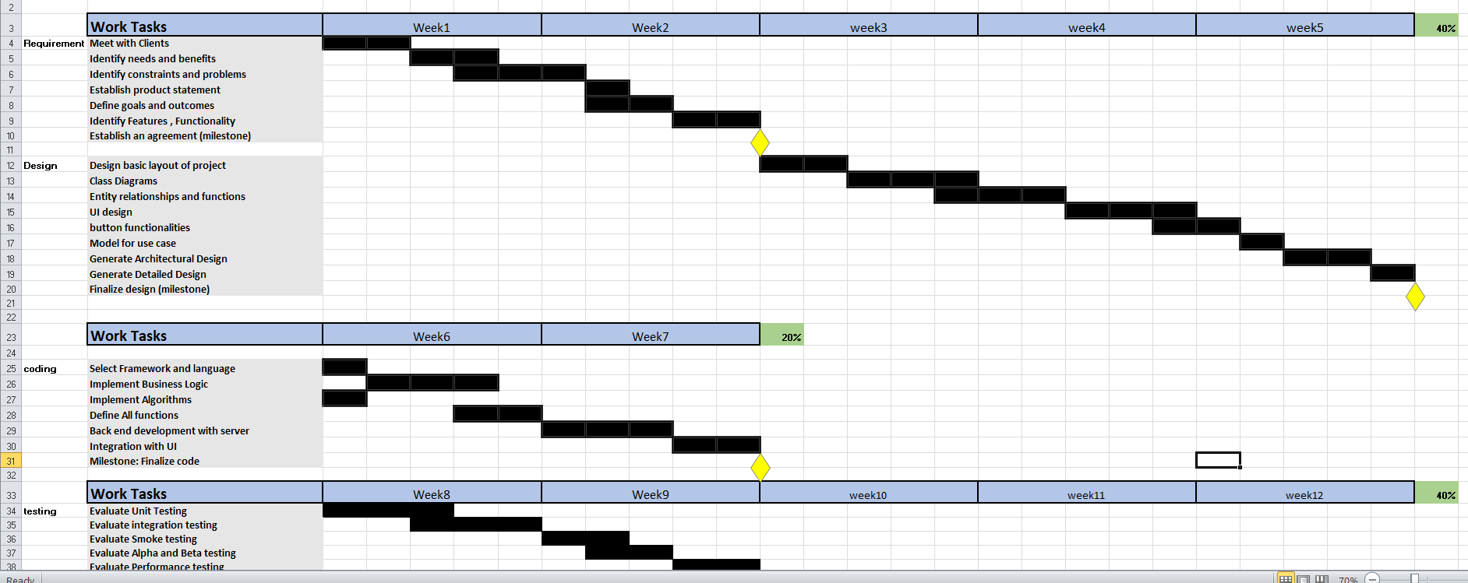

Fig 12: Gantt chart

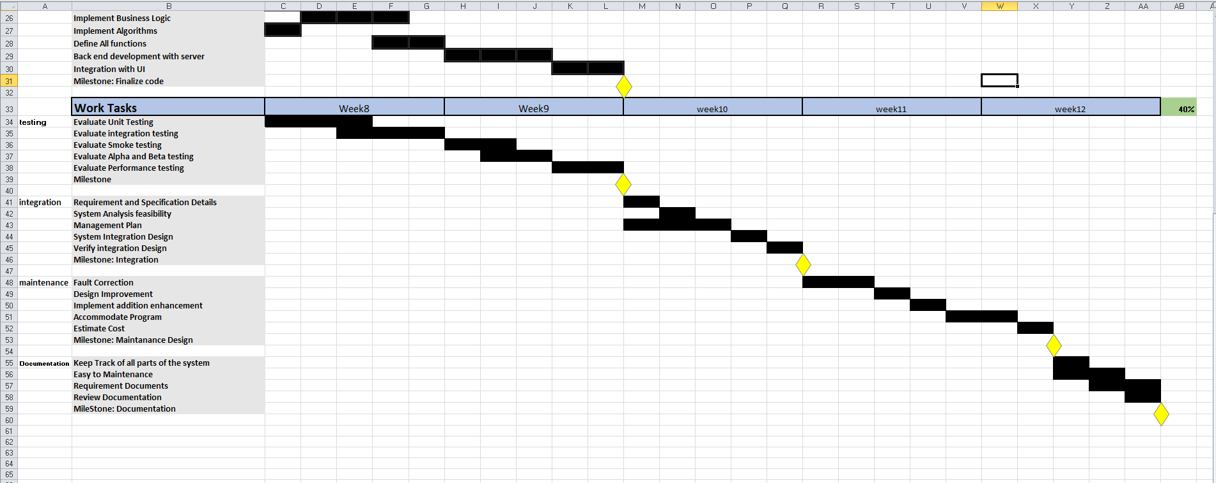

Fig 13: Gantt chart

**12: Risk Analysis**

Risk management means risk containment and mitigation. In the first place, you must recognize and plan. Then, at that point be prepared to act when a risk arises, drawing upon the experience and information on the whole group to minimize the impact to the project.

🗹 **Defect at planning**: If there are any errors found in the project plan during the project, it may take longer time.

🗹 **Communication Gaps**: There is an opportunity to gaps in communication between the team and supporters. In the event that this occurs, it might actually prompt fall behind. Assuming it occurs, we will make a decent attempt to arrive at that colleague. On the off chance that they become unreachable for a period being. We will rearrange the works.

🗹 **Budget Overrun**: At the point when customers need an excess of despite the fact that the undertaking has not many assets as it were. Cost risk can prompt other undertaking dangers, for example, plan risk and execution risk.

🗹 **Performance**: A project team can deliver the project within budget and schedule and still fail to produce the results and benefits. In addition, the company lost money and time on a project that failed to deliver.

🗹 **Hardware incapacity**: Organization worker could fall previously, during or after arrangement of our product. On the off chance that this occurs, no arrangement will come it implies this undertaking will unfit to convey to the support. All vital recuperation steps will be taken straightaway.

Risk analysis in project management refers to an important aspect of the feasibility study wherein various risks and uncertainties are identified in order to evaluate them, rank them in terms of priority and identify the areas where they are most likely to occur.

In Project, management risk can be represented as following:

**Risk = Potential Negative Event + Impact + Probability of Occurrence**

We can also demonstrate the risk of our project in the following way –

|  |  |  |  |  |  |
| --- | --- | --- | --- | --- | --- |
| # | Risk Event | Probability/100 | Impact | Score | Risk Mitigation Plan |
| 1 | Delayed development of data management system | 0.50 | 130 Hours | 65 Hours | Assign a supervisor  To monitor progress of development and notify management in case of delays |
| 2 | Failure of major supplier | 0.25 | 60 Hours | 15 Hours | Make a list of supplier who could provide necessary goods |
| 3 | Late delivery of procurement items | 0.40 | 150 Hours | 60 Hours | Develop early delivery schedule |
|  |  |  | **Total Risk** | **140 Hours** |  |

**SEVERITY**

|  |  |  |  |  |  |
| --- | --- | --- | --- | --- | --- |
| Risk Matrix | Insignificant | Minor | Moderate | Major | Severe |
| Almost Certain | Medium | High | Very High | Very High | Very High |
| Likely | Medium | High | High | Very High | Very High |
| Possible | Low | Medium | High | High | Very High |
| Unlikely | Low | Low | Medium | Medium | High |
| Rare | Low | Low | Low | Low | Medium |

**LIKELIHOOD**

Fig 10: Risk Analysis with likelihood and severity

**13: Conclusion**

Rent app has a great impact on the society. Rent app products have been known to save time and money of users. According to a study conducted by a newspaper, 95% people have to buy many products for one or two time using. This app can help them to rent product for some hour or days

Which they prefer. As a result, they can save their money and they can use product that they need. You can rent your thing and you can have some if you need. It also can give you some money as well if we want to give your product in rent. We can also minimize the wastes because we do not have buy product for one time using. Besides that, lower income people have to think many times for buy product, which they need for some time, they are available to rent product from this app. Sometimes it is seen that elderly people cannot walk properly as a result if they any product for one time use, it is a realistic solution for them to use this app. This is the social impact of our product.

****** THE END ******