PROJECT REPORT
FINTRACK
PERSONAL FINANCE MANAGEMENT SYSTEM
A secured full-stack web application for tracking income, expenses, budgets and savings goals
Submitted by
KAUSTAV ROY
UID: 24BCS11538
HEMANT SINGH
UID: 24BCS10030
Under the guidance of
NAMRTA TANWAR
SUPERVISOR
Department of Computer Science and Engineering


BONAFIDE CERTIFICATE
This is to certify that the project report entitled “FinTrack — Personal Finance Management System” is a bonafide record of the work carried out by Kaustav Roy (UID: 24BCS11538) and Hemant Singh (UID: 24BCS10030) in partial fulfillment of the academic requirements for the project evaluation during the academic session 2026.
The work presented in this report describes the analysis, design, implementation and validation of a multi-user personal finance application. The project integrates a responsive HTML/CSS/JavaScript interface with a secured Java Spring Boot REST backend and a MySQL relational database.
The work has been completed under my supervision and guidance. To the best of my knowledge, the report has not been submitted elsewhere for the award of any other qualification.
Date: ____________________
Place: ____________________
Signature: ______________________________
________________________________________
SUPERVISOR
Academic Designation: ____________________
Department: _____________________________
Institution: _____________________________

ACKNOWLEDGEMENT
We express our sincere gratitude to our supervisor for the guidance, review and encouragement provided throughout the development of FinTrack. The feedback received during problem definition, design selection and validation helped us convert an initial personal finance idea into a working full-stack application.
We thank the faculty members and the Department of Computer Science and Engineering for providing the academic environment, computing facilities and technical direction required to complete this project. We are also grateful to the open-source communities behind Java, Spring Boot, MySQL, Bootstrap, Chart.js and the other tools used in this work.
Finally, we acknowledge the support of our classmates, friends and family members who offered suggestions while the interface, documentation and demonstration workflow were refined. Their comments encouraged us to focus on clarity, usability and reliable backend integration.
Kaustav Roy
Hemant Singh

TABLE OF CONTENTS
CONTENTS | PAGE
Acknowledgement | iii
Table of Contents | iv
List of Figures | v
List of Tables | v
Abstract | vi
Graphical Abstract | vii
Abbreviations, Symbols and Nomenclature | viii
Chapter 1: Introduction | 9
Chapter 2: Literature Survey | 10
Chapter 3: Design Flow / Process | 11
Chapter 4: Results, Analysis and Validation | 13
Chapter 5: Conclusion and Future Work | 15
References | 16
Appendix A: User Manual | 17
Appendix B: Achievements and Contribution | 20

Note: Title page and bonafide certificate are not listed as report contents, consistent with the supplied project-report format.

LIST OF FIGURES
NUMBER | CAPTION | PAGE
Figure 1 | FinTrack end-to-end architecture | 12
Figure 2 | FinTrack dashboard with API-derived financial summary | 13
Figure 3 | Transaction search and history interface | 14
Figure 4 | Sign-in page used to enter the protected workspace | 17
Figure 5 | Budget monitoring and threshold states | 19
Figure 6 | Report generation and export interface | 19
Figure 7 | Responsive mobile dashboard | 19
LIST OF TABLES
NUMBER | CAPTION | PAGE
Table 1 | Technology stack and role | 13
Table 2 | Alternative designs evaluated | 11
Table 3 | Core data model | 12
Table 4 | Verification and validation results | 14
Table 5 | Project achievements and contribution | 20

ABSTRACT
FinTrack is a multi-user personal finance management system developed to help individuals record financial activity, understand spending patterns, plan monthly limits and monitor savings goals. The application responds to a common problem: personal financial information is often distributed across notebooks, spreadsheets and disconnected mobile applications, making it difficult to obtain a reliable and timely view of income, expenses and future plans.
The project uses a responsive HTML5/CSS3/JavaScript frontend and a Java 17 Spring Boot backend. The backend exposes validated REST endpoints, stores records in MySQL through Spring Data JPA and Hibernate, and protects user data with BCrypt password hashing, signed JSON Web Tokens and server-side session revocation. Dashboard and report values are calculated from backend aggregates rather than being stored as duplicated browser state. The interface includes transactions, categories, budgets, savings goals, charts, reports and CSV exports.
The design was implemented as a layered monolith so that the complete data path remains understandable and testable: browser, Fetch API, Spring Security, controllers, services, repositories, Hibernate/JDBC and MySQL. Validation included 30 automated JUnit/Mockito/MockMvc cases, JavaScript syntax checks, responsive Chromium rendering, API login and dashboard smoke tests, CORS verification and logout-token revocation checks. The result is a functional academic project that demonstrates Java/OOP, Spring Boot, REST, database integration and full-stack development in one coherent system.
Keywords: personal finance, Spring Boot, Java, REST API, MySQL, JWT, budgeting, savings goals, Chart.js, responsive web application.

GRAPHICAL ABSTRACT
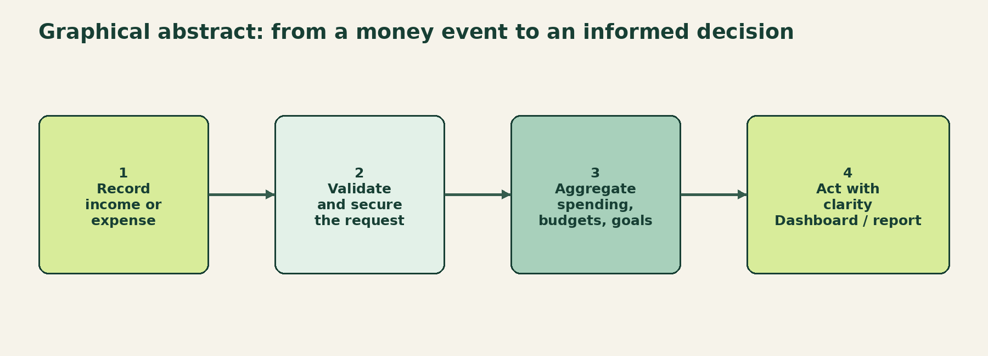
Graphical Abstract: FinTrack decision cycle
The project converts a simple financial event into a validated and useful decision cycle. A user records income or expense data in the browser. The request is authenticated and validated by the Spring Boot API, persisted through JPA/Hibernate and then included in aggregate views such as balance, budget usage, category spending and savings progress.
This flow keeps the browser responsible for interaction and presentation while the backend remains authoritative for ownership, money calculations, business rules and exports.

ABBREVIATIONS, SYMBOLS AND NOMENCLATURE
TERM | MEANING
API | Application Programming Interface
BCrypt | Adaptive password hashing algorithm
CORS | Cross-Origin Resource Sharing
CRUD | Create, Read, Update and Delete
CSV | Comma-Separated Values
DB | Database
DTO | Data Transfer Object
H2 | Embedded Java relational database used in tests
HTTP | Hypertext Transfer Protocol
INR / ₹ | Indian Rupee
JPA | Java Persistence API
JWT | JSON Web Token
ORM | Object-Relational Mapping
REST | Representational State Transfer
UI / UX | User Interface / User Experience
Symbols
SYMBOL | USE IN THIS REPORT
₹ | Currency values are represented in Indian rupees.
% | Percentage used for savings rate, progress and budget usage.
→ | Direction of data flow in architecture and process diagrams.
/ | Separates alternative values or closely related terms.

CHAPTER 1
INTRODUCTION

1.1 Identification of Client and Need
The intended client is an individual earner, student or household member who needs a private and understandable view of day-to-day finances. The user needs to record income and expenses, classify transactions, set realistic category limits and monitor progress towards goals without maintaining several separate spreadsheets.

1.2 Relevant Contemporary Issues
Digital payments have made financial activity frequent and fragmented. At the same time, users expect mobile-friendly interfaces, secure access and immediate summaries. A system that only stores transactions does not solve the full problem; it must also provide trustworthy calculations, useful warnings, searchable history and exportable evidence.

1.3 Problem Identification
The problem addressed by FinTrack is the absence of a small, integrated workspace that combines transaction capture, budget monitoring, manual savings goals and reports while preserving user ownership and secure authentication. Client-side-only storage is insufficient for multi-user privacy, persistence and trustworthy aggregation.

1.4 Task Identification and Timeline
PHASE | MAJOR TASK | OUTPUT
1 | Requirement analysis and domain modelling | Features, entities and rules
2 | Backend and database implementation | REST API, JPA mappings, security
3 | Frontend and charts | Responsive pages and API rendering
4 | Testing, redesign and documentation | Validated build, screenshots and report

1.5 Organization of the Report
Chapter 2 surveys related financial-management and secure web-application approaches. Chapter 3 explains alternatives, constraints, architecture and implementation flow. Chapter 4 presents implementation results and validation. Chapter 5 concludes the work and identifies future extensions. Appendices provide a user manual and achievements.

CHAPTER 2
LITERATURE SURVEY

2.1 Development Timeline of the Reported Problem
Personal finance tools evolved from paper ledgers to desktop spreadsheets, then to mobile banking and cloud-based dashboards. Early tools focused on recording transactions. Later systems introduced categorization, budgets, charts and notifications. Current expectations add privacy, mobile responsiveness, data export, explainable calculations and secure multi-user access.

2.2 Thematic Bibliometric Analysis
A qualitative mapping of selected standards, framework documentation and financial-literacy sources was performed using the themes of financial awareness, secure authentication, web architecture, persistence, visualization and usability. The mapping shows that a useful academic project should combine these themes instead of treating finance calculation, security and interface design as independent modules.
THEME | OBSERVATION FROM SELECTED SOURCES | PROJECT RESPONSE
Financial awareness | Users benefit from categorization, planning and feedback. | Budgets, goals, reports and dashboard summaries.
Security | Authentication and authorization must be separate concerns. | BCrypt, JWT verification, scoped queries and revocation.
Web engineering | Layered APIs improve maintainability and testing. | Controllers, services, repositories and DTOs.
Visualization | Aggregated information is easier to interpret than raw rows. | Chart.js cash-flow and category charts.
Usability | Responsive and accessible interactions reduce friction. | Mobile layout, labels, dialogs and keyboard support.

2.3 Proposed Solutions and Link to FinTrack
Proposed solutions commonly combine financial-literacy education, automated categorization, budgeting feedback and secure digital records. FinTrack adopts the practical academic subset: user-controlled categories, transparent calculations, budget warnings and explicit goal progress.

2.4 Problem Definition, Goals and Objectives
Problem definition: build a secure, responsive and testable workspace that stores user-owned records and turns them into actionable summaries. Goals are trustworthy CRUD, clear planning tools and a maintainable Java full-stack architecture; objectives cover authentication, finance modules, reports, exports, responsive UI and validation.

CHAPTER 3
DESIGN FLOW / PROCESS

3.1 Concept Generation
Three concepts were considered. The first was a spreadsheet-style local tool focused on manual entry. The second was a client-side dashboard storing JSON in browser storage. The third was a secured full-stack application with a Java API, relational database and responsive frontend. The third concept was selected because it satisfies persistence, privacy, ownership and academic integration requirements together.

3.2 Alternative Designs and Selection
DESIGN | STRENGTHS | LIMITATIONS | DECISION
A: Local spreadsheet | Fast to prototype; familiar | Weak validation, sharing and security | Rejected
B: Browser-only storage | Simple deployment; no server | Records tied to one browser; weak multi-user model | Rejected
C: Layered Spring Boot monolith | Secure, testable and explainable; persistent data | Requires Java, Maven and MySQL setup | Selected
Table 2: Alternative designs evaluated

3.3 Feature Evaluation and Finalization
Features were prioritized by user value, technical feasibility and evidence value for evaluation. Transactions form the base record; categories provide controlled classification; budgets provide constraints; goals provide forward-looking planning; reports provide analysis; security and validation protect every protected action. Charts were added only where aggregate data could be explained clearly.

3.4 Design Constraints
The project is constrained by academic time, local deployment resources and the need for transparent implementation. Professional and ethical constraints require that passwords are hashed, records are scoped to the authenticated user, exports are real, error responses do not leak stack traces and the UI does not claim financial advice. Economic and environmental impact is reduced by using a small layered deployment and bounded export pages. Health, safety and political risks are not materially introduced by the software, but privacy and responsible use remain explicit concerns.

CHAPTER 3
DESIGN FLOW / PROCESS

3.5 Selected Architecture and Data Flow
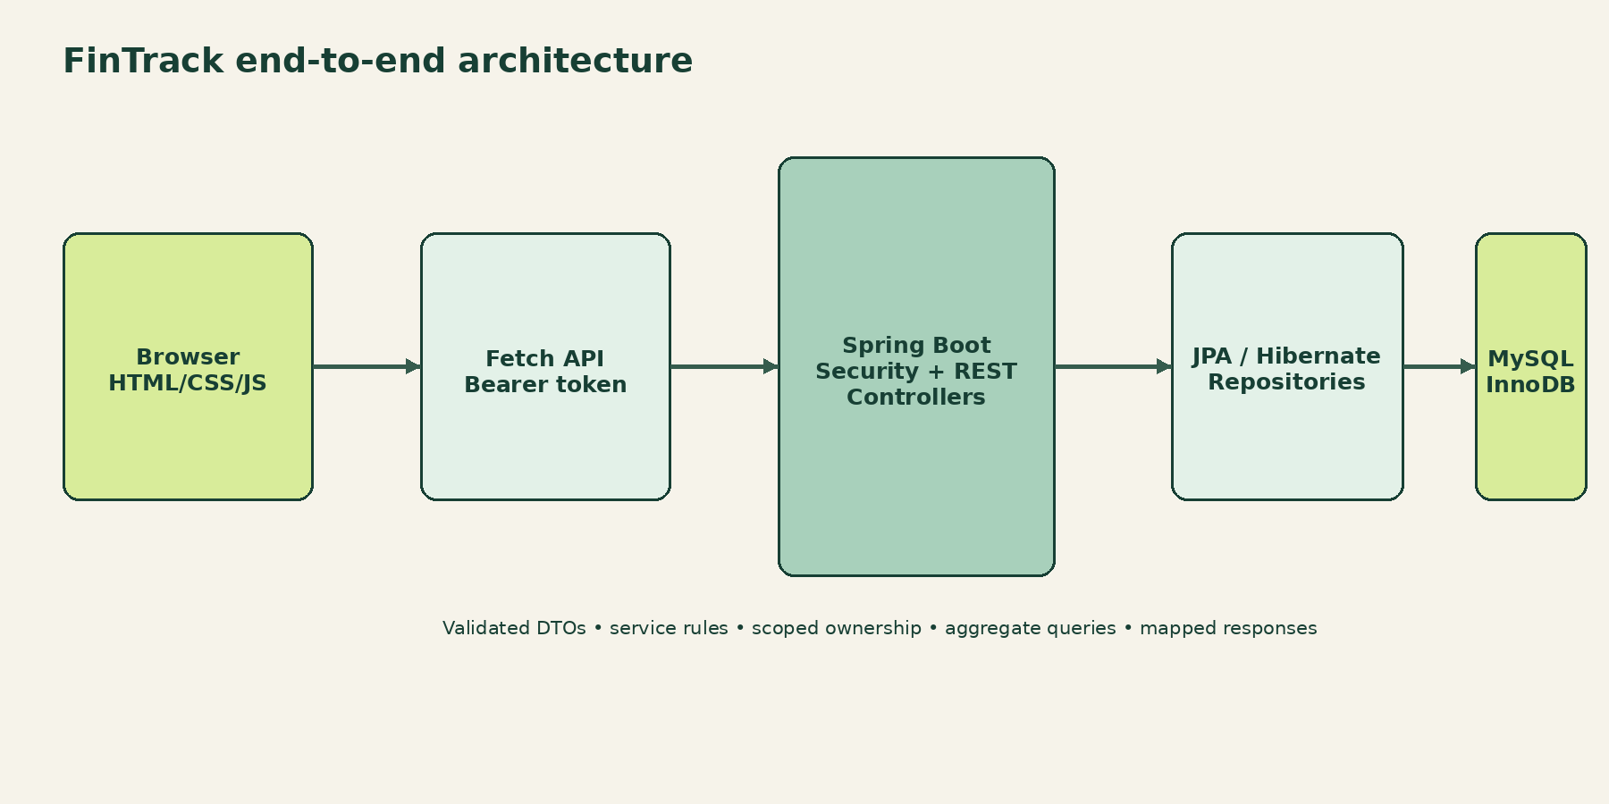
Figure 1: FinTrack end-to-end architecture
The selected layered monolith separates presentation, transport, security, business rules, persistence and relational storage without introducing unnecessary distributed-system complexity. Response records are mapped from entities so passwords, sessions and persistence relationships do not leak into the browser.

3.6 Core Data Model
TABLE | PURPOSE
users | Identity, email, BCrypt hash and profile
categories | User-owned labels with INCOME, EXPENSE or BOTH type
transactions | Amount, type, category, payment, date and description
budgets | Category limit for one user and month/year
financial_goals | Target, saved amount and deadline
auth_sessions | JWT session ID, owner and expiry for revocation
Table 3: Core data model

3.7 Implementation Algorithm
For a protected request, the browser sends a bearer token and JSON body. The JWT filter validates signature, issuer, expiry and active session. The controller binds and validates a request DTO. The service checks ownership and domain rules, then invokes a repository within a transaction. The mapper returns a password-free response. The page re-renders from the response and, where required, refreshes related aggregates.

CHAPTER 4
RESULTS, ANALYSIS AND VALIDATION

4.1 Implementation Using Modern Engineering Tools
LAYER | TOOLS | IMPLEMENTATION ROLE
Frontend | HTML5, CSS3, JavaScript ES modules, Bootstrap 5.3.3 | Responsive pages, forms, dialogs and state rendering
Charts / HTTP | Chart.js 4.4.7, Fetch API, async/await | Visual aggregates and JSON/CSV communication
Backend | Java 17, Spring Boot 3.5.6, Spring MVC | REST controllers, validation and embedded server
Persistence | Spring Data JPA, Hibernate, MySQL 8 | Entities, repositories, constraints and queries
Security | Spring Security, BCrypt, JJWT | Password hashing, JWT authentication and revocation
Testing | JUnit 5, Mockito, MockMvc, H2, Maven | Unit, integration and build verification
Table 1: Technology stack and role

4.2 Dashboard Result
The dashboard combines a balance card, income, expenses and savings rate with current-month spending, charts, recent activity, budget warnings and goal progress. The following capture was produced from the running frontend and API-backed demo data.
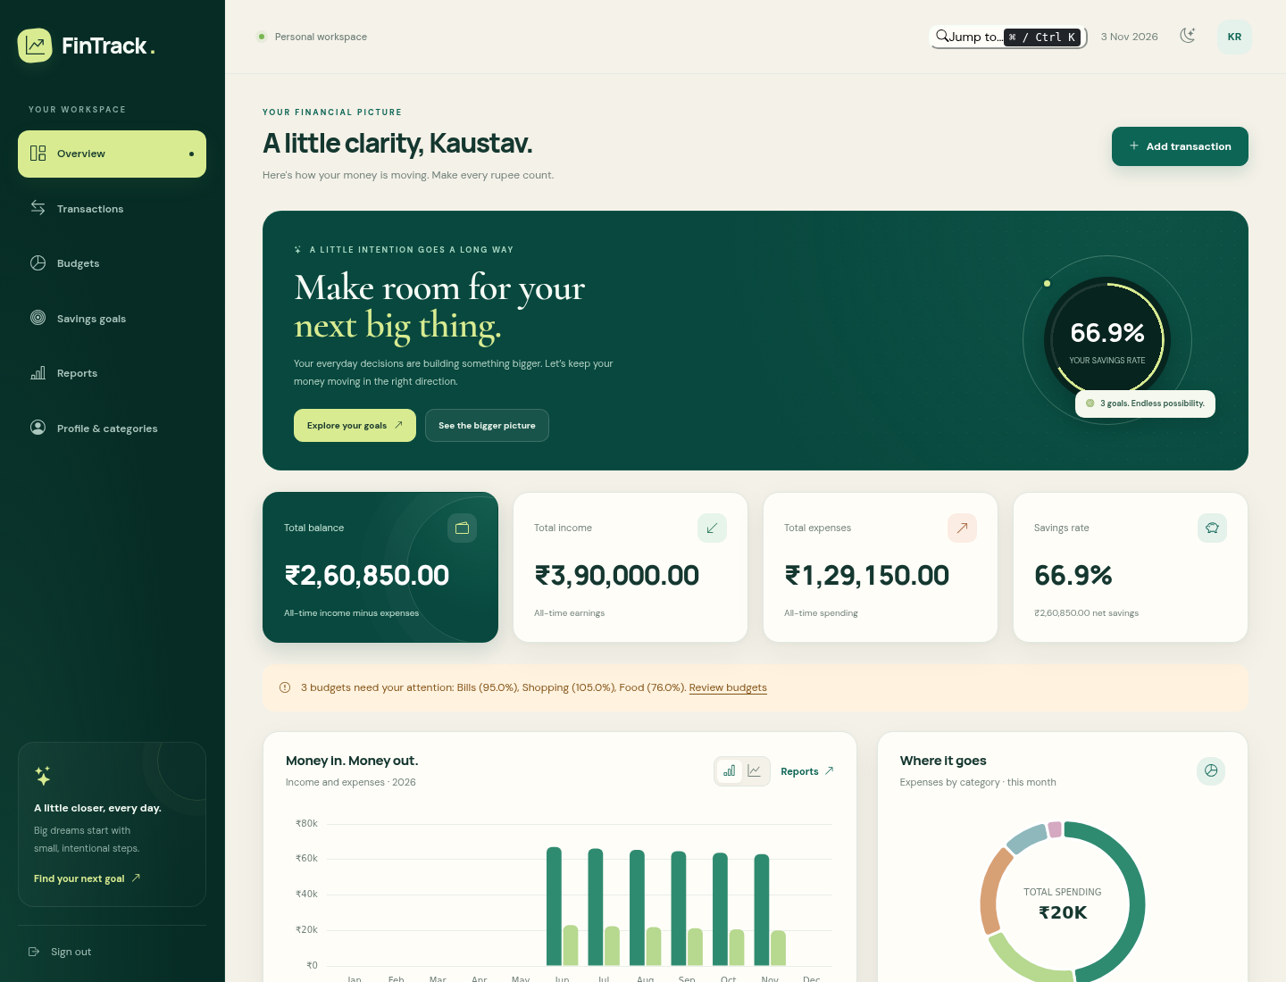
Figure 2: FinTrack dashboard with API-derived financial summary

CHAPTER 4
RESULTS, ANALYSIS AND VALIDATION

4.3 Transaction and Reporting Results
The transaction page supports server-side search, category/type/payment/date filters, sorting, pagination, editing, deletion and CSV export. The reports page derives monthly, category and date-range summaries from backend data. These results demonstrate that the interface is not a static mockup: visible records and totals are fetched from the Java API.
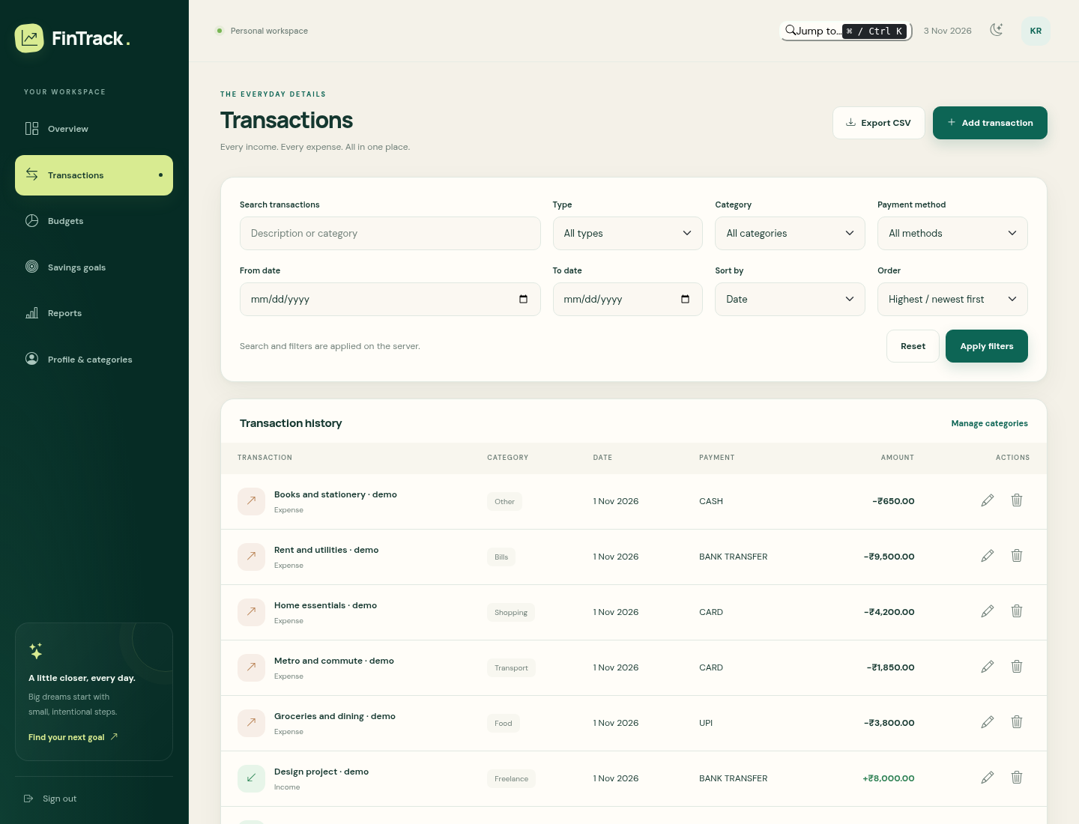
Figure 3: Transaction search and history interface

4.4 Verification and Data Validation
CHECK | SCOPE | RESULT
Backend automated suite | 30 | 0 failures, 0 errors, 0 skipped
Build verification | mvn verify | Spring Boot executable JAR generated
Frontend syntax | 13 modules | node --check passed
API smoke test | Login + dashboard | Token, summary, monthly and recent data passed
Security smoke test | Logout + old token | 204 logout; revoked token rejected with 401
Browser pages | 6 protected pages | Dashboard, transactions, budgets, goals, reports and profile loaded
Table 4: Verification and validation results

CHAPTER 5
CONCLUSION AND FUTURE WORK

5.1 Conclusion
FinTrack achieved the primary objective of providing a working personal finance workspace with a secure Java backend and a redesigned responsive frontend. The application accepts user-owned financial records, applies domain validation, calculates balance and planning metrics on the server, and presents those values through dashboards, charts and reports.

5.2 Analysis of Results and Deviations
The expected result was a coherent full-stack application rather than isolated screens. That result was achieved through the layered Spring Boot implementation, real REST integration and automated tests. The main deviation from a production banking product is deliberate: the project does not connect to bank accounts, classify transactions with machine learning or provide financial advice. These omissions keep the scope safe, explainable and suitable for an academic demonstration.

5.3 Future Work
- Add recurring transactions, verified email and password reset workflows.
- Introduce database migrations, backups, audit history and deployment observability.
- Add optional bank-import adapters with explicit consent and reconciliation controls.
- Extend reports with configurable currencies, tax categories and scheduled exports.
- Add accessibility testing and formal usability evaluation with representative users.

5.4 Way Ahead
The current layered design provides a stable foundation for these extensions. New features can be added behind services and DTOs without changing the fundamental ownership model or replacing the browser interface. The project therefore meets its academic goal while leaving a realistic path toward a more complete personal finance product.

REFERENCES
1. Chart.js Contributors (2024), Chart.js Documentation, https://www.chartjs.org/docs/latest/.
2. Hibernate ORM Team (2025), Hibernate ORM User Guide, https://hibernate.org/orm/documentation/.
3. MySQL Documentation Team (2025), MySQL 8.0 Reference Manual, Oracle Corporation.
4. OWASP Foundation (2024), JSON Web Token for Java Cheat Sheet, OWASP Developer Guide.
5. RBI (2020), National Strategy for Financial Education 2020–2025, Reserve Bank of India.
6. Spring Team (2025), Spring Boot Reference Documentation 3.5, https://docs.spring.io/spring-boot/.
7. Spring Team (2025), Spring Security Reference, https://docs.spring.io/spring-security/reference/.
8. Oracle (2024), Java Platform, Standard Edition Documentation, Java 17 API Specification.
9. Bootstrap Contributors (2024), Bootstrap 5.3 Documentation, https://getbootstrap.com/docs/5.3/.
10. Project source and verification records (2026), FinTrack repository documentation: architecture, API, database design and testing guide.
Note: Online documentation links are included for technical references. The report uses the project source code, test reports and captured application screens as primary implementation evidence.

APPENDIX A
USER MANUAL

A.1 Prerequisites
Install JDK 17, Maven 3.9 or later, MySQL 8 and a modern browser. Import database/schema.sql into a fresh MySQL database and create the application account as described in README.md. Configure DB_USERNAME, DB_PASSWORD, JWT_SECRET and CORS_ORIGINS before starting the API.

A.2 Start the Application
- Open a terminal in FinTrack/backend and run: mvn spring-boot:run
- Open another terminal in FinTrack/frontend and run: py -m http.server 5500 --bind 127.0.0.1
- Open http://localhost:5500/index.html in the browser.

A.3 Create an Account or Use Demo Data
Select Create your free account, enter a name, email and password, then submit. The password must contain 10–72 printable ASCII characters with uppercase, lowercase and a number. For an opt-in demonstration account, enable the backend demo seed and use the credentials documented in README.md.

A.4 Login and Navigation
Use the login page to obtain a JWT-backed session. The protected pages are Overview, Transactions, Budgets, Savings goals, Reports and Profile & categories. On a small screen, use the menu button to open the sidebar. Ctrl+K or Command+K opens quick navigation.

Figure 4: Sign-in page used to enter the protected workspace

APPENDIX A
USER MANUAL

A.5 Dashboard and Transactions
After login, review the balance, income, expenses and savings rate. Use the Add transaction button to record an income or expense. Choose a compatible category, amount, payment method and date. Save the form and confirm that the new row appears in Transaction history. Use Edit to replace values, or Delete and confirm the native dialog to remove a record.
The transaction filters are sent to the server. Search by description or category, restrict type/category/payment/date, change sorting and move through pages. Export CSV downloads all matching records rather than only the visible page. The workflow is shown in Figure 3.

A.6 Profile and Categories
Open Profile & categories to update the name, email or optional phone number. Create a personal category with type INCOME, EXPENSE or BOTH. A category that is already referenced by a transaction or budget cannot be deleted, protecting financial history.

APPENDIX A
USER MANUAL

A.7 Budgets, Goals and Reports
On Budgets, select a month and create an expense-category limit. The application calculates spent, remaining and usage from transactions; NORMAL is below 75%, WARNING is 75–<90%, CRITICAL is 90–100% and EXCEEDED is above 100%.
On Savings goals, enter a target, saved amount and deadline. On Reports, select a month or custom date range and generate the report or CSV export.
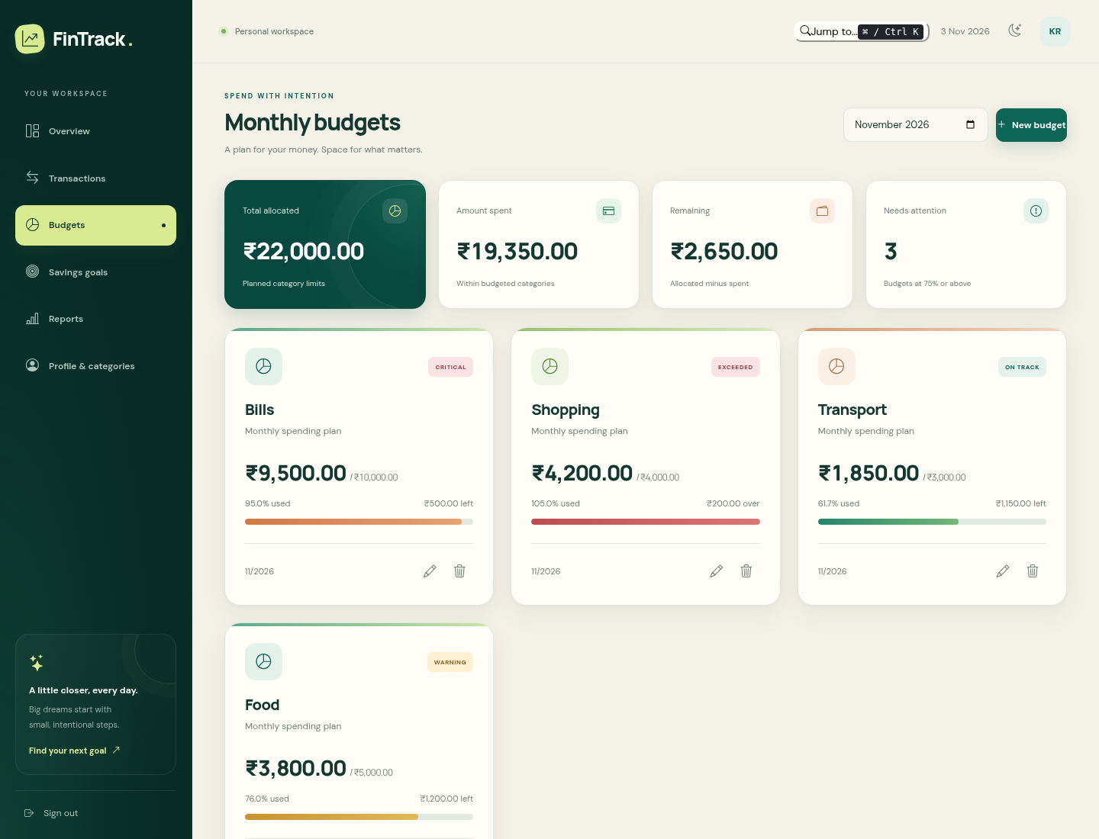 | 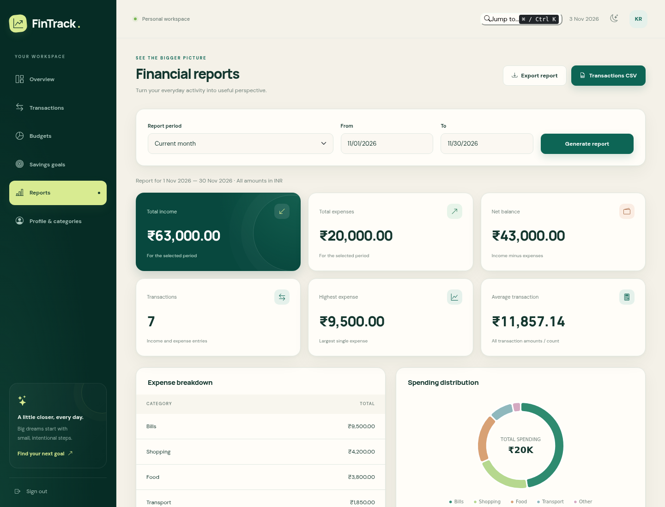
Figure 5: Budget monitoring and threshold states
Figure 6: Report generation and export interface
At mobile widths the sidebar becomes a drawer, cards collapse and tables remain readable through internal scrolling.
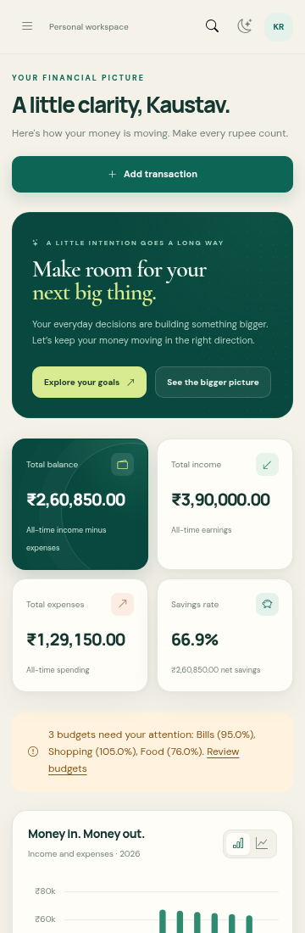
Figure 7: Responsive mobile dashboard

APPENDIX B
ACHIEVEMENTS AND CONTRIBUTION

B.1 Achievements
AREA | EVIDENCE
Functional scope | Authentication, transactions, categories, budgets, goals, reports, CSV export and responsive UI
Security | BCrypt password hashing, JWT validation, scoped ownership and durable logout revocation
Testing | 30 automated tests plus frontend syntax, API smoke, CORS, browser rendering and responsive checks
Documentation | Architecture, API, database, testing, Java/OOP and FSD evaluation notes
Design | Dark emerald Horizon frontend redesign with light/dark themes and mobile navigation
Table 5: Project achievements and contribution

B.2 Contributor Declaration
We declare that this report presents the work completed for the FinTrack project and that the implementation evidence, screenshots and test results correspond to the project files supplied with this report. The two contributors jointly participated in requirement analysis, design, implementation, testing and documentation.
Kaustav Roy
UID: 24BCS11538
Hemant Singh
UID: 24BCS10030

