LIMKOKWING UNIVERSITY OF CREATIVE TECHNOLOGY
SIERRA LEONE
Department of Information and Communication Technology

PROG101: PRINCIPLES OF PROGRAMMING LOGIC AND DESIGN
Individual Assignment 1
Designing Logical Solutions for Sierra Leone Community Challenges
Project: EduLink SL — Education Access and Resource Link System

Student Name: | Alieu Kamara
Student ID: | 6151
Examiner: | Elijah Fullah
Checked by: | Sheik Umar Kanu
Semester: | 01, September 2026 to January 2027
Submission Deadline: | Week 4
Date Submitted: | [Insert submission date]

Table of Contents
1. Rationale 3
1.1 Problem Description 3
1.2 Background 3
1.3 Who Is Affected 3
1.4 Proposed Solution 3
1.5 Community Impact 3
1.6 Computational Thinking Process 4
1.7 Algorithm Design Summary 4
1.8 SDG Alignment 4
1.9 Open Source Justification 4
1.10 Digital Public Goods (DPG) Justification 5
1.11 Long-Term Sustainability 5
2. Step-by-Step Algorithm 6
3. Pseudocode 7
4. Flowchart 11
Figure 1 — System Overview 12
Figure 2 — Check Tutor Availability 13
Figure 3 — Check Study Material Stock 14
Figure 4 — Book Tutoring Session 15
Figure 5 — Report School Disruption 16
5. Functional Modules 17
6. Expected Outputs — Sample Scenarios 18
7. GitHub Repository Evidence 20
8. References 21

1. Rationale

▎ 1.1 Problem Description
In many rural and peri-urban communities across Sierra Leone, students routinely travel long distances to the nearest community learning centre only to discover, on arrival, that no tutor is on duty, that the centre has no open seats for a tutoring session, or that it has run out of the specific study material they need (for example BECE or WASSCE past papers in a given subject). Because learning centres have no shared, real-time way of publishing their availability, students, parents, and guardians must travel first and find out second. This wastes scarce transport money and time, discourages students from seeking extra academic support at all, and in the case of a sudden school disruption (flooding, a teacher strike, or a temporary closure) can leave a student with nowhere to turn for days.

▎ 1.2 Background
Sierra Leone's education system is constrained by limited road and transport infrastructure, an uneven distribution of qualified tutors between urban and rural areas, and inconsistent supply of textbooks and past papers between district education offices and the community learning centres that serve outlying villages. At the same time, mobile phone penetration is comparatively high even in areas with poor internet coverage, because basic (non-smartphone) handsets are affordable and GSM network coverage reaches most districts. This combination -- poor physical and information infrastructure, but reasonably good basic mobile coverage -- is the starting point for the proposed solution: a system that does not depend on smartphones, continuous data connectivity, or new hardware, but instead works over the mobile network that already exists.

▎ 1.3 Who Is Affected
- Students, particularly those in rural and peri-urban areas preparing for national examinations (BECE, WASSCE), who cannot afford repeated wasted trips to a centre that turns out to have no tutor or no seats.
- Parents and guardians, who need a fast way to check which nearby learning centre can actually help their child before sending them there, especially during a school disruption.
- Community learning centre coordinators and District Education Office administrators, who currently have no simple channel to broadcast tutor availability, seat capacity, or material stock status to the community they serve.

▎ 1.4 Proposed Solution
EduLink SL -- the Education Access and Resource Link System -- is a logical system design for a USSD/SMS-based service that lets a student, parent, or guardian dial a short code from any basic mobile phone and, within seconds, (1) check which nearby learning centre currently has an available tutoring seat and a tutor on duty for the subject needed, (2) check whether a specific centre has a given study material or past paper in stock, (3) book a tutoring session at a centre with capacity, or (4) report a school disruption, which triggers a search outward from the student's location until a centre with a tutor on duty is found as an alternative. Centre coordinators maintain each facility's status (tutor on duty, open seats, material stock) through a simple administrative interface. Because the student-facing side runs over USSD/SMS rather than a smartphone app, it works on the handsets people in these communities already own, and it works even where data connectivity is weak or absent.

▎ 1.5 Community Impact
By letting students and parents check availability before travelling, EduLink SL is designed to reduce wasted journeys and the transport costs and lost study time that come with them, shorten the time between a school disruption and a student reaching a centre that can actually help them continue learning, give centre coordinators better visibility into incoming demand so they can plan tutor rosters and material stock, and give District Education Office administrators aggregated, anonymised usage data (which subjects are searched for most, which centres are consistently out of past papers) that can inform resource allocation. The direct beneficiaries are rural and peri-urban students and the parents or guardians who support them; the indirect beneficiaries are centre coordinators and the wider district education system, which gains a low-cost early-warning signal for tutor shortages and material stock-outs.

▎ 1.6 Computational Thinking Process
The design followed the four standard computational thinking steps:
- Decomposition -- the broad problem ("students cannot find available, stocked academic support nearby") was broken into four independent sub-problems: checking tutor availability, checking material stock, booking a tutoring session, and handling a school disruption report, each implemented as its own module.
- Pattern recognition -- all four sub-problems share the same underlying pattern: search outward from a location, over an expanding radius, for a learning centre that satisfies a condition (open seat, material in stock, tutor present). This pattern was generalised into a single repeated "expanding radius search" structure reused by the availability and disruption modules.
- Abstraction -- each module hides its internal detail behind a simple function signature (for example checkMaterialStock(location, materialName)), so the main menu and the disruption module can call it without needing to know how the search is implemented.
- Algorithm design -- each sub-problem was translated into an explicit, step-by-step algorithm using sequence, selection (IF/ELSE), and repetition (WHILE/FOR EACH) structures, shown in full in Sections 2 and 3.

▎ 1.7 Algorithm Design Summary
The full step-by-step algorithm and pseudocode appear in Sections 2 and 3. In summary, the system presents a main menu, routes the user's choice to one of four modules using a decision structure, and each module uses a repetition structure to search outward from the user's location for a learning centre that meets the required condition, stopping either when a match is found or when a maximum search radius is reached.

▎ 1.8 SDG Alignment
EduLink SL is designed primarily to support Sustainable Development Goal 4 -- Quality Education -- and specifically Target 4.1 and Target 4.5, which call for equitable access to quality education and the elimination of disparities between rural and urban learners. By removing a key information barrier (not knowing whether a learning centre can actually help before travelling there) and by speeding up access to an alternative centre during a disruption, EduLink SL addresses a concrete, local obstacle to equitable basic education in Sierra Leone.

▎ 1.9 Open Source Justification
The proposed solution should be built on open source components for three practical reasons specific to Sierra Leone:
- Cost: the Ministry of Basic Education, NGOs, and district education offices operate on constrained budgets; building on open source USSD/SMS gateway frameworks and open source databases (for example PostgreSQL) removes recurring licence fees and lets the system scale to more districts without a proportional rise in cost.
- Local capacity: releasing the source lets Sierra Leonean computer science and ICT students and graduates (including at Limkokwing) maintain, audit, and extend the system themselves, rather than the country depending on a single foreign vendor.
- Community contribution: an open codebase invites contributions such as translating the USSD menus into Krio, Mende, or Temne, adding new modules (for example scholarship application reminders or exam registration deadlines), or adapting the system for other districts or countries facing the same access problem.

▎ 1.10 Digital Public Goods (DPG) Justification
If released under an open licence (for example MIT or GPL) with open data schemas, clear documentation, platform independence, and no built-in collection of unnecessary personal data, EduLink SL would align with the core criteria of the Digital Public Goods Standard: relevance to the Sustainable Development Goals, open licensing, and a do-no-harm design. Because the student-facing interface works over USSD/SMS rather than requiring a smartphone or a data plan, it is accessible to the great majority of the population from day one. Publishing EduLink SL as a Digital Public Good would let other Ministries of Education, NGOs, or universities in similarly resourced countries adopt and adapt it at no licensing cost, multiplying its public-education benefit well beyond Sierra Leone.

▎ 1.11 Long-Term Sustainability
Because EduLink SL runs over basic USSD/SMS (no smartphone, app installation, or data plan required for students) and is built on open source components (no recurring licence fees), it does not depend on continued external funding to keep running. Ongoing maintenance could reasonably be handed to a local university ICT department or a Ministry of Basic Education digital learning unit, and the modular design (Section 5) means new SDG-aligned features can be added -- for example a scholarship or bursary notification module -- without redesigning the whole system.

2. Step-by-Step Algorithm
The algorithm below describes, in plain steps, how EduLink SL responds to a single USSD session from the moment a student, parent, or guardian dials in to the moment the session ends.
- 1. Start.
- 2. A student, parent, or guardian dials the USSD short code; the system displays the main menu (Check Tutor Availability, Check Material Stock, Book Tutoring Session, Report School Disruption).
- 3. Get the user's menu selection.
- 4. IF selection = Report School Disruption THEN get the student's location and a short description of the disruption; IF the description matches a recognised disruption keyword THEN search outward, radius by radius, for the nearest learning centre with a tutor on duty; IF one is found, display a redirect message and notify that centre, ELSE (maximum radius reached) display the District Education Office contact.
- 5. ELSE IF selection = Check Tutor Availability THEN get the student's location and the subject needed, then search outward for the nearest centre that has both a tutor on duty for that subject and at least one open seat, and display the result.
- 6. ELSE IF selection = Check Material Stock THEN get the material name and the student's location, then check nearby centres' stock records and display every centre that currently holds that material.
- 7. ELSE IF selection = Book Tutoring Session THEN IF the student is not yet registered, register them; get the preferred centre and date; IF a seat is available, confirm the booking, reduce the centre's open-seat count by one, and send an SMS confirmation; ELSE suggest the next available date.
- 8. ELSE display an invalid-option message and return to Step 2.
- 9. Log the interaction (choice made and outcome) for later District Education Office reporting and resource planning.
- 10. End.

3. Pseudocode
The pseudocode below implements the algorithm in Section 2 as a set of modules (functions), each using variables, constants, decision structures (IF / ELSE IF / ELSE) and repetition structures (WHILE, FOR EACH), as required by the assignment brief.
===========================================================
EduLink SL - Education Access and Resource Link System
PSEUDOCODE
===========================================================

CONSTANTS
MAX_SEARCH_RADIUS_KM = 25
RADIUS_STEP_KM = 5
DISRUPTION_KEYWORDS = ["flooding", "school closed", "teacher strike",
"no tutor present"]

DATA TYPES
Student
studentID : Integer
name : String
age : Integer
phone : String
location : String

LearningCenter
centerID : Integer
name : String
location : String
tutorOnDuty : Boolean
tutorSubject : String
openSeats : Integer
materialStock : List of MaterialRecord

MaterialRecord
materialName : String
quantity : Integer

Session
sessionID : Integer
studentID : Integer
centerID : Integer
date : Date
status : String

-----------------------------------------------------------
MODULE mainMenu()
-----------------------------------------------------------
DISPLAY "1. Check Tutor Availability"
DISPLAY "2. Check Study Material Stock"
DISPLAY "3. Book Tutoring Session"
DISPLAY "4. Report School Disruption"
GET userChoice
CALL routeRequest(userChoice)
END MODULE

-----------------------------------------------------------
MODULE routeRequest(choice)
-----------------------------------------------------------
IF choice = 1 THEN
CALL checkTutorAvailability()
ELSE IF choice = 2 THEN
CALL checkMaterialStock()
ELSE IF choice = 3 THEN
CALL bookTutoringSession()
ELSE IF choice = 4 THEN
CALL reportDisruption()
ELSE
DISPLAY "Invalid option, please try again"
CALL mainMenu()
END IF
END MODULE

-----------------------------------------------------------
MODULE checkTutorAvailability()
-----------------------------------------------------------
GET studentLocation
GET subjectNeeded
SET radius = RADIUS_STEP_KM
SET found = FALSE

WHILE (found = FALSE) AND (radius <= MAX_SEARCH_RADIUS_KM) DO
SET nearbyCenters = findCentersWithin(studentLocation, radius)
FOR EACH center IN nearbyCenters DO
IF center.tutorOnDuty = TRUE AND center.tutorSubject = subjectNeeded
AND center.openSeats > 0 THEN
DISPLAY center.name + " - " + center.openSeats + " seat(s) available"
SET found = TRUE
END IF
END FOR
IF found = FALSE THEN
SET radius = radius + RADIUS_STEP_KM
END IF
END WHILE

IF found = FALSE THEN
DISPLAY "No tutor availability found within " + MAX_SEARCH_RADIUS_KM + " km"
END IF
CALL logInteraction()
END MODULE

-----------------------------------------------------------
MODULE checkMaterialStock()
-----------------------------------------------------------
GET studentLocation
GET materialName
SET nearbyCenters = findCentersWithin(studentLocation, MAX_SEARCH_RADIUS_KM)
SET resultsFound = FALSE

FOR EACH center IN nearbyCenters DO
FOR EACH record IN center.materialStock DO
IF record.materialName = materialName AND record.quantity > 0 THEN
DISPLAY center.name + " has " + record.quantity + " copies of " + materialName
SET resultsFound = TRUE
END IF
END FOR
END FOR

IF resultsFound = FALSE THEN
DISPLAY materialName + " not currently in stock nearby"
END IF
CALL logInteraction()
END MODULE

-----------------------------------------------------------
MODULE bookTutoringSession()
-----------------------------------------------------------
GET studentPhone
SET student = findStudentByPhone(studentPhone)

IF student = NULL THEN
CALL registerStudent()
SET student = findStudentByPhone(studentPhone)
END IF

GET preferredCenterID, preferredDate
SET center = findCenterByID(preferredCenterID)

IF center.openSeats > 0 THEN
SET newSession.sessionID = generateID()
SET newSession.studentID = student.studentID
SET newSession.centerID = center.centerID
SET newSession.date = preferredDate
SET newSession.status = "Confirmed"
SET center.openSeats = center.openSeats - 1
CALL sendNotification(student.phone,
"Tutoring session confirmed at " + center.name + " on " + preferredDate)
ELSE
DISPLAY "No seats available on that date. Suggesting next available date..."
CALL suggestNextAvailable(center)
END IF
CALL logInteraction()
END MODULE

-----------------------------------------------------------
MODULE reportDisruption()
-----------------------------------------------------------
GET studentLocation, disruptionDescription
SET isDisruption = FALSE

FOR EACH keyword IN DISRUPTION_KEYWORDS DO
IF disruptionDescription CONTAINS keyword THEN
SET isDisruption = TRUE
END IF
END FOR

IF isDisruption = TRUE THEN
SET radius = RADIUS_STEP_KM
SET found = FALSE

WHILE (found = FALSE) AND (radius <= MAX_SEARCH_RADIUS_KM) DO
SET nearbyCenters = findCentersWithin(studentLocation, radius)
FOR EACH center IN nearbyCenters DO
IF center.tutorOnDuty = TRUE THEN
DISPLAY "REDIRECT: Nearest open center is " + center.name
CALL sendNotification(center.phone,
"Incoming redirected student from " + studentLocation)
SET found = TRUE
END IF
END FOR
IF found = FALSE THEN
SET radius = radius + RADIUS_STEP_KM
END IF
END WHILE

IF found = FALSE THEN
DISPLAY "No open learning center found. Contact District Education Office."
END IF
ELSE
DISPLAY "No disruption keyword detected. Redirecting to Book Tutoring Session."
CALL bookTutoringSession()
END IF
CALL logInteraction()
END MODULE

-----------------------------------------------------------
MODULE registerStudent()
-----------------------------------------------------------
GET name, age, phone, location
SET newStudent.studentID = generateID()
SET newStudent.name = name
SET newStudent.age = age
SET newStudent.phone = phone
SET newStudent.location = location
STORE newStudent
DISPLAY "Registration successful"
END MODULE

-----------------------------------------------------------
MODULE sendNotification(phone, message)
-----------------------------------------------------------
SEND SMS TO phone WITH message
END MODULE

-----------------------------------------------------------
MODULE logInteraction()
-----------------------------------------------------------
STORE timestamp, userChoice, outcome IN interactionLog
(used later for District Education Office reporting and resource planning)
END MODULE

-----------------------------------------------------------
MAIN
-----------------------------------------------------------
START
CALL mainMenu()
END
===========================================================

4. Flowchart
The flowcharts below are the visual equivalent of the pseudocode in Section 3, built in diagrams.net (Draw.io) -- one of the flowcharting tools named in the assignment brief. To keep every box and label legible when printed, the system is shown as one simple overview diagram (Figure 1) plus one full-page diagram per module (Figures 2-5), rather than a single diagram with all branches combined. The source file (diagrams/EduLink.drawio, containing all five diagrams as separate pages) is included in the project's GitHub repository and can be opened and edited directly at https://app.diagrams.net (File > Open From > Device).
The same logic was additionally rebuilt as an executable flowchart in Flowgorithm (diagrams/EduLink.fprg, also in the repository), with each module as its own linked flowchart using Flowgorithm's Declare, Input, Output, If, While, For, and Call symbols. Because Flowgorithm has no record/struct data type, each learning centre's details are represented as parallel arrays (centerName, centerTutorOnDuty, centerOpenSeats, centerPastPaperStock) rather than the LearningCenter record shown in Section 3 -- the decision and repetition logic is otherwise identical. This version can be run directly to produce the sample outputs in Section 6.
Insert a screenshot of the Flowgorithm flowchart below before printing.
[ Insert Flowgorithm screenshot here ]

▎ Figure 1 — System Overview
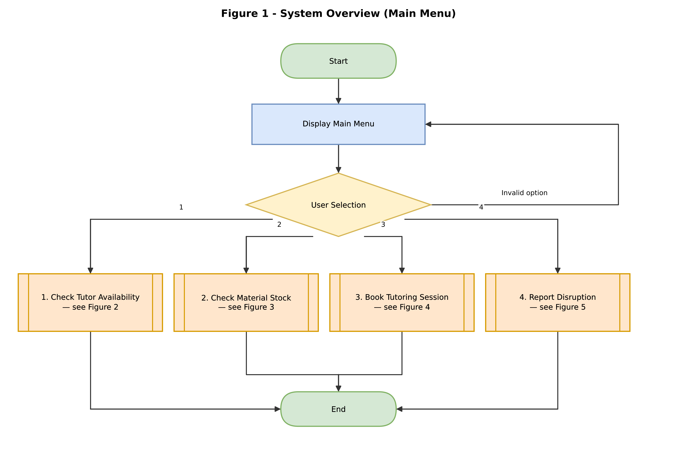
Figure 1: Main menu and routing to each module.

▎ Figure 2 — Check Tutor Availability
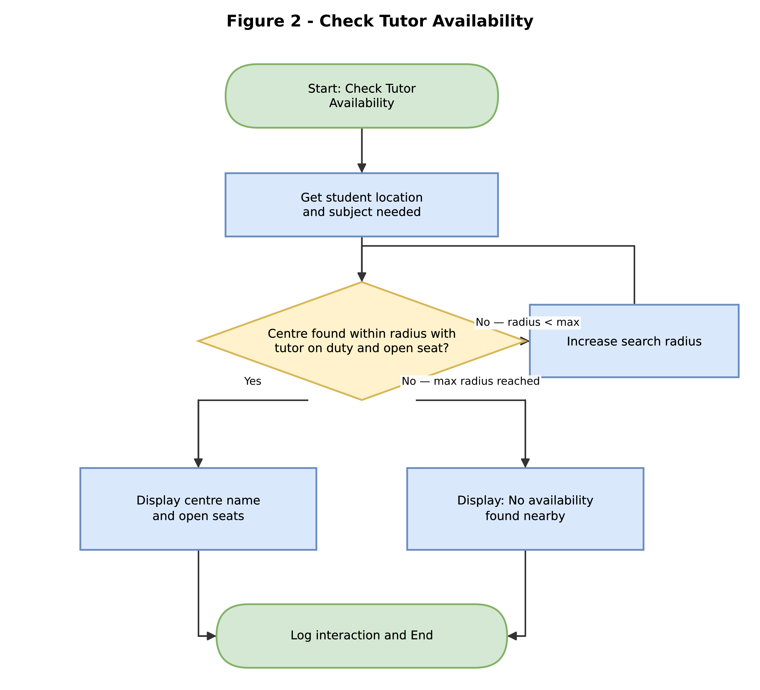
Figure 2: checkTutorAvailability() — expanding-radius search for a centre with a tutor on duty and an open seat.

▎ Figure 3 — Check Study Material Stock
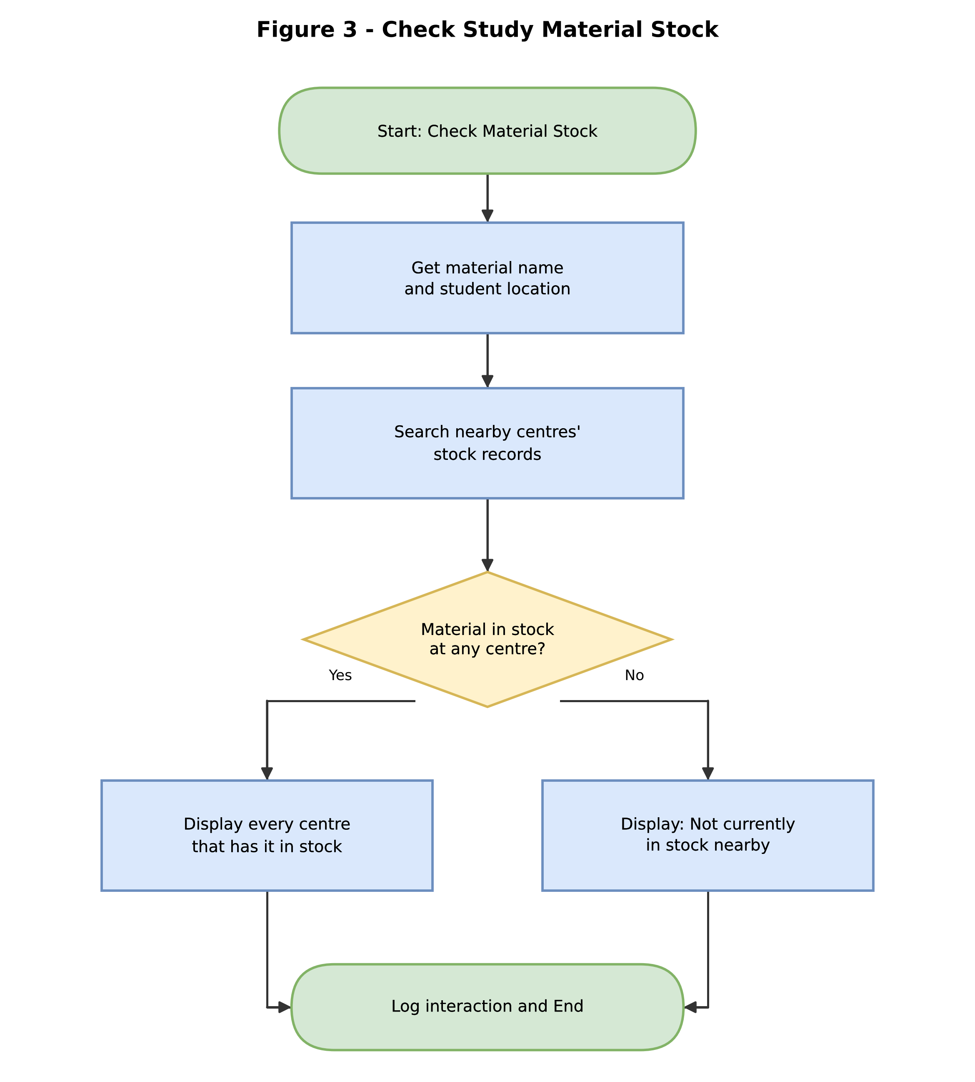
Figure 3: checkMaterialStock() — scans nearby centres' stock records for the requested study material.

▎ Figure 4 — Book Tutoring Session
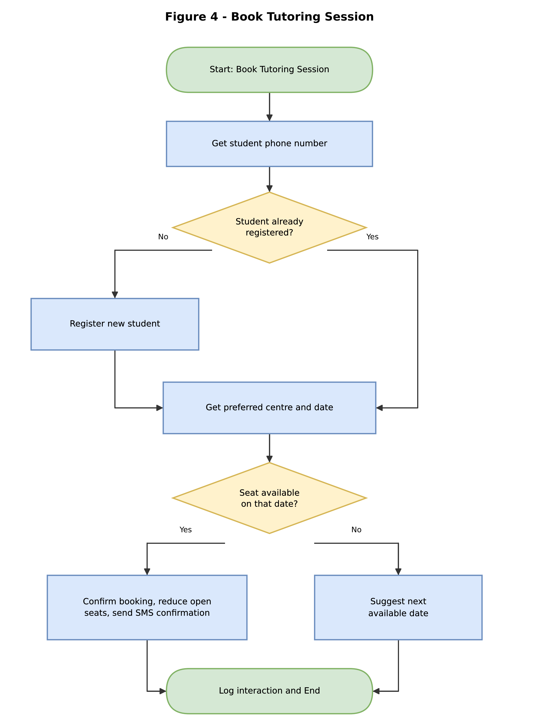
Figure 4: bookTutoringSession() — registers the student if needed, then confirms or suggests an alternative date.

▎ Figure 5 — Report School Disruption
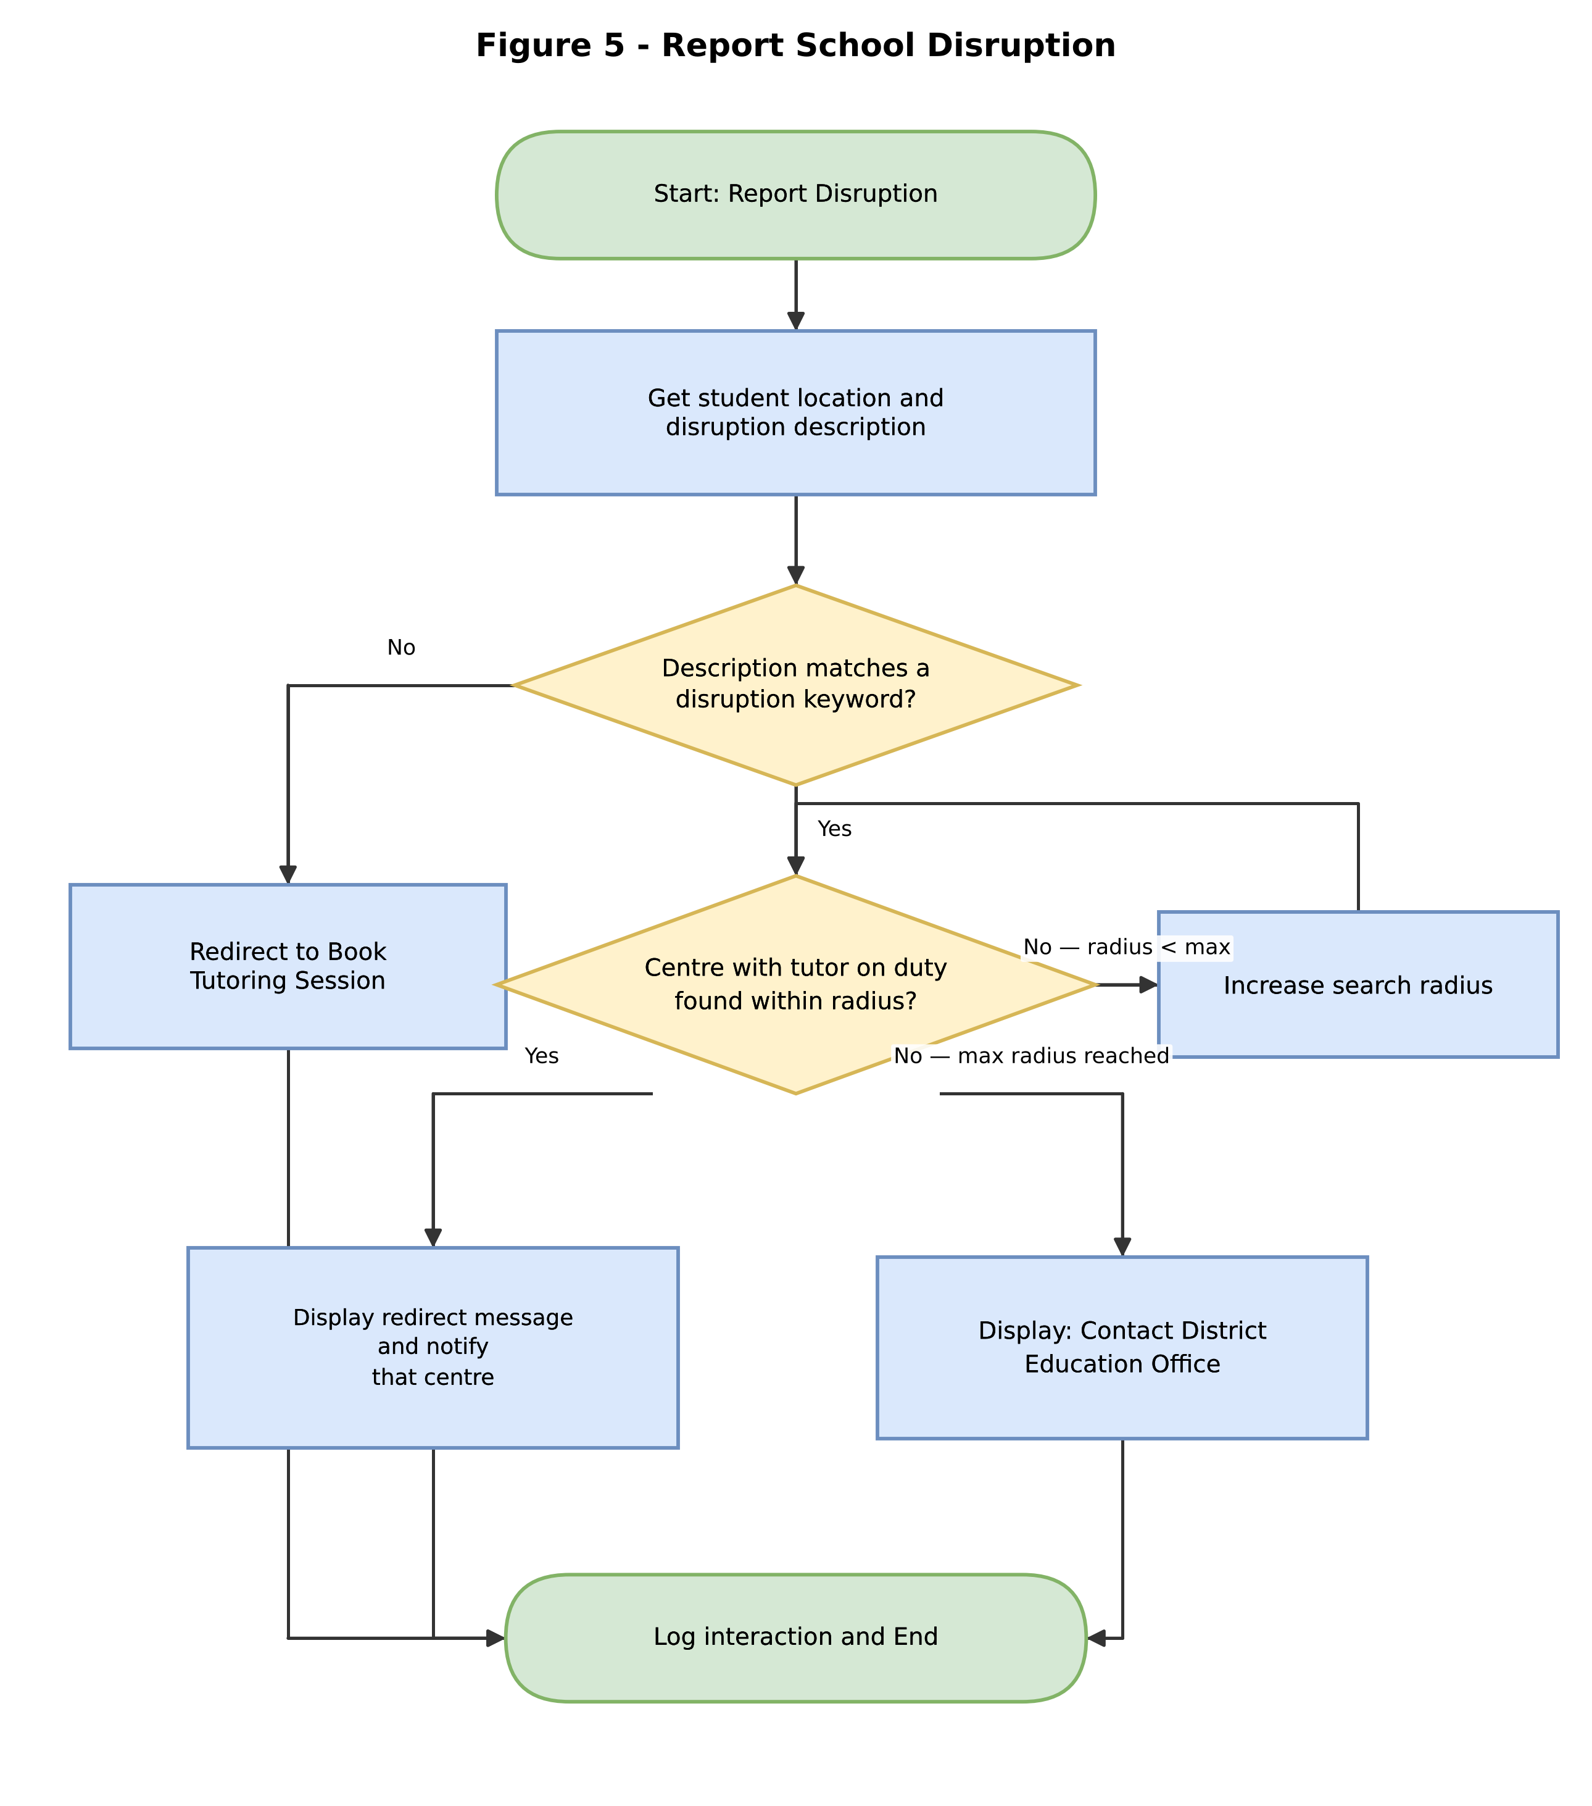
Figure 5: reportDisruption() — bypasses the open-seat requirement and searches only for a tutor on duty.

5. Functional Modules
The system is decomposed into nine independent, reusable modules, each with a single responsibility. This modular design means any one module (for example the disruption-report search logic) can be tested, maintained, or improved without affecting the others.
Module | Purpose | Inputs | Outputs
mainMenu() | Displays the menu and routes the user's choice. | userChoice | Calls routeRequest()
routeRequest(choice) | Decision structure that calls the correct module for the selected option. | choice | Module call
checkTutorAvailability() | Searches outward for a centre with a tutor on duty and an open seat. | studentLocation, subjectNeeded | List of available centres
checkMaterialStock() | Searches nearby centres' stock records for a named study material. | studentLocation, materialName | List of centres with stock
bookTutoringSession() | Registers the student if needed and books a confirmed seat. | studentPhone, centerID, date | Booking confirmation / SMS
reportDisruption() | Flags disruption keywords and searches outward for the nearest staffed centre. | studentLocation, disruptionDescription | Redirect message / DEO contact
registerStudent() | Creates a new student record. | name, age, phone, location | studentID
sendNotification(phone, msg) | Sends a confirmation or alert SMS. | phone, message | SMS sent
logInteraction() | Stores each session's outcome for reporting. | choice, outcome, timestamp | Log entry

6. Expected Outputs — Sample Scenarios
The scenarios below use the fixed five-centre sample dataset built into the Flowgorithm program (diagrams/EduLink.fprg), so they can be reproduced exactly by running that file -- these are not illustrative-only figures.
# | Learning Centre | Tutor on duty | Open seats | Past paper stock
1 | Njala Community School | Yes | 0
2 | Gondama Learning Hub | Yes | 4
3 | Kenema Secondary Resource Center | Yes | 6
4 | Bo Community Learning Center | No | 3
5 | Serabu Education Point | No | 0

▎ Scenario A: Routine tutor availability check (Menu option 1)
Input: Select "1. Check Tutor Availability".
Processing: The system scans centres nearest-first for the first one with both a tutor on duty and an open seat. Njala (#1) has a tutor but 0 open seats, so it is skipped; Gondama (#2) has a tutor and 4 open seats.
Output: "Gondama Learning Hub - 4 seat(s) available"

▎ Scenario B: Study material stock check (Menu option 2)
Input: Select "2. Check Study Material Stock" for BECE Mathematics Past Papers.
Processing: The system checks every centre's past-paper stock level, not just the nearest.
Output: "Kenema Secondary Resource Center has 15 copies in stock" and "Serabu Education Point has 8 copies in stock"

▎ Scenario C: Successful tutoring session booking (Menu option 3)
Input: Select "3. Book Tutoring Session", then enter centre number 2 (Gondama Learning Hub).
Processing: Gondama has 4 open seats, so the booking is confirmed.
Output: "Tutoring session confirmed at Gondama Learning Hub"

▎ Scenario D: School disruption report (Menu option 4)
Input: Select "4. Report School Disruption", then enter true when asked whether the school is currently disrupted.
Processing: Unlike Scenario A, this search only requires a tutor on duty -- it does not require an open seat, because a disrupted student cannot wait for a routine booking seat to free up. Njala (#1) is the nearest centre with a tutor, so it is selected immediately even though Scenario A had to skip it for having no open seats.
Output: "REDIRECT: Nearest open centre is Njala Community School"
This contrast between Scenario A and Scenario D is deliberate: it demonstrates why the disruption-report branch is a separate module with its own, less restrictive condition, rather than reusing the availability-check logic.

7. GitHub Repository Evidence
This project's report, pseudocode, and flowchart source (both the diagrams.net/Draw.io file behind the five figures in Section 4, EduLink.drawio, and the runnable Flowgorithm program, EduLink.fprg) are version-controlled in a GitHub repository named using the required convention PROG101_Assignment1_StudentName_StudentID. The repository contains a README.md describing the project, the pseudocode file, the flowchart source files, and this report, with regular commits made during development.
Repository URL: [Insert GitHub repository URL once the repository has been created and pushed]
Insert a screenshot of the repository's file listing below before printing.
[ Insert repository file-listing screenshot here ]
Insert a screenshot of the commit history below before printing.
[ Insert commit-history screenshot here ]

8. References
- United Nations. (2015). Sustainable Development Goal 4: Quality Education. https://sdgs.un.org/goals/goal4
- Digital Public Goods Alliance. (n.d.). Digital Public Goods Standard. https://digitalpublicgoods.net/standard/
- World Bank. (2022). Sierra Leone Education Sector and Digital Learning Overview. https://www.worldbank.org
- GSMA. (2023). The Mobile Economy: Sub-Saharan Africa. https://www.gsma.com
- Limkokwing University of Creative Technology, Sierra Leone. (2026). PROG101: Principles of Programming Logic and Design — Assignment Brief.
- JGraph Ltd (diagrams.net / Draw.io). (n.d.). Documentation. https://www.drawio.com/doc/

