医学信息集成技术实验报告

学 号： | 1519640532 | 姓 名： | 戴维 | 实验成绩：
实验名称： | HL7消息处理类设计 |  |  | 实验日期： | 2019-11-18
- 实验目的：
对一个基本的ACK消息进行构造，建立其各段、字段、组件、子组件的定义。
- 实验内容：
- 实现容器构件子类：
- 建立compositeMessage消息容器类：从compositeType类派生，在构造函数中为基类构造函数传递参数，详细实现并编译通过。
- 通过在类图中复制然后改名的方法建立其他类：compositeSegment段容器类和compositField字段容器类 。
- 在compositeSegment类中添加以下成员：
    - 重写方法public override bool Parse(string text)：去除text中的段名，然后调用基类的Parse。
    - 重写方法public override string ToString()：需要在基类的ToString方法上添加段名。

- 实现具体字段容器构件类(使用实验三的代码生成器)
- 建立HD类：从compositField类派生。打开HL7profile的ACK_1.3.6.1.4.12559.11.1.1.6.xml文件，找到其中的HD定义如下，选中后粘贴到代码生成器中：
所生成的代码具有以下成员：
    - 构造函数public HD(): 为基类构造函数传递参数，并按上表建立有3个元素的子组件数组，每个子组件分别以子组件名为实参构造其对应类型对象
    - 可读可写属性public IS NamespaceID: 对data[0]进行读写访问
    - 可读可写属性public ST UniversalID: 对data[1]进行读写访问
    - 可读可写属性public ID UniversalIDType: 对data[2]进行读写访问
- 按照上述方法添加其他复合类型字段类：VID, MSG, PT, EI......
- 添加单元测试，并测试通过。
- 实现具体段容器构件类(可使用修改的代码生成器)
- 建立MSA类：从compositeSegment类派生。从ACK_1.3.6.1.4.12559.11.1.1.6.xml文件中可见 ，该段具有6个字段：
据此添加如下类成员：

    - 构造函数public MSA(abstractType parent): 为基类构造函数提供参数(parent, “MSA”)，并创建有6个元素的子组件数组，分别用元素名称为参数(其中复合类型类的第一个参数为this)实例化ID、ST、ST、NM、ID、CE类对象
    - 可读可写属性public ID AcknowledgementCode: 对data[0]进行读写访问
    - 可读可写属性public ST MessageControlID: 对data[1]进行读写访问
    - 可读可写属性public ST TextMessage: 对data[2]进行读写访问
    - 可读可写属性public NM ExpectedSequenceNumber: 对data[3]进行读写访问
    - 可读可写属性public ID DelayedAcknowledgmentType: 对data[4]进行读写访问
    - 可读可写属性public CE ErrorCondition: 对data[5]进行读写访问
- 按照上述方法添加其他段类型（必要时添加其他具体字段容器构件类）：MSH(注意MSH段需重写Parse和ToString方法，做特殊处理)、ERR、EVN、PID、PV1。。。。。。
- 添加单元测试，并测试通过。
- 实现具体消息容器构件类
- 建立ACK类：从compositeMessage类派生。从ACK段定义表可知，该消息具有3个子组件，据此添加如下类成员：

    - 构造函数public ACK(): 为基类构造函数提供参数(null, “ACK”)，并创建有3个元素的子组件数组，分别用(this, 元素名称)为参数实例化MSH、MSA、ERR类对象
    - 可读可写属性public MSH msh: 对data[0]进行读写访问
    - 可读可写属性public MSA msa: 对data[1]进行读写访问
    - 可读可写属性public ERR err: 对data[2]进行读写访问
2．按照上述方法添加其他消息类型：
- 程序及注释：
Messages

using System;
using System.Collections.Generic;
using System.Linq;
using System.Text;
using System.Threading.Tasks;

namespace HL7Lib
{
public class ACK:Message
{
public MSH msh
{
get { return data[0] as MSH; }
set { data[0] = value; }
}

public MSA msa
{
get { return data[1] as MSA; }
set { data[0] = value; }
}
public ERR err
{
get { return data[2] as ERR; }
set { data[0] = value; }
}

public ACK(AbstractType parent,string name) : base(null, name)
{
data = new Segment[3];
data[0] = new MSH(this,"MSH");
data[1] = new MSA(this, "MSA");
data[2] = new ERR(this, "ERR");
}
public override string ToString()
{
return this.value;
}
}
}

Segments
using System;
using System.Collections.Generic;
using System.Linq;
using System.Text;
using System.Threading.Tasks;

namespace HL7Lib
{
/// <summary>
/// EVN段,待完善
/// </summary>
public class EVN : Segment
{

public EVN(Message parent,string name):base(parent,name)
{

}

public override string ToString()
{
throw new NotImplementedException();
}
}

/// <summary>
/// MSH段
/// </summary>
public class MSH : Segment
{
public ST FieldSeparator {
get { return data[0] as ST; }
set { data[0] = value; }
}
public ST EncodingCharacters
{
get { return data[1] as ST; }
set { data[1] = value; }
}
public HD SendingApplication
{
get { return data[2] as HD; }
set { data[2] = value; }
}
public HD SendingFacility
{
get { return data[3] as HD; }
set { data[3] = value; }
}
public HD ReceivingApplication
{
get { return data[4] as HD; }
set { data[4] = value; }
}
public HD ReceivingFacility
{
get { return data[5] as HD; }
set { data[5] = value; }
}
public TS DateTimeOfMessage
{
get { return data[6] as TS; }
set { data[6] = value; }
}
public ST Security
{
get { return data[7] as ST; }
set { data[7] = value; }
}
public MSG MessageType
{
get { return data[8] as MSG; }
set { data[8] = value; }
}
public ST MessageControlID
{
get { return data[9] as ST; }
set { data[9] = value; }
}
public PT ProcessingID
{
get { return data[10] as PT; }
set { data[10] = value; }
}
public VID VersionID
{
get { return data[11] as VID; }
set { data[11] = value; }
}
public NM SequenceNumber
{
get { return data[12] as NM; }
set { data[12] = value; }
}
public ST ContinuationPointer
{
get { return data[13] as ST; }
set { data[13] = value; }
}
public ID AcceptAcknowledgmentType
{
get { return data[14] as ID; }
set { data[14] = value; }
}
public ID ApplicationAcknowledgmentType
{
get { return data[15] as ID; }
set { data[15] = value; }
}
public ID CountryCode
{
get { return data[16] as ID; }
set { data[16] = value; }
}
public ID CharacterSet
{
get { return data[17] as ID; }
set { data[17] = value; }
}
public CE PrincipalLanguageOfMessage
{
get { return data[18] as CE; }
set { data[18] = value; }
}
public ID AlternateCharacterSetHandlingScheme
{
get { return data[19] as ID; }
set { data[19] = value; }
}
public EI MessageProfileIdentifier
{
get { return data[20] as EI; }
set { data[20] = value; }
}
public MSH(Message parent, string name) : base(parent, name)
{
data = new AbstractType[21];
data[0] = new ST("Field Separator");
data[1] = new ST("Encoding Characters");
data[2] = new HD(this, "Sending Application");
data[3] = new HD(this, "Sending Facility");
data[4] = new HD(this, "Receiving Application");
data[5] = new HD(this, "Receiving Facility");
data[6] = new TS("Date/Time Of Message");
data[7] = new ST("Security");
data[8] = new MSG(this, "Message Type");
data[9] = new ST("Message Control ID");
data[10] = new PT(this, "Processing ID");
data[11] = new VID(this, "Version ID");
data[12] = new NM("Sequence Number");
data[13] = new ST("Continuation Pointer");
data[14] = new ID("Accept Acknowledgment Type");
data[15] = new ID("Application Acknowledgment Type");
data[16] = new ID("Country Code");
data[17] = new ID("Character Set");
data[18] = new CE(this, "Principal Language Of Message");
data[19] = new ID("Alternate Character Set Handling Scheme");
data[20] = new EI(this,"Message Profile Identifier");
}

public override string ToString()
{
return value.Substring(4);
}

public override bool Parse(string text)
{
this.value = text;

string[] splitResult = text.Split(this.delimiter);
try
{
for (int i = 0; i < data.Length; i++)
{
if (splitResult[i] == null || splitResult[i].Length == 0) continue;
data[i].Parse(splitResult[i]);
}
}
catch { }
data[0].Value = text[3].ToString();
return true;
}
}

/// <summary>
/// MSA段
/// </summary>
public class MSA : Segment
{
public ID AcknowledgmentCode
{
get { return data[0] as ID; }
set { data[0] = value; }
}
public ST MessageControlID
{
get { return data[1] as ST; }
set { data[1] = value; }
}
public ST TextMessage
{
get { return data[2] as ST; }
set { data[2] = value; }
}
public NM ExpectedSequenceNumber
{
get { return data[3] as NM; }
set { data[3] = value; }
}
public ID DelayedAcknowledgmentType
{
get { return data[4] as ID; }
set { data[4] = value; }
}
public CE ErrorCondition
{
get { return data[5] as CE; }
set { data[5] = value; }
}

public MSA(Message parent, string name) : base(parent, name)
{
data = new AbstractType[6];
data[0] = new ID("Field Separator");
data[1] = new ST("Encoding Characters");
data[2] = new ST("Sending Application");
data[3] = new NM("Sending Facility");
data[4] = new ID("Receiving Application");
data[5] = new CE(this, "Receiving Facility");
}

public override string ToString()
{
return value;
}
}

/// <summary>
/// ERR段
/// </summary>
public class ERR : Segment
{
public ELD ErrorCodeandLocation
{
get { return data[0] as ELD ; }
set { data[0] = value; }
}
public ERL ErrorLocation
{
get { return data[1] as ERL; }
set { data[1] = value; }
}
public CWE HL7ErrorCode
{
get { return data[2] as CWE; }
set { data[2] = value; }
}
public ID Severity
{
get { return data[3] as ID; }
set { data[3] = value; }
}
public CWE ApplicationErrorCode
{
get { return data[4] as CWE; }
set { data[4] = value; }
}
public ST ApplicationErrorParameter
{
get { return data[5] as ST; }
set { data[5] = value; }
}
public TX DiagnosticInformation
{
get { return data[6] as TX; }
set { data[6] = value; }
}
public TX UserMessage
{
get { return data[7] as TX; }
set { data[6] = value; }
}
public IS InformPersonIndicator
{
get { return data[7] as IS; }
set { data[6] = value; }
}
public CWE OverrideType
{
get { return data[8] as CWE; }
set { data[8] = value; }
}
public CWE OverrideReasonCode
{
get { return data[9] as CWE; }
set { data[9] = value; }
}
public XTN HelpDeskContactPoint
{
get { return data[10] as XTN; }
set { data[10] = value; }
}

public ERR(Message parent, string name) : base(parent, name)
{

}

public override string ToString()
{
return base.ToString();
}
}
}

复杂字段
using System;
using System.Collections.Generic;
using System.Linq;
using System.Text;
using System.Threading.Tasks;

namespace HL7Lib
{
/// <summary>
/// 字段HD，复杂类型
/// </summary>
public class HD : compositeField
{
public IS NamespaceID
{
get { return (IS)data[0]; }
set { }
}
public ST UniversalID
{
get { return (ST)data[1]; }
set { }
}
public ID UniversalIDType
{
get { return (ID)data[2]; }
set { }
}

public override string ToString()
{
return base.ToString();
}

public HD(CompositeType parent, string name) : base(parent, name)
{
data = new AbstractType[3];
data[0] = new IS("NamespaceID");
data[1] = new ST("UniversalID");
data[2] = new ID("UniversalIDType");
}
}

/// <summary>
/// 字段MSG，复杂类型
/// </summary>
public class MSG : compositeField
{
public ID MessageCode
{
get { return data[0] as ID; }
set { data[0] = value; }
}
public ID TriggerEvent
{
get { return data[1] as ID; }
set { data[1] = value; }
}
public ID MessageStructure
{
get { return data[2] as ID; }
set { data[2] = value; }
}

public MSG(CompositeType parent, string name) : base(parent, name)
{
data = new AbstractType[3];
data[0] = new ID("MessageCode");
data[1] = new ID("TriggerEvent");
data[2] = new ID("MessageStructure");
}
public override string ToString()
{
return base.ToString();
}
}

/// <summary>
/// 字段EI，复杂类型
/// </summary>
public class EI : compositeField
{
public ST EntityIdentifier
{
get { return data[0] as ST; }
set { data[0] = value; }
}
public IS NamespaceID
{
get { return data[1] as IS; }
set { data[1] = value; }
}
public ID UniversalIDType
{
get { return data[2] as ID; }
set { data[2] = value; }
}

public EI(CompositeType parent, string name) : base(parent, name)
{
data = new AbstractType[3];
data[0] = new ST("EntityIdentifier");
data[1] = new IS("NamespaceID");
data[2] = new ID("UniversalIDType");
}
public override string ToString()
{
return base.ToString();
}
}

/// <summary>
/// 字段CE，复杂类型
/// </summary>
public class CE : compositeField
{
public ST Identifier
{
get { return data[0] as ST; }
set { data[0] = value; }
}
public ST Text
{
get { return data[1] as ST; }
set { data[1] = value; }
}
public ID NameOfCodingSystem
{
get { return data[2] as ID; }
set { data[2] = value; }
}
public ST AlternateIdentifier
{
get { return data[3] as ST; }
set { data[3] = value; }
}
public ST AlternateText
{
get { return data[4] as ST; }
set { data[4] = value; }
}
public ID NameOfAlternateCodingSystem
{
get { return data[5] as ID; }
set { data[5] = value; }
}

public CE(CompositeType parent, string name) : base(parent, name)
{
data = new AbstractType[6];
data[0] = new ST("Identifier");
data[1] = new ST("Text");
data[2] = new ID("NameOfCodingSystem");
data[3] = new ST("AlternateIdentifier");
data[4] = new ST("AlternateText");
data[5] = new ID("NameOfAlternateCodingSystem");
}
public override string ToString()
{
return base.ToString();
}
}

/// <summary>
/// 字段VID，复杂类型
/// </summary>
public class VID : compositeField
{
public ID VersionID
{
get { return data[0] as ID; }
set { data[0] = value; }
}
public CE Internationalizationcode
{
get { return data[1] as CE; }
set { data[1] = value; }
}
public CE InternationalVersionID
{
get { return data[2] as CE; }
set { data[2] = value; }
}

public VID(CompositeType parent, string name) : base(parent, name)
{
data = new AbstractType[3];
data[0] = new ID("VersionID");
data[1] = new CE(this,"Internationalizationcode");
data[2] = new CE(this,"InternationalVersionID");
}
public override string ToString()
{
return base.ToString();
}
}

/// <summary>
/// 字段PT，复杂类型
/// </summary>
public class PT : compositeField
{
public ID ProcessingID
{
get { return data[0] as ID; }
set { data[0] = value; }
}
public ID ProcessingMode
{
get { return data[1] as ID; }
set { data[1] = value; }
}

public PT(Segment parent, string name) : base(parent, name)
{
data = new AbstractType[2];
data[0] = new ID("ProcessingID");
data[1] = new ID("ProcessingMode");
}
public override string ToString()
{
return base.ToString();
}
}
/// <summary>
/// 字段ELD，复杂类型
/// </summary>
public class ELD : compositeField
{
public ST SegmentID
{
get { return data[0] as ST; }
set { data[0] = value; }
}
public NM SegmentSequence
{
get { return data[1] as NM; }
set { data[1] = value; }
}
public NM FieldPosition
{
get { return data[2] as NM; }
set { data[2] = value; }
}
public CE CodeIdentifyingError
{
get { return data[3] as CE; }
set { data[3] = value; }
}

public ELD(Segment parent, string name) : base(parent, name)
{
data = new AbstractType[4];
data[0] = new ST("SegmentID");
data[1] = new NM("SegmentSequence");
data[2] = new NM("FieldPosition");
data[3] = new CE(this, "CodeIdentifyingError");
}
public override string ToString()
{
return base.ToString();
}

}

/// <summary>
/// 字段ERL，复杂类型
/// </summary>
public class ERL : compositeField
{
public ST SegmentID
{
get { return data[0] as ST; }
set { data[0] = value; }
}
public NM SegmentSequence
{
get { return data[1] as NM; }
set { data[1] = value; }
}
public NM FieldPosition
{
get { return data[2] as NM; }
set { data[2] = value; }
}
public NM FieldRepeition
{
get { return data[3] as NM; }
set { data[3] = value; }
}
public NM ComponentNumber
{
get { return data[4] as NM; }
set { data[4] = value; }
}
public NM SubComponentNumber
{
get { return data[5] as NM; }
set { data[5] = value; }
}

public ERL(Segment parent, string name) : base(parent, name)
{
data = new AbstractType[6];
data[0] = new ST("SegmentID");
data[1] = new NM("SegmentSequence");
data[2] = new NM("FieldPosition");
data[3] = new NM("FieldRepeition");
data[4] = new NM("ComponentNumber");
data[5] = new NM("SubComponentNumber");
}
public override string ToString()
{
return base.ToString();
}
}

/// <summary>
/// 字段CWE，复杂类型
/// </summary>
public class CWE : compositeField
{
public ST Identifier
{
get { return data[0] as ST; }
set { data[0] = value; }
}
public ST Text
{
get { return data[1] as ST; }
set { data[1] = value; }
}
public ID NameOfCodingSystem
{
get { return data[2] as ID; }
set { data[2] = value; }
}
public ST AlternateIdentifier
{
get { return data[3] as ST; }
set { data[3] = value; }
}
public ST AlternateText
{
get { return data[4] as ST; }
set { data[4] = value; }
}
public ID NameOfAlternateCodingSystem
{
get { return data[5] as ID; }
set { data[5] = value; }
}
public ST CodingSystemVersionID
{
get { return data[6] as ST; }
set { data[6] = value; }
}
public ST AlternateCodingSystemVersionID
{
get { return data[7] as ST; }
set { data[7] = value; }
}
public ST OriginalText
{
get { return data[8] as ST; }
set { data[8] = value; }
}

public CWE(Segment parent, string name) : base(parent, name)
{
data = new AbstractType[9];
data[0] = new ST("Identifier");
data[1] = new ST("Text");
data[2] = new ID("NameOfCodingSystem");
data[3] = new ST("AlternateIdentifier");
data[4] = new ST("AlternateText");
data[5] = new ID("NameOfAlternateCodingSystem");
data[6] = new ST("CodingSystemVersionID");
data[7] = new ST("AlternateCodingSystemVersionID");
data[8] = new ST("OriginalText");
}
public override string ToString()
{
return base.ToString();
}
}

/// <summary>
/// 字段XTN，复杂类型
/// </summary>
public class XTN : compositeField
{
public ST TelephoneNumber
{
get { return data[0] as ST; }
set { data[0] = value; }
}
public ID TelecommunicationUseCode
{
get { return data[1] as ID; }
set { data[1] = value; }
}
public ID TelecommunicationEquipmentType
{
get { return data[2] as ID; }
set { data[2] = value; }
}
public ST EmailAddress
{
get { return data[3] as ST; }
set { data[3] = value; }
}
public NM CountryCode
{
get { return data[4] as NM; }
set { data[4] = value; }
}
public NM AreaCityCode
{
get { return data[5] as NM; }
set { data[5] = value; }
}
public NM LocalNumber
{
get { return data[6] as NM; }
set { data[6] = value; }
}
public NM Extension
{
get { return data[7] as NM; }
set { data[7] = value; }
}
public ST AnyText
{
get { return data[8] as ST; }
set { data[8] = value; }
}
public ST ExtensionPrefix
{
get { return data[9] as ST; }
set { data[9] = value; }
}
public ST SpeedDialCode
{
get { return data[10] as ST; }
set { data[10] = value; }
}
public ST UnformattedTelephoneNumber
{
get { return data[11] as ST; }
set { data[11] = value; }
}

public XTN(Segment parent, string name) : base(parent, name)
{
data = new AbstractType[12];
data[0] = new ST("TelephoneNumber");
data[1] = new NM("TelecommunicationUseCode");
data[2] = new NM("TelecommunicationEquipmentType");
data[3] = new NM("EmailAddress");
data[4] = new NM("CountryCode");
data[5] = new NM("AreaCityCode");
data[6] = new NM("LocalNumber");
data[7] = new NM("Extension");
data[8] = new NM("AnyText");
data[9] = new NM("ExtensionPrefix");
data[10] = new NM("SpeedDialCode");
data[11] = new NM("UnformattedTelephoneNumber");
}
public override string ToString()
{
return base.ToString();
}
}
}

简单字段
using System;
using System.Collections.Generic;
using System.Linq;
using System.Text;
using System.Threading.Tasks;

namespace HL7Lib
{
/// <summary>
/// 字段ID，简单类型
/// </summary>
public class ID : PrimitiveType
{
public ID(string name):base(name)
{
this.name = name;
}
public override string ToString()
{
return value;
}
public override bool Parse(string text)
{
this.value = text;
return true;
}
}

/// <summary>
/// 字段SI，简单类型
/// </summary>
public class SI : PrimitiveType
{
public SI(string name) : base(name)
{
this.name = name;
}
public override string ToString()
{
return value;
}
public override bool Parse(string text)
{
this.value = text;
return true;
}
}

/// <summary>
/// 字段TS，简单类型
/// </summary>
public class TS : PrimitiveType
{
public TS(string name) : base(name)
{
this.name = name;
}
public override string ToString()
{
return value;
}
public override bool Parse(string text)
{
this.value = text;
return true;
}
}

/// <summary>
/// 字段FT，简单类型
/// </summary>
public class FT : PrimitiveType
{
public FT(string name) : base(name)
{
this.name = name;
}
public override string ToString()
{
return value;
}
public override bool Parse(string text)
{
this.value = text;
return true;
}
}

/// <summary>
/// 字段TX，简单类型
/// </summary>
public class TX : PrimitiveType
{
public TX(string name) : base(name)
{
this.name = name;
}
public override string ToString()
{
return value;
}
public override bool Parse(string text)
{
this.value = text;
return true;
}
}

/// <summary>
/// 字段TN，简单类型
/// </summary>
public class TN : PrimitiveType
{
public TN(string name) : base(name)
{
this.name = name;
}
public override string ToString()
{
return value;
}
public override bool Parse(string text)
{
this.value = text;
return true;
}
}

/// <summary>
/// 字段TM，简单类型
/// </summary>
public class TM : PrimitiveType
{
public TM(string name) : base(name)
{
this.name = name;
}
public override string ToString()
{
return value;
}
public override bool Parse(string text)
{
this.value = text;
return true;
}
}

/// <summary>
/// 字段DT，简单类型
/// </summary>
public class DT : PrimitiveType
{
public DT(string name) : base(name)
{
this.name = name;
}
public override string ToString()
{
return value;
}
public override bool Parse(string text)
{
this.value = text;
return true;
}
}

/// <summary>
/// 字段ST，简单类型
/// </summary>
public class ST : PrimitiveType
{
public ST(string name) : base(name)
{
this.name = name;
}
public override string ToString()
{
return value;
}
public override bool Parse(string text)
{
this.value = text;
return true;
}
}

/// <summary>
/// 字段NM，简单类型
/// </summary>
public class NM : PrimitiveType
{
public NM(string name) : base(name)
{
this.name = name;
}
public override string ToString()
{
return value;
}
public override bool Parse(string text)
{
this.value = text;
return true;
}
}

/// <summary>
/// 字段IS，简单类型
/// </summary>
public class IS : PrimitiveType
{
public IS(string name) : base(name)
{
this.name = name;
}
public override string ToString()
{
return value;
}
public override bool Parse(string text)
{
this.value = text;
return true;
}
}
}

四.运行结果

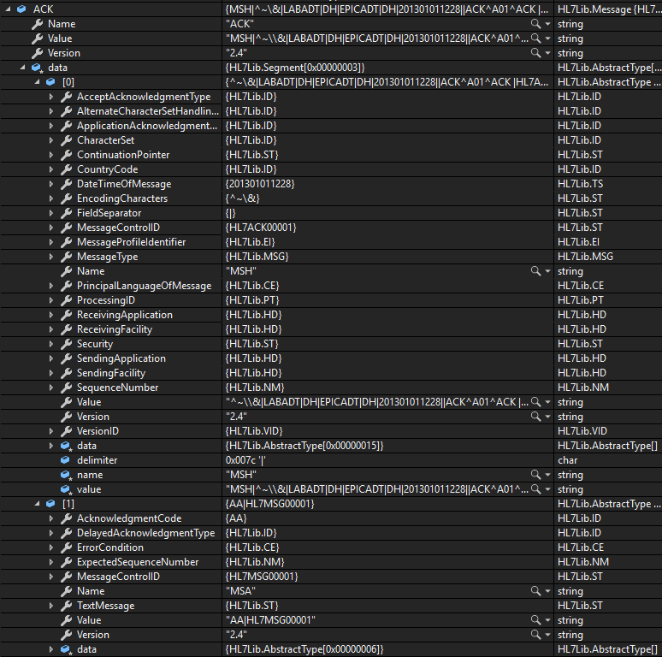
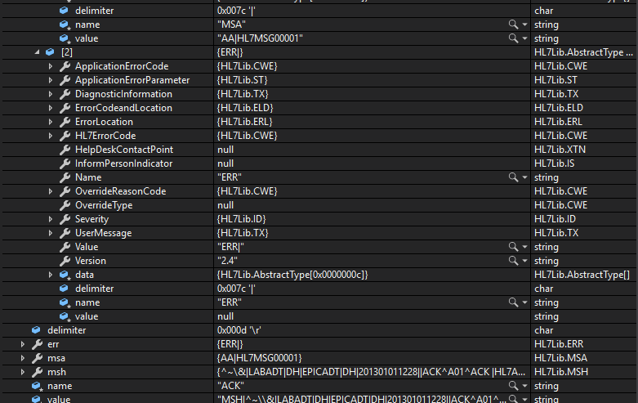
五.小结(不少于200字)
在本次实验中，通过之前实验的代码生成器，便捷地批量生成了段、复杂字段、复杂组件等复杂类型的定义代码，根据参考对应版本的HL7文档，对每个元素的定义进行了规范，增添get、set，重写parse、ToString等各种方法，对于每个元素进行修正，最终达成ACK消息的构成。
本次实验中，遇到了部分命名的问题。在给出的参考xml文件中，有的组件名中会带有斜杠/，或连接符-等情况，在C#的代码中无法用于对象命名，因此要进行单独处理，或在正则筛选时，考虑到这些特殊情况。

