医学信息集成技术实验报告

学 号： | 1519640532 | 姓 名： | 戴维 | 实验成绩：
实验名称： | HL7消息构造与解析 |  |  | 实验日期： | 2019-12-02
- 实验目的：
NHAPI库对HL7消息的操作。
- 实验内容：
- 用NHAPI库实现以下ADT消息的解析，并在界面中显示患者ID、姓名、性别、出生年月、联系地址、电话等信息。
MSH|^~\&|HIS||DRAGONRIS||201206281130||ADT^A01|MSG00005|P|2.4<cr>
EVN|A01|201206281130|||0148^Addison^James|201206281130<cr>
PID|||263656||张^三丰||1977-01-01|M|||北京市海淀区西直门外高梁桥斜街1号^人民医院||(010)62256622<cr>
PV1||I|神内^room1^bed4^^^住院楼^2||||||||||||||||3<cr>
提示：
- 引用类库NHapi.Base.dll Nhapi.Model.V24.dll
- 包含名字空间
using NHapi.Base;
using NHapi.Base.Parser;
using NHapi.Base.Model;
using NHapi.Model.V24;
using NHapi.Model.V24.Message;
using NHapi.Model.V24.Segment;
- 实例化PipeParser类
PipeParser parser = new PipeParser();
- 解析消息
IMessage m = parser.Parse(message);
- 强制转换消息
ADT_A01 adtA01 = m as ADT_A01;
- 获得消息各字段的值
  - 获取字段值: 消息对象名.段名.字段名.value
  - 获取组件值: 消息对象名.段名.字段名.组件名.value
  - 获取子组件值: 消息对象名.段名.字段名.组件名.子组件名.value
  - 获取重复字段值：消息对象名.段名.get字段名(0).组件名.value
消息对象名.段名.get字段名(1).组件名.value
- 用NHAPI库实现以下消息的构造：
MSH|^~\&|REGADT|MCM|IFENG||199901101501||ADT^A04|00001|P|2.4|<cr>
EVN|A04|199901101500|199901101400|01||199901101410<cr>
PID|||191919^^^GENHOS^MR~371-66-9256^^^USSSA^SS|253763|MASSIE^JAMES ^A||19560129|M|||171 ZOBERLEIN^^ISHPEMING^MI^49849^""^||(90 0)485-5344|(900)485-5344||S|C| 10199925^^^GENHOS^AN|371-66-9256||<cr>

- 程序及注释：
1.
PipeParser parser = new PipeParser();
string m = @"MSH|^~\&|HIS||DRAGONRIS||201206281130||ADT^A01|MSG00005|P|2.4
EVN|A01|201206281130|||0148^Addison^James|201206281130
PID|||263656||张^三丰||1977-01-01|M|||北京市海淀区西直门外高梁桥斜街1号^人民医院||(010)62256622
PV1||I|神内^room1^bed4^^^住院楼^2||||||||||||||||3
";
IMessage message = parser.Parse(m);
ADT_A01 adta01 = message as ADT_A01;
textBox1.Text = adta01.MSH.FieldSeparator.Value.ToString();
textBox2.Text = adta01.MSH.EncodingCharacters.Value.ToString();
textBox3.Text = adta01.MSH.DateTimeOfMessage.TimeOfAnEvent.Value.ToString();
textBox4.Text = adta01.MSH.MessageType.MessageType.Value.ToString() +
adta01.MSH.MessageType.TriggerEvent.Value.ToString();
textBox5.Text = adta01.MSH.MessageControlID.Value.ToString();
textBox6.Text = adta01.MSH.ProcessingID.ProcessingID.Value.ToString();
textBox7.Text = adta01.MSH.VersionID.VersionID.Value.ToString();
2.
ADT_A04 message = new ADT_A04();
message.MSH.FieldSeparator.Value = @"|";
message.MSH.EncodingCharacters.Value = @"^~\&";
message.MSH.SendingApplication.NamespaceID.Value = "REGADT";
message.MSH.SendingFacility.NamespaceID.Value = "MCM";
message.MSH.ReceivingApplication.NamespaceID.Value = "IFENG";
message.MSH.DateTimeOfMessage.TimeOfAnEvent.Value = "199901101501";
message.MSH.MessageType.MessageType.Value = "ADT";
message.MSH.MessageType.TriggerEvent.Value = "A04";
message.MSH.MessageControlID.Value = "00001";
message.MSH.ProcessingID.ProcessingID.Value = "P";
message.MSH.VersionID.VersionID.Value = "2.3.1";

message.EVN.EventTypeCode.Value = "A04";
message.EVN.RecordedDateTime.TimeOfAnEvent.Value = "199901101500";
message.EVN.DateTimePlannedEvent.TimeOfAnEvent.Value = "199901101400";
message.EVN.EventReasonCode.Value = "01";
message.EVN.EventOccurred.TimeOfAnEvent.Value = "199901101410";

message.PID.GetPatientIdentifierList(0).ID.Value= "191919";
message.PID.GetPatientIdentifierList(0).AssigningAuthority.NamespaceID.Value = "GENHOS";
message.PID.GetPatientIdentifierList(0).IdentifierTypeCode.Value = "MR";
message.PID.GetPatientIdentifierList(1).ID.Value = "371-66-9256";
message.PID.GetPatientIdentifierList(1).AssigningAuthority.NamespaceID.Value = "USSSA";
message.PID.GetPatientIdentifierList(1).IdentifierTypeCode.Value = "SS";
message.PID.GetAlternatePatientIDPID(0).ID.Value = "253763";
message.PID.GetPatientName(0).FamilyLastName.FamilyName.Value = "MASSIE";
message.PID.GetPatientName(0).GivenName.Value = "JAMES";
message.PID.GetPatientName(0).MiddleInitialOrName.Value = "A";
message.PID.DateTimeOfBirth.TimeOfAnEvent.Value = "19560129";
message.PID.Sex.Value = "M";
message.PID.GetPatientAddress(0).StreetAddress.Value = "171 ZOBERLEIN";
message.PID.GetPatientAddress(0).City.Value = "ISHPEMING";
message.PID.GetPatientAddress(0).StateOrProvince.Value = "MI";
message.PID.GetPatientAddress(0).ZipOrPostalCode.Value = "49849";
message.PID.GetPatientAddress(0).Country.Value = null;
message.PID.GetPhoneNumberHome(0).Get9999999X99999CAnyText.Value = "(90 0)485-5344";
message.PID.GetPhoneNumberBusiness(0).Get9999999X99999CAnyText.Value = "(900)485-5344";
message.PID.MaritalStatus.Identifier.Value = "S";
message.PID.Religion.Identifier.Value = "C";
message.PID.PatientAccountNumber.ID.Value = "10199925";
message.PID.PatientAccountNumber.AssigningAuthority.NamespaceID.Value = "GENHOS";
message.PID.PatientAccountNumber.IdentifierTypeCode.Value = "AN";
message.PID.SSNNumberPatient.Value = "371-66-9256";

PipeParser parser = new PipeParser();

richTextBox1.Text = parser.Encode(message);
四.运行结果
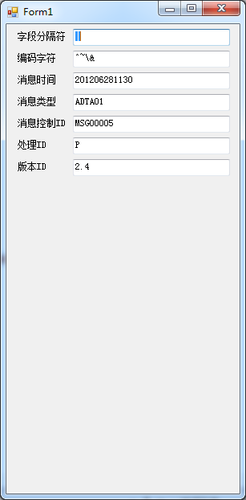
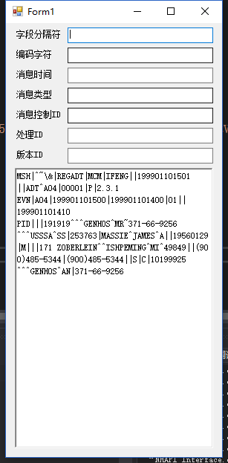
五.小结(不少于200字)
本次实验中，采用基于Java的HL7消息处理库HAPI的.NET框架NHAPI，对HL7消息进行简单的实例化创建、解析等操作。
本实验中要注意区分HL7的不同版本。对于不同的版本，字段、组件可能会有不同的定义或位置变更等。如在2.3.1版本之后，已经废弃ADT_04的消息类型。在编码时，要注意翻查文档，对相应版本的HL7消息进行查验审核。
另，多元素（如可重复字段）采用其对应的Get方法进行更新，简单元素可以直接更新其Value值。空值元素（“”）尚未找到相应操作介绍，此点存疑。

