Cheerios effect controlled by magnetowetting

Yu-Chin Chien and Huei Chu Weng*

Department of Mechanical Engineering, Chung Yuan Christian University, Taoyuan 32023, Taiwan
* Corresponding author. Tel.: +886-3-2654311; Email: hcweng@cycu.edu.tw

ABSTRACT The Cheerios effect is an attraction or repulsion phenomenon due to wetting properties existing between floating objects or between floating objects and the wall surfaces [1]. This interesting phenomenon usually causing the small objects floating in liquid tends to assemble together or stick to the sidewall [2-3]. In nature, some water-dwelling creatures even utilize this phenomenon to climb up the water bank [4-6]. Recently, Yuan et al. [7] introduces control of the Cheerios effect adopting electrowetting on dielectric. Therefore, the repulsive and attractive forces on the floating objects can be controlled by applying an electrical potential. On the other hands, the magnetic nanofluids also provide a simple way for switching the repulsive and attractive force with an applied magnetic field. This paper presents an experimental study on the Cheerios effect of the small objects floating in magnetic nanofluids under an applied magnetic field. The control concept of Cheerios effect controlled by magnetowetting is shown in Figure 1. As the wall and the floating object both are hydrophobic, the wall would attract the object. When the wall is switched to hydrophilic state by applying magnet, the wall would repulse the object. To investigate the Cheerios effect, the stable water-based magnetic nanofluids are first prepared by linking the co-precipation [8] and sol-gel methods. Then, the floating objects are manufactured by the 3-D printer. For the magnetowetting wall, two types of surfaces (hydrophilic and hydrophobic) are treated by sticking the hydrophobic materials. Finally, an experimental setup is used to measure the floating object motion. After CCD camera record the displacement of the floating object, the repulsive or attractive forces are calculated. According to magnetowetting, the floating objects can be switched by controlling the wettability of the wall surface.

Keywords: Magnetic nanofluids, Magnetowetting, Cheerios effect, Wetting properties

REFERENCES
- Vella, D. and Manadevan, L., 2005, “The “Cheerios effect”,” Am. J. Phys., 73, 817–825.
- Walker, J., 1977, The Flying Circus of Physics, Wiley, New York.
- Nicolson, M. M., 1949, “The interaction between floating particles,” Proc. Cambridge Philos. Soc., 45, 288–295
- Hu, D. L. and Bush, J. W., 2005, “Meniscus-climbing insects,” Nature, 437, 733–736.
- Yu, Y., Guo, M., Li, X., and Zheng, Q. S., 2007, “Meniscus-climbing behavior and its minimum free-energy mechanism,” Langmuir., 23, 10546–10550.
- Yuan, J. and Cho, S. K., 2012, “Bio-inspired micro/mini propulsion at air-water interface: A review,” J. Mech. Sci. Technol., 26, 3761–3768.
- Yuan, J., Feng, J., and Cho, S. K., 2015, “Cheerios Effect Controlled be Electrowetting,” Langmuir., 31, 8502–8511.
- 下飯坂潤三, 1966, “粉體の液像中における凝集分散,” 粉体および粉末冶金, 12, 263–274.

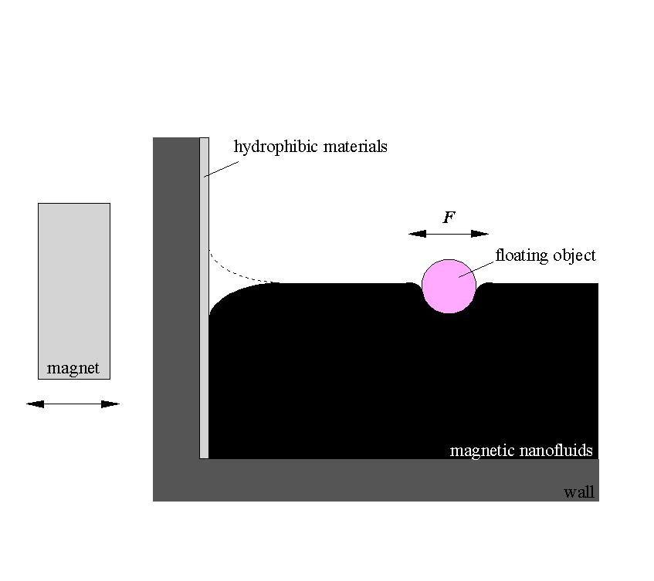
Figure 1. Control concept of Cheerios effect controlled by magnetowetting.

