Magnetic-assisted rapid aptamer selection (MARAS) & new biomedical application horizon of aptamer

Chin-Yih Hong*

Graduate Institute of Biomedical Engineering, National Chung Hsing University, Taichung, Taiwan
* Corresponding author. Tel.: +886-4-22840733; Email: cyhong@dragon.nchu.edu.tw

ABSTRACT
Systematic Evolution of Ligands by EXponential enrichment (SELEX) was originally developed during the early 1990s. The SELEX protocol is an in vitro selection method for isolating DNA or RNA sequences. The basic steps of the SELEX process are incubation, separation, elution, amplification, and single-strand oligonucleotide purification; this is usually repeated for five to fifth selected rounds. Therefore, the aptamer generation using SELEX or its modified protocols is time consuming and technically difficult that limits the popularity of aptamer application. Recently, the Magnetic-Assisted Rapid Aptamer Selection (MARAS) method has been reported to generate high-binding affinity aptamers [1]. The MARAS method does not require the repeated selection cycles to produce high-affinity aptamers and the generation of suitable aptamers using MARAS protocol becomes easy and rapid. Therefore, the new horizon in biomedical application using aptamers as capture ligands is emerged. In this talk, the new applications, including aptamer-based clinical assays [2] and multiplex immunoassay utilizing differential affinity [3], will be discussed and results will be presented.
For the aptamer-based clinical assays, aptamers were generated from a randomized oligonucleotide library via RO-MARAS using C-reactive protein (CRP) as the target. Figure 1 shows the results of the comparison of measuring CRP concentration in forty blind clinical serum samples using aptamer-based q-PCR method and monoclonal antibody-based nephelometry method. Results indicate that the two analysis methods, aptamer-based q-PCR (without/with primer) and monoclonal antibody-based nephelometry, were highly consistent by analyzing CRP concentration in blind serum samples. For the multiplex immunoassays utilizing differential affinity, the aptamer capable of conjugating with multiple targets having different affinities were generated using window-MARAS. Figure 2 shows the results of the recovered target quantities in both binding buffer and three serum samples by using the reagent composing of the generated aptamer as the capture probe. These results indicate that if affinity between aptamer and targets can be controlled at a desired range, it is possible to synthesize reagent capable of performing multiplex immunoassays utilizing different affinities, especially for the disease diagnosis in clinical applications.

Keywords: SELEX, MARAS, aptamer, multiplex immunoassays, differential affinity

REFERENCES
- Ji-Ching Lai and Chin-Yih Hong, 2014 “Magnetic-Assisted Rapid Aptamer Selection (MARAS) for Generating High-Affinity DNA Aptamer Using Rotating Magnetic Fields,” ACS Combinatorial Science, 16, 321-327.
- Huan-Hao Li, Chih-Yung Wen, Chin-Yih Hong, and Ji-Ching Lai, 2017 “Evaluation of Aptamer Specificity with or without Primers Using Clinical Samples for C-reactive Protein by Magnetic-Assisted Rapid Aptamer Selection,” RSC Adv., 7, 42856-42865.
- Lai J C, Horng HE, and Hong CY, 2017 “Multiplex Immunoassays Utilizing Differential Affinity Using Aptamers Generated by MARAS,” Sci. Rep., 7, 6397; doi:10.1038/s41598-017-06950-1.

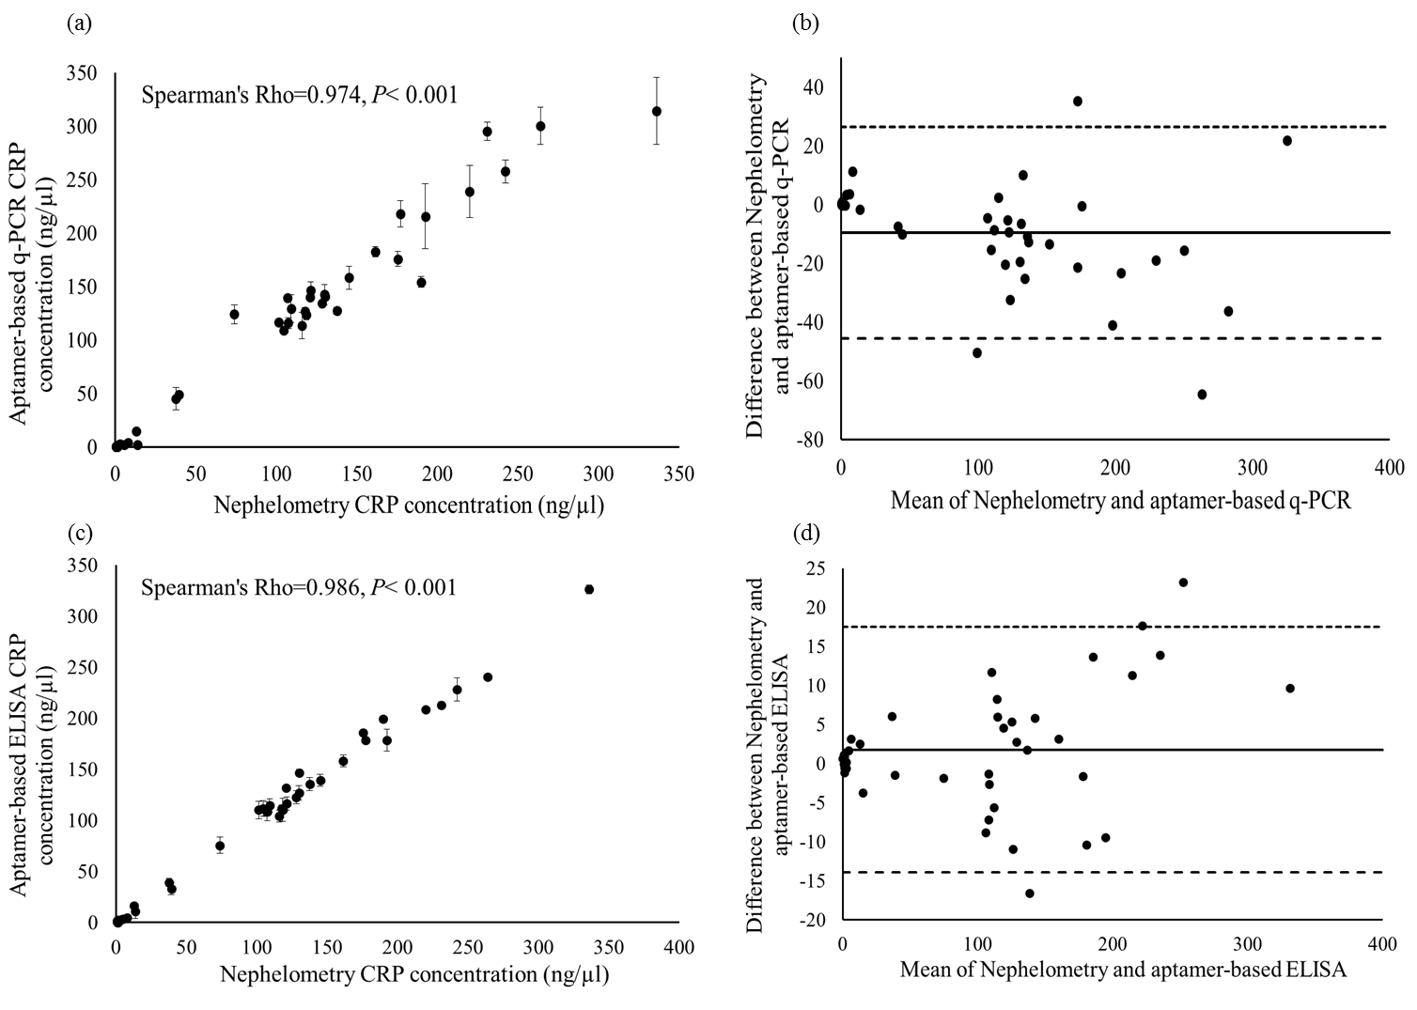
Figure 1. Comparison of the measured CRP concentration using aptamer-based q-PCR method and aptamer-based ELISA method vs. monoclonal antibody-based nephelometry method for blind serum samples. (a) q-PCR vs. nephelometry and (c) ELISA vs. nephelometry; (b) and (d) Bland-Altman plot analyses of the CRP concentrations measured by monoclonal antibody-based nephelometry method vs. aptamer-based q-PCR and ELISA method, respectively.
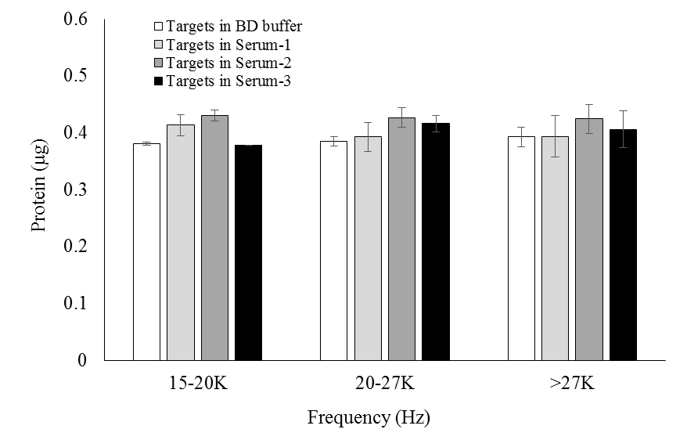
Figure 2. The recovered quantities of spiked target analytes in samples using the MP-1 aptamer as a capture ligand.

