Precision Processing Utilizing Magnetic Compound Fluid and Evaluation of Magnetic Cluster Behavior During Processing

Hisashi Yamamoto¹, Hitoshi Nishida¹, Noboru Momose¹,
Shinji Ikeda¹ and Yasushi Ido²

¹National Institute of Technology, Toyama College, Hongo-machi, Toyama, Toyama, Japan
²Nagoya Institute of Technology, Gokiso-cho, Showa-ku, Nagoya, Aichi, Japan
*Corresponding author. Tel.: +81-76-493-5465; Email: h.yamamoto@nc-toyama.ac.jp

ABSTRACT In this study, we propose the processing of the inner surface of cylindrical parts with a magnetic compound fluid (MCF). We evaluate the processing characteristics of material removal and the changes in surface roughness and roundness. The processing tool consists of a round SUS bar and a permanent magnet inserted in it. Processing was performed by coaxial and eccentric processing, as shown in the experimental apparatus in Figure 1. In the processing experiments, the material removal value (Figure 2) and the surface roughness obtained peak values as the processing surface shear rate increased. An observation experiment was then conducted to clarify the behavior of the magnetic clusters during the MCF processing. Moreover, we clarified the clusters’ shape and distribution (Figure 3) and the processing speeds at various rotation speeds of the processing tool. The magnetic clusters expanded with the existence region in the material removal peak.

Keywords: Magnetic compound fluid, honing, processing characteristic, magnetic cluster, visualization

REFERENCES
- T. Furuya, Y. Wu, M. Nomura, K. Shimada, K. Yamamoto, 2008, “Fundamental performance of magnetic compound fluid polishing liquid in contact-free polishing of metal surface,” Journal of Materials Processing Technology, vol. 201, Nos. 1–3, pp. 536–541
- H. Nishida, K. Shimada and Y. Ido, 2012, “Basic characteristics of surface polishing utilizing magnetic compound fluid by magnetic field control,” Journal of the Japanese Society for Experimental Mechanics, vol. 12, No. 4, pp. 354–360, in Japanese
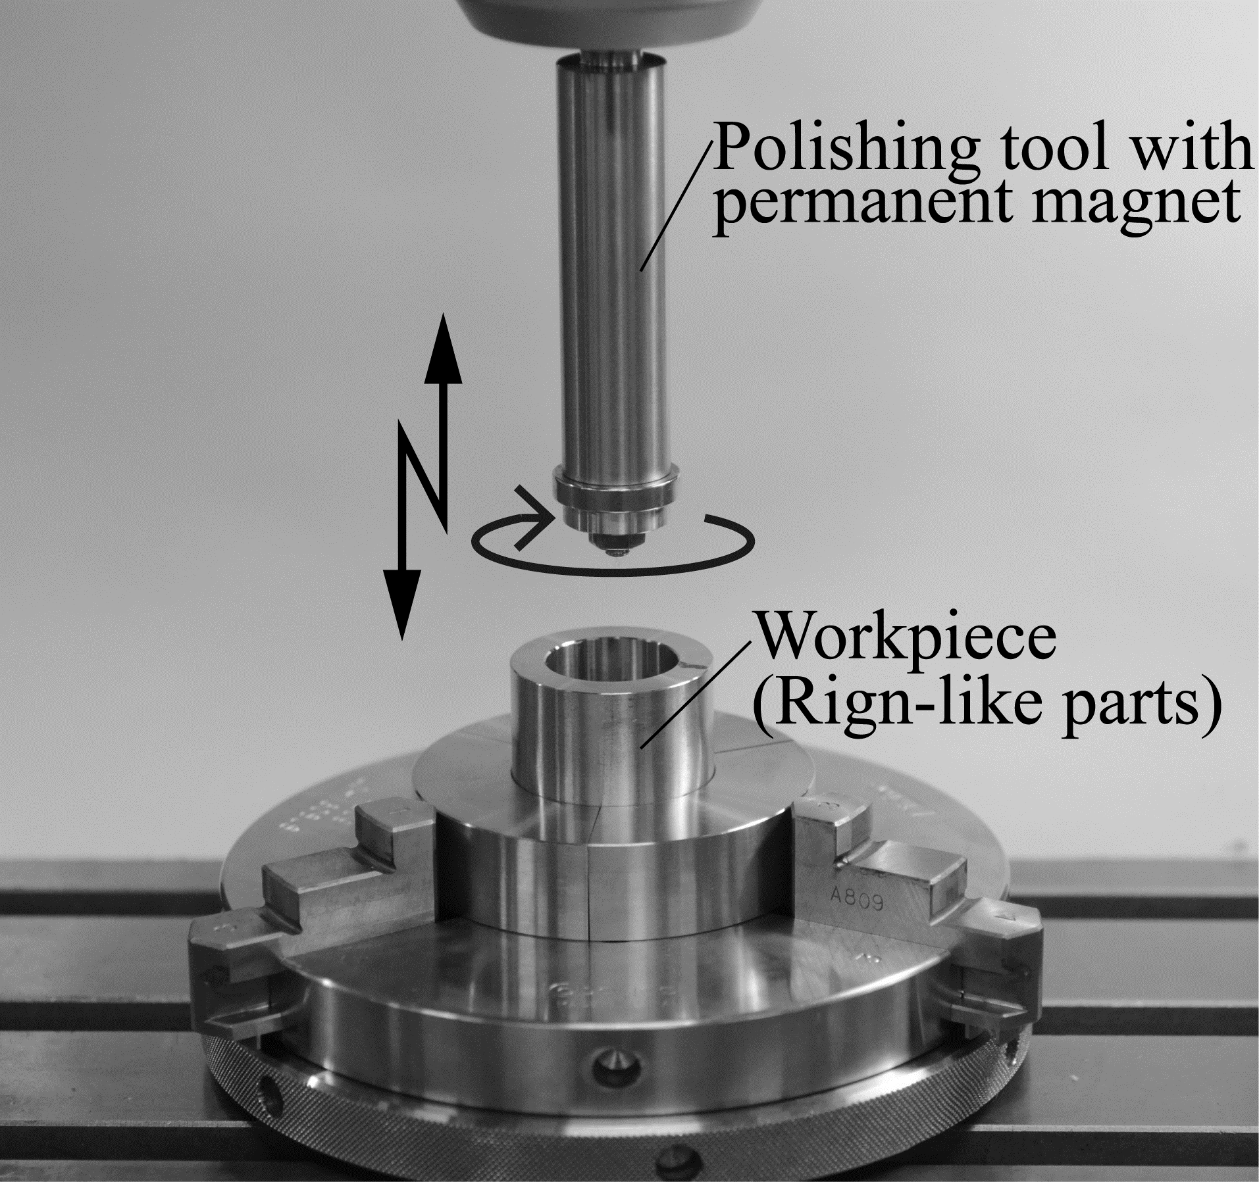
Figure 1 Experimental setup for the processing utilizing MCF

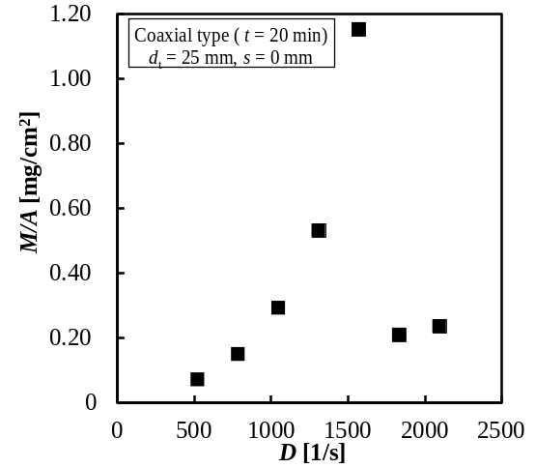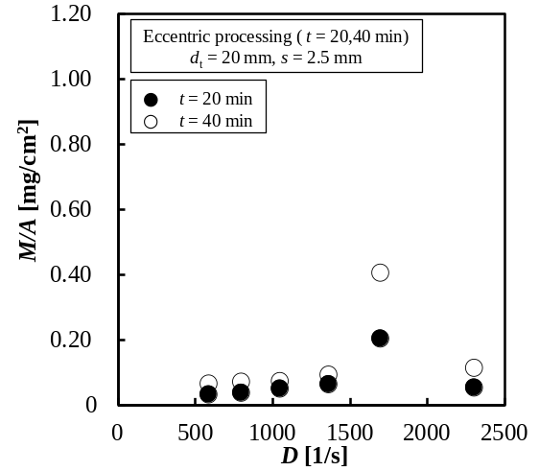
(a) Coaxial processing (b) Eccentric processing
Figure 2 Relationships between shear rate D and material removal M/A

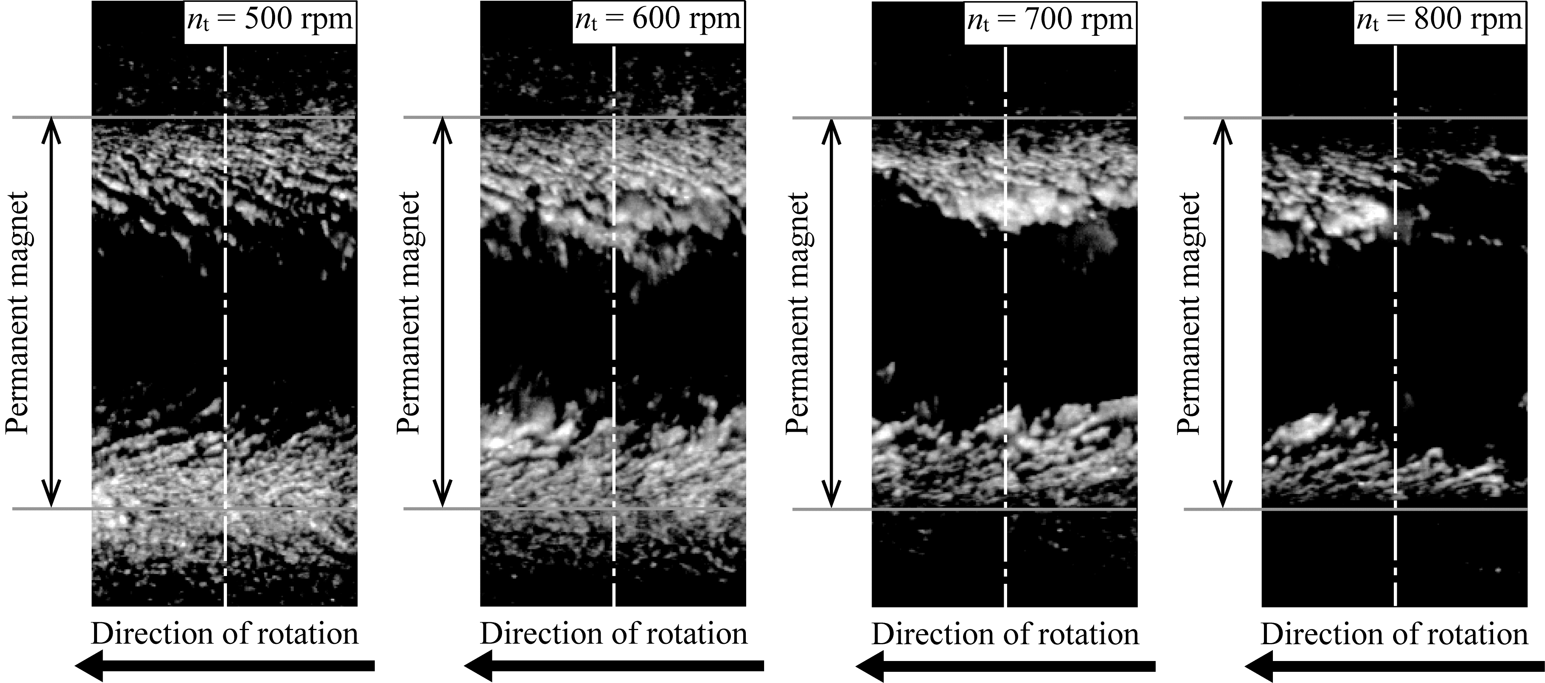
Figure 3 Schematic images of magnetic cluster at various tool rotation speeds

