Opto and magneto dual imaging platform for rapid ex-vivo and in-vivo discrimination of tumors

Ging-Rue Liou¹, Wen-Chu Wei¹, Jen-Jie Chieh¹, Kai-Wen Huang^{2,3}, Hong-Chang Yang³, and Herng-Er Horng³

¹ Institute of Electro-Optical Science and Technology, National Taiwan Normal University, 116 Taipei,Taiwan
²Graduate Institute of Clinical Medicine, National Taiwan University, 10051 Taipei, Taiwan
³Department of Surgery and Hepatitis Research Center, National Taiwan University Hospital,10002 Taipei, Taiwan

ABSTRACT A novel dual-imaging model system integrating an optical camera and magnetic scanning superconducting-quantum-interference device (SQUID) biosusceptometry (SSB) was proposed. The simultaneous coregistration of low-field magnetic images of MNP distributions and optical images of anatomical regions enabled the tumor distribution to be determined easily and in real time.

Keywords: Dual-imaging model system, scanning superconducting-quantum-interference device (SQUID) biosusceptometry (SSB)

REFERENCES
- K.W. Huang, J.J. Chieh*, S.H. Liao, W.C. Wei, P.Y. Hsiao, H. C. Yang, and H. E. Horng, “Rapid and quantitative discrimination of tumour cells on tissue slices,” Nanotechnology 27, 235101 (2016).
- J. J. Chieh*, K. W. Huang, Y. Y. Lee, and W. C. Wei, “Dual-Imaging Model of SQUID Biosusceptometry for Locating Tumors Targeted Using Magnetic Nanoparticles,” Journal of Nanobiotechnology 13, 11 (2015)

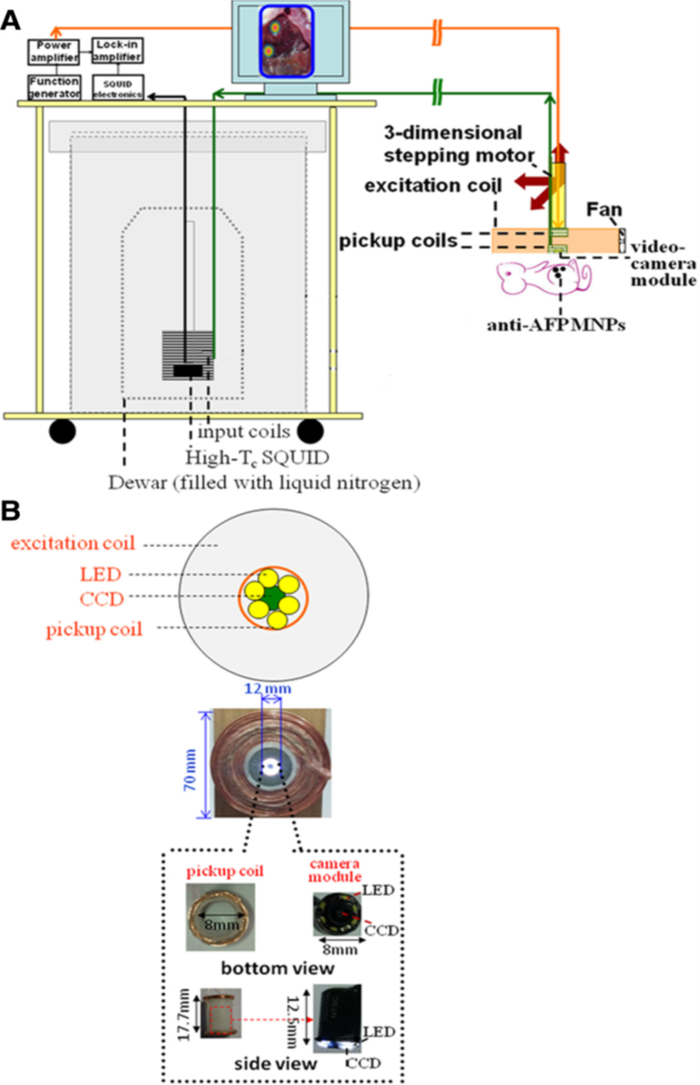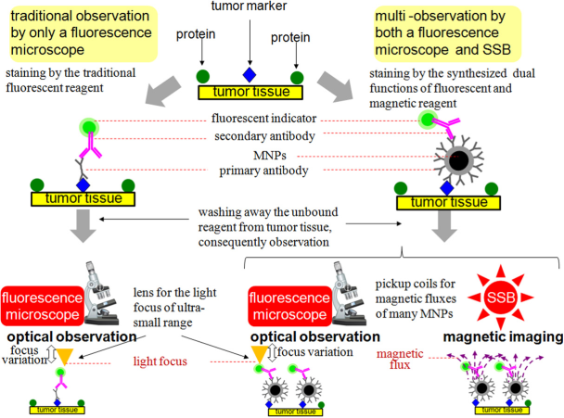

Figure 1. The dual-model SSB developed for simultaneous optical imaging and magnetic imaging (A)Scheme. (B) Tissue stain

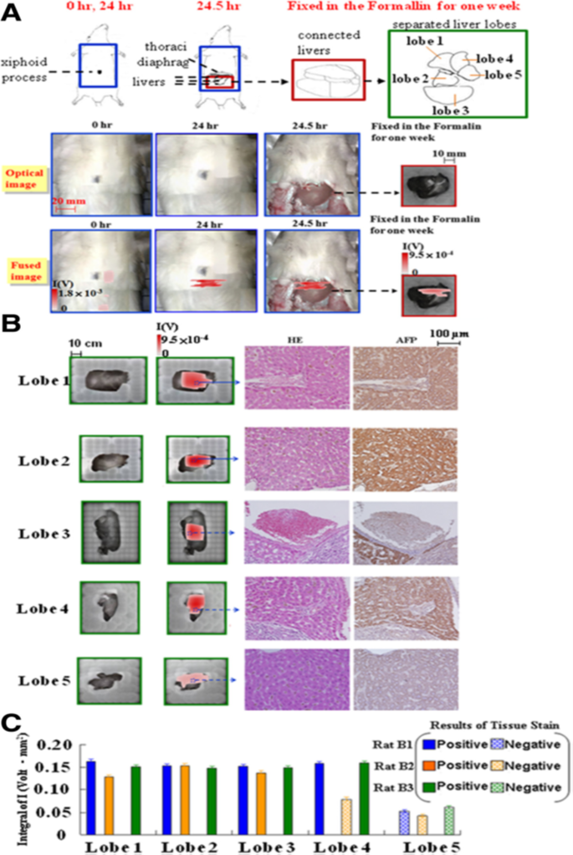
Figure 2. The dual-model SSB developed for simultaneous optical imaging and magnetic imaging. Scheme for the examination of tumor rats. The animal test for 3 rats with a liver tumor in the liver. Rat B1 was imaged in a supine position at 0 h and 24 h, and with i(C).

