**Influence of Magnetic Forces on Pool Boiling Heat Transfer of Magnetic Fluids**

Huei Chu Weng1, Cheng-Hung Cheng1

1Department of Mechanical Engineering, Chung Yuan Christian University

Taoyuan City 32023, Taiwan, ROC

**ABSTRACT**

In this study, a research of magnetic field effects on pool boiling heat transfer characteristics of magnetic fluids is conducted. The purpose is to investigate the influences of external magnetic field on the pool boiling heat transfer perform of magnetic fluids. Results reveal that as a uniform magnetic field strength increases, the excess temperature increases but the critical heat flux decreases. However, one can use a magnetic field gradient to reduce the excess temperature but enhance the critical heat flux.

**1. Introduction**

It is known from the literature that when the working fluid is added to the nanoparticles, the pool boiling heat transfer performance of nanofluids is different from that of base fluids [1-11]. This study, therefore, combines the advantages of nanofluids in pool boiling heat transfer and magnetic fluids in magnetic controllability. The effects of external magnetic field on the pool boiling heat transfer perform of magnetic fluids could then be investigated.

**2. Method**

To investigate the pool boiling heat transfer characteristics of magnetic fluids under an applied external magnetic field, water-based magnetite nanofluids are first prepared by chemical coprecipitation method and sol-gel process. A testing system is further designed and set up, as shown in Fig. 1. The relationship between current and induction field strength is calculated by using the Biot-Savart law and solved by using the Simpson method, so as to know how to set the magnetic field. Finally, the analysis of the pool boiling heat transfer characteristics - the excess temperature  and critical heat flux *CHF* are calculated by using Fourier's law of conduction through experimental data obtained.

**3. Results and Discussion**

The pool boiling heat transfer performance of magnetic fluids of particle volume fraction  for different magnetic field strengths and gradients are illustrated. Fig. 2 and Fig. 3 illustrate the variation of the heat flux and the excess temperature  and the variation of the critical heat flux *CHF* and the applied magnetic field strength *B*, respectively. It is found that as the magnetic field strength increases, the excess temperature is enhanced but the critical heat flux is reduced. Fig. 4 and Fig. 5 illustrate the variation of the heat flux and the excess temperature  and the variation of the critical heat flux *CHF* and the applied magnetic field strength *B*, respectively. It is observed that the excess temperature decreases first and then increases, but the critical heat flux is enhanced first and then reduced as the magnetic field gradient increases.

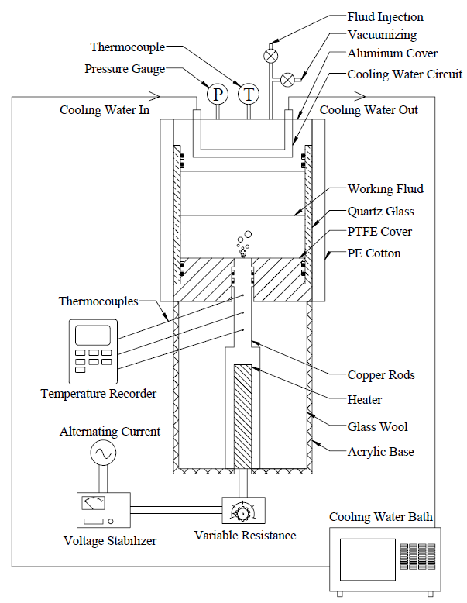

Fig. 1 Schematic diagram of testing system.



Fig. 2 Heat flux versus the excess temperature for different magnetic field strengths.



Fig. 3 Critical heat flux versus the magnetic field strength.



Fig. 4 Heat flux versus the excess temperature for different magnetic field gradients.



Fig. 5 Critical heat flux versus the magnetic field gradient.

**4. Concluding Remarks**

A study on the experimental investigations of pool boiling heat transfer characteristics of magnetic fluids in an applied magnetic field has been made. For uniform magnetic field strength effect, as the magnetic field strength increases, the excess temperature is enhanced but the critical heat flux is reduced. As for magnetic field gradient effect, the excess temperature decreases first and then increases, but the critical heat flux is enhanced first and then reduced as the magnetic field gradient increases.

**References**

[1] S.M. You, J.H. Kim, K.H. Kim, *Applied Physics Letters*, 83 (2003), 3374–3376.

[2] I.C. Bang, S.H. Chang, *International Journal of Heat and Mass Transfer*, 48 (2005), 2407–2419.

[3] D. Wen, and Y. Ding, *Journal of Nanoparticle Research*, 7 (2005), 265–274.

[4] H.D. Kim, J. Kim, M.H. Kim, *International Journal of Multiphase Flow*, 33 (2007), 691–706.

[5] K.J. Park, D. Jung, *Energy and Buildings*, 39 (2007), 1061–1064.

[6] Z.H. Liu, J.G. Xiong, R. Bao, *International Journal of Multiphase Flow*, 33 (2007), 1284–1295.

[7] S.J. Kim, I.C. Bang, J. Buongiorno, L.W. Hu, *International Journal of Heat and Mass Transfer*, 50 (2007), 4105–4116.

[8] S.B. White, A.J. Shih, K.P. Pipe, *Journal of Applied Physics*, 107 (2010), 1143023.

[9] S.M. Kwark, R. Kumar, G. Moreno, J. Yoo, S.M. You, *International Journal of Heat and Mass Transfer*, 53 (2010), 972–981.

[10] H. Peng, G. Ding, H. Hu, W. Jiang, *International Journal of Heat and Mass Transfer*, 54 (2011), 1839–1850.

[11] P. Naphon, *International Journal of Thermophysics*, 36 ( 2015), 2810–2819.