10 ENGINEERS WHO BECAME A GENERAL MANAGER

PRESIDENT OR CEO OF A LARGE COMPANY

1.Larry Page (Computer Engineer)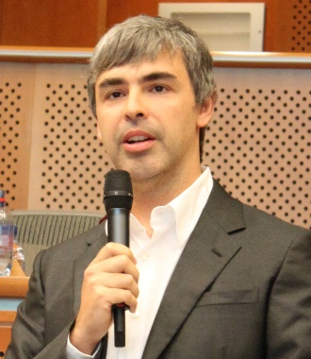

Probably never dreamed that he would one day attempt to re-make the world, but that's essentially what he's trying to do in his role CEO of Alphabet, Inc. Alphabet, the parent company of Google, has a breathtakingly ambitious list of projects it's overseeing, including. the creation of artificial intelligence, the study of aging, the development of home automation systems and engineering of self-driving cars, among many others. Page, co-founder of Google and inventor of its search-ranking algorithms, is probably one of the few individuals. the planet with the vision for that job, having been exposed to cutting- edge technology since his childhood. His father is regarded as a pioneer in artificial intelligence and his mother was a computer science instructor at Michigan State University. Page was the first student in his elementary school to a word processor to turn in an assignment and once created an inkjet printer out of Lego bricks. He went on to BS in computer engineering from the University of Michigan, where he was a member of the school's Solar Car team. He also earned an MS in computer science from Stanford University.

2. Satya Nadella's (Electrical Engineer)

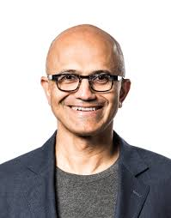Microsoft CEO Satya Nadella's most prominent characteristic is his energy. After earning a BS In electrical engineering from the Manipal Institute of Technology in India, he moved to the US, earned an MS in computer science, went to work for Sun Microsystems, and then launched a career with Microsoft Corp. While at Microsoft, Nadella earned an MBA from the University of Chicago by flying from Redmond, WA to Chicago every Friday night, taking classes on Saturday, and flying back for the work week. His mantra to Microsoft team members: "Our industry does not respect tradition only respects innovation.’

3. Vincent Roche (Electrical Engineer) He joined Analog Devices, Inc. a marketing engineer in Limerick, Ireland in 1988 and worked his way to president and CEO of the company 25 years later, in 2013. In the interim, he worked with disk drive electronics, Interfaces, optical systems, and power management technology. Roche holds a BS in electrical engineering from the University of Limerick.

4.Jeff Bezos (Electrical Engineer)

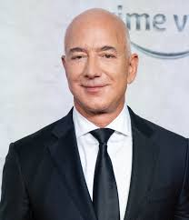He was engineer long before he gained fame as founder and CEO of Amazon.com. He is said to have tried to dismantle his crib as a toddler, and he laid pipe and fixed windmills while still in elementary school. earned a BS in electrical engineering and computer science from Princeton University, where he was also president of the local chapter of Students for the Exploration and Development of Space.

5.Ben van Beurden (Chemical Engineer)

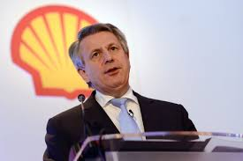In his 30-plus years at Royal Dutch Shell pic, Ben van Beurden has exhibited two qualities that are critical to reaching the CEO's office an ability to understand different business units and a willingness to move. He has served in a range of Shell businesses, including chemicals and liquefied natural gases, which has taken him from his native Netherlands to Malaysia to the United Kingdom and to the US. He has also served on the International Council of Chemical Associations and the European Chemical Industry Council, van Beurden earned an MS in chemical engineering from Delft University of Technology in the Netherlands.

6. Andrew Liveris (Chemical Engineer)

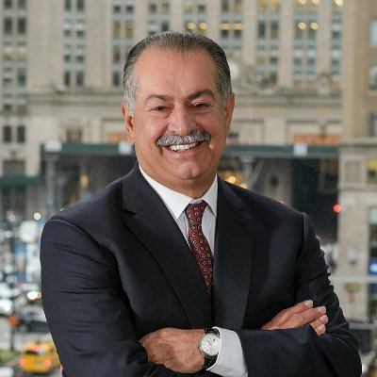Chairman and CEO of The Dow Chemical Co., has made his mark on the world of technology in numerous ways. He has been named to the President's Export Council by Barack Obama, to the co-chair position of the Advanced Manufacturing Partnership, and to the leadership position of the American Manufacturing Council by Donald Trump. He also authored a book, Make It in America.

7. Virginia Rometty (Electrical Engineer)

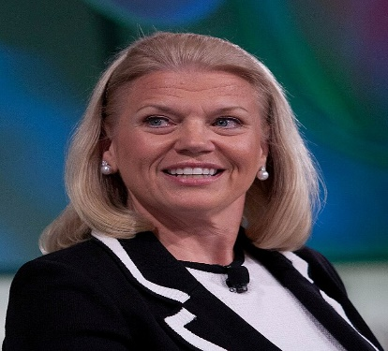 IBM CEO and chairwoman, Virginia Rometty, is the first female to head the giant multinational company. She joined IBM as a systems engineer in 1981 and is credited with spearheading its move to cloud computing. She's been named by Bloomberg as one of the "50 Most Influential People in the World" and by Fortune as one of the "50 Most Powerful Women in Business" for 10 consecutive years. Rometty graduated from Northwestern University in 1979 with a BS in computer science and electrical engineering.

8. Sundar Pichai (Metallurgical Engineer)

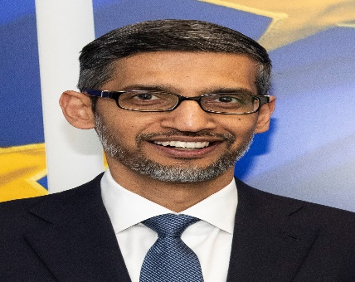 Google, Inc. CEO Sundar Pichai has served as product chief for some of the most recognizable brands in the world, including Google Chrome, Gmail, Google Maps, and Android. A native of India, Pichai earned his BS in metallurgical engineering from the prestigious Indian Institute of Technology, then went on to get an MS in material science from Stanford University and an MBA from the University of Pennsylvania's Wharton school.He was selected as google’s CEO in August,2015,succeeding founder Lary page.

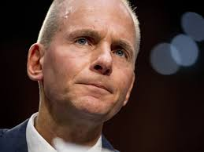9. Dennis Muilenburg (Aerospace Engineer)

As chairman, president and CEO of Boeing, Inc., Dennis Muilenburg oversees a $94.6 billion aerospace powerhouse with employees in 65 countries. He has served in numerous engineering posts since joining Boeing in 1985, on such projects the Joint Strike Fighter Aircraft, the F- 22, the High Speed Civil Transport and the Condor reconnaissance aircraft. He holds a BS in aerospace engineering from lowa State University and an MS in aeronautics and astronautics from the University of Washington.

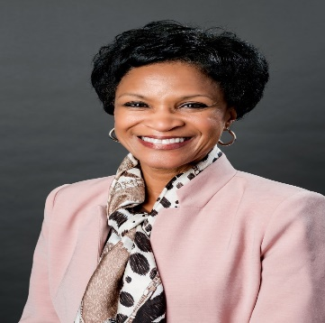10. Denise Gray (Electrical Engineer)

As CEO and president of LG Chem Power, Inc.. Denise Gray heads the company that designs the lithium-ion battery for the well-known Chevy Bolt electric car. Although she's now part of one of the world's largest chemical conglomerates, Gray also knows the auto industry well, having served in the design of electro-mechanical systems, powertrain software, transmission controls and battery systems engineering with General Motors. She holds a BS in electrical engineering from Kettering University and an MS in engineering management from Rensselaer Polytechnic Institute.