Introduction: This report presents the results of an interview with a small-scale Vegetables farming in Babatngon Leyte. The interview focused on the planning activities undertaken by the farmer to ensure successful crop production.

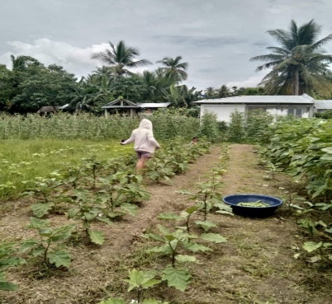

1.Good morning, Ms. Rosalie. Thank you for taking the time to speak with me today. I'd like to ask you about the planning activities you undertake for vegetables farming.

**Farmers:** Sure, I'm happy to share. Planning is essential for a successful harvest.

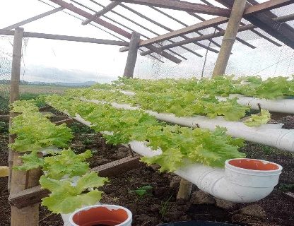2. Can you tell me about the types of planning you do?

**Farmers:** We focus on a few key areas:

**Seasonal Planning:** We plan our planting and harvesting schedules based on the monsoon seasons and local weather patterns.

**Crop Rotation:** We rotate our crops to maintain soil fertility andreduce pest and disease pressure.

**Input Planning:** We estimate our needs for seeds, fertilizers, pesticides, and other inputs for the upcoming season.

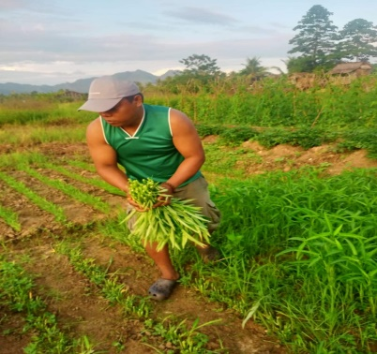**Marketing Planning:** We consider the market demand vegetables and plan our sales strategies accordingly.

3.How do you gather information for your planning?

**Farmers:**We rely on local agricultural extension services, weather forecasts, and our own experience. We also talk to other farmers in the area to share knowledge and best practices.

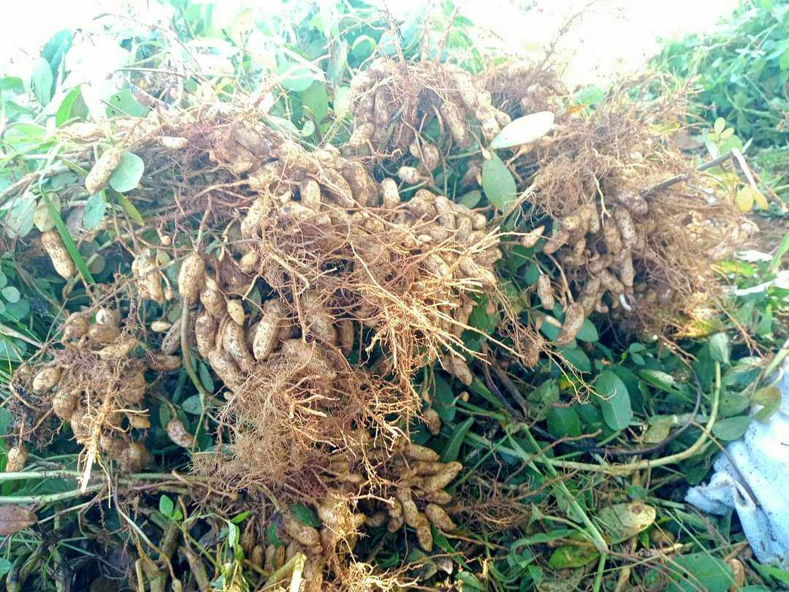4. Are there any challenges you face in the planning process?

**Farmers:**One of the biggest challenges is dealing with unpredictable weather conditions, especially typhoons. We try to be prepared by planting varieties that are more resistant to adverse weather.

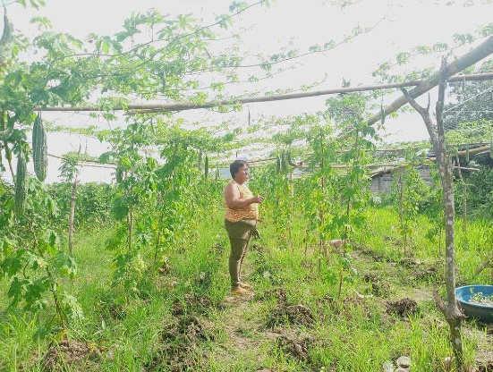

5.How do you monitor and adjust your plans as needed?

**Farmers:**We regularly inspect our fields and track the growth of our crops. If we notice any problems, we can make adjustments to our plans, such as applying additional fertilizer or controlling pests.

**Conclusion:** The interview with the vegetables farmer revealed the importance of effective planning in agricultural activities. The farmer's approach to planning encompassed seasonal planning, crop rotation, input planning, and marketing planning. By considering factors such as weather patterns, soil health, market demand, and potential risks, the farmer was able to make informed decisions and optimize their agricultural practices.