|  |
| --- |
| **MODULE 1: Communication in the Twenty-First Century** |
| GE 115: Purposive Communication |
| MARIENELL C. PINEDA  Instructor |
|  |

MODULE 1:Communication in the Twenty-First Century

Part 1: Communication Models and Communication Ethics

**I. Module Overview**

This chapter will introduce several concepts about communication beginning from the Ancient Greeks until the twenty-first century. It will illuminate several perspectives about communication, the most important one being that it is necessary and important skill that should be honed to become better citizens and to help in building one’s society.

It will explore the use of English in the world, as well as its usage in the Philippines. It will also discuss the perils of language, and how we can find the seeds of racism, sexism, and classism in the language that we use---and what one can do to ensure that one’s language is as academic and inclusive as possible.

**II. Motivation Questions**

1. Why is communication important to you?
2. What is ethics?

**III. Learning Outcomes**

By the end of this module, you should be able to:

1. have a thorough understanding of communication models and processes; and
2. understand the importance of ethics in communication and academic writing.

**IV. Discussion**

**Lesson 1: Communication Models**

**Motivation Question:** Why is communication important to society?

**Discussion:**

Although people communicate with one another every day, communication is not as simple as we perceive it. It is a complex process that encompasses different elements. The following models of communication will show us how communication works:

1. 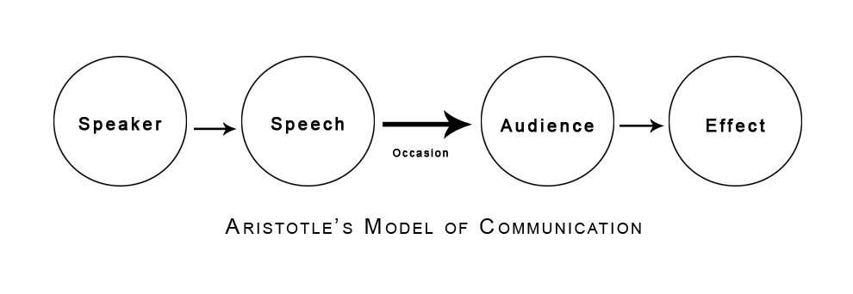Aristotle’s Model of Communication

* Came from Aristotle at around 5 B.C.
* In this model, Aristotle explains that speakers should adjust their messages according to their audience and the occasion to achieve a particular effect.
* E.g. *After the Japanese attacked Pearl Harbor on December 7, 1941, then US President Franklin Roosevelt delivered a stirring speech to declare war on Japan on December 8.*

Speaker = US President Franklin Roosevelt

Speech = delivered by the US President

Occasion = US President’s response to the attack on Pearl Harbor

Audience = US Congress

Effect = Congress members were persuaded to declare war on Japan

1. Shannon-Weaver’s Model of Communication

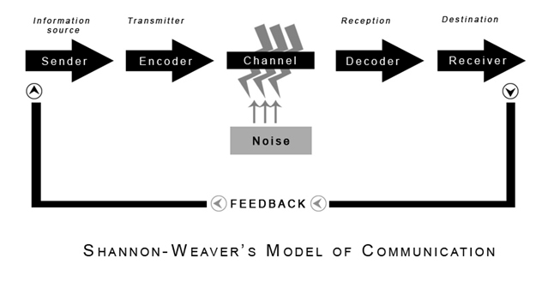

* Created by **Claude Shannon** and **Warren Weaver**
* Often called the “Telephone Model” since it was developed because of the technology of the telephone and the experience of noise coming from the switchboard
* E.g. mobile phone communication

Sender = the person calling

Encoder = cellphone

Channel = radio frequencies

Decoder = the reception place of the signal which converts signals into message

Receiver = the person being called

Noise = whatever problem that may interfere with the message

Feedback = the receiver’s response

1. Osgood-Schramm’s Model of Communication

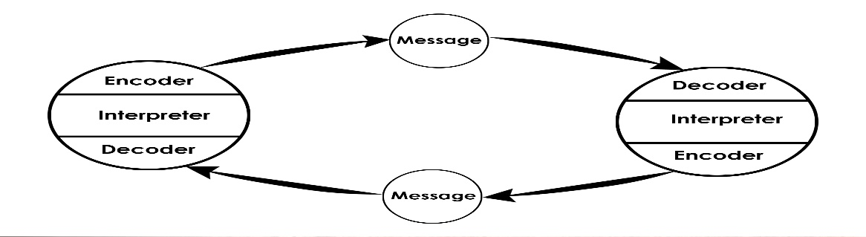

* In this model, pay attention to the role of the interpreter. Encoding and decoding are not automatic processes. Both go through the filter of the interpreter. Therefore, the message may succeed or fail, based on the interpreter’s appreciation of the message.
* There are times when the sender and the receiver may apply different meanings to the same message, and this is termed as “semantic noise.”

1. 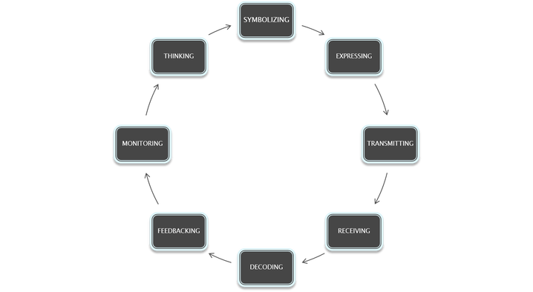Eugene White’s Stages of Oral Communication

* According to White, it is possible to begin at any of the stages outlined in his model.
* The model shows that oral communication is a continuous process with no real beginning or end.

**Lesson 2: Communication Ethics**

**Motivation Question:** Why do you think there should be ethics in communication?

**Discussion**:

* Communication should always be guided by certain ethical principles.
* The US National Communication Association (NCA, 1999) discusses this in their Credo for Ethical Communication, stating that, “Ethical communication is fundamental to responsible thinking, decision-making, and the development of relationships, and communities within and across contexts, cultures, channels, and media.”
* The following are the ethical principles of communication stated in the Credo:

1. Advocate truthfulness, accuracy, honesty, and reason as essential to the integrity of communication;

2. Endorse freedom of expression, diversity of perspective, and tolerance of dissent to achieve the informed and responsible decision-making fundamental to a civil society;

3. Condemn communication that degrades individuals and humanity through distortion, intimidation, coercion, and violence, and through the expression of intolerance and hatred; and

4. Accept responsibility for the short- and long-term consequences of our own communication and expect the same of others.

**V. Reference**

Uychoco, M.T., Santos, M.L. (2018). Communication for Society: Purposive Communication. Rex Bookstore.