Github link: https://github.com/RoyHoldaway/CSUGlobal_Classes/tree/718ac42e522a59650efe1cc153df07e48058d686/Java/Crit4

Pseudocode: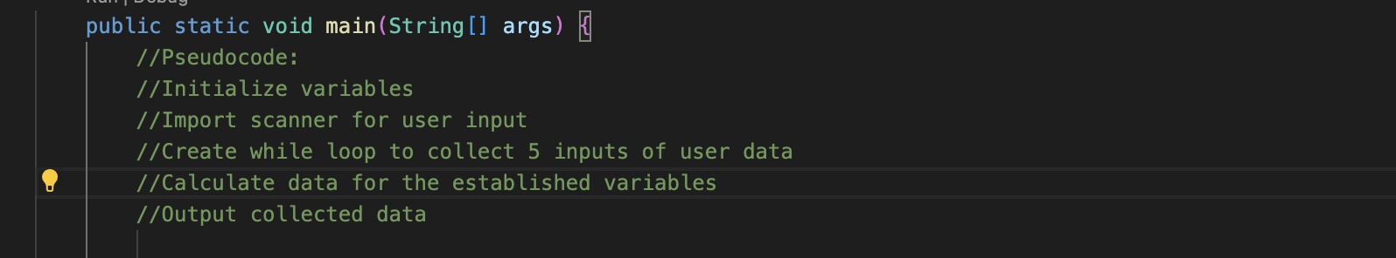

Output:

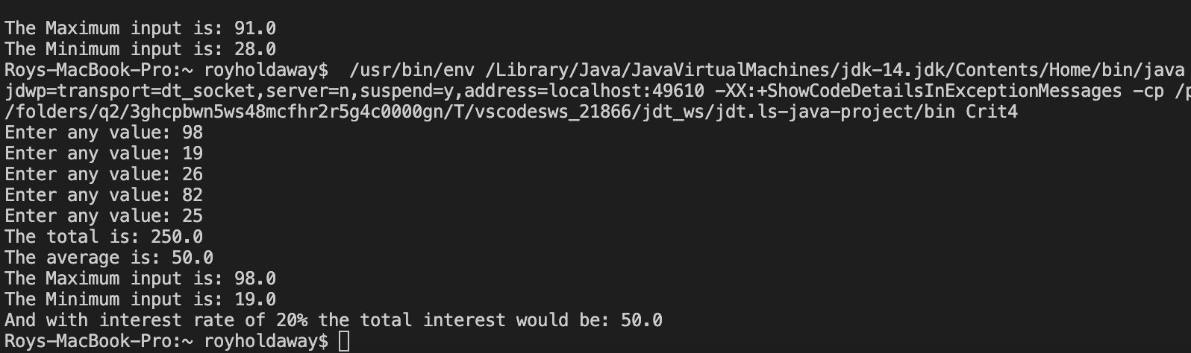

Code block: