Millamis, Roy D.  
BSCPE 2-2

Short Quiz on Trees

Given the tree to the right, identify the ff.:

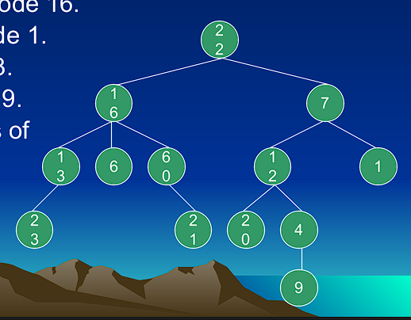

6. Children of node 16.

Answer: Nodes 12,6, and 60

7. Parent of node 1.

Answer: NODE 7

8. Siblings of 23.

Answer: Node 21

9. Ancestors of 9.

Answer: Nodes 4, 20, 12, and 7

10. Descendants of 16.

Answer: Nodes 13, 6, 60, 23, and 21

11. Leaves.

Answer: Nodes 23, 6, 21, 20, 9, and 1

12. Non – Leaves.

Answer: Nodes 22, 16, 13, 60, 12, 4, and 7.

13. Depth of node 4.

Answer: Depth 3.

14. Degree of the tree.

Answer: Degree 3.

15. Height of the tree.

Answer: Height is 4.

16. Weight of the tree.

Answer: Weight is 6.

17. Is the tree a binary tree?

Answer: NO.

18. Removing 6, is the tree a full binary tree?

Answer: NO.

19. Removing 6, is the tree a complete binary tree?

Answer: YES.

20. Is a full binary tree complete?

Answer: NO.

21. Is a complete binary tree full?

Answer: NO.

22. How many leaves does a complete n-ary tree of height h have?

Answer: n^h

23. What is the height of a complete n-ary tree with m leaves?

Answer: lognm

24. What is the number of internal nodes of a complete n-ary tree of height h?

Answer: 2^h -1

25. What is the total number of nodes a complete n-ary tree of height h have?

Answer: n=[(k^(h+1))-]/(h-1)