CropDeal
POC
Low Level Design (LLD)

Table of Contents
1.0 Document Purpose 3
2.0 Intended Audience 3
3.0 Project Background, Objective(s) 3
3.1 Project Background 3
3.2 Project Objective 3
4.0 Design Pattern 3
5.0 Solution Diagram 4
6.0 Use Case Diagram 4
7.0 Sequence Diagram 5
8.0 ER-Diagram 6
9.0 Database Diagram 6
10.0 User Requirement 6
10.1. Hardware 6
10.2. Software 6
11.0 Developer Requirements 7
11.1. Hardware 7
11.2 Software 7
12.0 Solution Steps 7

Document Purpose
This document translates the provided Customer Management LLD template to a complete Low Level Design for CropDeal — an online marketplace connecting farmers, dealers and admins with features for crop listing, inventory, orders, subscriptions, reviews and payments.

Intended Audience
Product owners, solution architects, backend/frontend developers, QA, DevOps and other stakeholders implementing CropDeal.

Project Background, Objective(s)

Project Background
Crop Deal Microservice allows farmers to list their crops for sale directly from their farms, and interested dealers can subscribe, negotiate, and purchase crops seamlessly. This platform eliminates intermediaries, ensuring fair pricing and transparent transactions.

Project Objective
CRUD for crops, users (farmer/dealer), inventory - Ordering & payments (Razorpay integration) - Subscriptions (recurring orders) - Reviews & ratings - Authentication & role-based authorization - Email Services

Design Pattern

Name | Description
Repository Pattern | Encapsulates data access logic, keeps EF Core queries out of controllers.
Dependency Injection | ASP.NET Core’s built-in DI injects repositories/services into controllers.
DTO Pattern | Prevents exposing domain models directly to clients, supports validation/mapping.
Middleware Pattern | Centralized exception handling for all requests.
Controller Pattern (MVC) | Organizes endpoints by resource, part of ASP.NET Core MVC.

Solution Diagram
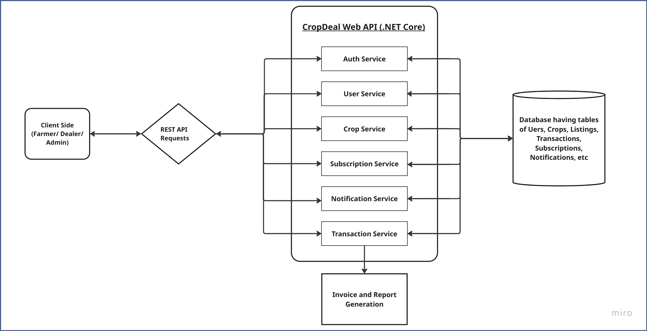

Use Case Diagram
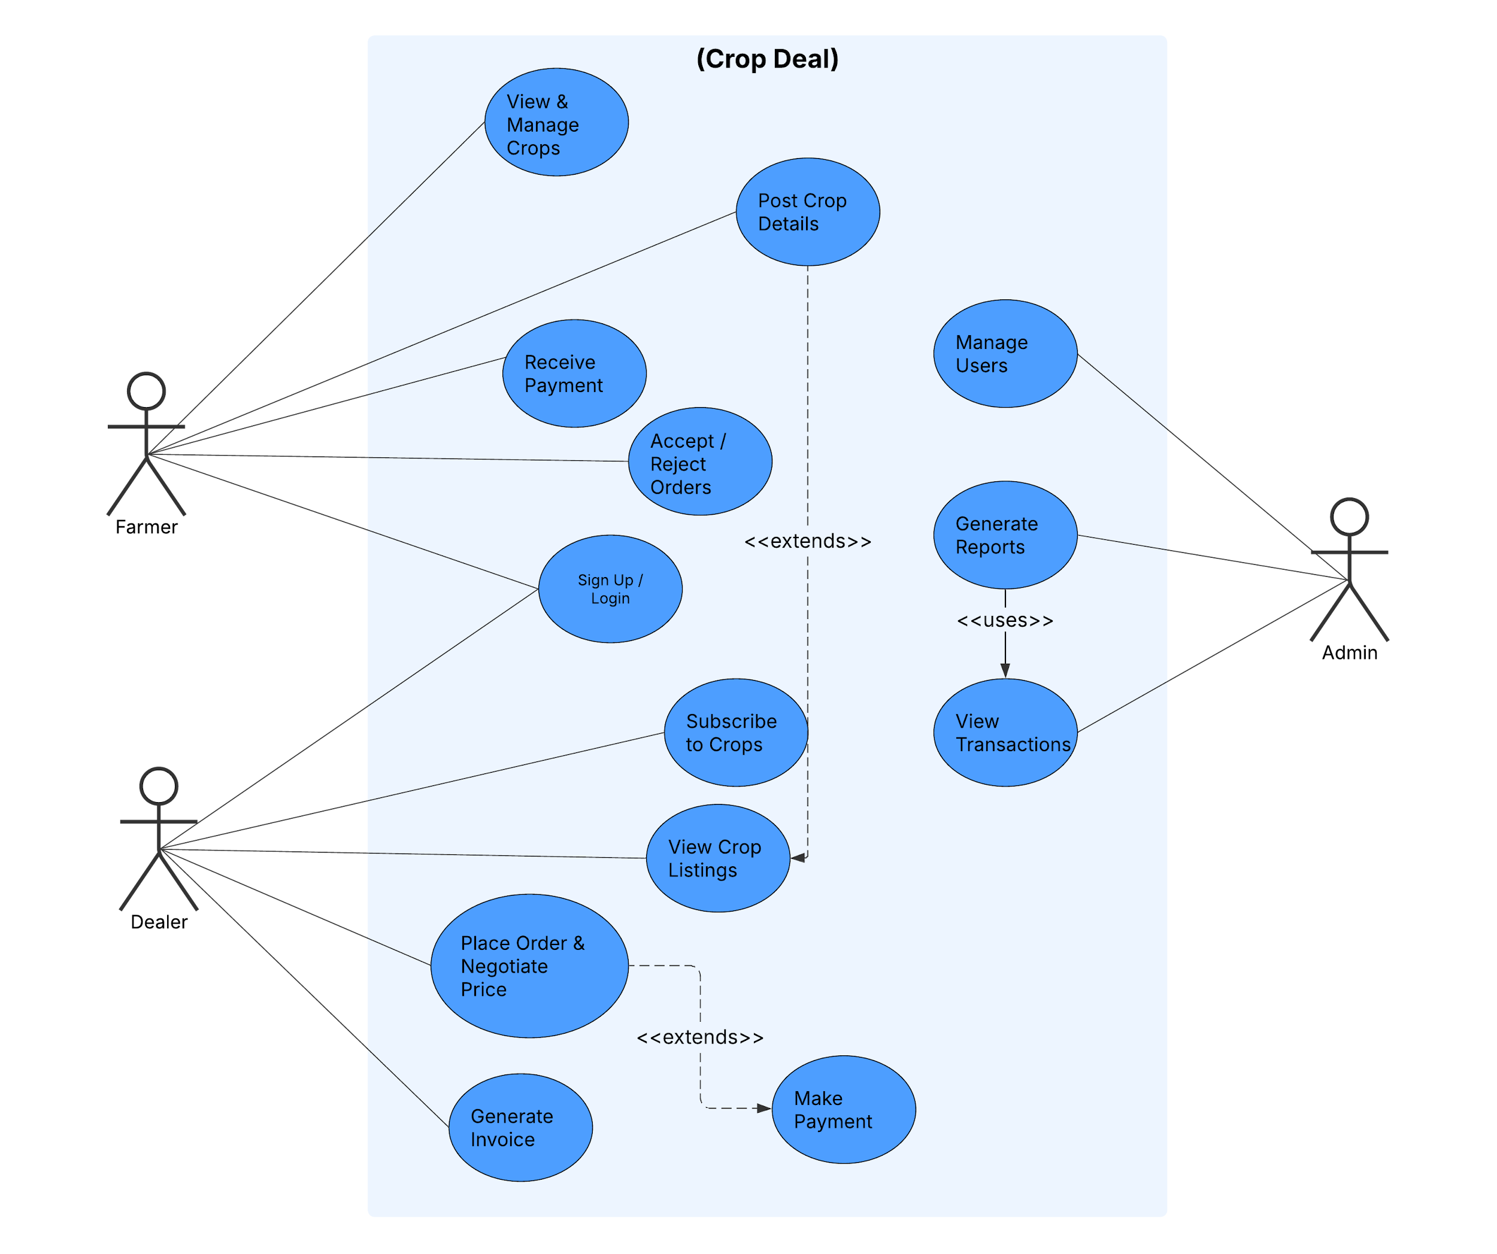

7.0 Sequence Diagram

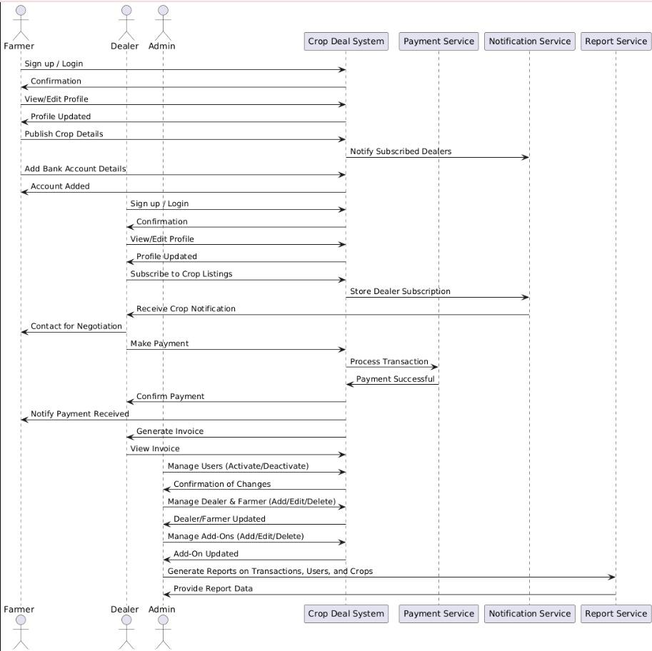

ER-Diagram
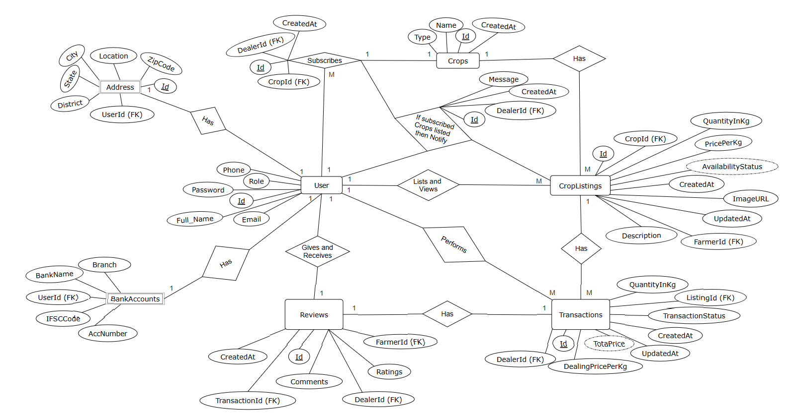

Database Schema
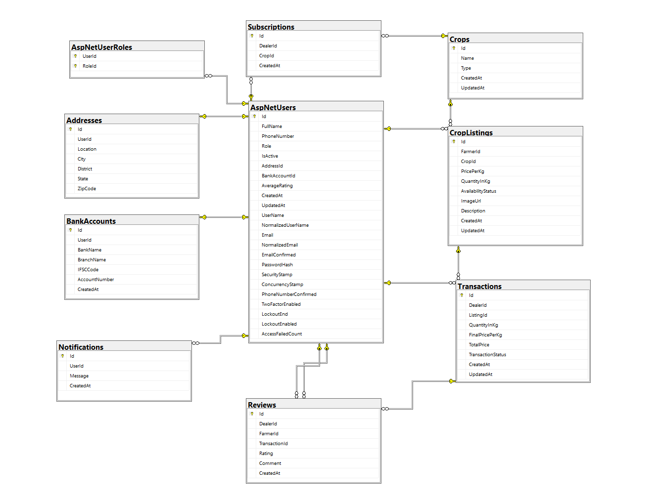

User Requirements
  - Hardware
• Processor: Minimum 2 GHz.
• Memory (RAM): 4 GB minimum, Recommended 8 GB.
• Hard Drive: 100 GB minimum.
  - Software
• Browsers: Latest versions of Chrome, Edge, or Firefox.
• OS: Windows 10 or higher.

Developer Requirements
  - Hardware
• Processor: Minimum 2 GHz, Recommended 3 GHz.
• Memory (RAM): 8 GB minimum.
• Hard Drive: 500 GB or more.
  - Software
• Visual Studio 2022
• SQL Server Management Studio (SSMS)
• Node.js and Angular

Solution Steps
User Registration
- The user enters name, email, phone number, password, role (Farmer/Dealer/Admin) and submits the request.
- The request reaches the API Gateway.
- The API Gateway routes the request to registerUserHandler.handle(), which calls doProcess().
- doProcess() calls userSchemaValidator.doValidate() to validate input:
- If validation fails → Returns an error code & description.
- If validation succeeds → Calls registerUserService.registerUser(), which invokes registerUserRepository.registerUser() to store user data in the database.
- A success response is sent back with a 200 HTTP status.
- The user is successfully registered.

Crop Listing
- Farmer enters crop details such as name, type (Fruit/Vegetable/Grain), quantity, location, etc., and clicks submit. The browser sends a request to the Crop Registration API.
- The request reaches the API Gateway.
- The API Gateway routes the request to registerCropHandler.handle(), which calls the doProcess() function.
- doProcess() calls cropSchemaValidator.doValidate(), passing cropValidator.validateCropRegistration() for validation.
- If validation fails → Returns an error code & description with HTTP status.
- If validation succeeds → Calls registerCropService.registerCrop(), which invokes registerCropRepository.registerCrop() to store the data in the database.
- Sends an HTTP Success response to registerCropHandler.
- registerCropHandler returns a JSON response.
- Success JSON response and HTTP status code 200 with a success message.

Transaction
- Dealer selects a listing and submits a deal price → request sent to Deal Initiation API.
- API Gateway routes to initiateDealHandler → validates and stores deal.
- Farmer reviews and accepts/rejects → request sent to Deal Response API.
- API Gateway routes to respondToDealHandler → updates deal status.
- If accepted → Dealer pays via Razorpay → request sent to Payment API.
- API Gateway routes to processPaymentHandler → validates and completes payment.
- On success → Dealer and farmer download invoice → request sent to Invoice API.
- API Gateway routes to generateInvoiceHandler → generates and returns invoice.
- Dealer rates farmer → request sent to Rating API → stores feedback.

