Computational Physics

Project 10

Roy Rinberg

Hw problems : 1, 3,5

For the simplest version of the problem – we simply insert initial conditions of the slice of line charge, and then apply relaxation to solve for a very simple version of Laplace’s equation solved for after a certain delta t (where in the physical universe, delta t is very small)

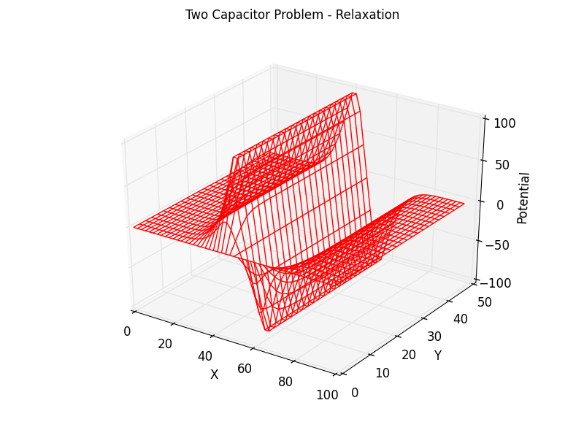

Here is a plot, that is color coordinated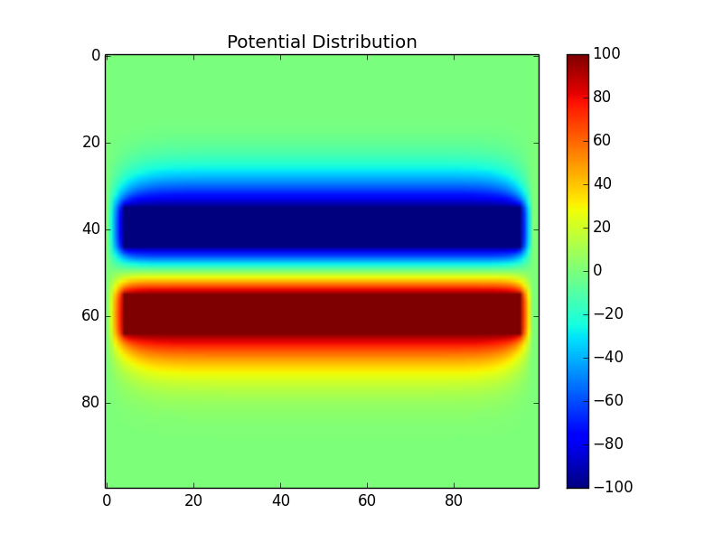

3 – Investigate how the charges inside the conductor distribute themselves. So we know a few things about physics that make this easier – charges have to be inside of a conductor (no free floating charges), and also the potential inside of a conductor is equal to 0, so any charges **must** be on the edge of the conductors. So the only places that we need to do any calculations about the charges density is on the contours of the conductor (makes the computation a lot easier).

Having done this, we get the very simple plot of:

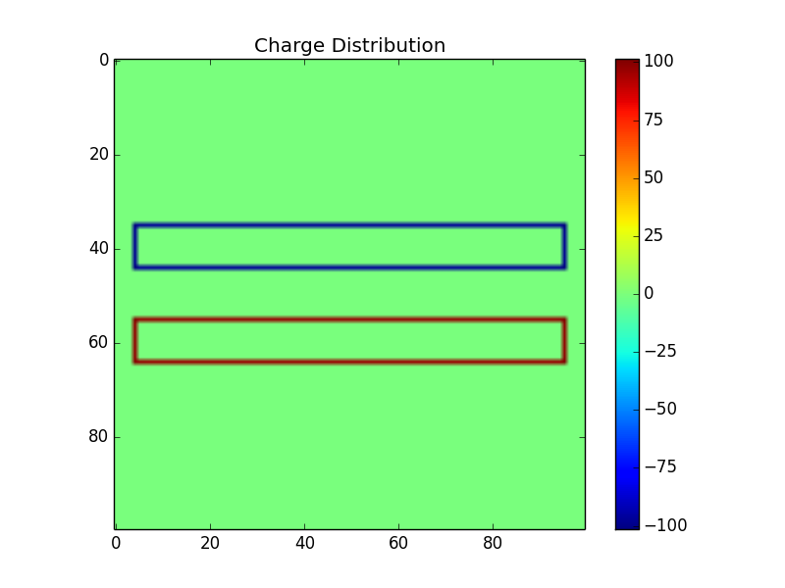

Note that this plot’s accuracy is confirmed by the fact that only the edges can have charges, and any charges would immediately move to cancel one another out – so this plot is almost entirely predictable, and it’s good that it fits what we expect.

5 – The problem is a little vague, and I had a hard time understanding if it was asking for a 3D cube inside of a 3D cube (because it says box), or it meant a 2D square inside of a 2D square. I wrote the code for a 3d cube inside of a 3D cube because that 1- seems more physical, and 2- contains the solution to a 2d square inside a 2d square as well.

I solved for the electric field by first solving for the potential, then taking the negative derivative. I took two z-slices of the magnitude of the electric field – 1 that was below the inner box, and 1 that was through the inner box.

Z slice = 0.5 (through the middle of both boxes)

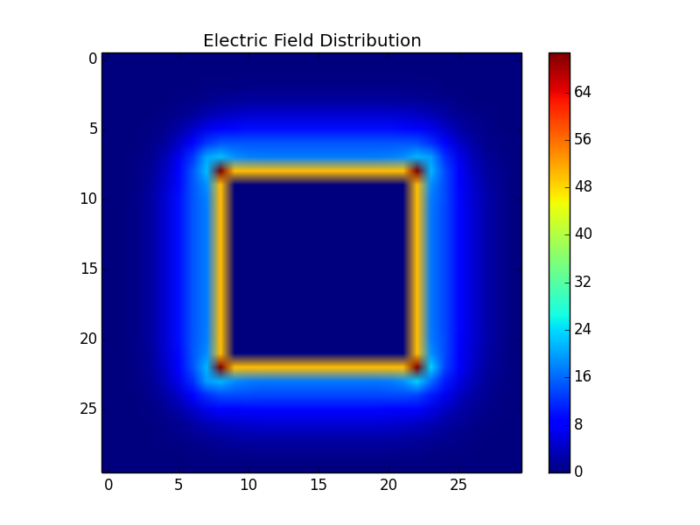

Z slice = 0.125 (below the inner box)

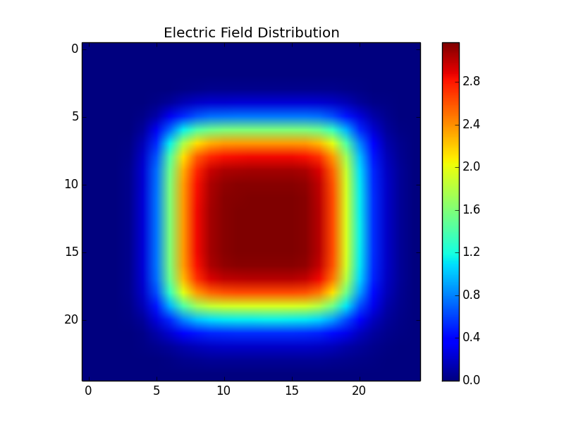

The first plot, only somewhat suggests that the center of sides of the cubes have the strongest potential. But combined with the 2nd plot, and a good sense of intuition, it makes sense that the strongest electric field lines originate from the center of the square sides of the inner cube. (Since at the extreme- the ones of the corners, have much fewer charges to contribute than the ones in the centers).

Extra Credit

Here is a plot of the electric field lines, coming out of a z-slice from the center of the box:

