Computational Physics

Roy Rinberg

Project 4

5.5.1 –

h = 0.01

Cosine Error

|  |  |  |  |  |
| --- | --- | --- | --- | --- |
|  | Forward | Central | Extrapolated |  |
| T = 0.1 | 0.497332 | 0.000042 | 0.000000 |  |
| T= 1.0 | 0.268746 | 0.000351 | 0.000000 |  |
| T=100. | 0.432000 | 0.000211 | 0.000000 |  |

Exponent Error

|  |  |  |  |
| --- | --- | --- | --- |
|  | Forward | Central | Extrapolated |
| T = 0.1 | 0.554432 | 0.000460 | 0.000000 |
| T= 1.0 | 1.363683 | 0.001133 | 0.000000 |
| T=100. | 13485499892092547921320749485192791877222400.000000 | 11200499654636747843164176182109693542400.000000 | 5949539828805537601165191020544000.000000 |

Plot log10 |error| vs. log10 h and check whether the number of decimal places obtained agrees with the estimates in the text

For cosine:

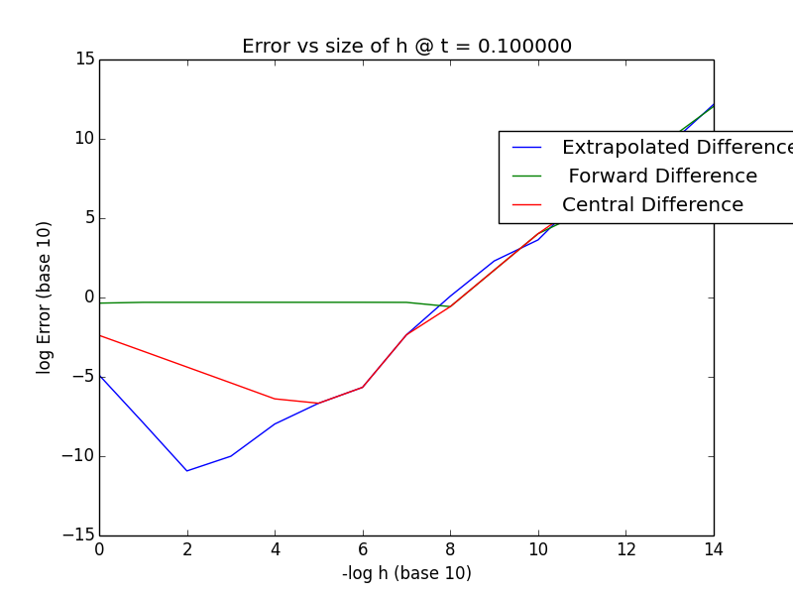

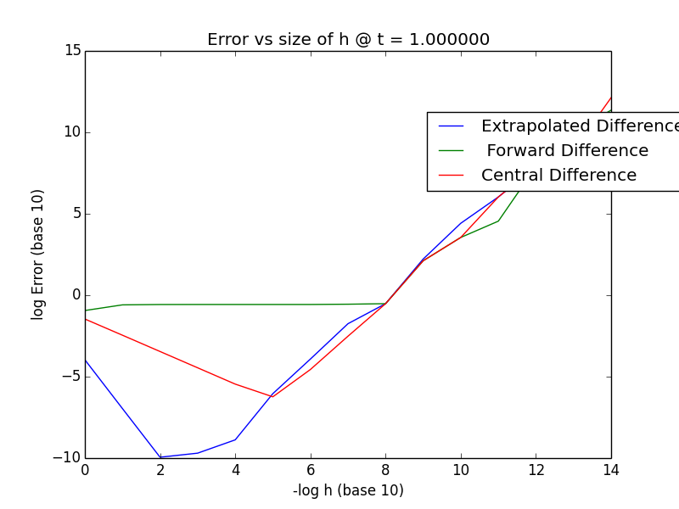

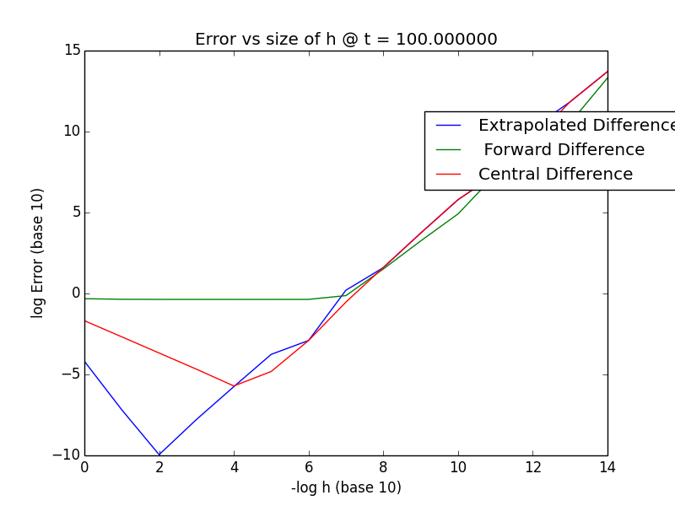

Are there regions that seem to work better for the different algorithms?

Yes, definitely. It’s not surprising that the extrapolated differentiation technique is generally the best, and the forward differentiation is generally the worst. Additionally, it falls generally in line with the ratios that the ideal extrapolated is ~1000x larger than it is for central, and 10^6 times larger than it is for forward. However, it is surprising the exact numbers – I expected smaller h’s.

5.6.1

Write a program to calculate the second derivative of cos t using the central difference algorithms (5.22) and (5.23).Test it over four cycles. Start with h≃ π∕10 and keep reducing h until you reach machine precision. Is there any noticeable differences between (5.22) and (5.23)?

Here are the plots of Cosine being evaluated at 6 locations, and their corresponding Errors

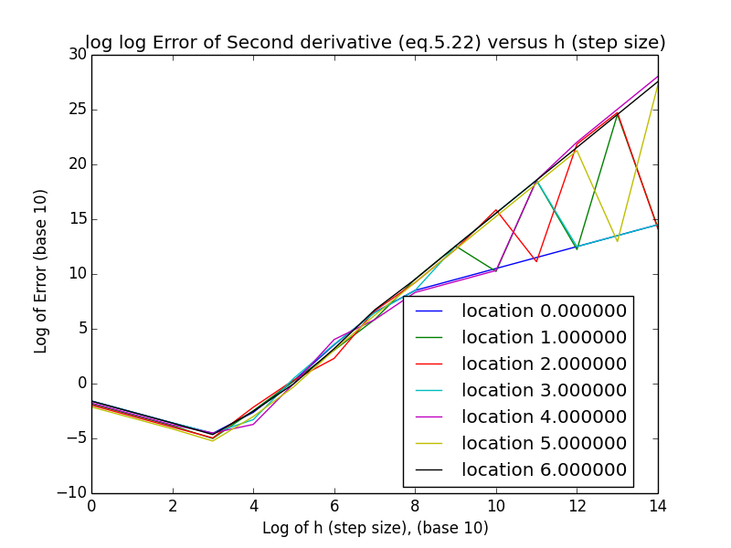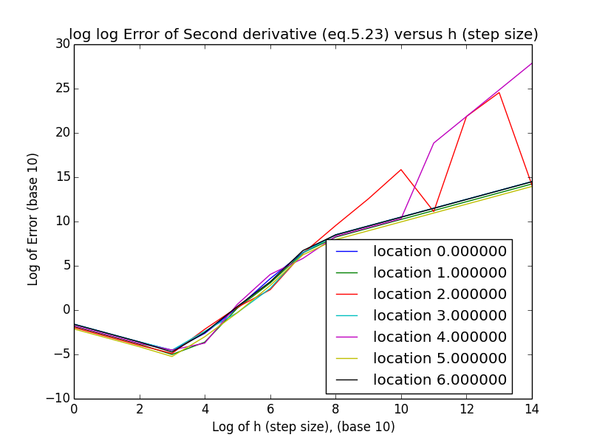

It seems there are not really hugely different results for the erros as a function of h – perhaps there is at larger x evaluations.

5.12.3

Numerical Integrations

Compute the relative error 𝜖 = |(numerical-exact)∕exact| in each case. Presentyour data in the tabular form

|  |  |  |  |
| --- | --- | --- | --- |
|  | Trapezoid | Simpson | Gaussian |
| N =2 | 0.872965 | 1.357946 | 0.000224 |
| N =10 | 0.919018 | 0.690694 | 0.000000 |

How strange, that the error in the trapezoid actually increases ( but later it decreases again)

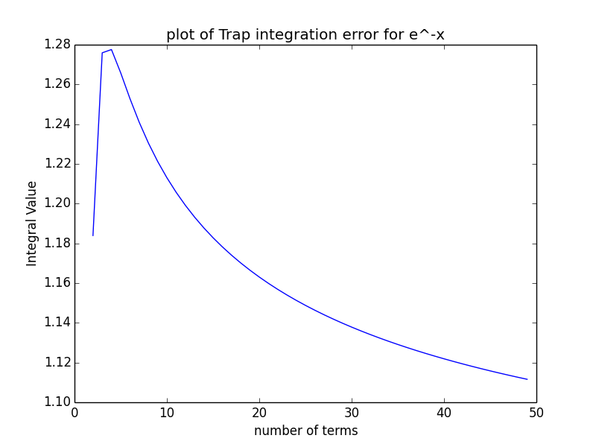

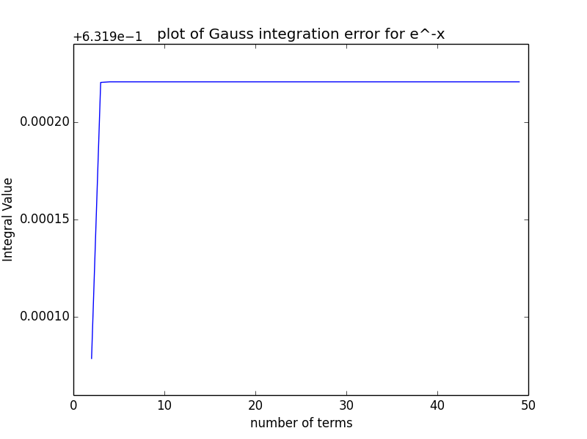

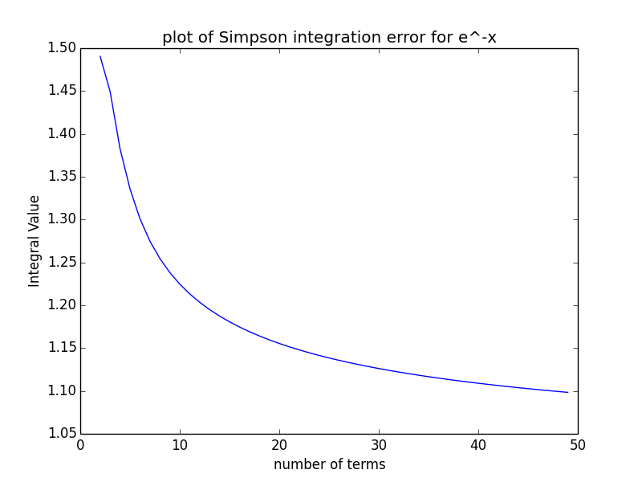

What is odd, is that the plot of the error tells me that the rate of increase for all the errors identical – this does not make sense to me.

I was unable to plot the error of the gaussian – I guess because it was taking the log of 0, and that was causing an error.

Additonally, this plot of the error of the trapezoidal and simpon’s looks correct in shape, but not in scale, so I don’t know what to say about that.

