Computational physics

Roy Rinberg

Hw 7

8.7.1 (write own rk 2 code)

1-

See file 8.7_rungeKuttark2_rk4.py

2- Here is the solver for Eq. 8.25

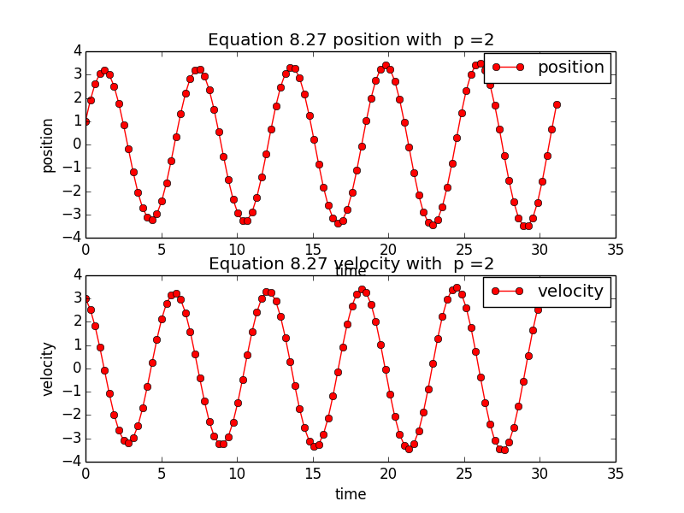

3- 100 time steps:

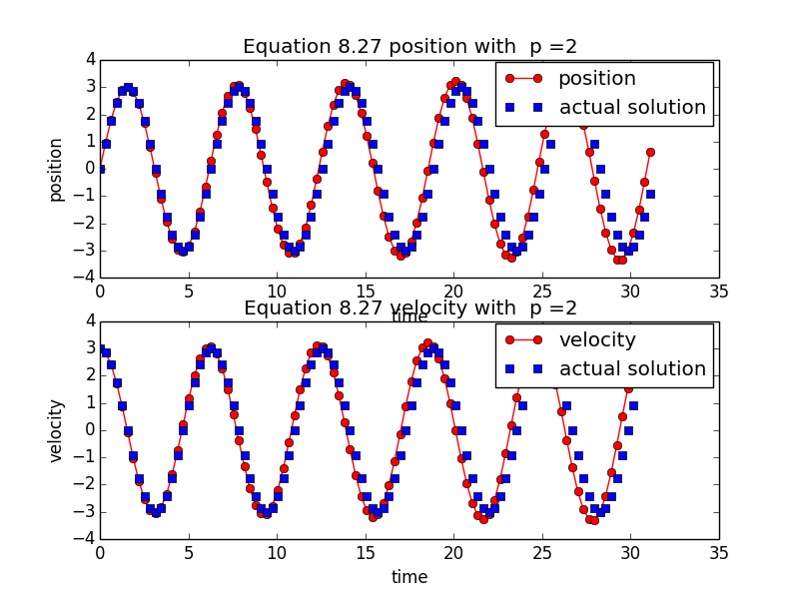

1000 time steps :

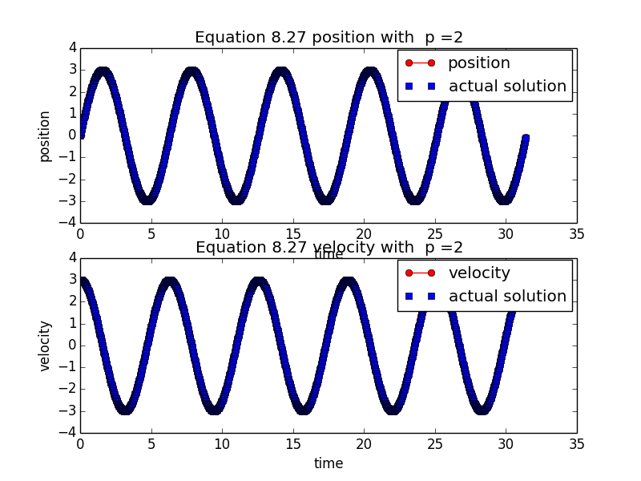

The period does not change if you change the amplitude – it is isochronous

4- Here is a plot of the function using RK4, and only 100 steps, clearly it is a better fit than RK2 with the same number of steps (it does not seem that the phase is changing greatly)

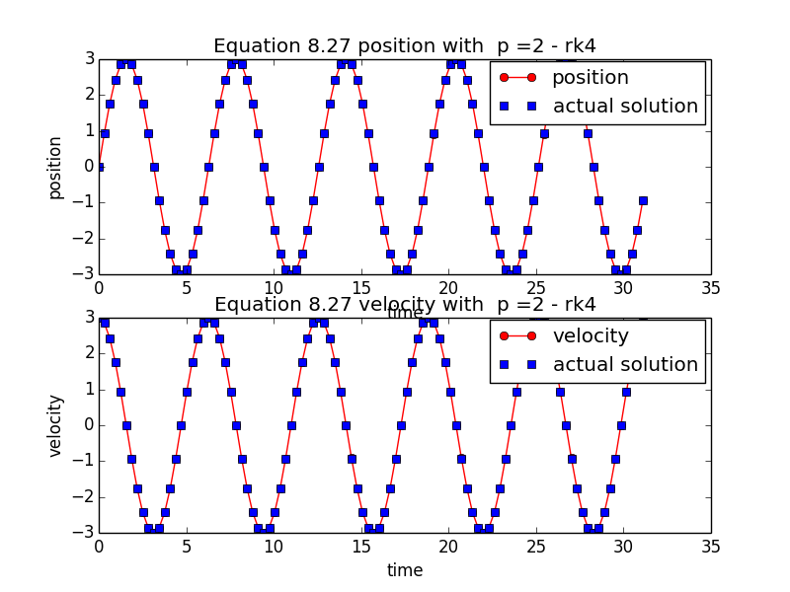

8.8      1-5

Use your rk4 program to study anharmonic oscillations by trying powers in the range p = 2−12, or anharmonic strengths in the range 0 ≤ αx ≤ 2. Do not include any explicit time-dependent forces yet. Note that for large values of p, the forces and accelerations get large near the turning points, and so you may need a smaller step size h than that used for the harmonic oscillator.

1. Check that the solution remains periodic with constant amplitude and period for a given initial condition regardless of how nonlinear you make the force. In particular, check that the maximum speed occurs at x = 0 and that the velocity v = 0 at maximum x’s, the latter being a consequence of energy conservation.

Here is a plot for initial conditions x(0) = 0; v(0) = 3.0 , for p = 2 and p=6 superimposed on the same graph. Clearly it is periodic for both. Clearly the maximum is reached periodically (as that is how periodic functions work), and the initial velocity was the maximum initially (and then also every period).

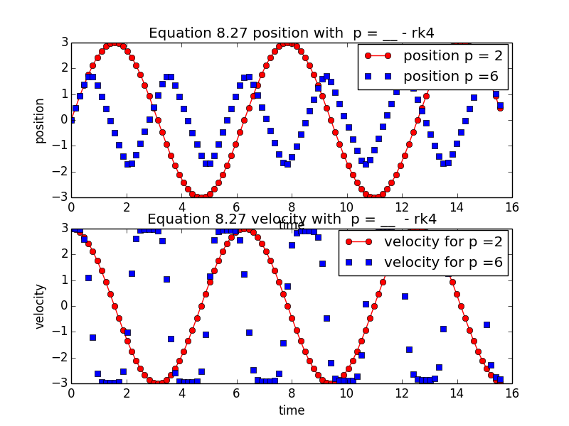

1. Runge Kutta-4 solved with initial conditions x = 0.0 , v = 3.0

F = -kx2

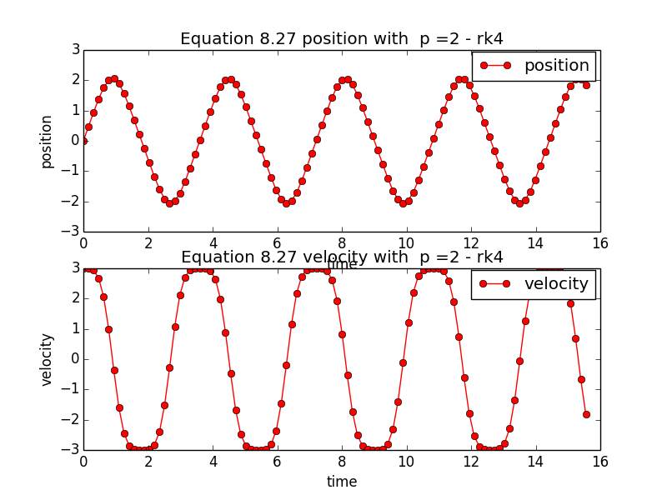

Runge Kutta-4 solved with initial conditions x = 0.0 , v = 15.0

F = -kx2

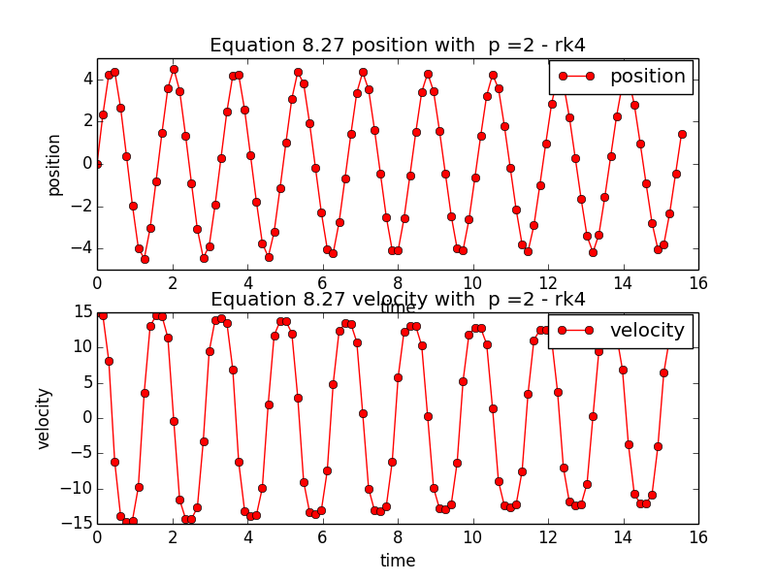

Clearly the frequency is amplitude dependent, and it is nonisochronous

1. the shapes change with p, because that is changing the potential well that the particles are in – so clearly it is changing the way they respond physically.
2. Here is a plot of the period of a function for p =6 for different initial velocity amplitudes (I chose velocity, because it looks less discrete than the plot of changing initial amplitudes, even though it shouldn’t really affect much. Though it is still vaguely exponential-decay looking)
3. 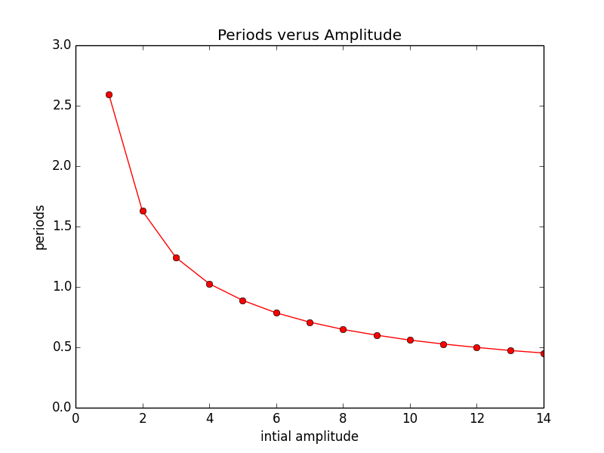

8.8.1

1- I didn’t plot 50 cycles here, because it isn’t that easy to see what’s going on. KE and PE are out of phase with one another by 180 degrees, and so they cancel to be a constant

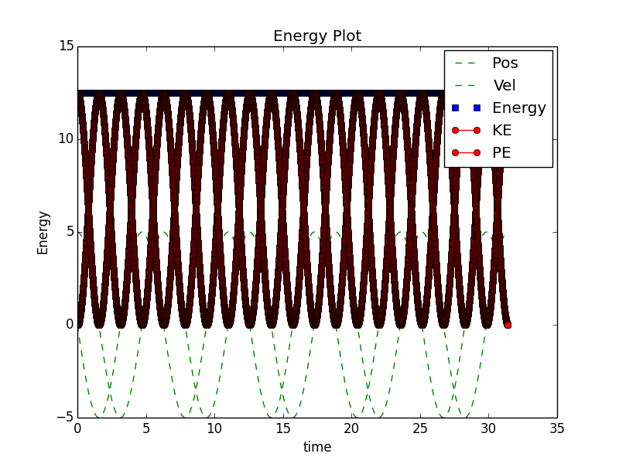

2-

for p = 2

KE = 0.5 m v2 PE = 0.5 k x2

Here is a plot of it such that energy is conserved! It re-updates the velocity and position to keep energy conserved at every time step!

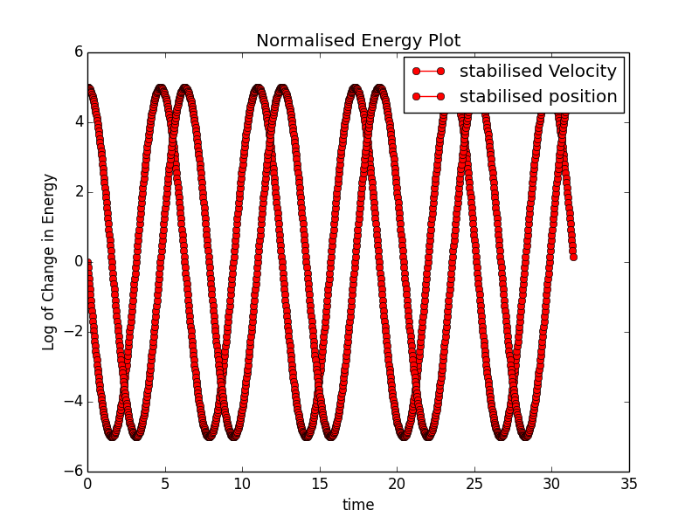

I was getting a problem with taking a log that divided by 0, so I added all the terms by 10-9

Which shifted the solution that I had upwards by 9. Here is the stability of the non-normalized energy : 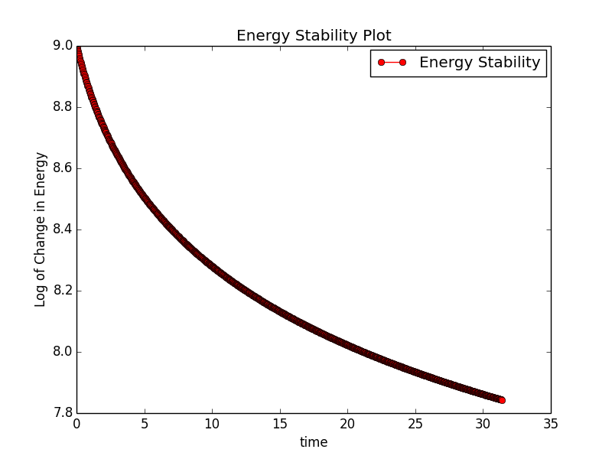

Here is the plot of the energy stability for the normalized energy – it does not follow a clear function but it is clear that the energy is much more stable! It only varies by ~2 * 10-7 on a log plot! It is essentially holding entirely at a stable energy unwaveringly

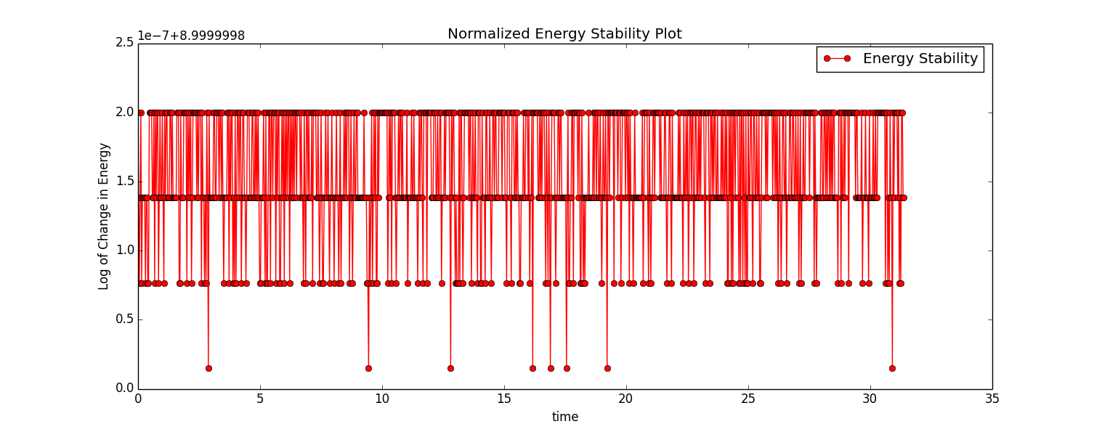

3- I ran this experiment across 10 cycles with 1000 time steps -

For p =2

I get that <KE> = 2.25 , and <PE> = -(2.25)

Which confirms the virial theorem (if you remove the negative value)

For p =6

<KE> = 3.38789118133

<PE>*6/2 =
-3.33562991497;

Which is not perfectly equivalent, but is close (ignoring the negative aspect of it)