Homework 8

Roy Rinberg

Computational Physics

Problems:

* 9.2.2 Quantum well
* depth = -10.
* Width = 4.

For my simulation, I took m =1.0, and also hbar (planck’s constant) = 1.0, so to get physical results, the solution should be scaled appropriately – but this reduces errors from underflow and overflow)

Solving from the left and right :

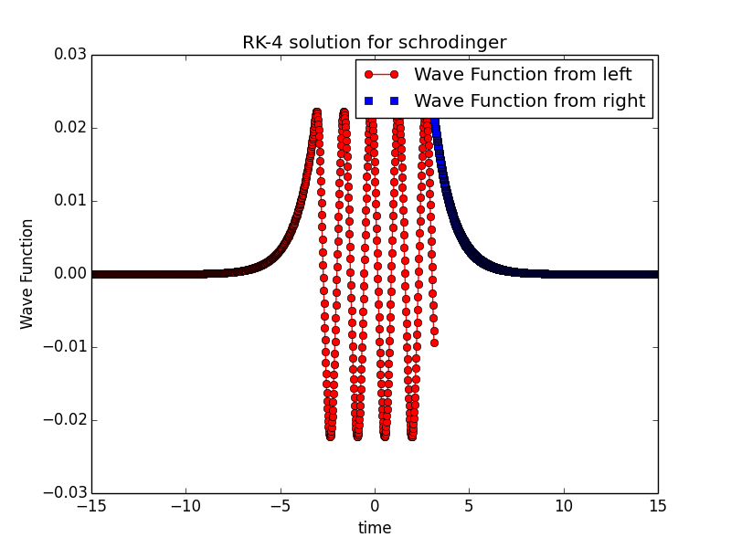

Evaluating the error to be a difference of the logarithmic derivative (which is defined as the wave function’s derivative divided by the wave function) :

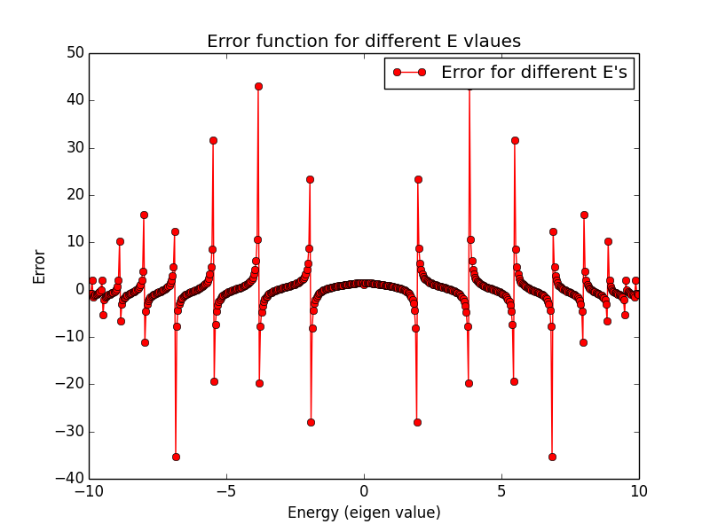

Then I solve for a good eigenvalue, by minimizing Error:

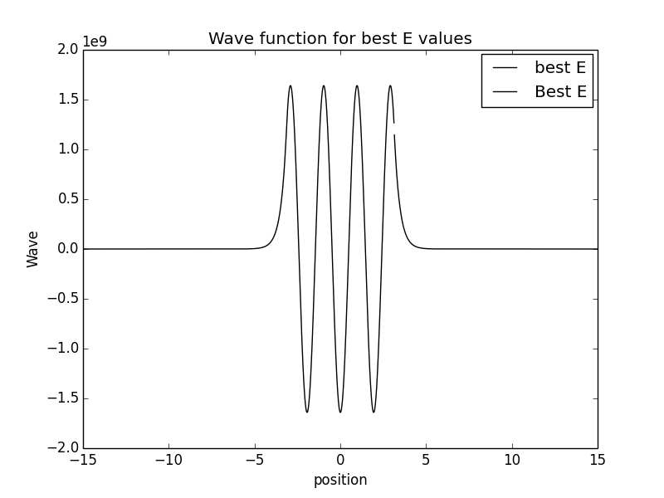

In this case the Energy is : 4.68

Here is the solution for the ground state:

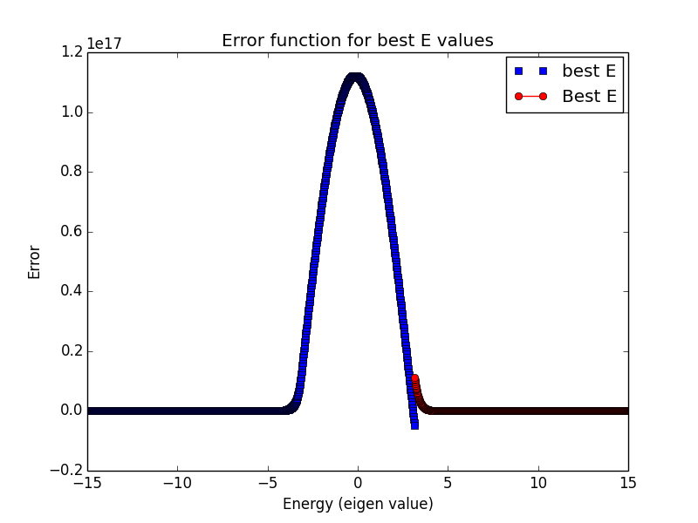

With eigenvalue E = -9.92

**Balls falling with Drag!**

**9.6.2**

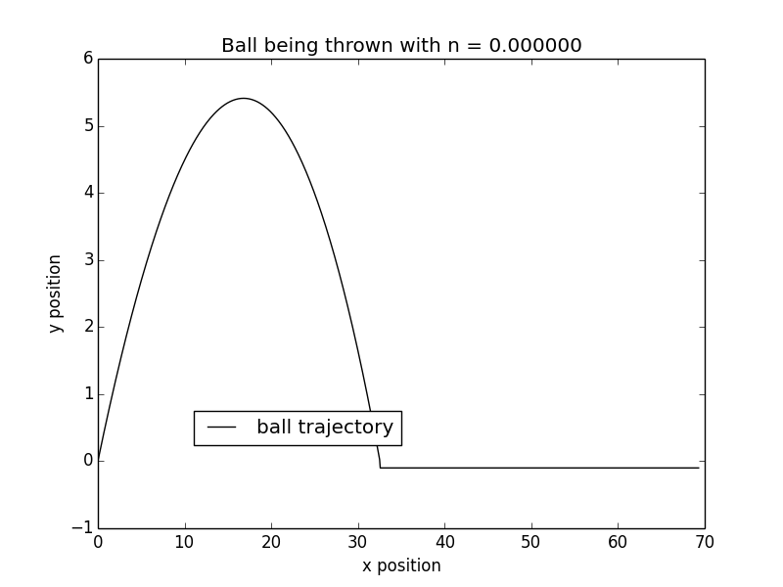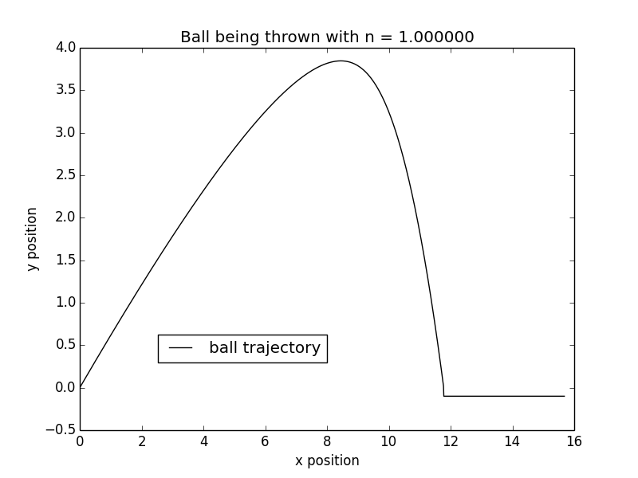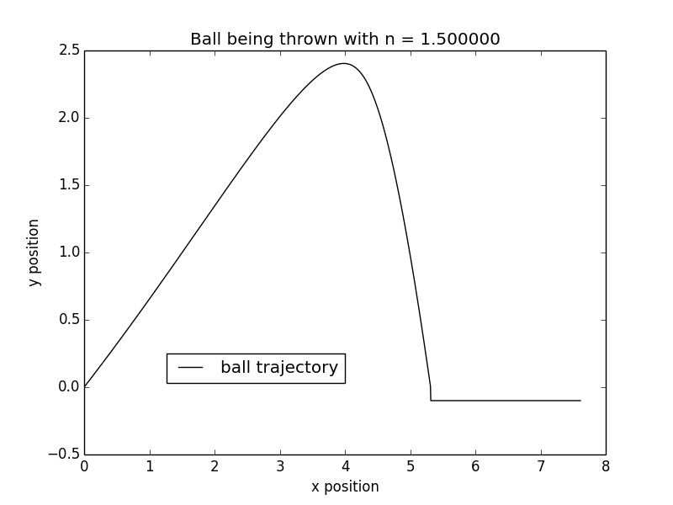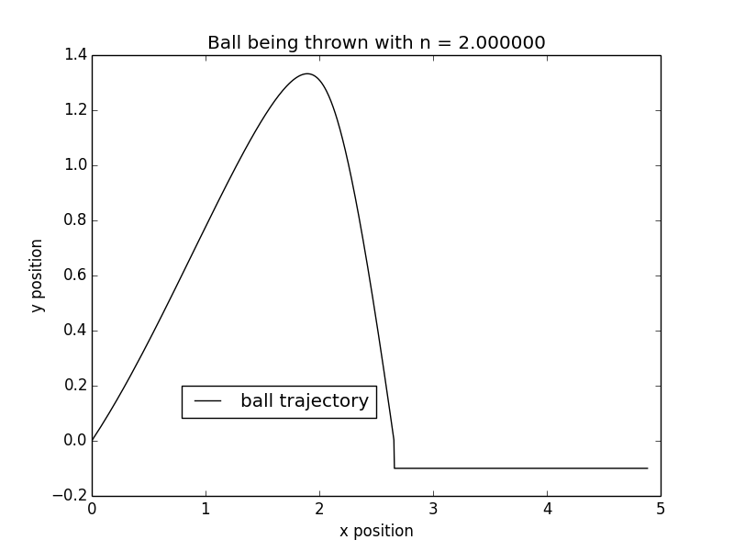

 - 9.6.2 Ball thrown in air with friction

* what's the best angle to throw at to maximize distance?

Note: I am unsure about the terminal velocity calculations that I made – I threw the ball with only vertical velocity, and viewed the velocity at the last step downwards – this is only accurate if it indeed reached terminal velocity. (It’s certainly easy enough to do this calculation better, by letting the ‘fall’ run for a relatively long period of time)

For k = 0.

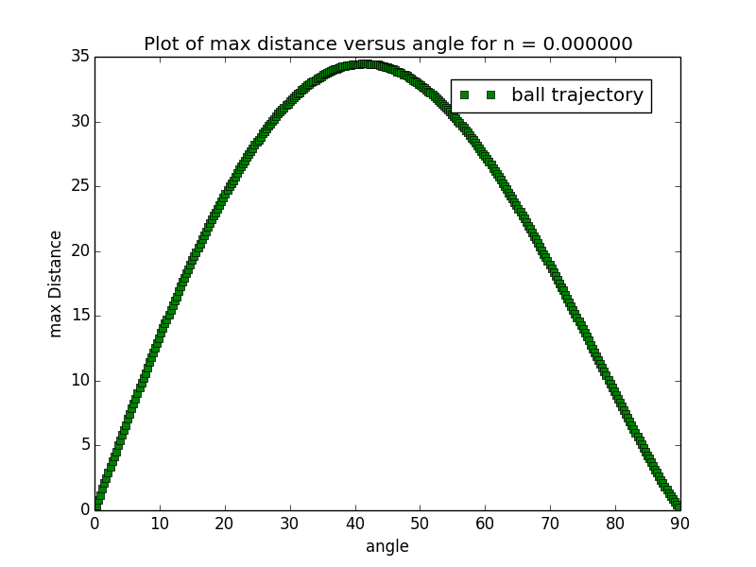We know this is 45 degrees

There is no terminal velocity – it is the same as how you shot it upwards

For k =1

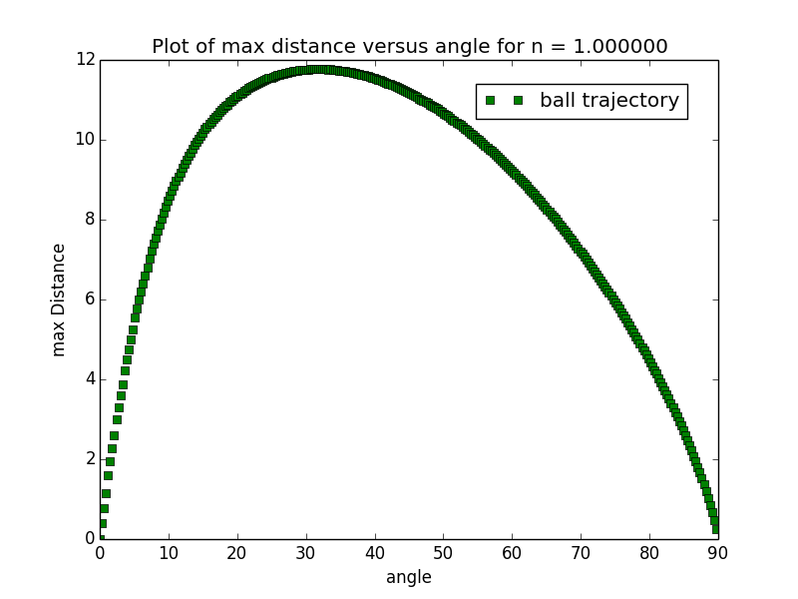

Terminal velocity for the angle 89.7:
6.539 m/s

roughly 20degrees

For k =1.5

Max distance roughly 33 degrees

the terminal velocity for:
89.7 degres :
3.497 m/s

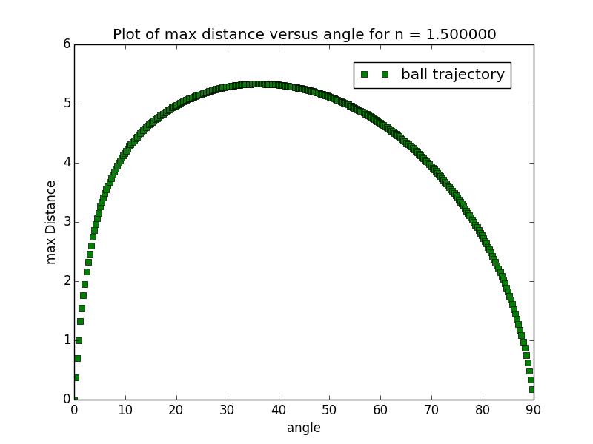

For k = 2.

There was a problem, due to the fact that the numbers were getting to large

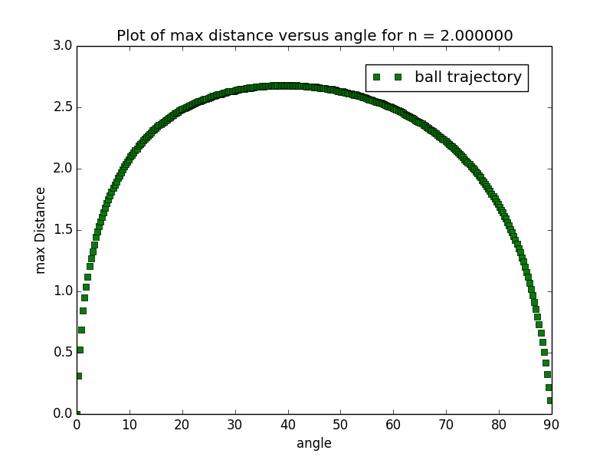

max roughly 40 degrees