Test sequence: ['turing', 'widely', 'considered', 'father', 'theoretical', 'computer', 'science']

RNN next word prediction: turing

LSTM next word prediction: turing

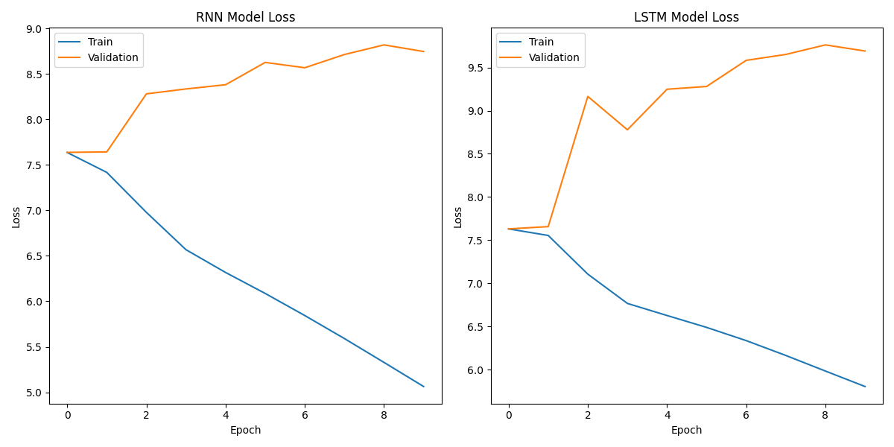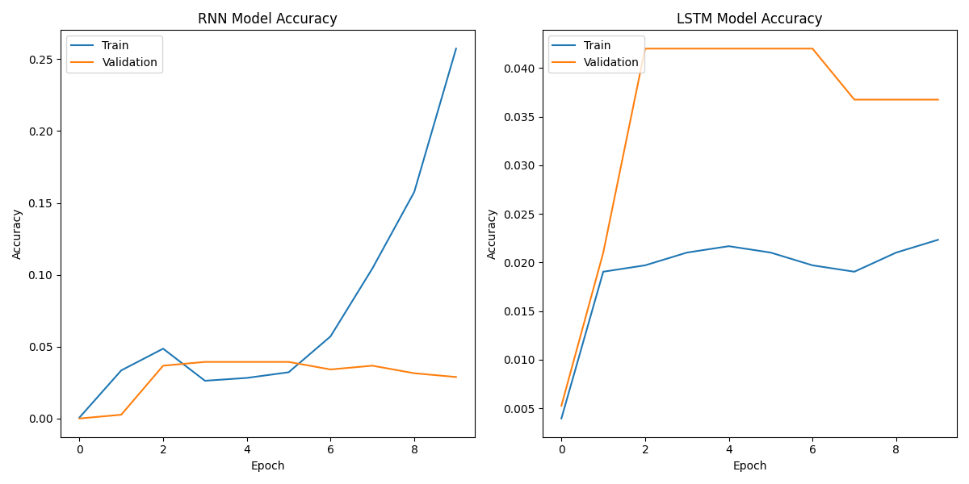

We can see from the graphs that the accuracy is low, and there might be a case of over fitting because of the graph with the loss function, we think it is because we don’t have enough data to train the RNN,LTSM models.

An example of 5 sentences (Original & Generated):  
  
1) Original: He was highly influential in the development of

1. Generated: He was highly influential in the development of the concept of the "new" world order. He was also a member of the Council of Europe, the European Parliament, the European Commission, the European Parliament, the European Parliament of the United Kingdom, the

2) Original: Turing devised techniques

1. Generated: Turing devised techniques to detect and eliminate the presence of the virus in the blood of infected patients.

The study was published in the journal Nature Communications.

The study was led by Dr. Michael J. Schoenfeld, a professor

1. Original: Despite these accomplishments, he was never fully
2. Generated: Despite these accomplishments, he was never fully satisfied with his work. He was also not satisfied with his work. He was also not satisfied with his work.

He was also not satisfied with his work. He was also not satisfied with his work

1. Original: After graduating from Sherborne
2. Generated: After graduating from Sherborne College in New York City, I was a student at the University of California, Berkeley. I was a student at the University of California, Berkeley. I was a student at the University of California, Berkeley. I was a

5) Original: Turing spent most of his time studying

1. Generated: Turing spent most of his time studying the world, and he was able to learn a lot about the world. He was able to understand the world through the eyes of a human. He was able to understand the world through the eyes of a human

* For some sentences the generated was bad, we think its because, we didn’t fine tune it as well as it is a old GPT model.
* for some reason it made a space between some of the sentences.
* stats:

Total Sentences: 334

Very Positive Sentences: 11.38%

Positive Sentences: 30.84%

Neutral Sentences: 19.76%

Negative Sentences: 17.07%

Very Negative Sentences: 20.96%

Examples of Very Positive sentences:

- [5] He was highly influential in the development of theoretical computer science, providing a formalisation of the concepts of algorithm and computation with the Turing machine, which can be considered a model of a general-purpose computer.

- [6][7][8] Turing is widely considered to be the father of theoretical computer science.

- He led Hut 8, the section responsible for German naval cryptanalysis.

Examples of Positive sentences:

-

Alan Mathison Turing OBE FRS (/ˈtjʊərɪŋ/; 23 June 1912 – 7 June 1954) was an English mathematician, computer scientist, logician, cryptanalyst, philosopher and theoretical biologist.

- [9]

Born in London, Turing was raised in southern England.

- He graduated in maths from King's College, Cambridge, and in 1938, earned a maths PhD from Princeton University.

Examples of Neutral sentences:

- [17][18] Turing's father was the son of a clergyman, the Rev.

- The Stoneys were a Protestant Anglo-Irish gentry family from both County Tipperary and County Longford, while Ethel herself had spent much of her childhood in County Clare.

- However, both Julius and Ethel wanted their children to be brought up in Britain, so they moved to Maida Vale,[21] London, where Alan Turing was born on 23 June 1912, as recorded by a blue plaque on the outside of the house of his birth,[22][23] later the Colonnade Hotel.

Examples of Negative sentences:

- Despite these accomplishments, he was never fully recognized during his lifetime because much of his work was covered by the Official Secrets Act.

- The first day of term coincided with the 1926 General Strike, in Britain, but Turing was so determined to attend that he rode his bicycle unaccompanied 60 miles (97 km) from Southampton to Sherborne, stopping overnight at an inn.

- His headmaster wrote to his parents: "I hope he will not fall between two stools.

Examples of Very Negative sentences:

- [14]

In 1952, Turing was prosecuted for homosexual acts.

- Turing died on 7 June 1954, aged 41, from cyanide poisoning.

- An inquest determined his death as suicide, but the evidence is also consistent with accidental poisoning.

Like we talked about in class, we can see that the model applied sentiment analysis correctly, so we don’t need to manually add labeled sentences.