**Instruction**

**Member: Rui Cai, Ruonan Zhang**

**1. Installation (Eclipse/MyEclipse)**

Because we use the SSH framework, so it is easier for us to implement our final project on eclipse. (Sorry about that we didn’t use NetBeans.)

In the archive file, there is a folder called “**JobSeeker**”, you can just go into eclipse and import the folder as an existing project into eclipse.

Edit some configuration of the program. Firstly, go to the **applicationContext-common.xml** to edit the related information of **MySql;** Secondly, go to **ConnectingToMysql.java** to edit related database information.

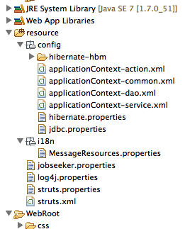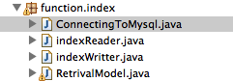

Then you should install **tomcat** on your eclipse and **deploy** this project onto the tomcat.

Then come to the Database part that we used **mysql** because we wrote a crawler to craw a lot of jobs information into our database, which we think derby cannot handle. There is a file called “**JobSeeker.sql**” file that can be imported in mysql.

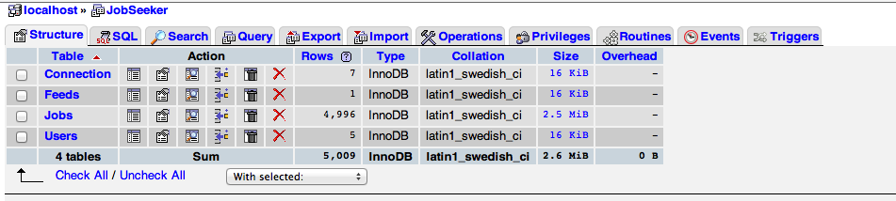

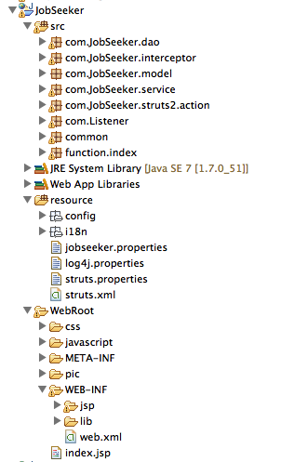

**2. Run Project**

Main page:

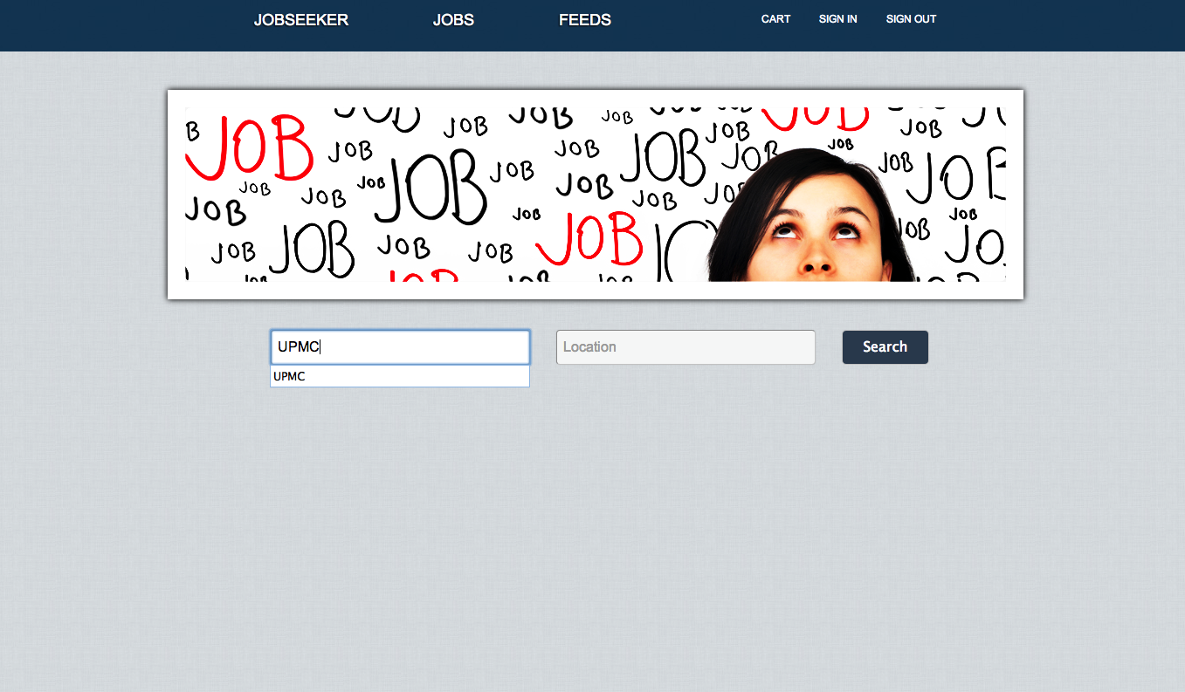

Search Result (Use Lucene to build and read index, use Language Model to calculate scores):

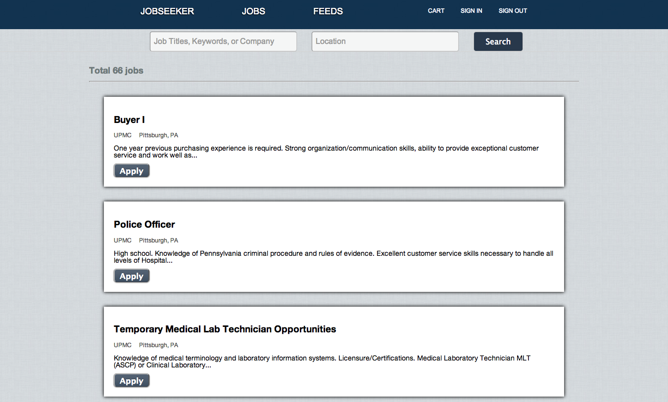

Automatically jumping to login page when related to privacy issue (Use interceptor to filter the request):

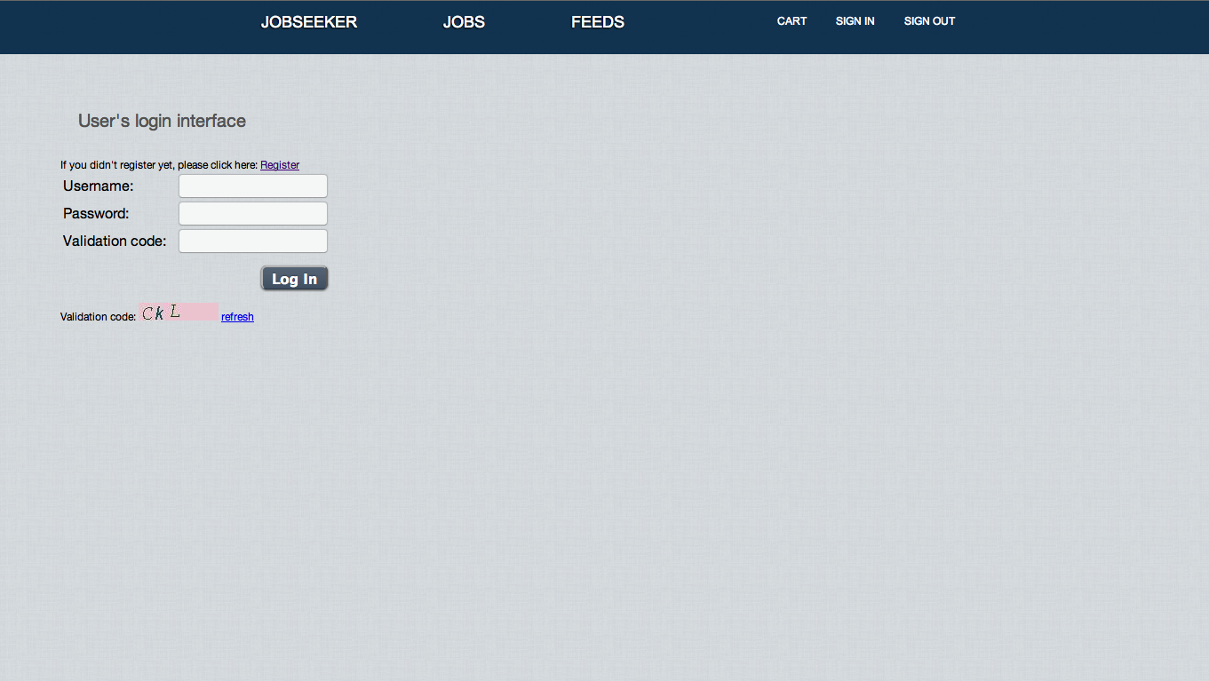

The jobs applied into the cart will still be kept in cart after register (Make full use of cookie to record the behavior of users and then finally combine users registering information with cookie):

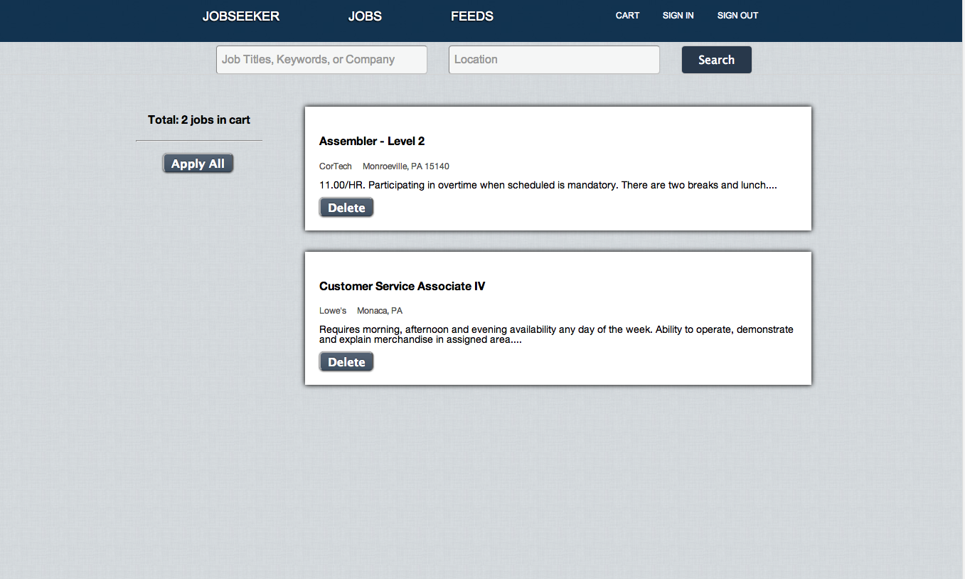

More importantly here is when we logged in we can keep on browsing the pages we browsed before because of the pre-page storage technology.

Automatically email alert each day with new jobs alerting (JavaMail, Struts2 Listener):

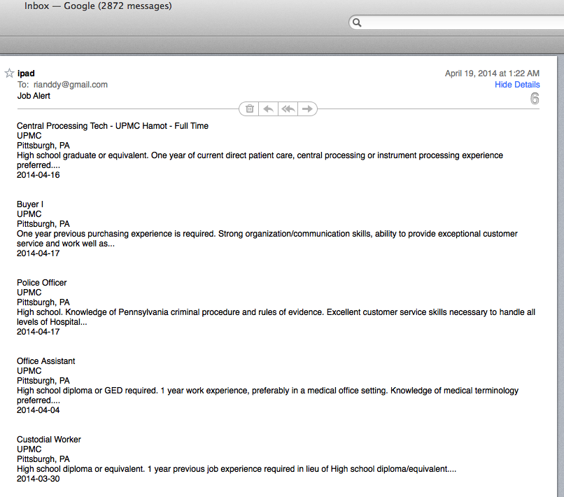

**3. Beautiful Codes!**

Make full use of Spring’s IOC container to control the logistic: 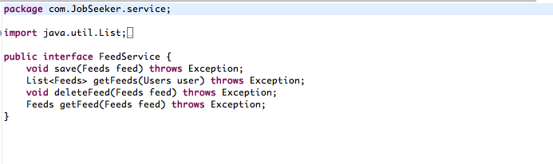

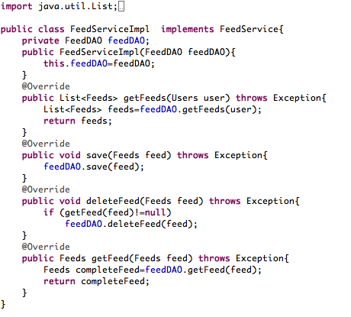

JPA technology of Hibernate (Wrote a lot of codes can be reused and hibernate session mechanism):

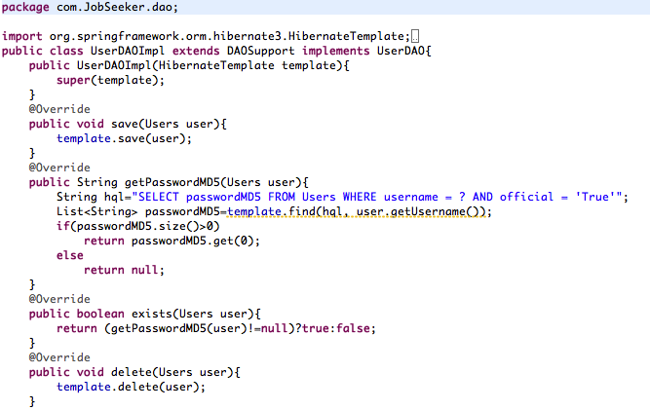

Store the static parameters:

