The Impact of Gasoline Prices on Gasoline Demand in the United States
Evidence from Monthly Data, 1993–2026

Roya Rezaie, University at Albany, SUNY
BFIN 515: Economic Analysis
October 5, 2026
Replication package (code, data, figures, this paper): https://github.com/RoyaRezaie/gasoline-demand

1. Business Question
Gasoline is the single largest operating cost for most road-transport businesses and the core revenue line for retail fuel stations, where the profit on a gallon is measured in cents and volume is what pays the rent. That makes one question unusually valuable to a retailer: when the price of gasoline changes, how much does the quantity that customers actually buy change? The business question addressed in this paper is therefore: how does the price of gasoline affect the quantity of gasoline demanded in the United States, and how can that relationship guide gasoline retailers in their pricing and inventory decisions?
Three groups of decision makers can use the answer. A pricing manager at a fuel or convenience chain needs to know whether raising the posted price will cost more in lost gallons than it gains in margin. An inventory and wholesale buyer needs a demand forecast in gallons in order to schedule deliveries and tank levels. A policymaker considering a fuel tax or a clean-fuel regulation needs the same elasticity to predict how much consumption, and therefore revenue or emissions, would actually change. This paper speaks to all three, with the retailer as the primary audience.
Using 399 monthly observations from April 1993 through July 2026 from the U.S. Energy Information Administration (EIA)and the Federal Reserve Bank of St. Louis, I estimate that U.S. gasoline demand is price-inelastic in the short run: a preferred estimate of -0.066 (HAC standard error 0.020) means a ten percent increase in the real pump price reduces the quantity demanded by less than one percent. The estimate is stable across fourteen alternative specifications, samples, and price measures, it is close to instrumental-variable estimates built on crude oil cost shocks, and a model estimated through 2015 beats three standard forecasting benchmarks in a pre-pandemic hold-out sample. The practical implication is that market-level demand barely moves when prices move, so for a retailer the volume risk of a modest price increase is small while the revenue upside is large, and inventory planning should be driven by seasonality and macroeconomic conditions rather than by price swings.
2. Data
Quantity is measured as monthly U.S. product supplied of finished motor gasoline, reported by the EIA in thousands of barrels per month in the Petroleum and Other Liquids data navigator. Product supplied is the standard EIA supply-side proxy for consumption: it equals production plus net imports minus the change in stocks, so it measures the volume that reaches the market. I convert it to thousands of barrels per day by dividing by the number of days in each month; over the sample the United States consumes a mean of 8,747 thousand barrels per day, with a minimum of 5,866 in April 2020 and a maximum of 9,834.
Price is the EIA monthly average retail price of all grades of gasoline, all formulations, in dollars per gallon, for the same months. The series begins in March 1993, which is why the sample starts in April 1993 and runs 399 months to July 2026. Prices are deflated by the Consumer Price Index (CPIAUCSL) into constant 2017 dollars, giving a mean of $2.64 per gallon and a range of $1.43 to $4.63. Nominal prices are kept for a robustness check. Exhibit 1 plots the two headline series; Exhibit 2 reports descriptive statistics.
Three controls and one instrument come from FRED, the Federal Reserve Bank of St. Louis economic database: real disposable personal income (DSPIC96), which I divide by resident population (POPTHM) to obtain real income per capita as the shift variable for the demand curve; the unemployment rate (UNRATE), used only in a robustness check; and the West Texas Intermediate crude oil spot price (DCOILWTICO), which is the cost shifter used as an instrument for the retail price. All series are monthly and are merged on the calendar month, leaving 399 complete observations with no missing values.
The raw source files are downloaded directly from the EIA and FRED by the script download_data.py, which writes the analysis file data/gasoline_demand_monthly.csv. Nothing in the paper is hand-entered: every table and figure in the exhibits is regenerated by analyze_demand.py. The full repository, including this paper's source, is at https://github.com/RoyaRezaie/gasoline-demand.
3. Method
The object of interest is a demand function: quantity demanded as a function of price, income, and other determinants. I estimate it in log-linear form, so each slope coefficient is an elasticity. The baseline specification is
ln Q_{t} = a + b ln P_{t} + c ln Y_{t} + month dummies + d · t + e_{t},
where Q is product supplied in thousands of barrels per day, P is the real retail price, Y is real income per capita, eleven month dummies absorb seasonality with December as the base month, and t is a linear time trend. The coefficient b is the short-run price elasticity of demand: the percentage change in quantity for a one percent change in price.
Two features of this problem make the naive version of that equation unreliable, and it is worth being explicit about them because they drive the whole design. First, the demand path is not a straight line. Improvements in fleet fuel economy, the aging of the vehicle stock, the shift toward sport-utility vehicles and later toward electrification, and the plateau in vehicle miles traveled after 2007 all shift gasoline demand gradually and non-linearly. Second, the pandemic was an enormous exogenous shock to mobility that moved price and quantity down together. A single linear trend cannot represent either. As Section 4 shows, the naive equation returns a positive price coefficient of +0.091, which is an artifact of omitted structural change rather than genuine behavior.
The preferred specification therefore adds a step indicator and a slope change at January 2007, plus a dummy for March 2020 through June 2021, the period of formal mobility restrictions and remote work: ln Q = a + b ln P + c ln Y + month dummies + step + trend after 2007 + pandemic + e. The break year and the pandemic window are judgment calls, so Section 5 reports how the elasticity moves when either is changed.
Because consumption adjusts slowly to its determinants, I also estimate a partial-adjustment (ARDL) model that adds the lagged level of ln Q.In that model b is the short-run elasticity and b / (1 - rho) is the long-run elasticity, where rho is the coefficient on the lagged dependent variable; the long-run standard error is computed with the delta method.
Price is not randomly assigned. Demand shocks raise both price and quantity, which biases ordinary least squares upward, and refining and crude costs are passed through to the pump. I therefore estimate a two-stage least squares model in which the real retail price is instrumented by the real WTI crude oil price, whose exclusion restriction is that crude costs affect gasoline quantity only through the retail price they produce. A first-stage F statistic of 133 indicates a strong instrument. As a specification test I add the lagged crude price as a second instrument and compute the Sargan statistic: J = 10.02 (p = 0.002) rejects the over-identified model, so the just-identified version is the one reported, and the rejection is itself evidence that a lagged crude price is contaminated by global demand conditions.
Because the data are monthly and the residuals are strongly serially correlated (the Durbin-Watson statistic of the preferred regression is about 1.0), all standard errors are Newey-West heteroskedasticity- and autocorrelation-consistent with twelve lags. Inference on the long-run elasticity uses the delta method.
The estimation plan includes four validation exercises, described in Section 5: an out-of-sample hold-out period with explicit benchmarks, a stress test of the pandemic regime, a robustness table over alternative specifications, samples, and price measures, and a comparison of the elasticity with published estimates from the literature.
4. Results
Exhibit 3 reports the main estimation results. Column 1 is the baseline equation with a linear trend. Its price coefficient is +0.091 (s.e. 0.033), a positive and significant elasticity that would say consumers buy more gasoline when it gets more expensive. That is not credible, and the reason is visible in Exhibit 1: over 1993 to 2007 both real prices and quantity trended upward together, while after 2007 quantity flattened and prices did not. Pooling the two eras under a single straight line loads the structural change onto the price coefficient. Column 2 is the preferred specification with the 2007 break and the pandemic dummy; it raises R-squared from 0.503 to 0.838 and returns an elasticity of -0.066 (s.e. 0.020, significant at one percent). The pandemic dummy is -0.123, about twelve percent lower quantity during the restriction period, as expected.
Column 3 adds the lagged dependent variable. The adjustment coefficient is 0.494, so about half of any deviation from the steady state closes within a month. The short-run elasticity is -0.035 (s.e. 0.013) and the long-run elasticity is -0.069 (s.e. 0.022), both statistically significant. Column 4 instruments the price with crude oil costs and gives -0.046 (s.e. 0.021), close to the least-squares estimate, which suggests that simultaneity bias is small in this setting once the structural controls are in place.
The income coefficient in the preferred specification is small and insignificant (-0.034, s.e. 0.136), which is common in monthly aggregate gasoline studies: income moves slowly, is absorbed by the trend terms, and its variation is modest relative to price over this sample. What remains is a demand curve that is steeply inelastic in quantity.
Exhibit 4 shows the identifying variation directly: after residualizing both logs on income, seasonality, the trend terms, and the pandemic dummy, the scatter of price against quantity has a clearly negative slope. Exhibit 5 overlays the actual and fitted series; the preferred model tracks the 1990s expansion, the post-2007 plateau, the 2008 recession, the 2014–2016 price collapse, and the pandemic collapse and recovery.
Two results matter for the business question. First, the magnitude: with an elasticity of -0.066, a ten percent increase in the real pump price reduces market quantity by about 0.66 percent. Exhibit 10 converts this into the units a retailer thinks in: at the sample mean real price of $2.64, a $0.25 per gallon increase (9.5 percent) lowers quantity by about 0.63 percent, or 55 thousand barrels per day across the market, and raises fuel revenue by about 8.8 percent, because demand is inelastic. Second, the seasonal pattern in Exhibit 11: holding price and income fixed, demand in July runs 4.4 percent above December and in August 5.0 percent above, while January is 5.5 percent below. Volume planning, not price movement, is what moves gallons.
5. Validation
Out-of-sample hold-out. I re-estimate both the baseline and the preferred equations using only data through December 2015 (323 months) and forecast one month ahead for January 2016 through February 2020 (50 months), a period that no estimation equation has seen and that ends before the pandemic. Exhibit 6 reports root mean squared error (RMSE) and mean absolute percentage error (MAPE) in thousand barrels per day. The preferred model produces an RMSE of 135 and a MAPE of 1.2 percent, against 240 for the baseline model with the linear trend, 141 for a seasonal naive forecast that repeats the same month one year earlier, 305 for a random walk, and 636 for the training-sample mean. Exhibit 7 overlays the preferred model's one-step-ahead path on the actual series alongside the baseline forecast and the seasonal naive benchmark. The preferred model beats every benchmark, and the gap between 135 and 240 shows that the structural controls improve forecasting as well as estimation, which is the practical justification for the extra terms rather than a purely statistical one.
Stress period. The second check asks what happens when the regime changes in a way the model has never seen. Forecasting March 2020 through July 2026 with the pre-2020 model gives an RMSE of 935 thousand barrels per day, worse than the random walk benchmark at 411, because a model that knows nothing about mobility restrictions extrapolates a demand level that no longer exists. Inside the sample, adding the pandemic dummy reduces in-sample error over March 2020 to June 2021 from 1018 to 801. The honest conclusion is that the elasticity itself remains usable, but demand forecasts must be re-estimated, or explicitly flagged, when a shock of this type arrives.
Alternative specifications and samples. Exhibit 8 reports the price elasticity from fourteen variations on the preferred equation: moving the trend break to 2006, 2008, or 2009; shortening or lengthening the pandemic window; adding the unemployment rate; using per-capita quantity as the dependent variable; restricting the sample to pre-pandemic months; splitting at 2004; using the nominal price with the CPI included as a separate regressor; using regular-grade rather than all-grade prices; the crude-oil instrument; and a linear-in-levels form whose implied elasticity at the sample mean is reported. Every estimate is negative, ranging from -0.084 to -0.035, and most are significant at five percent or better. The pre-pandemic subsample alone gives -0.063 (s.e. 0.015), which is close to the full-sample result and shows that the estimate is not driven by the pandemic months.
Stability over time. Exhibit 9 re-estimates the preferred equation in rolling six-year windows. Estimates are negative and mostly between -0.02 and -0.10 through 2019, become positive only in the windows that contain the pandemic collapse, and return to negative values afterwards. This is the same lesson as the stress test: the sign of the raw coefficient in a short window is dominated by whatever demand shock dominated that window, which is why the pooled estimate with an explicit pandemic control is the appropriate summary statistic.
Comparison with published estimates. Hughes, Knittel, and Sperling (2008) report short-run price elasticities of U.S. gasoline demand of -0.034 to -0.077 for 2001–2006, compared with -0.21 to -0.34 for 1975–1980, arguing that responsiveness has fallen. Havranek, Irsova, and Janda (2012), correcting a meta-analytic literature for publication selection bias, put the average short-run elasticity at -0.09 and the long run at -0.31; Espey (1998) is the classic earlier meta-analysis. My short-run estimates of -0.035 to -0.066 sit inside the post-2000 range and are close to the publication-bias-corrected average. The long-run estimate of -0.069 is smaller in absolute value than the -0.31 benchmark, which is consistent with how the model identifies long-run behavior: the trend terms deliberately absorb the slow secular shifts in fuel economy and vehicle stock, so the long-run response is identified only from medium-horizon price variation. That is a limit of this design rather than a contradiction of the literature, and it is reported as such.
6. Recommendation
For a pricing manager. Market demand for gasoline is inelastic: quantity moves by roughly 0.7 percent for every ten percent change in price. Within the limits of local competition, that means a modest price increase is far more likely to raise fuel revenue than to lose gallons: Exhibit 10 implies that $0.25 per gallon at the average station's market price changes volume by only 0.63 percent while raising revenue by about 8.8 percent. The essential caveat is that this is a market-wide elasticity. A single station raising its posted price while the station across the street does not will lose more than 0.63 percent of its volume, because drivers substitute across stations; this data set cannot identify that own-price elasticity. The correct use of the result is therefore at the chain or market level, setting the direction and rough magnitude of a price move, while the store-level price gap against local competitors should be tuned with the retailer's own point-of-sale history.
For an inventory and wholesale buyer. Because demand barely responds to price, price movements should not drive ordering. What does drive gallons is the seasonal cycle, which Exhibit 11 quantifies at roughly 4.4 to 5.0 percent above December in July and August and about 5.5 percent below it in January, together with income and the level of economic activity. Order schedules, tank sizing, and delivery cadence should be built from that seasonal profile and from a short-horizon macro forecast, with a price-driven adjustment of at most a fraction of a percent for a typical price swing.
For forecasting and planning. The preferred model's hold-out MAPE of 1.2 percent per month is good enough to use directly as a one-to-three-month demand plan, and it clearly beats the naive benchmarks in normal times. Two operating rules follow from the validation exercise. Re-estimate the equation annually so the trend terms track fuel economy and fleet changes. And when an exogenous mobility shock appears, do not extrapolate: the pre-2020 model's error rose to 935 thousand barrels per day through the pandemic, worse than a random walk, so switch to a scenario forecast until the regime is over.
For a policymaker. The same inelasticity cuts the other way. A fuel tax or carbon charge of ten percent at the pump would reduce consumption by well under one percent in the short run, so tax-based policy needs to be large, permanent, and paired with efficiency or alternative-fuel measures if the goal is material reductions in gasoline use; in the short run it behaves mostly as a revenue instrument.
Limitations. The analysis uses national monthly aggregates, so it cannot separate regions, stations, or grades, and it cannot identify the own-price elasticity a single retailer faces. Product supplied is a supply-side proxy for consumption. Fuel economy, vehicle miles traveled, and fleet composition are absorbed by the trend break rather than measured directly, which is why the long-run elasticity is smaller than published benchmarks. The instrument's exclusion restriction is imperfect, as the Sargan test indicates. Finally, the sample ends in July 2026, so the most recent months are preliminary EIA figures that are subject to revision. None of these caveats changes the central finding for the decision maker: in the short run, U.S. gasoline demand is driven far more by seasonality and the state of the economy than by the price at the pump.
Data and code availability. The data set, the estimation code, every table and figure in this paper, and the source of the paper itself are publicly available at https://github.com/RoyaRezaie/gasoline-demand. Running download_data.py, analyze_demand.py and paper/build_paper.py reproduces every number reported above.

References
Espey, M. (1998). Gasoline demand revisited: An international meta-analysis of cross-country elasticity estimates. Energy Economics, 20(3), 273–295.
Hughes, J. E., Knittel, C. R., & Sperling, D. (2008). Evidence of a shift in the short-run price elasticity of gasoline demand. The Energy Journal, 29(1), 113–134.
Havranek, T., Irsova, Z., & Janda, K. (2012). Demand for gasoline is more price-inelastic than commonly thought. Energy Economics, 34(1), 201–207.
U.S. Energy Information Administration. Petroleum and Other Liquids: Supply and Disposition, and Retail Prices (monthly series, downloaded October 2026). https://www.eia.gov/dnav/pet/
Federal Reserve Bank of St. Louis. FRED: CPIAUCSL, DSPIC96, POPTHM, UNRATE, DCOILWTICO (downloaded October 2026). https://fred.stlouisfed.org/
Using Supply and Demand Functions: A Survey by Data Availability. SSRN Electronic Journal. https://papers.ssrn.com/sol3/papers.cfm?abstract_id=7399858 (starting point for this project).
Wooldridge, J. M. (2020). Introductory Econometrics: A Modern Approach (7th ed.). Cengage Learning.

Exhibits
Exhibit 1. U.S. retail gasoline price and gasoline product supplied, 1993–2026
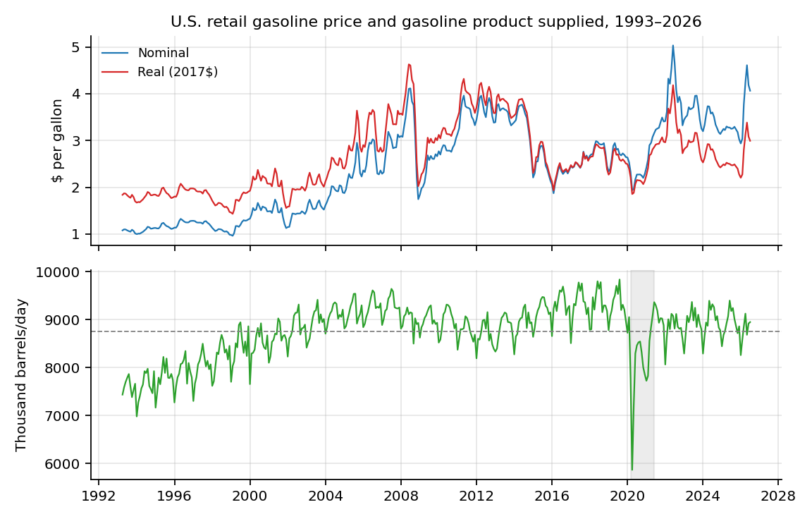
Monthly data. Top panel: nominal and real (2017$) retail price of all grades of gasoline. Bottom panel: motor gasoline product supplied, thousand barrels per day. Shaded area: March 2020–June 2021. Source: EIA; author's calculations.
Exhibit 2. Descriptive statistics
Variable | N | Mean | Std. dev. | Min | Max | First month | Last month
Gasoline product supplied (thousand b/d) | 399 | 8746.78 | 582.5 | 5865.77 | 9833.68 | 1993-04 | 2026-07
Retail gasoline price (2017$ per gallon) | 399 | 2.64 | 0.72 | 1.43 | 4.63 | 1993-04 | 2026-07
Retail gasoline price (nominal $ per gallon) | 399 | 2.43 | 0.96 | 0.96 | 5.03 | 1993-04 | 2026-07
Real disposable income per capita ($) | 399 | 40913.4 | 6812.78 | 29265.5 | 61764.2 | 1993-04 | 2026-07
WTI crude oil price (2017$ per barrel) | 399 | 59.12 | 26.87 | 15.84 | 150.91 | 1993-04 | 2026-07
Unemployment rate (percent) | 399 | 5.55 | 1.77 | 3.4 | 14.8 | 1993-04 | 2026-07

N = 399 monthly observations, April 1993 to July 2026. Prices and the crude oil price are in constant 2017 dollars.
Exhibit 3. Main results: price elasticity of gasoline demand
Model | Term | Coefficient | HAC s.e. | p-value | Sig. | N | R2
(1) Baseline OLS | ln(real gasoline price) | 0.0913 | 0.033 | 0.0057 | *** | 399 | 0.503
(1) Baseline OLS | ln(real income per capita) | 0.3445 | 0.3173 | 0.2777 |  | 399 | 0.503
(2) Preferred OLS | ln(real gasoline price) | -0.066 | 0.0201 | 0.001 | *** | 399 | 0.838
(2) Preferred OLS | ln(real income per capita) | -0.0336 | 0.1364 | 0.8053 |  | 399 | 0.838
(2) Preferred OLS | Pandemic dummy (Mar20–Jun21) | -0.123 | 0.0335 | 0.0002 | *** | 399 | 0.838
(3) Preferred ARDL | ln(real gasoline price) | -0.0347 | 0.0131 | 0.0083 | *** | 398 | 0.877
(3) Preferred ARDL | ln(quantity) lagged | 0.4944 | 0.0766 | &lt;0.0001 | *** | 398 | 0.877
(3) Preferred ARDL | ln(real income per capita) | 0.0094 | 0.0965 | 0.9223 |  | 398 | 0.877
(3) Preferred ARDL | Long-run elasticity | -0.0686 | 0.0224 | 0.0022 | *** | 398 | 0.877
(4) IV: WTI cost shifter | ln(real gasoline price) | -0.0459 | 0.0211 | 0.0295 | ** | 398
(4) IV: WTI cost shifter | ln(real income per capita) | -0.0123 | 0.1379 | 0.9292 |  | 398

Dependent variable: ln(quantity). Newey-West HAC standard errors in parentheses; *** p<0.01, ** p<0.05, * p<0.10. Column (1) uses a linear trend only; column (2) adds the 2007 step and slope break and the March 2020–June 2021 pandemic dummy; column (3) adds the lagged dependent variable and reports the delta-method long-run elasticity; column (4) instruments ln(price) with the real WTI crude price (first-stage F = 133, Sargan J = 10.02, p = 0.002).
Exhibit 4. Partial relationship between price and quantity
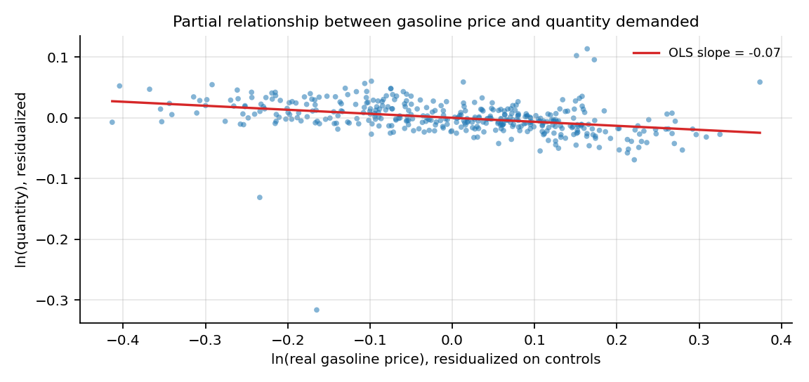
Quantity and price residualized on ln(real income per capita), month dummies, the trend terms, and the pandemic dummy; the fitted slope equals -0.07.
Exhibit 5. Actual and fitted gasoline demand, preferred model
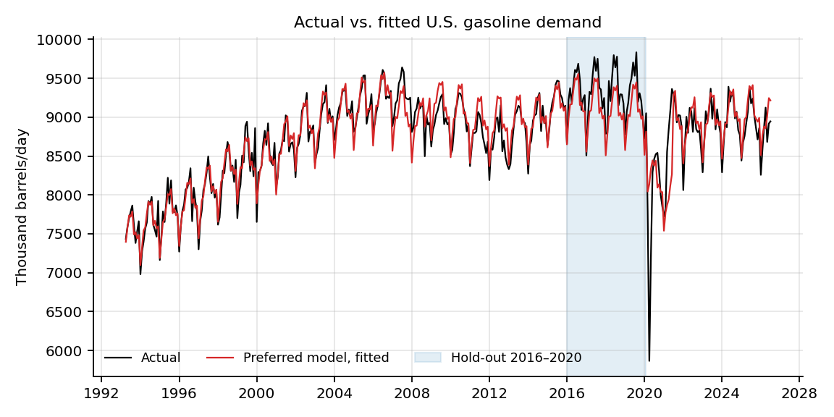
Shaded area: the 2016–2020 hold-out period used in Section 5.
Exhibit 6. Out-of-sample forecast accuracy
Period | Method | N | RMSE | MAE | MAPE (%)
Hold-out 2016-01..2020-02 | Preferred model (1-step) | 50 | 135.1 | 111.2 | 1.2
Hold-out 2016-01..2020-02 | Baseline model (linear trend) | 50 | 239.6 | 204.4 | 2.2
Hold-out 2016-01..2020-02 | Benchmark: random walk (t-1) | 49 | 304.8 | 247 | 2.7
Hold-out 2016-01..2020-02 | Benchmark: seasonal naive (t-12) | 38 | 140.8 | 113 | 1.2
Hold-out 2016-01..2020-02 | Benchmark: training mean | 50 | 636.1 | 569.1 | 6
Stress 2020-03..2026-07 | Preferred model pre-2020 (1-step) | 76 | 934.6 | 717.2 | 8.7
Stress 2020-03..2026-07 | Benchmark: random walk (t-1) | 75 | 410.9 | 288.1 | 3.5
Stress 2020-03..2026-07 | Benchmark: seasonal naive (t-12) | 64 | 576 | 331.8 | 3.7
In-sample 2020-03..2021-06 | Preferred model with pandemic dummy | 16 | 801.1 | 544 | 7.2
In-sample 2020-03..2021-06 | Same model without pandemic dummy | 16 | 1017.5 | 803.6 | 10.8

Errors in thousand barrels per day. Forecasts are one month ahead. Hold-out: equations estimated on data through December 2015, evaluated over January 2016–February 2020. Stress period: equations estimated through February 2020, evaluated over March 2020–July 2026. The last two rows compare in-sample fit in the pandemic window with and without the pandemic dummy.
Exhibit 7. One-step-ahead forecasts against benchmarks, 2016–2020 hold-out
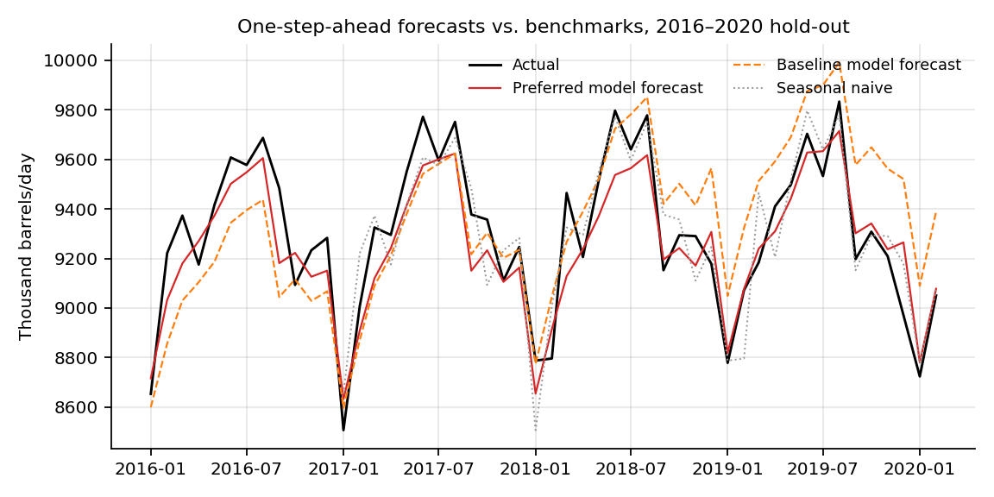
Thousand barrels per day.
Exhibit 8. Robustness of the price elasticity
Specification | Elasticity | HAC s.e. | p-value | N | R2 | Note
Preferred specification (column 2) | -0.066 | 0.0201 | 0.001 | 399 | 0.838 | benchmark
Trend break moved to 2006 | -0.0672 | 0.0214 | 0.0017 | 399 | 0.837
Trend break moved to 2008 | -0.07 | 0.0189 | 0.0002 | 399 | 0.844
Trend break moved to 2009 | -0.0788 | 0.0189 | &lt;0.0001 | 399 | 0.827
Pandemic window ends 2020-12 | -0.0841 | 0.0147 | &lt;0.0001 | 399 | 0.868
Pandemic window ends 2021-12 | -0.0513 | 0.0261 | 0.0495 | 399 | 0.806
Plus unemployment rate | -0.0584 | 0.0148 | 0.0001 | 399 | 0.89
Per-capita quantity as dependent variable | -0.055 | 0.0197 | 0.0053 | 399 | 0.843
Pre-pandemic sample (1993-04..2020-02) | -0.0634 | 0.0151 | &lt;0.0001 | 323 | 0.948 | another period
Sub-sample 1993-2003 | -0.0351 | 0.0059 | &lt;0.0001 | 129 | 0.962 | structural controls
Sub-sample 2004 onward | -0.0737 | 0.0278 | 0.0081 | 270 | 0.593 | structural controls
Nominal price with CPI control | -0.0404 | 0.0164 | 0.014 | 399 | 0.849 | Fisher-style check
Regular-grade price | -0.0634 | 0.0192 | 0.0009 | 399 | 0.838 | all-grade price in column 2
IV: real WTI crude cost shifter | -0.0459 | 0.0211 | 0.0295 | 398 |  | cost-shock instrument
Linear in levels (elasticity at sample mean) | -0.0686 | 0.017 | 0.0001 | 399 | 0.854 | dQ/dP x mean(P)/mean(Q)

Each row re-estimates the preferred equation with one change: trend break year, pandemic window, additional controls, dependent variable, sample period, price measure, instrument, or functional form. HAC standard errors.
Exhibit 9. Rolling six-year price elasticity
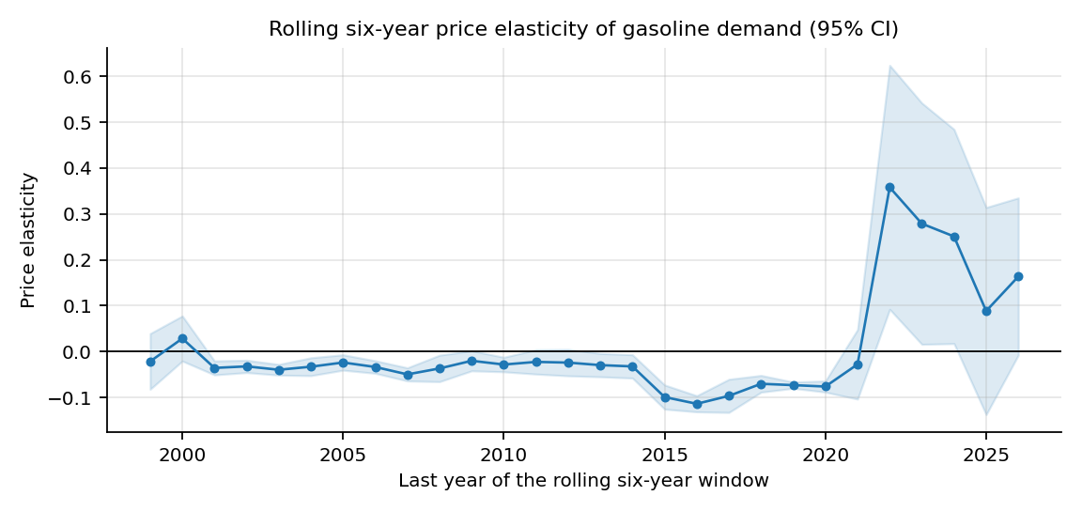
Point estimates and 95 percent confidence intervals from six-year rolling samples of the preferred equation, labelled by the final year of each window.
Exhibit 10. Implied response of market demand to a price increase
Price change ($/gal) | Price change (%) | Quantity change (%) | Revenue change (%) | Quantity change (000 b/d)
0.1 | 3.79 | -0.25 | 3.53 | -21.9
0.25 | 9.47 | -0.626 | 8.79 | -54.7
0.5 | 18.95 | -1.252 | 17.46 | -109.5

Computed from the preferred elasticity -0.066 at the sample mean real price of $2.64 per gallon and mean quantity of 8,747 thousand barrels per day. Revenue change is the product of the price and quantity changes at the market level.
Exhibit 11. Seasonal pattern of gasoline demand
Month | Effect vs. December (%)
January | -5.51
February | -2.42
March | 0.13
April | 0.6
May | 2.94
June | 4.97
July | 4.42
August | 5.05
September | 0.77
October | 1.22
November | -0.21
December | 0

Percent difference in quantity relative to December, from the preferred regression (December = base month).

Appendix
This appendix contains supporting material: data sources and variable construction, the complete regression output behind Exhibit 3, model diagnostics, and the commands needed to reproduce every number in the paper. It is supplementary to the main text and is not part of the 15-page limit.
Appendix A. Data sources and variable construction
The analysis file data/gasoline_demand_monthly.csv is assembled entirely by download_data.py. It contains 399 monthly observations from April 1993 to July 2026 with no missing values.
Variable | Definition and construction | Source
Quantity (Q) | Monthly product supplied of finished motor gasoline, thousand barrels per month, divided by days in the month to obtain thousand barrels per day | EIA, PET_CONS_PSUP_DC_NUS_MBBL_M.xls
Price, nominal (P) | Monthly retail price, all grades and all formulations, dollars per gallon | EIA, PET_PRI_GND_DCUS_NUS_M.xls
Price, real (2017$) | Nominal price multiplied by the 2017 average of CPIAUCSL and divided by the CPIAUCSL value of the same month | FRED, CPIAUCSL
Real income per capita (Y) | Real disposable personal income (billions of chained 2017 dollars, SAAR) multiplied by 1e9 and divided by population in persons | FRED, DSPIC96 and POPTHM
Unemployment rate | Civilian unemployment rate, percent, seasonally adjusted | FRED, UNRATE
WTI crude price | West Texas Intermediate spot price, daily data averaged to a monthly mean, then deflated to 2017 dollars | FRED, DCOILWTICO
Time trend (t) | 0 for April 1993, increasing by one each month | Constructed
Step indicator | 0 through December 2006, 1 from January 2007 | Constructed
Trend after 2007 | 0 through December 2006, then months since January 2007 divided by 12 | Constructed
Pandemic dummy | 1 from March 2020 through June 2021, else 0 | Constructed
Month dummies | Eleven indicators for January through November; December is the base month | Constructed

Appendix Table A1. Variables used in the estimation, their construction, and their sources.
Appendix B. Complete regression output and diagnostics
Appendix Table B1 reports every coefficient of the preferred specification that underlies column 2 of Exhibit 3, including the eleven month dummies, the trend terms and the pandemic dummy. Appendix Table B2 reports the diagnostics. Two of them matter for inference: the residuals are strongly serially correlated (Durbin-Watson 1.01) and strongly non-normal (Jarque-Bera p-value below 0.0001, driven by the pandemic months), which is why every standard error in the paper is Newey-West HAC with twelve lags. The instrument is strong (first-stage F of 133), and the Sargan test reported in Section 3 rejects the over-identified version, so the just-identified IV is the one reported.
Term | Coefficient | HAC s.e. | p-value | Sig.
Constant | 9.28932 | 1.40448 | &lt;0.0001 | ***
ln(real gasoline price) | -0.06605 | 0.02007 | 0.001 | ***
ln(real income per capita) | -0.03363 | 0.13641 | 0.8053
January dummy (vs. December) | -0.05665 | 0.00514 | &lt;0.0001 | ***
February dummy (vs. December) | -0.0245 | 0.00422 | &lt;0.0001 | ***
March dummy (vs. December) | 0.00127 | 0.00533 | 0.8116
April dummy (vs. December) | 0.00596 | 0.01038 | 0.5659
May dummy (vs. December) | 0.02902 | 0.007 | &lt;0.0001 | ***
June dummy (vs. December) | 0.04847 | 0.00527 | &lt;0.0001 | ***
July dummy (vs. December) | 0.04325 | 0.00418 | &lt;0.0001 | ***
August dummy (vs. December) | 0.04929 | 0.00476 | &lt;0.0001 | ***
September dummy (vs. December) | 0.00765 | 0.00483 | 0.113
October dummy (vs. December) | 0.01215 | 0.00464 | 0.0089 | ***
November dummy (vs. December) | -0.00213 | 0.00415 | 0.6089
Linear trend (per month) | 0.00168 | 0.00028 | &lt;0.0001 | ***
Step indicator (January 2007 and after) | -0.03068 | 0.01401 | 0.0285 | **
Trend after 2007 (per year) | -0.02065 | 0.0014 | &lt;0.0001 | ***
Pandemic dummy (Mar 2020-Jun 2021) | -0.12303 | 0.03348 | 0.0002 | ***

Appendix Table B1. Preferred specification, dependent variable ln(quantity); 399 monthly observations, R-squared 0.838.
Statistic | Value
Observations | 399
Sample period | Apr 1993 to Jul 2026
R-squared | 0.8382
Adjusted R-squared | 0.831
Durbin-Watson statistic | 1.006
Jarque-Bera statistic | 42199.2
Jarque-Bera p-value | <0.0001
Price elasticity (preferred, HAC s.e.) | -0.0660 (0.0201)
Price elasticity, ARDL short-run (HAC s.e.) | -0.0347 (0.0131)
Price elasticity, ARDL long-run (delta s.e.) | -0.0686 (0.0224)
ARDL adjustment coefficient (rho) | 0.4944
IV price elasticity (HAC s.e.) | -0.0459 (0.0211)
IV first-stage F statistic | 133.2
IV first-stage R-squared | 0.9576
Sargan J (two instruments), p-value | 0.0015
Hold-out RMSE 2016-01 to 2020-02 (thousand b/d) | 135.1

Appendix Table B2. Model diagnostics for the preferred, ARDL and IV estimates reported in Exhibit 3.
Appendix C. Reproducing the analysis
The repository contains everything needed to rebuild the results from scratch; nothing in the paper is entered by hand. From the project root:
python3 -m pip install -r requirements.txt
python3 download_data.py # fetches the EIA and FRED source files
python3 analyze_demand.py # estimates all models, writes tables and figures
python3 paper/build_paper.py # builds the PDF version of the paper
python3 paper/build_docx.py # builds the Word version of the paper
download_data.py writes the raw source files to data/raw/ and the merged panel to data/gasoline_demand_monthly.csv. analyze_demand.py writes output/tables/*.csv, output/figures/*.png and output/results.json. Both builders read those outputs, so the tables and figures in the paper always match the estimation code. The project is public at https://github.com/RoyaRezaie/gasoline-demand.

Using Supply and Demand Functions: A Survey by Data Availability. SSRN Electronic Journal. https://papers.ssrn.com/sol3/papers.cfm?abstract_id=7399858 (starting point for this project).
U.S. Energy Information Administration. Petroleum and Other Liquids: Supply and Disposition, and Retail Prices (monthly series, downloaded October 2026). https://www.eia.gov/dnav/pet/
Federal Reserve Bank of St. Louis. FRED: CPIAUCSL, DSPIC96, POPTHM, UNRATE, DCOILWTICO (downloaded October 2026). https://fred.stlouisfed.org/
Wooldridge, J. M. (2020). Introductory Econometrics: A Modern Approach (7th ed.). Cengage Learning.
Hughes, J. E., Knittel, C. R., & Sperling, D. (2008). Evidence of a shift in the short-run price elasticity of gasoline demand. The Energy Journal, 29(1), 113–134.
Havranek, T., Irsova, Z., & Janda, K. (2012). Demand for gasoline is more price-inelastic than commonly thought. Energy Economics, 34(1), 201–207.
Espey, M. (1998). Gasoline demand revisited: An international meta-analysis of cross-country elasticity estimates. Energy Economics, 20(3), 273–295.

