**Bug ID:** BUG-001  
**Title:** Book details page shows blank white screen  
**Environment:**

* OS: Windows 10 Version 22H2
* Browser: Google Chrome 140
* Website: <https://demoqa.com/books>
* Date: 18-Sep-2025

**Steps to reproduce:**

1. Open <https://demoqa.com/books>
2. Scroll down to the book list
3. Click on any book title (for example: *Learning JavaScript Design Patterns*)

**Expected result:**  
The book details page opens showing the book’s title, author, publisher, description, and “Add to Your Collection” button.

**Actual result:**  
A completely blank white screen appears with no error message or content. User cannot view book details.

**Severity:** Major  
**Priority:** High

**Attachments:**

Screenshot_5

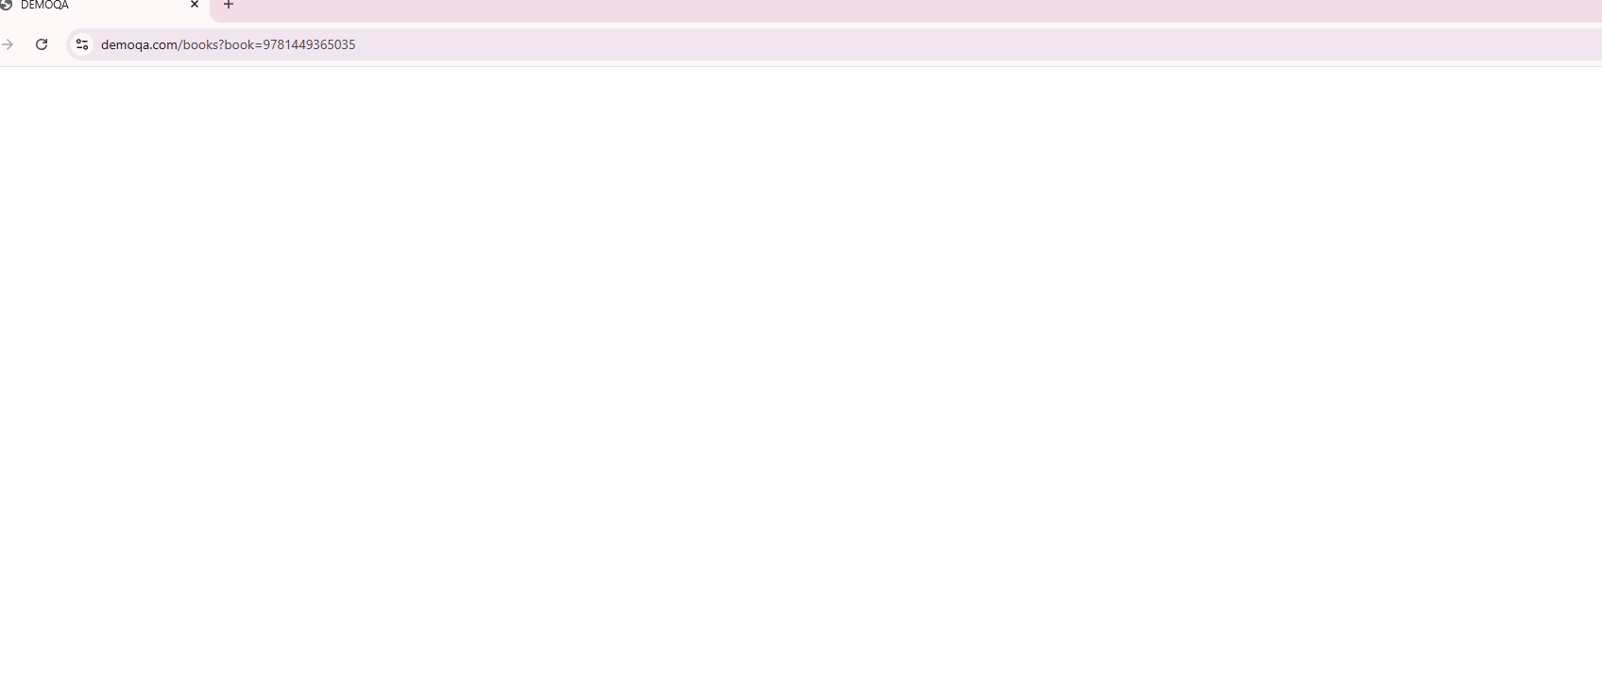

Figure : Blank details page (shows blank white screen with URL visible)