**Bug ID:** BUG-002  
**Title:** White screen appears when adding book to collection while logged in  
**Environment:**

* OS: Windows 10 Version 22H2
* Browser: Google Chrome 140
* Website: <https://demoqa.com/books>
* Date: 18-Sep-2025

**Steps to reproduce:**

1. Log in with valid credentials on <https://demoqa.com/books>
2. Click on any book title to open its details page
3. Click “Add To Your Collection”

**Expected result:**  
Book is successfully added to the user’s collection and a confirmation message appears.

**Actual result:**  
A completely blank white screen appears; book is not added and no message is displayed.

**Severity:** Major  
**Priority:** High

**Attachments:**

Screenshot_8

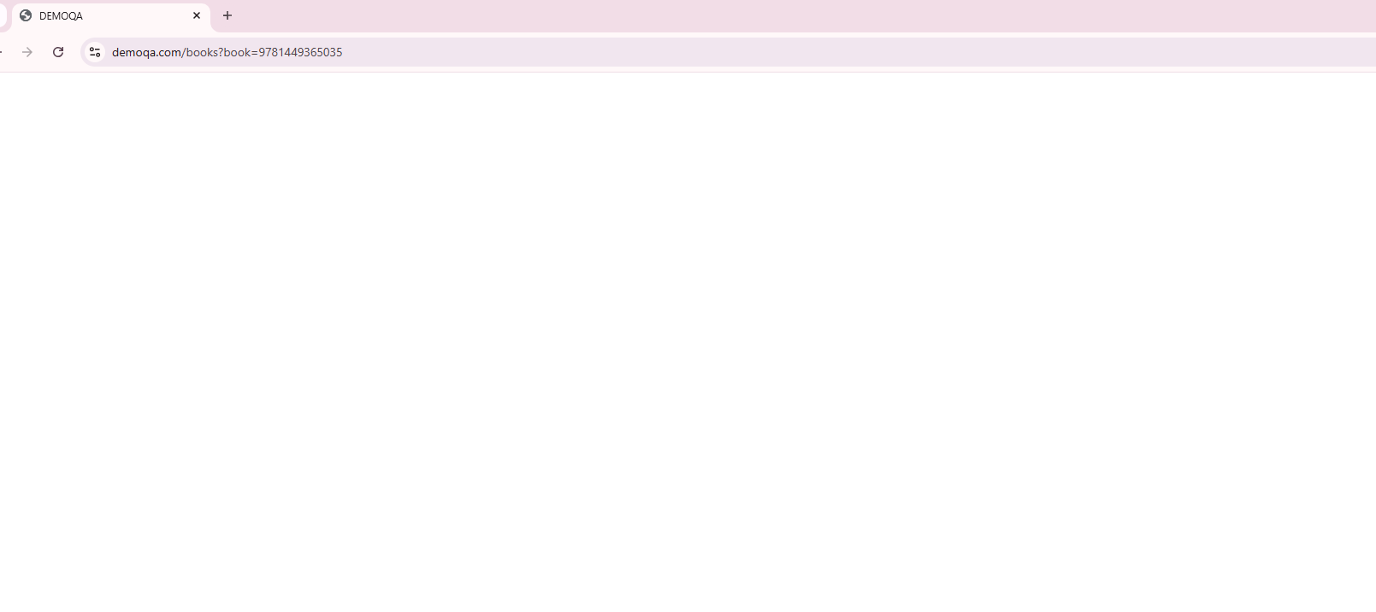

Figure 1:Embedded screenshot showing blank screen after clicking “Add To Your Collection” while logged in